**BIRLA INSITUTE OF TECHNOLOGY AND SCIENCES PILANI, Hyderabad Campus**

**Comprehensive examination 2022-2023 1st semester; 17th December 2022**

**BIOCHEMISTRY (BIOF211) OPEN BOOK (Total 40 Marks) Maximum time (90 minutes)**

**PART C**

1. A) What is the role of thioester in the formation of ATP in glycolysis? **4M**

B) Name the compounds having thioesters involved in the reaction catalysed by pyruvate dehydrogenase complex? **2M**

1. Hexokinase in red blood cells has a KM of approximately 50μM. Assume that hexokinase displays Michaelis-Menten kinetics. What concentration of blood glucose would yield Vo equals to 90% Vmax? Show the calculation. What does this result indicate if normal blood-glucose levels range, approximately, from 3.6 and 6.1 mM? **2+2=4M**
2. What energetic barrier prevents glycolysis from running in reverse to synthesize glucose? What is the energetic cost of overcoming this barrier? **4M**
3. During your morning exercise, the rate of the citric acid cycle increase. What would be the most crucial molecule to be replenished to run the citric acid cycle? Name the enzyme and the co-enzyme that play a key role in replenishing the above molecule to run the citric acid cycle**. 3M**
4. Calculate the net ATP yield from linoleic acid. Show the appropriate calculation. Given that 1 mole of NADH and 1 mole of FADH2 produce 2.5 mole and 1.5 mole equivalent of ATP molecules. **5M**
5. I) Identify the structures from A to D and arrange them in order as they appear in one of the catabolic cycles. Name the cycle. **5M**

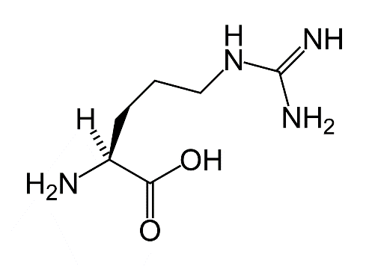A) 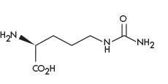B)

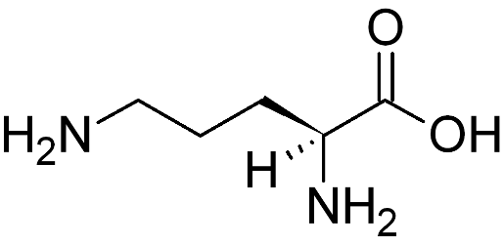C) 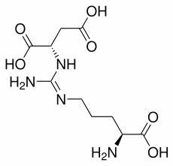D)

ii) Name the a-keto acids that can be obtained from the transamination reaction of a) phenylalanine and b) tyrosine **2M**

1. In the following table, two inhibitors and their target respiratory chain components are shown. Predict the relative oxidation-reduction states of the given respiratory chain components when treated with these three inhibitors – a) NAD+, b) coenzyme Q, c) cytochrome a. Answer should be given in the prescribed format. **6M**

|  |  |
| --- | --- |
| Inhibitor | Inhibits electron flow through enzyme complex/electron carrier |
| Rotenone | NADH-Q |
| Antimycin A | Flow between cytochromes b and c1 |

Answer format

|  |  |  |  |
| --- | --- | --- | --- |
| Inhibitor | NAD+ (redox state) | Coenzyme Q (redox state) | Cytochrome A (redox state) |
| Rotenone |  |  |  |
| Antimycin A |  |  |  |

1. In an anabolic process, the following molecules (A to D) are involved. Name these molecules. Arrange those molecules to complete the steps of the anabolic process starting from the precursor molecule to the final product. Name the anabolic process. **5M**

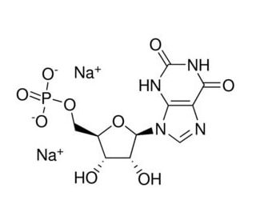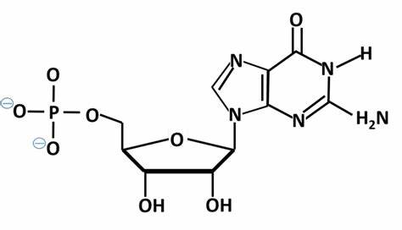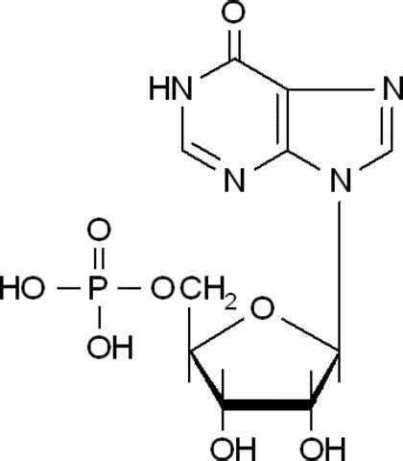 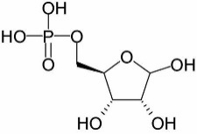

1. **(B) (C) (D)**