**BIRLA INSTITUTE OF TECHNOLOGY AND SCIENCE, PILANI - HYDERABAD CAMPUS FIRST Semester, 2022-2023 MIDSEMESTER EXAMINATION-CLOSED BOOK**

**Course Name: BIOLOGICAL CHEMISTRY Course Number: BIOF211**

**Max. Marks: 60 Duration: 90 minutes Date: 31-10-2022**

**INSTRUCTIONS: There are FOUR questions in all. Answer all the sections of a question together, all questions are compulsory.**

**Ensure that both sides of the paper are printed. Start answering each question on a fresh page and answer all parts of the question together. Pencil should not be used. Provide concise answers.**

**1(A).**Why are negatively charged residues, aspartic acid and glutamic acid more common towards the N-terminus of α- helices? Why is Proline not observed in the middle of the of α-helices? ***(5M)***

**1(B).** Write the single letter codes for the following amino acids: Glutamine, Lysine, Tryptophan, Glutamic acid. ***(5M)***

**1(C).** Consider you have a mixture of five different proteins listed in the table below:

|  |  |  |  |
| --- | --- | --- | --- |
| **#** | **Protein** | **pI** | **Mol. wt.** |
| **A** | **Myoglobin** | **7** | **16.7** |
| **B** | **Ubiquitin** | **6.4** | **8.5** |
| **C** | **Ovalbumin** | **4.6** | **45** |
| **D** | **Cytochrome c** | **10.6** | **13** |
| **E** | **Serum albumin** | **4.9** | **68.5** |

**(i)**Indicate the order in which the proteins listed in the above table will elute from a gel-filtration column (starting with the one that elutes first).

**(ii)**You load this mixture on a cation exchange column (i.e. column that bears negatively charged groups). The buffer you use for this column is acetate buffer, pH 4.76. List protein(s) that will be eluted fast (i.e. will not bind to the column). ***(6M)***

**1(D).** List 5 forces that are responsible for maintaining the correct three-dimensional structure of proteins. Indicate the amino acid pair that is involved in each type of interaction. ***(5M)***

**2(A).** When bacteria growing at 20°C are warmed to 30°C, are they more likely to synthesize membrane lipids with **(i)** saturated or unsaturated fatty acids, and **(ii)** short-chain or long-chain fatty acids? Explain. ***(4M)*** **2(B).** Draw a schematic drawing of a portion of a lipid bilayer. What is the energetic driving force for the formation of phospholipid membrane bilayers. ***(4M)*** **2(C).** Given below is Fischer representation of glucose. Which one of the labeled carbons is epimeric. What is the basis of your choice? Draw the Howarth representation for β-D glucose. ***(4M)***

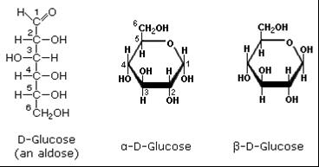

**3(A).** What are the reasons for why guanine pairs with cytosine and not with thymine. ***(4M)***  **3(B).** What is helical twist and propeller twist. What is their importance in B-DNA structure? ***(4M)*** **3(C).** When a mixture of 3-phosphoglycerate and 2-phosphoglycerate is incubated at 25 °C with phosphoglycerate mutase until equilibrium is reached, the final mixture contains six times as much 2-phosphoglycerate as 3-phosphoglycerate. For the 3-Phosphoglycerate → 2-phosphoglycerate conversion by obtaining the free energy change in kJ mol-1) comment on the spontaneity of the reaction. (*R* = 8.315 J/mol·K; *T* = 298 K) ***(5M)***

**4(A).** For two alternative substrates, A & B, the measured Km and Vmax for the same enzyme are: for substrate (i) 4.0 mM, 25 mol/sec and for substrate (ii) 0.5 mM, 15 mol/sec, respectively. At lowsubstrate concentration which substrate will react most rapidly? Justify your choice showing the working. ***(4M)***

**4(B).** Between MWC model and sequential model for allosteric enzymes, which one can account for negative cooperativity and why? Consider the concerted model for cooperative oxygen binding to hemoglobin. The simplest, two-subunit model for the protein is shown below:

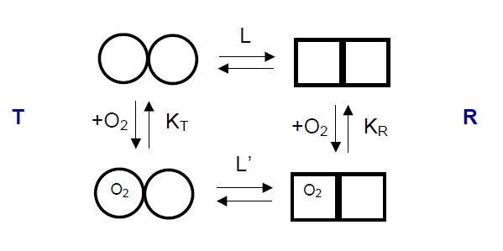

What should be the relationship between KT and KR and between L and L’ in order to achieve positive cooperativity for O2 binding in this model? (KT and KR are the dissociation constants for O2 binding to the T or R state, while L and L’ are the equilibrium constants for T/R and T(O2)/R(O2). ***(4M)***

**4(C).** Calculate the reaction velocity, v for [S] = 10 KM. Show the value as a percentage of Vmax. Indicate the x and y axes in the Lineweaver-Burk plot for an enzyme catalyzed reaction exhibiting Michaelis- Menton kinetics and show how KM and Vmax can be determined . On each plot, indicate how KM and Vmax will be affected. would be affected by the presence of a competitive inhibitor. ***(4+2M)***

**\*\*\*\*\*\*\*\*\*\*\*\*\*\*\*\*\***