**BITS Pilani Hyderabad**

**Microbiology BIO F212**

**Lecture Quiz 2 Makeup**

**Date: 14-12-2022 Time: 20 minutes Total Marks: 20M**

**IC: Dr. Ruchi Jain Dey**

**Name: ________________________ ID ___________________________**

**Instructions:**

**1. Please fill in your answer by writing in the blank.**

**2. Each blank carries 1M.**

**3. NEGATIVE MARKING: For every wrong answer, 0.25M will be deducted**

1. Methylation and acetylation of DNA and histone that allows a cell to adapt to different conditions come under ___________________________regulation leading to changes in _________________changes. **[2M]**
2. Genetic, epigenetic
3. Transcription, epigenetic
4. Epigenetic, Transcriptional
5. Genetic, Transcriptional
6. Action of Topoisomerase (or gyrase) relaxes the supercoiled DNA leading to initiation of DNA replication at ________________________________________, wherein _______________strand is synthesized continuously and ____________________strand is synthesized discontinuously with the help of short piece of RNA called ________________________made by ____________________enzyme. **[5M]**

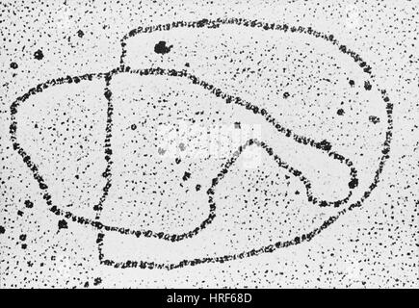

1. See the picture on right and answer the following.
2. Identify the process ________________________ **[1M]**
3. Name the structure formed during this process shown on right **_____________________**  **[1M]**

4. Ribonucleic acid synthesis results in addition on ribonucleotides to the 3’ end of the growing ribonucleic acid chain, in eukaryotes it is followed by addition of **___________________** on 5’ end and **_____________**tail at the 3’ end to protect the ribonucleic acid from degradation by____________________________. **[3M]**

5. The phenomenon of having multiple codons for the same amino acid arises due to the last base called the **__________________**position and codons are called **_________________________**codons. **[2M]**

6. In Arg operon, when arginine **____________________**, it binds to **______________________**facilitating its binding to **________________________** region on DNA causing**____________________** of further synthesis of arginine. **[4M]**

7. Shine Dalgarno sequence is the site of **___________________**binding on **________________** **[2M]**