1. Derive the expression for effective moment of inertia of the following circular RC section.

Use generic symbols for geometry of the section and reinforcements. 10

*x*

*b’*

*R*

Use the following information to compute the first moment of area equations and the expression for effective MI of the section. Assuming radius of the circle to be *R*, and length of the chord at a distance of *x* (N-A depth of the RC section) from the apex of the circle to be *b’*, find the expression for θ in terms of the cross-sectional dimensions.

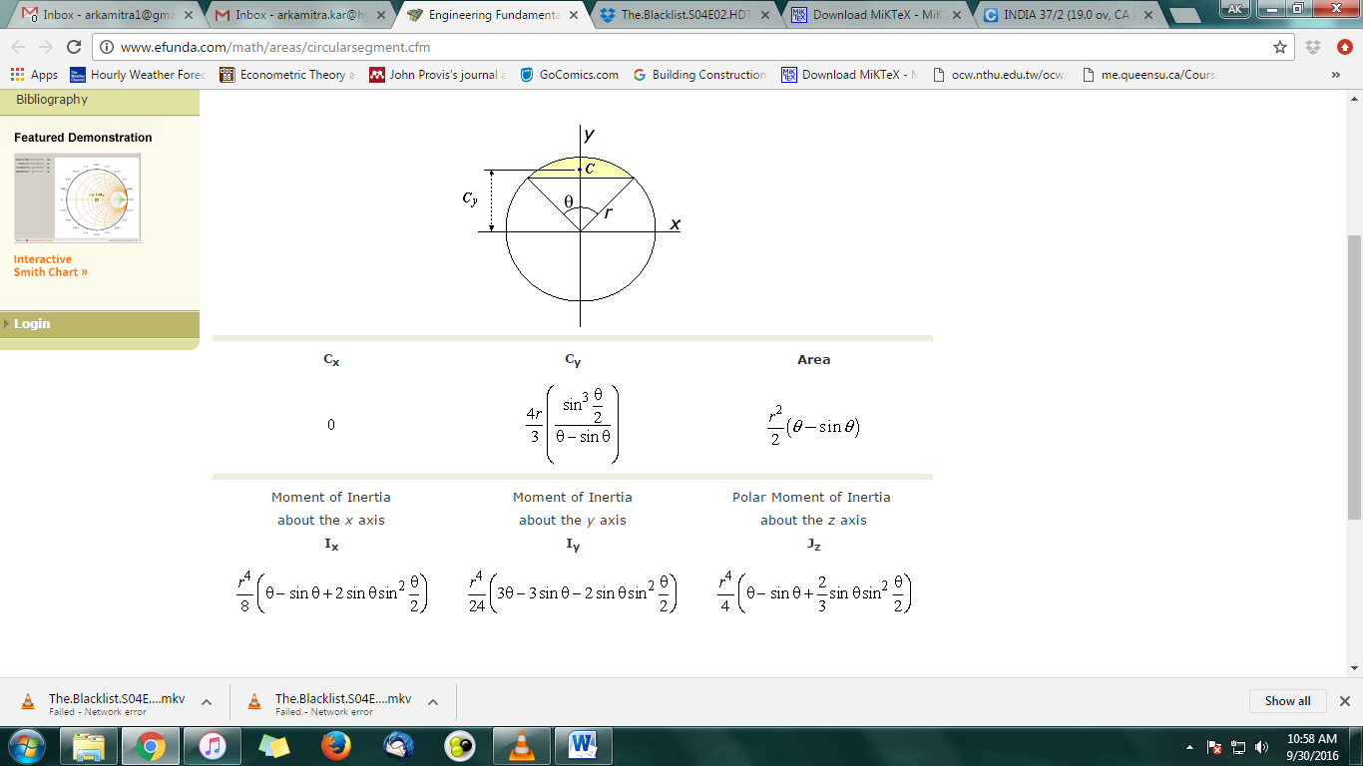

1. Calculate the moment carrying capacity of the following section of a simply supported RC beam having **width** = 300mm, and **total depth** restricted to 600 mm and subjected to severe conditions. Use M25 concrete and Fe 415 HYSD. Provide 5-25Φ (1-layer) at bottom and 2-20Φ at top as tension reinforcement. 10
2. What is the advantage of using a T- or L- beam, from design point of view? Under which loading condition is it not advisable to take that advantage into account? 2+3=5
3. What is the basic assumption of the equation from which the coefficients of maximum bending moments per unit width in a slab are derived in Table 27 of IS-456: 2000? How does it justify the expression for *M*y in terms of *l*x? What is the ratio of the central deflection for a unit strip, 1m by 1m spanning along *l*y and *l*x and why? List the factors that would govern the provision of a corner grid two-way slab 2+3+(1+2)+2 = 10
4. Draw representative figures to show how the placement and subsequent curtailments of top and bottom reinforcements along the shorter span would vary in a two-way **corner slab panel having dimension 6m by 6m**. Assume the provision of middle strip main bars as 12Φ @ 250 mm c/c. 5+5=10
5. Design and detail (plan view and both side views) the reinforcements in a short column 300 × 500 mm at the corner of a multistoried building to support an axial design load of 1500kN, together with factored biaxial moments of 60 kN-m. Use M-25 concrete and Fe 415 steel. 10 + 3×5 = 25
6. Design a suitable footing for the above column, given that the safe bearing capacity of local soil is 18.5 t/m2. Use **suitable** grade of concrete and Fe 415 steel. Provide final c/s and plan diagrams for final combined column-footing section. 20
7. Show the reinforcement details in ONE FLIGHT of a dog-legged RC Stair case having 10 risers (9 treads), highlighting the 4 layers of main reinforcement and distributors. Assume the thickness of waist slab as 150 mm. The risers are 150 mm and treads are 300 mm. Assume the stair case to be supported on RC beams at the floor and mid landing levels. The staircase is reinforced with 12Φ @ 150 c/c (BOT) and 10Φ @150 c/c (TOP) along with 8φ @ 200 c/c distributors. Assume a scale of 1:50 or any other suitable scale for the diagram. 10