BITS Pilani Hyderabad Campus

Fluid Mechanics (CHE F212) - First Semester 2022-23

ENDSEMESTER TEST (CLOSED BOOK)

Date: 22nd Dec. 2022 Marks: 80 Marks

Time: 2 PM – 5 PM Weightage: 40 %

*All questions must be answered. Calculators are allowed. Mobile phones/laptops and other electronic devices are not allowed.*

**Q.1**. The control volume for analysis of laminar flow between stationary infinite parallel plates is given in the figure below.

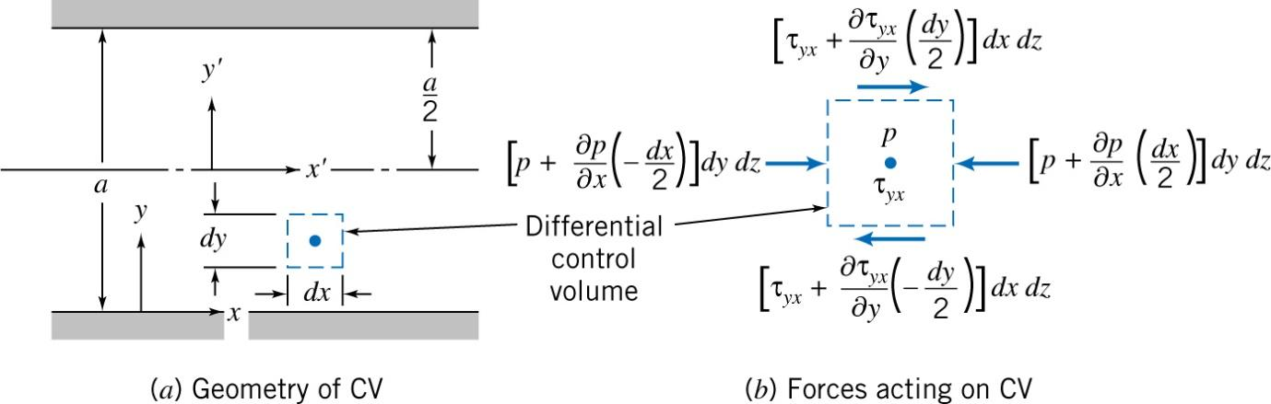

By stating appropriate assumptions, derive the expressions for the following,

1. Velocity Profile (4 Marks)
2. Shear Stress Distribution (2 Marks)
3. Volume Flow Rate (2 Marks)

**Q.2**. Viscous oil flows steadily between parallel plates as shown in the figure below,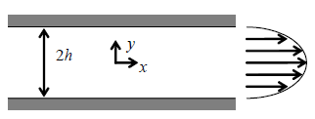

The flow is fully developed and laminar with the expression for velocity being, 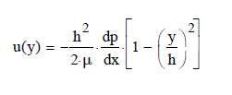.

The pressure gradient is 1.25 kPa/m and the channel half-width is h = 1:5 mm. Calculate the magnitude and direction of the wall shear stress at the upper plate surface (μ = 0.5 N.s/m2). (3 Marks)

**Q.3**. Air at 1000C enters a 125 mm diameter duct. Find the volumetric flow rate at which the flow becomes turbulent. At this flow rate, estimate the entrance length required to establish fully developed flow. (5 Marks). Kinematic viscosity of air= 2.29 X10-5 m2/s

**Q.4**. In relevance to flow of fluid through bed of solids, match the following (2 Marks)

|  |  |
| --- | --- |
| * 1. Hagen-Poiseuille equation for laminar flow | …(I) |
| * 1. Ergun equation | (II) |
| * 1. Burke-Plummer equation | + ..(III) |
| * 1. Kozeny-Carman equation | $\frac{Δp}{L}=\frac{32\underline{V}μ}{D^{2}}$ (IV) |

**Q.5**. Between venturi meter and orifice plate used for flow measurements, which causes the largest head loss and why? (2 Marks)

**Q.6**. State True or False (10 Marks)

1. Due to frictional effects in a fully developed flow in constant area tubes, the major head losses result from entrances, fittings and valves
2. For a fully developed laminar flow in a pipe, the shear stress varies from zero at the centerline to a maximum at the pipe wall.
3. In a flow over a flat plate normal to the flow, the wall shear stress is perpendicular to the flow direction and therefore, does not contribute to the drag force.
4. In flow through bed of solids, *Kozeny-Carman* equation is applicable when *Re* is > 1000
5. In agitation and mixing of liquids, the Reynolds number is expressed as the ratio of viscous forces to inertial forces.
6. Synovial fluid in human knee joints can be categorized as viscoelastic fluid.
7. For unsteady flow, streak lines and pathlines will in general have different shapes and do not coincide
8. Fluid continuously deforms in response to an applied shear stress that sets it apart from solids
9. In toothpaste kind of fluids, shear stress is not directly proportional to shear rate
10. Viscosity of the silicone oil is lower than the water and that is the reason why it can be used as heat conducting fluid at 150 OC

**Q.7.** When subjected to shear force, the amount of deformation of the solid depends on solid’s__________and rate of deformation of fluid depends on the fluid’s ________ ( 1M)

**Q.8.** The load cell used for mechanical testing can sustain till 112 lbf. Calculate the load cell capacity in N? ( 1M)

**Q.9**. **a**. Write the Bernoulli equation imagining two points in venture meter (assume water is flowing in a circular pipe) and write the dimensions of each term and how it can be made dimensionless. ( 3 M)

**b.** Write the limitations of Bernoulli equation (assuming a flow in circular pipe) ( 2M)

**Q.10.** Specific weight is defined as the weight of the substance per _______and specific modulus is defined as the modulus of the substance per _______( 1 M)

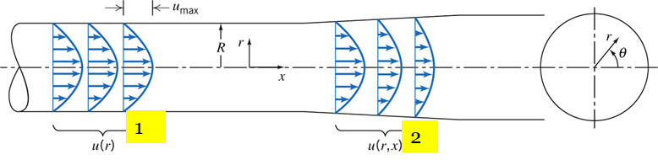**Q.11**.

Which of the following statement is true for the flow through a straight pipe with divergent section (1 M)

a. Location-1 is one dimensional flow;

b. location-2: two dimensional flow due to decrease in velocity;

**c.** location-2: two dimensional flow due to increase in velocity;

**d**: u = u max. 1- (r/R) 2 velocity distribution is applicable for locations 1 and 2

**Q.12**. Unlike viscosity in Newtonian fluid, apparent viscosity in non-newtonian fluid (ɳ) depends on __________. In case of shear thinning fluids (paper pulp slurry) ɳ decreases with increase in _____ ( 1M)

**Q.13**. In differential analysis of fluid motion, write the equation for the

a. acceleration of a fluid particle in a velocity field for unsteady flow ( 2M)

b. Write the Navier stokes equation for Newtonian fluids (momentum equation for incompressible flow with constant viscosity) (2 M)

**Q.14.** Draw the qualitative picture of incompressible flow over a sphere and tear drop shaped objective and explain the wake formation, form drag (pressure drag) and boundary layer (3 M)

**Q.15**. Explain the significance of Cavitation number and Mach number ( 3M)

**Q.16**. From the CFD learning (ANSYS), draw the velocity profile imagining the fluid flow in a duct (one inlet and three outlets). Out of three outlets, two are small in diameter with sharp corners (2 M)

**Q.17**. Using Buckingham PI theorem, obtain a set of dimensionless groups that can be used to correlate experimental data wherein drag force F2 on a smooth sphere depends on the relative speed V2, sphere diameter D2, fluid density ρ and fluid viscosity µ. ( 3 M)

**Q.18**. Derive the Bernoulli equation by applying the first law of thermodynamics to a stream tube of control volume (flow through a stream tube). State the all restrictions need to be considered to derive this equation. (4 M)

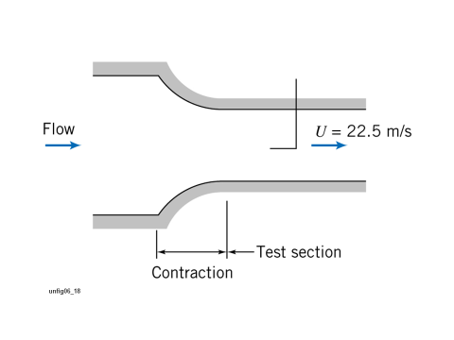**Q.19**. The contraction and test section of the laboratory wind tunnel is shown in the figure wherein air speed in the test section is 22.5 m/s. A total-head tube pointed upstream (left side of the image) indicates the stagnation pressure on the test section centreline and it was found to be 6 mm of water below atmospheric. Lab is maintained at 101 KPa and 23 OC. Evaluate the dynamic pressure and static pressure on the centre line of the wind tunnel of the test section. How the static pressure can vary between centre line to tunnel wall in case of a) test section zone b) contraction zone (2+2+2= 6 M)

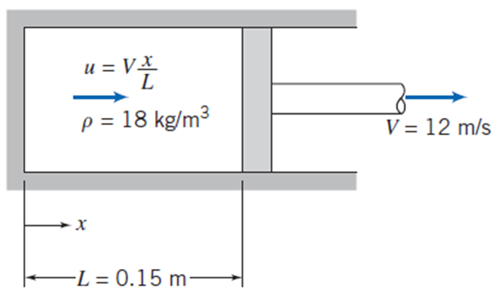

10

8 m/s

**Q.20.** A gas-filled pneumatic strut in an automobile suspension system behaves like a piston-cylinder apparatus. At one instant when the piston is L = 0.15m away from the closed end of the cylinder, the gas density is uniform at 𝜌 = 10 kg/m3 and the piston begins to move away from the closed end at V = 8 m/s. Assume as a simple model that the gas velocity is one-dimensional and proportional to distance from the closed end (varies linearly). Find the rate of change in gas density at this instant (4 M)

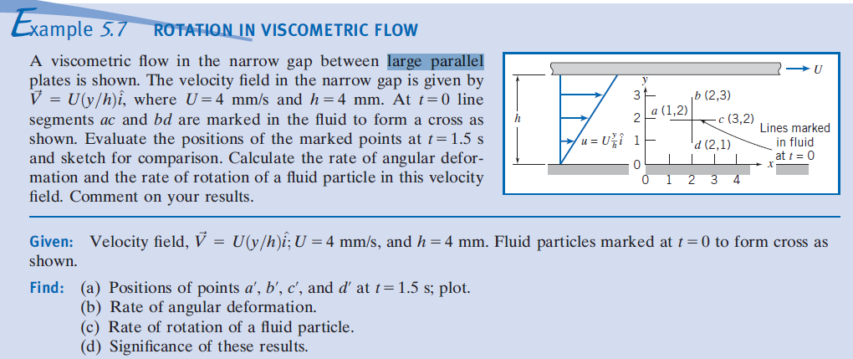

**Q.21**. A viscometric flow in the narrow gap between large parallel plates is shown in the diagram, wherein U= 5 mm/s, h =5 mm. At t=0 line segments a,c and b,d are marked in the fluid to form a cross as shown. Evaluate the positions of the marked points at t=2s and sketch for comparison. Calculate the rate of angular deformation and the rate of rotation of a fluid particle in this velocity field. (3+3=6 M)

**Q.22.** Explain briefly about Reynolds transport theorem (relation of system derivative to the control volume formulation) and write formula for conservation of mass and Linear momentum ( 1+2+2= 5 M)