BITS Pilani Hyderabad Campus

Fluid Mechanics (CHE F212) - First Semester 2022-23

MIDSEMESTER TEST (CLOSED BOOK)

Date: 02nd Nov. 2022 Marks: 60 Marks

Time: 11 AM – 12:30 noon (90 min) Weightage: 30 %

***All questions must be answered. Calculators are allowed. Mobile phones/laptops and other electronic devices are not allowed.***

**Q1**. What methods are used to prevent the circulatory flow and swirling in a typical agitated vessel? (2 marks)

**Q2**. What are the major classes of impeller agitators based on the current that is generated? How does the flow pattern vary in each case? (1 + 2 = 3 Marks)

**Q3**. A tank 1.2 m in diameter and 2 m high is filled to a depth of 1.2 m with a latex having a viscosity of 10 Poise and a density of 0.8 g/cm3. A three-blade 360 mm diameter propeller is installed in the tank 360 mm from the bottom. The pitch is 1:1 (pitch equals diameter). The motor available develops the power of 9000 W. Is the motor adequate to drive this agitator at a speed of 800 r/min for cases when the a) tank is unbaffled and b) baffled? (3 + 3 = 6 Marks)

You may refer to the following data if needed

1. 1 Poise = 0.1 Pa.s
2. Graph showing Power Number *Np* vs Reynolds number *Re* for marine propellers (pitch = 1.5:1) and helical ribbons

**Q.4.** The x component of velocity in a laminar boundary layer in water is approximated as u= U Sin ($\frac{π y}{2 δ}$), where U = 4 m/s and $δ=2.5 mm. The y component of velocity is much$ smaller than u. Obtain an expression for the net shear force per unit volume in the x-direction on a fluid element. Calculate its maximum value for this flow. (6 M) (given: viscosity of water = 1.01 X 10-3 N.s / m2)

**Q.5**. Explain the terms along with units for A, B, C, D and E mentioned in the below diagram. Write the major difference that exists between fluid deformation and solid deformation (3+3=6 M)



**Q.6.** a. Write the continuity equation (Conservation of Mass to a Differential control volume for rectangular coordinates for <<incompressible fluid>> and also for <<steady state>> (2M)

b. In fluid translation, write the equation for Acceleration of a fluid particle in a velocity field (2 M)

c. Write the Navier-stokes equation for Newtonian fluids (momentum equation for incompressible flow with constant viscosity) – (2 M)

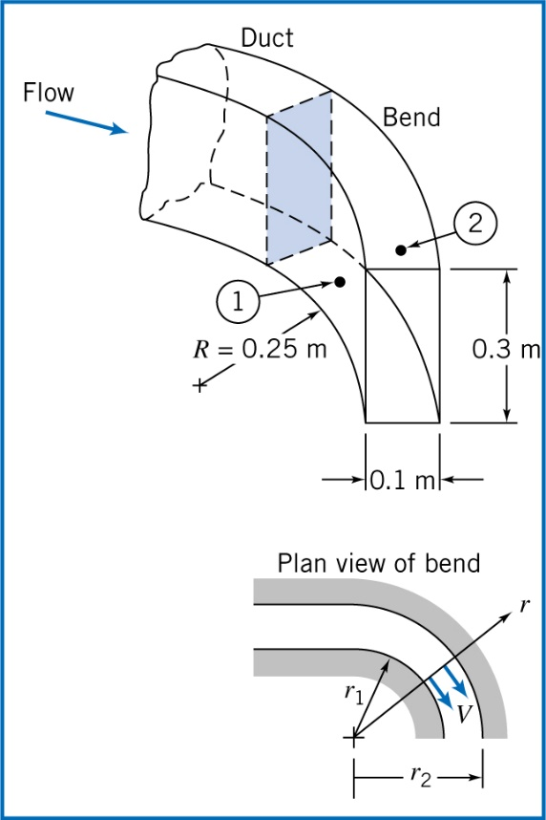**Q.7.** The flow rate of air at standard condition in a flat duct is to be determined by installing pressure taps across the bend. The duct is 0.4 m deep and 0.2 m wide. The inner radius of the bend is 0.35 m. If the measured pressure difference between the taps is 20 mm of water, Compute the approx. velocity? Imagine the Incompressible flow, Frictionless flow and Uniform flow at measured section. (8 M)

**Q.8**. A tank of 0.2 m3 volume is connected to a high pressure airline; both line and tank are initially at a uniform temperature of 20OC. The initial tank gauge pressure is 120 KPa. The absolute line pressure is 20 MPa, the line is large enough so that its temperature and pressure may be assumed constant. The tank temperature is monitored by a fast response thermocouple. At the instant after the valve is opened, the tank temperature rises at the rate of 0.1 OC/s. Determine the instantaneous flowrate of air into the tank if Q is neglected (8 M) (assume the R value of air as 287 J / kg. K)

**Q.9**. A venturi meter installed along a water pipe consists of constant-area throat. The pipe diameter is D=120mm, and the throat diameter is d = 45mm. Find the net fluid force acting on the convergent section if the water pressure in the pipe is 620 kPa (gage) and the velocity is 5 m/s. For this analysis, neglect viscous effects. (8 M)

b. Is the length of the divergent section remains same as convergent section? Write the answer with justification (1M)

**Q.10.** Stagnation pressure for incompressible flow is the sum of static pressure and ______________ . It is obtained from neglecting __________in Bernoulli equation (2 M)

**Q.11.** Which of the following sentences are wrong? (2 M)

|  |  |
| --- | --- |
|  | Equation-1 |
|  | Equation-2 |

1. Equation-1 is total (net) force acting on fluid element (assumption of fluid statics)
2. Equation-2 is total surface force acting on fluid element (assumption of fluid statics)
3. Equation-1 is total body force acting on fluid element (assumption of fluid statics)
4. Equation-2 is total body force acting on fluid element (assumption of fluid statics)

**Q.12**. Which of the following sentence is wrong? (2 M)

a. Bernoulli equation along a stream line for steady, frictionless, incompressible flow have dimensions of L2/t

b. For steady flow, Path lines, streaklines and stream lines are identical lines in the flow field.

c. Kinematic viscosity υ has the units of m2/s

d. For details of fluid flow, differential forms (instead of integral approach) of the equation of motion is needed

END OF THE PAPER 02nd Nov. 2022