Development of Reporter-gene based Novel Bacterial Biosensors for the Detection of Arsenic and Antibiotics

THESIS

Submitted in partial fulfillment

of the requirements for the degree of

DOCTOR OF PHILOSOPHY

By
JOY SCARIA

Under the supervision of
Dr. S.K.Verma



BIRLA INSTITUTE OF TECHNOLOGY AND SCIENCE
PILANI (RAJASTHAN) 333 031
INDIA

2005
BIRLA INSTITUTE OF TECHNOLOGY AND SCIENCE

PILANI, RAJASTHAN, INDIA

CERTIFICATE

This is to certify that the thesis entitled “Development of Reporter-gene based Novel Bacterial Biosensors for the Detection of Arsenic and Antibiotics” submitted by Joy Scaria, ID No. 2000PHXF020 for award of Ph.D. Degree of the Institute, embodies original work done by him under my supervision.

Signature in full of the Supervisor

Name in capital block letters: S.K. VERMA

Designation: Associate Professor & Group
Leader

Date:

ACKNOWLEDGMENTS

I express my deep gratitude to my supervisor Prof.S.K Verma, Group Leader, Biological Sciences Group, BITS, Pilani. It has been a privilege to be under his mentoring and guidance. He had always been very patient and supportive throughout my studentship. I shall forever be obliged to him for giving me all the freedom and molding me towards an independent career.

I express my sincere gratitude to Vice Chancellor Prof. Venkateswaran, Pro Vice Chancellor Prof. L.K Maheshwari and Dean Research and Consultancy Division Prof. Ravi Prakash for providing all the support and facilities for the successful completion of this work.

My heartfelt thanks are to Prof Barry Rosen, School of Medicine, University of Michigan, Prof S Yasuda, National Institute of Genetics, Japan and Dr.Partha Roy, IIT, Roorkee for providing reporter genes and plasmids without which this study would not have materialized. I sincerely acknowledge Mrinal K Sengupta, Research Fellow, SOES, Jadavpur University for providing critical inputs for collecting arsenic containing water samples from various districts of W. Bengal.

It is my pleasure to thank Dr.A.K Das for all the suggestions and encouragement. He has always been there with a smile to give critical inputs for the work and also for pepping up my morale.

I am extremely grateful to Prof Suman Kapur, member of my Doctoral advisory Committee, for critical suggestions and cooperation. I am also grateful to the Faculty, Biological Sciences Group, BITS, Pilani for their help and support.

My group members had always been very supportive. I thank Ravi for the great company, for all his suggestions and advices in the early days of this work, Ramchandran for his concern and support in bench work, Aswin for his ever willing cooperation.

I fondly acknowledge my friend Umesh (Umamaheswaran) for his active support for database development and for his cheerful company, Fabian and Chitra for help with GFP detection in the first phase of the thesis work.

I extend my sincere thanks to my very affectionate friends, Vijay, Vidya, Vishal and Shilpi for their ever willing support and company.

I am extremely happy to express my gratitude to Dr.Neeru Sood for her kindness, support and advices, Dr.Saby John for all her suggestions for the compilation of this report.

My special thanks goes to Srividya, Bhargavi, Nirmala, Jasbeer, Pradeep, Mukund, Anand and Tarun for all their assistance in lab and for making the bench work more cheerful.

I am grateful to all my labmates Deepak, Narayana, Manav, Sashwat and Shipra

I gratefully acknowledge the financial support from Council of Industrial and Scientific Research (CSIR) in the form of Senior Research Fellowship.

Above all, the credit of this work goes to my family. Chachen, Amma, Ancy chechi, Tomy, Sherly chechi, Deepthi and Gimmy have been very loving, caring and were there to provide all the energy to successfully complete this study.

Joy Scaria

Abstract

The present work was planned towards developing GFP based whole cell bacterial biosensors to aid detection studies on two serious problems facing the country i.e. rise in the prevalence of antibiotic resistant bacteria and arsenic contamination in Gangetic basin of north-eastern India. An EGFP based whole cell bacterial biosensor for arsenic detection was constructed by creating a transcriptional fusion between the ars regulatory sequences and EGFP gene in plasmid PEGFP. The resultant recombinant plasmid pJSKV51 was used to transform E. coli DH5α and the new strain (E. coli DH5αpJSKV51) was used as a whole cell bacterial biosensor for the detection of arsenic in drinking water samples from W. Bengal. Under optimal conditions, the Arsenic biosensor strain could detect arsenic from 5ppb to 500ppb. This range of detection satisfies the WHO standards of detection limits (50ppb) for arsenic in drinking water samples. To promote intensive studies on antibiotic resistance genes and to facilitate the selection of most suitable regulatory sequences for the construction of biosensor for antibiotic detection, an Internet based database on antibiotic resistance genes (ARGO) was developed (http;//www.argodb.org) and was made available to academia and industry as a free resource. Based on the searches made in ARGO, a bacterial biosensor strain for the detection of tetracyclines was developed by cloning the regulatory elements of tet operon from plasmid pOT182 into plasmid pEGFP. Under standard conditions, the strain could detect tetracycline in the range of 10-60ng/ml and oxytetracycline in the range of 25-125ng/ml of sample. The strain was evaluated for its efficacy by using it to detect residual tetracyclines in milk and water. The fluorescence induction in the biosensor strain (E.coliJM109pJSKV41) by all concentrations of tetracycline spiked pond water samples was equivalent to that of the EGP induction levels that was obtained by same concentrations of tetracyclines dissolved in de-ionized water. This strain was able to detect tetracyclines in milk samples well below the specifications of the European union standards (100ng/ml) and was found to be having superior sensitivity than FDA approved Bacillus Stearothermophilus Assay (BSDA). The results suggest that the biosensor strains developed in this study could be a cheaper alternative to the conventional methods of arsenic and antibiotic detection.

CONTENTS

 | Page No.
Certificate
Acknowledgements
Abstract
Contents
List of Figures
List of Tables
List of Abbreviations
Chapter I Introduction | 1
Chapter II Development of Whole Cell Biosensor for Arsenic Detection | 10
2.1 Introduction | 10
2.2 Materials and Methods | 16
2.2.1 Bacterial strain and culture media | 16
2.2.2 Enzymes and chemicals | 16
2.2.3 Metal ion analysis | 16
2.2.4 Fluorescence microscopy | 17
2.2.5 Fluorescence assay | 17
2.2.6 Construction of biosensor strain | 17
2.2.6.1 Isolation of plasmid DNA | 17
2.2.6.2 Agarose gel electrophoresis of DNA | 18
2.2.6.3 Purification of DNA from enzymatic reactions | 18
2.2.7 PCR amplification of the target | 19
2.2.7.1 Design of Polymerase Chain Reaction (PCR) primers | 19
2.2.7.2 PCR amplification | 19
2.2.8 Restriction Endonuclease digestion of DNA | 19
2.2.9 Dephosphorylation of vector DNA | 22
2.2.10 Phosphorylation of insert DNA | 22
2.2.11 Ligation | 22
2.2.12 Transformation | 25
2.2.12.1 Preparation of competent cells | 25
2.2.12.2 Transformation | 25
2.2.13 Screening of the transformants for recombinants | 26
2.3 Optimization of biosensor assay conditions and evaluation of strain’s  performance | 26
2.3.1 Range of detection and time | 26
2.3.2 Effect of pH | 26
2.3.3 Effect of temperature | 28
2.3.4 Effect of photobleaching | 28
2.3.5 Effect of shaking | 28
2.3.6 Effect of cell density | 29
2.3.7 Non specific induction | 29
2.4 Evaluation of biosensor performance | 29
2.4.1 Field sample collection | 29
2.4.2 Estimation of arsenic by biosensor | 31
2.4.3 Estimation of arsenic by Atomic Absorption Spectroscopy (AAS) | 31
2.5 Results and Discussion | 31
2.5.1 Construction of the biosensor strain | 32
2.5.2 Determination of sensitivity range and optimal incubation time | 32
2.5.3 Effect of pH | 40
2.5.4 Effect of temperature | 42
2.5.5 Effect of photobleaching | 42
2.5.6 Effect of shaking | 45
2.5.8 Effect of cell density | 47
2.5.9 Effect of co-ions | 47
2.5.10 Evaluation of biosensor performance | 49
Chapter III Development of Internet Based Database on Antibiotic  Resistance Genes | 56
3.1 Introduction | 56
3.2 Methodology of database development | 59
3.2.1 Gene categories | 59
3.2.2 Database architecture | 59
3.2.3 Retrieval of sequence information from Genbank | 59
3.2.4 PHP Code of Genbank parser routine | 61
3.2.5 Populating ARGO tables | 67
3.2.6 Establishment of Internet based server | 72
3.2.7 Analysis of sequence data in ARGO | 72
3.3 Results and Discussion | 72
3.3.1 Construction of the database | 72
3.3.2 Sequence analysis of ARGO data | 77
Chapter IV Development of Whole Cell Biosensor for the Detection of  Tetracyclines | 81
4.1 Introduction | 81
4.2 Materials and methods | 85
4.2.1 Host strain, plasmids and reagents | 85
4.2.2 Fluorescence microscopy and Fluorescence assay | 85
4.2.3 Construction of biosensor strain | 86
4.2.3.1 Restriction Endonuclease digestion of DNA | 86
4.2.3.2 Dephosphorylation of vector DNA | 89
4.2.3.3 Ligation, transformation and selection of recombinants | 89
4.2.3.4 Screening of the transformants for recombinants | 89
4.2.4 Optimization of biosensor assay conditions and evaluation of strains  performance | 89
4.2.4.1 Determination of sensitivity range and optimal incubation  time | 89
4.2.4.2 Effect of cell density | 92
4.2.4.3 Effect of temperature | 92
4.2.4.4 Effect of photo bleaching | 92
4.2.4.5 Effect of pH | 93
4.2.4.6 Effect of Shaking | 93
4.2.4.7 Effect of co-antibiotics | 93
4.2.5 Evaluation of biosensor performance | 94
4.2.5.1 Estimation of tetracyclines in water and determination of  biosensor stability | 94
- Estimation of tetracyclines in Milk and comparison with  BSDA method | 95
4.3 Results and Discussion | 95
4.3.1 Construction of the biosensor strain | 95
- Optimization of biosensor assay conditions and evaluation of strains  performance | 99
4.3.2.1 Determination of sensitivity range and optimal incubation  time | 99
4.3.2.2 Effect of cell density | 101
4.3.2.3 Effect of temperature | 103
4.3.2.4 Effect of Photo bleaching | 103
4.3.2.5 Effect of pH | 105
4.3.2.6 Effect of Shaking | 108
4.3.2.7 Effect of co-antibiotics | 108
4.3.3 Estimation of tetracyclines in water and determination of biosensor  stability | 111
4.3.4 Estimation of tetracyclines in milk and comparison with BSDA  method | 114
Chapter V Summary | 117

Future scope of the work
References | 121

Appendices

Appendix –I List of Publications and presentations

Appendix –II Brief Biographies of Supervisor and Candidate

List of Tables

- Properties of primer set used to PCR amplify the ars regulatory elements  - Composition of PCR mixture used to amplify the ars regulatory elements  - PCR conditions for amplifying arsenic regulatory sequence  - Composition of reaction mixture used for Hind III digestion of ars and pEGFP DNA  - Composition of reaction mixture used for Sal1 digestion of ars and pEGFP DNA  - Composition of reaction mixture used for Phosphorylating ars insert  - Composition of ligation mixture used to clone ars insert  - Arsenic concentration in samples collected from West Bengal  - Details of TEM-1 gene variants used for phylogenetic analysis  - TEM-1 sequence identity matrix  - Properties of primer set used to PCR amplify the tet regulatory elements  - Composition of PCR mixture used to amplify the tet regulatory elements  - PCR Conditions for amplifying tet regulatory sequence  - Composition of reaction mixture used for Hind III digestion of tet and pEGFP DNA  - Composition of reaction mixture used for Sal1 digestion of tet and pEGFP DNA  - Composition of reaction mixture used for phosphorylating tet insert DNA  - Composition of ligation mixture used to clone tet regulatory elements | 20  21  21  23  23  24  24  53  73  79  87  87  87  88  88  90  90

List of Figures

- “Lights off” strategy of developing bacterial biosensors  - “Lights on” strategy of developing bacterial biosensors  - Organization of the ars operon in E. coli.  - Cloning strategy for the construction of biosensor plasmid pJSKV51  - Location of water samples collected from WB, India  - PCR amplification of arsenic regulatory sequences  - Cloning of ars regulatory sequence into vector pEGFP  - Expression of EGFP from Arsenic biosensor cells grown on LB agar plates  - Induction of EGFP expression by varying arsenite concentrations  - Induction co-efficient for the upper and lower limits detection for Arsenic Biosensor  - EGFP expression from Arsenic biosensor inducted by arsenite  - Effect of pH on Arsenic biosensor specificity  - Effect of temperature on Arsenic biosensor specificity  - Effect of photobleaching on Arsenic biosensor specificity  - Effect of shaking on Arsenic biosensor specificity  - Effect of cell density on Arsenic biosensor specificity  - Effect of co-ions on Arsenic biosensors specificity  - Dose response curve of EGFP induction over different arsenite concentrations.  - Architecture of ARGO database  - Screen capture of ARGO homepage  - Search page of ARGO  - Phylogeny tree of TEM-1 sequences from ARGO  - Cloning strategy followed for the construction of tetracycline biosensor  - PCR amplification of tet regulatory elements  - Cloning of tet regulatory sequences into vector pEGFP  - Determination of detection limits and optimum time for tetracycline detection.  - Determination of detection limits and optimum time for oxytetracycline detection.  - Effect of cell density on the specificity of tetracycline detection  - Effect of cell density on the specificity of oxytetracycline detection  - Effect of temperature on the specificity of tetracycline detection  - Effect of temperature on the specificity of oxytetracycline detection.  - Effect of photobleaching on the specificity of tetracycline detection  - Effect of photobleaching on the specificity of oxytetracycline detection  - Effect of pH on the specificity of tetracycline detection  - Effect of ph on the specificity of oxytetracycline detection.  - Effect of shaking on the specificity of tetracycline detection  - Effect of shaking on the specificity of oxytetracycline detection  - Effect of co-antibiotics on the specificity of tetracycline detection  - Effect of co-antibiotics on the specificity of oxytetracycline detection  - Dose response curve of biosensor cells against known concentrations of tetracycline.  - Dose response curve of biosensor cells against known concentrations of oxytetracycline.  - EGFP induction in biosensor cells incubated in tetracycline containing de-ionized water and pond water  - EGFP induction in biosensor cells incubated in oxytetracycline containing de-ionized water and pond water  - Detection of tetracycline and oxytetracycline in milk samples | 3  3  15  27  30  33  33  34  35  37  38  41  43  44  46  48  50  51  60  75  76  80  91  98  98  100  100  102  102  104  104  106  106  107  107  109  109  110  110  112  112  113  113  115

Chapter 1
INTRODUCTION

Due to the anthropogenic activities, in the recent past there has been a considerable increase in the amount of chemicals released into the environment. These chemicals may undergo biochemical or chemical transformations leading to the formation of new compounds of unknown toxicity (Marco and Barcelo 1996). Additionally, some may be introduced into the trophic chain and bio-accumulate in organisms, and these facts have created serious concerns regarding their adverse effects on the ecosystem and public health. This increased awareness of the environmental problems caused by industrial and agricultural pollution has created a demand for more sophisticated methods with increased sensitivity for detecting toxic substances. In response, many chemical and physical methodologies were developed for detecting toxic compounds in environmental samples (Kohler et al. 2000). The resulting techniques such as gas or high pressure liquid chromatography, mass and atomic absorption spectroscopy etc, are powerful, accurate and sensitive. However, they are costly, require specialized instrumentation and they do not provide direct data on the bio availability of a pollutant and it’s effects on living systems (Kohler et al. 2000).

Thus, in parallel to the advances in analytical approaches, an increasingly vast set of environmental pollutant detection methods employing “biosensors” have also been under continuous development. Because of the different approaches adopted by various research groups for it’s development, the term “biosensor” has been applied to many kinds of detection devices incorporating a biological element in the detection system (Marco and Barcelo 1996). Thevenot et al.(1999) proposed a very stringent definition for “biosensor” as “a self contained integrated device which is capable of providing specific quantitative or semi-quantitative analytical information using a biological recognition element which is in direct spatial contact with a transducer element. A biosensor should be clearly distinguished from a bio-analytical system which requires additional processing steps, such as reagent addition. Further more, a biosensor should be distinguished from a bioprobe which is either disposable after one measurement, i.e. single use or unable to continuously monitor the analyte concentration”. However, Scheller et al. (2001), relaxed this definition by excluding the condition of continuous monitoring and termed biosensor as a self-contained integrated device which is capable of providing a specific quantitative or semi quantitative analytical information using a biological recognition element which is in direct spatial contact with a transducer element. The choice of the biological material in biosensors will depend on a number of factors viz the specificity, storage, operational and environmental stability (D’sousa 2001). Enzymes, antibodies, DNA, receptors, organelles, microorganisms as well as animal and plant cells or tissues have been used as biological sensing elements (Kohler et al. 2000; D’sousa 2001). Depending upon the type of biological element utilized in the detection system, biosensors have been grouped as nucleic acid based, enzyme based, antibody and receptor based, biomimetic and whole cell biosensors (Scheller et al. 2001).

In contrast to the use of other biological elements as sensing elements, advances in genetic engineering have enabled the use of live, intact microbial cells as the biological entity in biosensors (Belkin 2003). Such biosensors contain a reporter gene often under the control of a constitutively expressing promoter. Due to analyte toxicity, when exposed to any toxic analyte, reporter gene expression diminishes and results in reduction of light production. This strategy has been termed as “Lights off” approach (Belkin 2003) (Fig.1). The ‘lights off’ assay is an extension of the widely accepted microbial toxicity bioassays. Although this type of biosensors does not have analyte specificity, it is more than compensated for by being able to detect, by very simple means, a very complex series of reactions that can exist only in an intact, functioning cell. Global parameters such as bioavailability, toxicity and genotoxicity cannot be probed with molecular recognition or chemical analysis; they can be only assayed using whole cells.
Another strategy of developing whole cell bacterial biosensors is through genetically engineered bacteria harboring a contaminant-sensing gene capable of detecting the presence of an analyte, coupled with a reporter gene capable of producing a detectable response. Such strains contain two linked genetic elements: a sensing element and a reporter gene (Fig.2). The former senses the presence of the target molecule(s), and turns
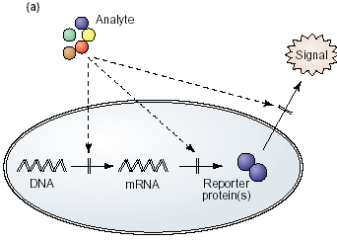
Fig: 1 “Lights off” strategy of developing bacterial biosensors. In ‘lights off’ approach (a), sample toxicity is estimated from the degree of inhibition of a ‘normally on’ reporter gene activity. Such inhibition can occur along any stage of the reaction’s development or in any site affecting cellular well being (Source: Belkin, 2003).

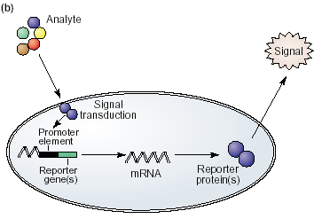

Fig:2. “Lights on” strategy of developing bacterial biosensors. A quantifiable molecular reporter is fused to specific gene promoters, known to be activated by the target chemical(s) (source Belkin, 2003).
on the latter which emits a detectable signal. The reporter element is always one of a typical set of genes or groups of genes, coding for proteins with an easily detectable presence or activity. The sensing element, in contrast, is different in each bacterial sensor, and in its selection lies the uniqueness and specificity of the final construct. In most cases, the sensing element is a promoter for a gene or a group of genes normally activated in response to a specific or general environmental change. Under normal conditions, this activation would lead to the synthesis of proteins, the presence or activity of which would help the cell to combat the sensed hazard or adapt to it. In the recombinant strain, in addition to this function, the selected promoter also drives the synthesis of the reporter protein(s) and this strategy is called “Lights on” approach (Belkin 2003) (Fig.2) . Using this principle, a promoter sequence from one bacterial species can be genetically fused to a reporter gene from a second species and introduced into the cells of a third microorganism. In practice, in order for the promoter sequence to sense its target chemicals, an additional element has often to be included: the gene for regulatory protein. The fused promoter::reporter can be introduced into the host cell in one of two options: either as a plasmid, normally a multi copy one, or integrated into the bacterial chromosome. The latter option, which calls for a somewhat lengthier molecular procedure, allows better stability of the system but may suffer from reduced signal strength.

Just as the specificity of the final whole cell biosensor construct depends upon the proper selection of the sensing promoter, the facility, sensitivity and degree of resolution of the detection will depend to a large extent upon the proper choice of the reporter (Kohler et al. 2000). A reporter gene is a gene that can be used to monitor the activity of another gene/promoter sequence and gives an easily measurable phenotype. If the reporter system is well chosen then the level of reporter gene expression will correlate with the transcriptional activity of the introduced regulatory/promoter sequences. The most commonly used reporter genes are those which code for Green Fluorescent Protein (GFP), bacterial luciferase(lux), firefly luciferase(luc), β-galactosidase(β-Gal), β-glucuronidase, catechol 2,3-dioxygenase and the ice nucleation protein, InaZ. Each reporter protein has its own advantages and disadvantages. The use of β–Gal as a reporter results in higher background levels due to the constitutive expression of this gene from host genome. Further, β–Gal detection is time consuming, often requires lysis of the cells and is difficult to perform in turbid lysates. Although bacterial luciferases are useful for sensitive detection and measurement of prokaryotic gene transcription, their applicability is limited since these enzymes are heat labile (>30ºC)(Billard and DuBow 1998; Naylor 1999). For detection, often both these reporters require lysis of the host cells and addition of substrates to initiate chromogenic reaction and hence GFP has been the preference of many groups for biosensor development.

The Green Fluorescent Protein (GFP) from bioluminescent jellyfish Aequorea victoria is one of the most widely used reporter genes in molecular biology. Aequorea victoria produces light when energy is transferred from Ca²⁺-activated photoprotein aequorin to GFP (Johnson et al. 1962; Morin and Hastings 1971). The cloning of the Wild-type GFP gene (wtGFP) (Prasher et al. 1992; Inouye and Tsuji 1994) and its subsequent expression in heterologous systems (Chalfie et al. 1994; Inouye and Tsuji 1994; Wang and Hazelrigg 1994) established GFP as a novel genetic reporter system. When expressed in either eukaryotic or prokaryotic cells and illuminated by blue or UV light, GFP yields a bright green fluorescence. Wild-type GFP absorbs UV and blue light and emits green light. Enhanced Green Fluorescent Protein (EGFP) is a mutated version of GFP and contains two amino acid substitutions: F64L and S65T. EGFP fluoresces 35-fold more intensely than wt GFP when excited at 488 nm (Yang et al. 1996; Cormack et al. 1997) due to an increase in its extinction coefficient and a higher efficiency of chromophore formation. EGFP chromophore formation is much more efficient at 37°C than wt GFP and 95% of the soluble EGFP protein contains the chromophore when expressed at this temperature (Patterson et al. 1997).GFP fluorescence is very stable in a fluorometer and is more resistant to photobleaching than is fluorescein (Wang and Hazelrigg 1994; Niswender et al. 1995). The fluorescence of wtGFP and EGFP is quite stable when illuminated with 450–490 nm light (the major excitation peak for the red-shifted excitation variants, but the minor peak for wtGFP). GFP has been expressed as a fusion to many different proteins. In many cases, chimeric genes encoding either N- or C-terminal fusions to GFP retain the normal biological activity of the heterologous partner, as well as maintaining fluorescent properties similar to native GFP (Flach et al. 1994; Wang and Hazelrigg 1994; Marshall et al. 1995; Stearns 1995). Light-stimulated GFP fluorescence is species-independent and does not require any cofactors, substrates, or additional gene products from A. victoria. Additionally, detection of GFP and its variants can be performed in living cells and tissues as well as in fixed samples. GFP owes much of its popularity to its ease of detection in individual cells by epifluorescence and confocal laser scanning microscopy, and its amenability to quantitative single-cell analysis using image cytometry, spectrofluorimetry or flow cytometry.

A large number of bacterial biosensors have been developed for the detection of a wide range of substances. A variety of assays using biosensors were developed for the detection of mercury (Condee and Summers 1992; Barkay et al. 1998), with different promoters of the mer operon driving several reporter genes : lux (Selifonova et al. 1993; Rouch et al. 1995) Iuc (Virta 1995) and lacZ (Rouch et al. 1995). A highly specific bacterial chromate sensor reported by Peitzsch et al. (Peitzsch et al. 1998) was based on chr::lux fusion, performing optimally with glycerol as a carbon source. Biosensors for aluminum was developed by Guzzo et al. (1991), using chromosomal fliC::luxAB fusion; and the biosensor strain exhibited a pH dependence due to decreased solubility of aluminum at higher pH values. An interesting variation, in which the absence of the compound is detected rather than it’s presence, was described by Khang et al. (Khang et al. 1997) for the determination of Iron(Fe). When a fragment containing pupa promoter of Pseudomonas putida WC358 was fused to the luxCDABE cassette of Vibrio fischeri, the bacterium was able to respond to iron starvation. Alcaligenes eutrophus, which harbors two mega plasmids (pMOL28 and pMOL30) governing multiple resistance to heavy metals, served as a resource for promoters in several biosensors (Collard et al. 1994), as was the plasmid p1258 of Staphylococcus aureous (Corbisier 1998). Corbosier et al (1998) developed a bacterial biosensor strain which could detect arsenic (As) and cadmium (Cd) by constructing a shuttle vector between E. coli and S. aureus containing arsR::luxAB or cad::luxAB. Yoon et al. (1991) constructed a translational cadA-bla fusion and reported β-lactamase activity when induced with cadmium, bismuth or lead. The cloning of cadC gene and promoter/operator of the cadA operon from the plasmid p1258 in front of the lux gene created a sensor strain responsive to cadmium and lead (Tauriainen et al. 1998). Another detection method for arsenite or antimonite was developed by the fusion of arsR and promoter/operator region of plasmid R773 to lacZ (Ramanathan et al. 1997; Scott et al. 1997). The only report of a genetically engineered biosensor for an inorganic compound was a nitrate sensor described by Prest et al. (1997) in E .coli JM109. A number of whole cell bacterial biosensors also have been developed for the detection of organic pollutants. Kobatake et al (1995) constructed a biosensor in E. coli HB101 for the detection of benzene derivative, utilizing xyl system from TOL plasmid of Pseudomonas putida. A different construct based on the xyl system was reported by Burlage (Burlage et al. 1990), using Pseudomonas as a host instead of E. coli and Vibrio fischeri lux as a reporter. Another construct detecting benzene derivatives was reported by Willardson et al. (Willardson et al. 1998), in which lnc was placed under the control of xylR and Pn. Simpson et al. (1998) presented a prototype of bioluminescent-bioreporter integrated circuit (BBIC) by placing the toluene-responsive bioreporter Psendomonas putida TVA8 on an Optical Application-specific Integrated Circuit (OASIC). A number of luminous microbial biosensors for naphthalene have been developed utilizing salicylate hydroxylase (nahG) promoter from the naphthalene degradation pathway of P. fluorescens.(King et al. 1990; Heitzer et al. 1994; Matrubutham et al. 1997). A very specific biosensor for 4-chlorobenzoic acid was constructed by Rozen et al. (1999) by fusion of the promoter of fcbA gene of dehalogenase operon from Arthrobacter sp. to the V. fischeri luxCDABE in E. coli. The only reported microbial biosensor for aliphatics was constructed by Sticher et al. (Sticher et al. 1997), who described the detection of middle chain alkanes. A general system with a broad specificity for hydrocarbons was reported by Selifonova and Eaton (Selifonova and Eaton 1996). A bioluminescent strain of Ralstonia eutropha was constructed for the detection of biphenyls (Layton et al. 1998). Using lux, β-Gal and GFP bacterial biosensors have been developed for the detection of antibiotics like tetracyclines (Hansen and Sorensen 2000; Hansen et al. 2001).
A number of recombinant bacterial biosensors have been developed employing promoters, which belong to global regulatory circuits. Since the activities controlled by many of these circuits can be classified as “stress responses”, such strains respond to a broad range of environmental changes. E. coli strains containing promoters of heat shock genes grpE, dnaK or lon fused to V. fischeri luxCDABE responded by enhanced bioluminescence to a variety of chemicals, including metal ions, solvents, pesticides and other organic molecules (Dyk et al. 1994). Sensitive detection of peroxides have been achieved by fusing promoters of KatG and micF, under the control of oxyR, to lux genes (Belkin et al. 1996). Another potential use for recombinant bacterial biosensors is as rapid indicators of genotoxicity. Vollmer et al. (1997) described a sensor system in which DNA damage inducible promoters recA, uvrA, alkA from E. coli were fused to luxCDABE of Vibrio fischeri. The recA fusion exhibited the most prominent and sensitive response to mitomycinC, H₂O₂, N-methly-N’-nitro-N-nitrosoguanidine, ethidium bromide and UV irradiation. A different SOS based approach was that employed in rec-lac test (Nunoshiba and Nishioka 1991), based on E. coli tester strains carrying rec::lacZ, uvrA::lacZ or lexA::lacZ fusions. Also based on monitoring SOS activation is the VITOTOX® test, developed by Van der Lelie et al. (1997). A different genotoxicity sensor construct was developed in yeast by Billington et al. (Billinton et al. 1998) who used GFP as reporter protein and the promoter of RAD54 as its genotoxin-inducible activator. Another sensing system for the detection of DNA-damaging agents is the commercially available SOS chromotest; which is based on the induction of the SOS gene sfiA, monitored by means of a lacZ fusion (Quillardet and Hofnung 1993). In view of its simplicity and rapid response, the SOS chromotest was proposed as a complimentary or alternative test to the “Ames test” (Quillardet and Hofnung 1993). A different SOS induction-based system which is gaining acceptance for the detection of genotoxicants is based on a lacZ fusion to the umu promoter, which is induced by DNA damaging agents and is regulated genetically by recA and lexA (Oda et al. 1985). Whole cell biosensors have also been developed for the detection of general toxicity. The most widely accepted microbial toxicity test system is marketed as Microtox (Johnson et al. 2004) and is based upon the wild type luminescent bacterium V. fischeri. A similar approach to ecotoxicity testing using a genetically engineered bacterium was reported by Hakkila et al (2004), who cloned the lux gene from Vibrio fischeri under the control of lac promoter. The general approach for using promoter::lux fusions for the detection of diverse environmental stress factors, including general toxicity and genotoxicity, has been established in several patents (Imaeda and Masana 1994; LaRossa et al. 1994).
Through advancements in genetic engineering, cell-based systems can be designed to afford high specificity and selectivity for the analyte that are stable in various environmental settings including fluctuations of temperature and pH. The greatest advantage of whole cell-based systems is their ability to provide physiologically relevant data in response to the analyte and to measure the bioavailability of the analyte.

The present work is planned towards developing GFP based whole cell bacterial biosensors to aid detection studies on two serious problems facing the country i.e. arsenic contamination in Gangetic basin of north-eastern India and rise in the prevalence of antibiotic resistant bacteria. The specific objectives of the present study are

- To develop a GFP based whole cell bacterial biosensor strain for the detection of arsenic contamination in potable water in West Bengal and to compare the effectiveness of the biosensor strain with conventionally used Atomic absorption spectroscopy.
- To develop an Internet based antibiotic resistance gene sequence database to aid the studies on antibiotic resistance.
- To develop a GFP based bacterial biosensor for the detection of residual tetracycline in field samples.

For lucidity, the thesis has been organized into five chapters. Apart from this chapter, second chapter describes the construction of biosensor and its application for the detection of arsenic in field samples. Third chapter presents a birds eye view of the problem of antibiotic resistant bacteria worldwide and India, and details of the development of Antibiotic resistance gene sequence database. The fourth chapter chronicles the development of biosensor strain for the detection of tetracyclines in field samples. And finally, chapter five summarizes the overall results of the present investigation.

Chapter 2

DEVELOPMENT OF WHOLE CELL BIOSENSOR FOR ARSENIC DETECTION

2.1 Introduction
Arsenic (As) is a metalloid found in water, soil and air. It exists in inorganic and organic forms and in different oxidation states. As is considered to be a very toxic metal and the Maximum Permissible Limit (MPL) of As in drinking water is 50μg/L and water containing Arsenic above 10μg/L is considered unfit for human use(WHO 1999; Mukherjee et al. 2005). Arsenic enters biosphere primarily by leaching from geological formations and anthropogenic sources (Nordstorm 2002). Anthropogenic sources of As include As-containing fungicides, pesticides and herbicides. Before the onset of the 21st century, ground water As contamination was already reported in twenty countries, out of which four major incidents were from Asia (Matschullat 2000; Chakraborti et al. 2003). In the order of severity of occurrence, this includes Bangladesh> West Bengal (WB, India)> Inner Mongolia (Peoples Republic of China) > Taiwan (Chakraborti et al. 2002; Nordstorm 2002). Of all As ground water incidents reported worldwide, As contamination in Bangladesh and West Bengal have been termed as “the biggest mass poisoning in history” (Mushtaq and Chowdhury 1999).

Ground water As contamination in the lower Gangetic plain of West Bengal came to lime light in 1983 when few patients were identified with symptoms of As poisoning from one village of 24 Parganas district (Saha 1984). Search for the source of this As poisoning revealed that the tube well water used by these patients for drinking to be containing high levels of As. Subsequent epidemiological studies and analysis of water samples from the region revealed that the problem is more wide spread and a devastating health crisis was unfolding (Pallava Bagla and Jocelyn Kaise 1996). Current assessments indicates that of eighteen districts of West Bengal, nine districts are severely As contaminated and other districts are affected in varying degrees. In the affected districts of West Bengal, 51% of hand-tubewells contain As above 10μg/L and 25.5% above 50μg/L, where as in the fifty affected districts of Bangladesh, 48.5% of tubewells contain As above 10μg/L and 31% above 50μg/L respectively. Surveys estimate that approximately 65 million people are drinking contaminated water with As levels above 50μg/L in the affected districts of West Bengal with an additional 32 million people in Bangladesh plain. Recent surveys conducted in India indicate that the As poisoning reported so far is only the tip of iceberg. Survey results of 152 villages of Bihar, India shows that of the total surveyed villages, 107 villages are As affected (Chakraborti et al. 2003). Analysis of water samples from 25 villages of Uttar Pradesh during October-December, 2003, showed As levels above 50μg/L in twenty two villages(Chakraborti et al. 2003). Studies conducted in seventeen villages of Jharkhand, India in 2004, revealed that this state also is under the threat of groundwater As poisoning (Chakraborti et al. 2003; Chakraborti et al. 2004). Epidemiologic studies and analysis of water samples from this region are underway in a larger scale and indications are that more areas are As contaminated.

Several studies have been conducted to discern the source of As contamination in the groundwater. It is now widely accepted that source of As in Gangetic West Bengal is geologic (Das et al. 1996; Bhattacharyya et al. 2003). The presence of As containing pyrite in Bengal basin is related to geochemical and climatic evolution of the basin(Nickson et al. 1998; Nickson et al. 2000; Bhattacharya et al. 2002). As rich sediments derived from the Himalayan mountains and the foothills of Shillong is deposited in the Gangetic plain, Padma-Meghna-Bhrahmaputra delta of Bangladesh, Terai of Nepal, Uttar Pradesh and Bihar, India(Chakraborti et al. 2001; Khatlwada, Takizawa et al. 2002). The meandering pattern of the river Ganga is responsible for the localized depositions of As rich sediments in selected areas (Chakraborti et al. 1999). Some parts of Bangladesh and West Bengal are geologically free of As. The processes controlling the transfer of As between aquifer sediments and ground water is not completely understood(Akai et al. 1998; Bhattacharya et al. 2002; Bhattacharyya, Chatterjee et al. 2003; Acharyya and Shah 2004). Although the deep soil in the region contained such deposits, presence of As in drinking water was noticed in mid 80’s. In 1970’s and 80’s as a measure to provide safe drinking water to villagers, thousands of tube wells of varying depths were drilled in this region resulting in withdrawal of huge amounts of groundwater (Chakraborti et al. 2001). Thirty to forty years earlier, agriculture in West Bengal was rain fed. In order to meet the increased food demand , cropping intensity was increased along with the higher amount of bore-well irrigation in the state. Das et al. (Das et al. 1996) reported that a single rural water supply scheme in one of As affected districts withdraws 147 kg As/year through ground water. The status of aquifer exploitation is as high as 79.40% from a single district (Roychowdhury et al. 2002). This extensive use of As laden water has caused widespread pollution of soil, surface water and entry of As in food chain (Mandal et al. 1998; Sengupta, Mukherjee et al. 2003). The mean As concentration in agricultural land soil is 11.35 mg/kg, which is much higher than that of non-polluted areas. Agricultural produces like vegetables, rice, cereals, fish, etc from this area have excess amount of As crossing tolerance level of 760 mg/kg and ranged up to 1430 mg/kg (Roychowdhury et al. 2002; Das et al. 2004).
Symptomatology of As toxicity may develop insidiously after six months to two years or more, depending on the amount of As concentration in the drinking water and food intake. The As toxicity may be aggravated or diminished by several factors like: As concentration in drinking water and food (Meharg and Rahman 2003), temporal fluctuations in As content in well water (Takahashi et al. 2004), nutritional status (Zaldivar and Ghai 1980), the genetic variation of the humans(Rahman et al. 2005), synergistic or antagonistic effect of other elements in water (Bose and Sharma 2002), immunity level of people, and age and sex of the exposed individuals (WHO 1984; Anawar et al. 2002; Bose and Sharma 2002; Chakraborti et al. 2003; Das, Mitra et al. 2004). About 20% of the total population of West Bengal and Bangladesh are exposed to As related health hazards (Subramanian and Kosnett 1998) . Darkening of the skin (diffuse melanosis) in the whole body or on the palm of the hand is the earliest symptom of As toxicity (Rahman et al. 2005). Spotted pigmentation on chest, back or limbs is another early symptom(Chowdhury 2004). Keratosis is a late feature of arsenical dermatosis. Other symptoms of As toxicity are conjunctival congestion and non-pitting swelling at the feet. Complications such as hepatomegaly, splenomegaly, ascitis and neuropathy are seen in severe cases (Chakraborti et al. 2004). People who have suffered many years of As poisoning are affected by several types of cancers, including squamous cell carcinoma, basal cell carcinoma, and Bowen’s disease, carcinoma affecting lung, uterus, bladder, genitourinary treat, or other sites like limbs (Berg et al. 2001; Alam et al. 2002; Anawar et al. 2002).
Considering the wide ranging impact of As toxicity in the life and health of people in the region, continuous monitoring of As levels in water, soil and food samples are required. It is estimated that there are about 2.5 million tube wells in Bangladesh alone and about 45% of the water pumped out has As above permissible levels (Hussam et al. 2003). Hence testing of water supplied by hand-pumps alone is a formidable job. Several technologies including Inductively Coupled Plasma Mass Spectroscopy (ICP-MS), Anodic Stripping Votametry (ASV), X-ray fluorescence (XRF), Graphite Furnace Atomic Absorption Spectroscopy (GF-AAS), and Flow Injection Hydride Generation Atomic Absorption Spectrometry (FI-HG-ASS) are available for the accurate measurement of low levels of As (Chakraborti et al. 1992; Chatterjee et al. 1993; Wang et al. 2003). However, these are expensive; require specialized laboratories and significant training and expertise to use. Spot-checking of As is done by a number of kits including the Merck field kit(Van Geen, Cheng et al. 2005). However, field kits are based on the classical chemistry employing the reduction of tri and pentavalent As species to arsine gas (AsH₃). Arsine gas is very toxic with a threshold limiting value (TLV) of 50 parts per billion by volume (ppbv) (Hussam et al. 1999). From 1997, WHO initiated mass testing of all hand-pumped tube wells in the region mostly using the Merck kit. Based on this, wells having more than 50µg/L As have been marked unsafe by painting in red or in green to show that the water is safe (<10µg/L). However recent studies to evaluate the performance of the kits indicate that, based on field test kit results, a large number of tube wells were wrongly marked as As contaminated (Erickson 2003). Although the conventional spectroscopic methods are highly accurate, mass testing of tube wells would catapult the analysis cost because a field kit test cost US$1 whereas a laboratory test costs approximately US$9 (Ahmed 2002).
Biosensors present an alternative to conventional analysis of heavy metals, such as As. The presence of As in the environment has resulted in the development of As resistance mechanisms in bacteria and a number of biosensors utilizing bacterial ars operon genes have been described for detection of As. The resistance machinery used by bacteria against arsenate, arsenite, and antimonite is encoded by the ars operon found in plasmids and chromosomes (Silver et al. 1981; San Francisco et al. 1990; Ji and Silver 1992; Kaur and Rosen 1992). It consists of a set of structural genes (arsA, arsB, and arsC) and two regulatory genes (arsR and arsD) (Figure 3A) (Rosen et al. 1995). The structural genes encode for proteins that form the efflux pump (Figure 3B) capable of extruding antimonite and arsenite out of the cell (Silver et al. 1993). ArsA, encoded by the arsA gene, is a membrane-linked ATPase protein stimulated by arsenite and antimonite. It is responsible for driving the protein pump by providing energy via ATP hydrolysis. ArsB is a membrane transport protein that forms the channel through which antimonite and arsenite are effluxed from the cells. ArsB combines with ArsA to form an ArsAB complex that can make the efflux pump either ATPase or chemiosmotic type (Dey and Rosen 1995). However, this pump cannot transport arsenate out of the cell. To circumvent this problem, an arsenate reductase ArsC, encoded by arsC gene acts on the arsenate when it enters the cell, reducing it to the more toxic arsenite, which then can be removed by the protein pump(Ji and Silver 1992). ArsR is a trans-acting regulatory protein responsible for the basal expression of the ars operon (Wu and Rosen 1991; Shi et al. 1994). In the absence of the toxic metalloids, ArsR binds to the operator/promoter (O/P) region of the ars operon preventing expression of the other genes. When the oxoanions enter the cell, they bind to ArsR forcing some conformational change that leads to the dissociation of ArsR from the O/P region and subsequent expression of the genes needed for the resistance mechanism. Thus, ArsR is a repressor of the ars operon in the absence of the oxoanions. ArsD is another regulatory protein that is present in some ars operons and is instrumental in controlling the over expression of the ars operon (Wu and Rosen 1993).

The early reports on As biosensors utilized bacterial luciferase and β-galactosidase as reporter genes (Ramanathan et al. 1997; Scott et al. 1997). Taurianen et al. (1997) reported the development of firefly (Photinus pyralis) luciferase (lux) gene based biosensor for arsenite. Roberto et al. (Roberto et al. 2002) reported the evaluation of a GFP based reporter gene construct for environmental As detection. However, all these biosensors were used only on a laboratory scale and were not assessed by measuring real-

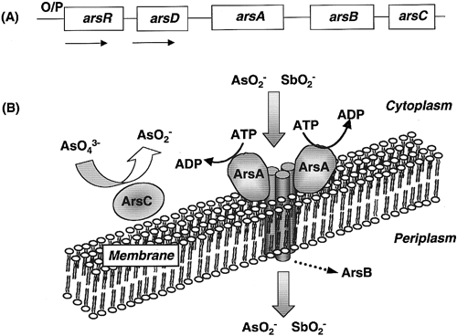
Figure:3-A Organization of the ars operon in E. coli. Genes are represented by the boxes. The arrows indicate the direction of mRNA transcripts. Fig 3-B Machinery of the arsenite pump in Gram-negative bacteria. (Source Silver et al. 1993).

time environmental samples. Stocker et al (Stocker et al. 2003) reported the development of a set of simple bacterial biosensor strains for quantitative measurement of As in potable water. Although they developed a set of lacZ, lux and GFP based biosensor strains, only lacZ strain was evaluated for it’s efficacy in measuring field samples. EGFP is known to be much more fluorescent than wtGFP and thereby is a more efficient reporter gene. Hence this work is planned to develop an EGFP based bacterial biosensor strain as a probable cheaper alternative to present arsenic testing methods and evaluate it’s efficacy in detecting As poisoning in drinking water samples from West Bengal.

2.2 Materials and Methods
2.2.1 Bacterial strain and culture media
E. coli DH5α was used as the host for recombinant DNA protocols and biosensor assays. Axenic culture of E. coli DH5α was purchased from Bangalore Genie Laboratories, Bangalore. This was grown either in Luria Bertani (LB) broth or LB agar purchased from Himedia Labs, Mumbai.

2.2.2 Enzymes and Chemicals
All the enzymes used for DNA manipulations, PCR and cloning were purchased from New England Biolabs (USA). All the metal salts used were of analytical grade (Merck Germany). They were dissolved in deionised distilled water and digested using 1-2 % nitric acid. Atomic spectral standard for arsenic was purchased from National Physical Laboratory, New Delhi, and was used for preparing working standard for atomic absorption study and biosensor assay. To avoid contamination, all glassware and plastic wares were cleaned before use with cedepol detergent, followed by overnight soaking in 50% nitric acid.

2.2.3 Metal ion analysis
Metal ion concentrations were determined in a Perkin Elmer (A Analyst 300) atomic absorption spectrometer using air-acetylene flame. All instrumental conditions were optimized for maximum sensitivity as described by the manufacturer. The instrument was first calibrated with the standard metal solution in the range covering the concentrations likely to be found in the samples. The samples were analyzed in triplicates to maintain reproducibility.
2.2.4 Fluorescence Microscopy
EGFP expression in recombinant bacteria was analyzed and documented with an Olympus CXKX41 epifluorescence microscope fitted with an Olympus Camedia C4000 digital camera. Bacterial cells were spread on a gelatin coated glass slide and were viewed by exciting with a 100W mercury arc lamp and filter block fitted with a 465-495 nm excitation filter and a 500-540nm emission filter. Photomicrographs were captured with 11X digital zoom, ISO200 light sensitivity and automatic capture mode.
2.2.5 Fluorescence Assay
EGFP expression levels in Biosensor bacterial cells were estimated with a Wallac Victor³ Multilabel counter. All instrumental conditions were optimized for maximum sensitivity as described by the manufacturer. To minimize the background fluorescence, low background 96 well plates (Tarsons, Mumbai) were used. For measurements, 200µl of bacterial suspension was pipetted into each well and fluorescence was estimated by exciting the cells at 580nm and emission was detected using a 510nm filter set. All measurements were performed in triplicates.

2.2.6 Construction of Biosensor Strain
2.2.6.1 Isolation of plasmid DNA
Plasmid DNA was isolated with a Quiagen plasmid isolation kit as follows. 10 ml of Luria Bertani broth (LB broth) containing 100 μg/ml ampicillin was inoculated with a single colony of E. coli DH5α containing pEGFP or pBGD23. The flasks were incubated overnight at 37°C with 200 revolutions per minute (rpm) in an orbital shaker incubator. 2 ml of this overnight culture was transferred to 2 ml microtubes and was spun at 7000 rpm for one minute. The supernatant was discarded and the pellet was resuspended in 300 μl of resuspension buffer Pl. 300 μl of Lysis buffer P2 was then added and the contents were mixed gently by inversion. Contents were then spun at 12000 rpm for 10 minutes at 4°C and the supernatant was transferred to a fresh autoclaved 2 ml micro centrifuge tube. 1 ml of 70% isopropanol was then added to this and mixed by inversion and the tube was spun at 12000 RPM for 20 min at 4°C. The supernatant was discarded and the DNA pellet was washed with 1 ml of 70% ethanol and spun again as before. The supernatant was discarded and tubes were air dried for 30 minutes and the DNA was resuspended in 30 μl of Tris EDTA Buffer (TE Buffer). The isolated plasmid DNA was stored at -20°C until use.
2.2.6.2 Agarose Gel Electrophoresis of DNA.
Electrophoresis of DNA was carried out using a BioRad electrophoresis apparatus. 1% agarose gels were cast in 1X Tris Acetate EDTA Buffer ( TAE buffer) and was electrophoresed with 1X TAE buffer in the gel tank at 90 Volts (V) for 1 hour. The resolved gels were visualized and documented with a Syngene Genesnap system.
2.2.6.3 Purification of DNA from enzymatic reactions
The DNA to be purified was loaded into a 1% agarose gel in TAE and was electrophoresed at 90 Volts (V) for 1 hour; and DNA fragment was excised from the agarose gel with a clean, sharp scalpel. The slice was weighed in a micro centrifuge tube and 3 volumes of buffer QG was added to 1 volumes of gel slice (100mg=100μl). Gel slice with the buffer was incubated at 50°c until the gel was completely dissolved. After the dissolution of the gel fragment 1 volume of absolute isopropanol was added and mixed. The Qiaquick column was placed in the 2 ml collection tube. To bind DNA, the sample was applied to the column and was centrifuged at 13000rpm for 1 minute in an Eppendorf micro centrifuge. The flow-through was discarded and the column was placed back in the same collection tube. 0.5 ml of buffer QG was then added to the column and was centrifuged as in the previous step. Column was further washed twice by adding 0.75 ml of buffer PE and centrifuging as before. The flow-through was discarded and column was centrifuged for additional 1 minute at 13000rpm. To elute DNA the column was transferred on top of a 2 ml micro centrifuge tube, and 30 μl of autoclaved Millipore water was added to the center at the QIAquick membrane inside the column and the assembly was centrifuged at 13000 rpm for 1 minute. The purified DNA collected inside the 2 ml micro centrifuge tube was stored at -20°c until use.

2.2.7 PCR amplification of the target
2.2.7.1 Design of Polymerase Chain Reaction (PCR) primers
PCR primers were designed using Biology WorkBench Suite of programmes hosted at San Diego Super Computing center (SDSC), University of California, San Diego. The published DNA sequences of arsR and arsD genes of R773 operon (Genbank accession numbers X16045, U13073) were used as the target sequences for primer design. Properties of PCR primers designed is given in Table.1
2.2.7.2 PCR amplification
PCR amplification of ars promoter, arsR and part of arsD was carried out using forward primer JSKV 11 and reverse primer JSKV 12 using plasmid pBDG23 as template. The composition of PCR amplification mixture given in Table: 2. Except for pfu polymerase enzyme, all other components were added on to the wall of PCR tube. The pfu polymerase enzyme was added to mixture at the end and contents were mixed by tapping the tube gently and briefly spinning the tubes once in an Eppendorf microfuge. PCR reaction on the above mixture was carried out as per reaction conditions given in Table: 3, using a Perkin Elmer gene amp system. At the end of the reaction the tubes were removed from PCR machine, and the PCR mix was electrophoresed as described in section 2.2.6.2. For determining the size of the DNA band of interest, a maker also was electrophoresed. At the end of electrophoresis the gel was photographed using Syngene gel documentation system and DNA band corresponding to 560 bp was excised from the gel under UV transillumination and DNA was retrieved using a QIAquick column as described in section 2.2.6.3.
2.2.8 Restriction Endonuclease digestion of DNA
Plasmid pEGFP was used to clone the PCR amplified DNA containing the promoter/operater, arsR and part of arsD. The PCR product (insert DNA) contained Hind III restriction site at 5’ end and Sal I site at 3’ end. To obtain maximum efficiency of restriction digestion of vector as well as insert DNA, both were first digested with Hind III and the DNA at the end of the reaction was purified using a QIAquick column as

Table:1 Properties of primer set used to PCR amplify the ars regulatory elements

Parameter | JSKV11 (forward primer) | JSKV12 (reverse primer)
Sequence | 5’CCGCAAGCTTAGTTATCTC  ACCTACCTTAAG 3’ | 5’GCGTCGACCTCAGAATTAC  GATCAGGGGTAT 3’
Molecular weight | 9470.2 | 8637.7
Tm | 43.3 | 46.4
Filter Tm | 35.8 | 38.8
% GC Tm | 45.0 | 50.0
GC + AT Tm | 90.0 | 84.0
ug/A260 | 32.8 | 31.8
%GC | 45.2 | 50.0

Table : 2 Composition of PCR mixture used for the amplification of ars regulatory elements
Component | Stock | Volume
Template DNA (pBDG23)  Forward primer (JSKV11)  Reverse Primer (JSKV12)  Pfu polymerase  Pfu polymerase buffer  dNTP mix  Autoclaved Millipore water | 200 ng/ml  100 ng/ml  100 ng/ml  10 x  10 mM  - | 1 μl  2 μl  2 μl  1 μl  5 μl  5 μl  34 μl
Total |  | 50 μl

Table: 3 PCR Conditions for amplifying arsenic regulatory sequence.
Component | Temperature (°C) | Time (minutes) | No. of cycles
Phase I  Initial Melting  Denaturation  Annealing  Extension  Phase II  Denaturation  Annealing  Extension  Final extension  End storage | 98  94  52  72  94  59  72  72  4 | 2  2  1  1  2  2  1.3  7  ∝ | 4  25

described section 2.2.6.3; and this digested purified DNA was further digested with Sal I. The restriction digestion conditions for HindIII and SalI are given in Tables 4 and 5.
2.2.9 Dephosphorylation of vector DNA
To reduce the probability of self-ligation of the linearised vector, after digestion with Sal I restriction enzyme, 1 unit of Calf Intestinal Alkaline Phosphate (CIAP) was added to the restriction endonulease digestion mixture and was incubated for another 30 minutes at 37°c in a pre-adjusted circulating water bath. The dephosphorylated DNA was then purified using a QIAquick column as described in section. 2.2.6.3.
2.2.10 Phosphorylation of insert DNA
To increase the probability of formation of recombinant DNA by the proper ligation of the insert with the restriction-digested vector, insert DNA was treated with T4 polynucleotide kinase. A 50 μl reaction was set up as per the composition given in Table-6. All the above were mixed in a pre-chilled 0.5 ml micro centrifuge tube and was incubated at 37°c for 45 minutes in a pre adjusted circulating water bath. The phosphorylated DNA was purified from the reaction mixture using QIAquick column as described in section 2.2.6.3.

2.2.11 Ligation
Ligation of the restriction enzyme digested, phosphorylated insert DNA and the restriction enzyme digested, dephosphorylated pEGFP vector DNA was carried out with T4 DNA ligase. A 10 μl reaction mixture was set up as per the composition given in Table: 6. For obtaining the maximum number of recombinants, a vector: insert molar ratio of 1:2 was maintained in the reaction mixture. The above mixture was prechilled in a 0.5 ml micro centrifuge tube and the tube was incubated at 16°c for 12 hours in a preset circulating water bath, and the reaction mixture was used to transform competent cells of E.coliDH5α.

Table 4 : Composition of reaction mixture used for HindIII digestion of ars and pEGFP DNA.
Component | Stock | Volume
Component | Stock | Vector | Insert
pEGFP DNA  Insert DNA  Hind III  Hind III buffer  Autoclaved Millipore water | 100 ng/μl  150 ng/μl  10 U/μl  10x  - | 9 μl  -  0.5 μl  2 μl  8.5 μl | -  6 μl  0.5 μl  2 μl  11.5 μl
Total |  | 20 μl | 20 μl

Table 5: Composition of reaction mixture used for SalI digestion of ars and pEGFP DNA
Component | Stock | Volume
Component | Stock | Vector | Insert
pEGFP DNA  Insert DNA  SalI  SalI buffer  Autoclaved Millipore water | 80 ng/μl  120 ng/μl  10 U/μl  10x  - | 10 μl  -  0.5 μl  2 μl  8.5 μl | -  7 μl  0.5 μl  2 μl  11.5 μl
Total |  | 20 μl | 20 μl

Table 6 : Composition of reaction mixture used for Phosphorylating ars insert
Component | Stock concentration | Volume
Insert DNA  T4 ligase buffer  T4 Polynucleotide kinase  Autoclaved Millipore water | 33 ng/μl  10 x  1 U/μl  - | 22 μl  5 μl  1 μl  22 μl
Total |  | 50 μl

Table 7 : Composition of ligation mixture used to clone ars insert
Component | Stock concentration | Volume added
_{P}EGFP vector DNA  Insert DNA  T4 DNA ligase  T4 DNA ligase buffer  Autoclaved Millipore water | 20 ng/μl  40 ng/μl  1 U/μl  10 x  - | 2 μl  1.6 μl  1 μl  1 μl  4.4 μl
Total |  | 10 μl

2.2.12 Transformation
2.2.12.1 Preparation of Competent Cells
For the preparation of competent cells, E. coliDH5α strain was streaked on Luria Bertani Agar plate (LB plate) containing 100μg/ml ampicillin and was incubated at 37°C for 12 hours. A single colony was transferred from this plate to 5 ml of LB broth in a 20 ml conical flask and was incubated at 37°C with 200rpm shaking in an orbital incubator shaker for 14 hours. 1 ml of this starter culture was used to inoculate 100 ml of LB broth in a 1000 ml conical flask and was incubated at 37°C with 200 rpm shaking till OD₆₀₀nm reached 0.5. The flask was then chilled on ice for 10 minutes, and culture was transferred to two 50 ml Oakridge tubes and was centrifuged in a refrigerated centrifuge at 8000 rpm for 10 min at 4°C. The supernatant was discarded and the pellet was resuspended in 12 ml of 100 mM prechilled CaCl₂. The suspension was then incubated on ice for 30 minutes. The cells were harvested by centrifuging at 10000rpm for 7 minutes. The supernatant was discarded and pellet was re suspended in 1 ml of 100 mM CaCl₂ and 626 μl of absolute glycerol was added and mixed. The cell suspension was then stored at -70°C until use.

2.2.12.2 Transformation
10 μl of the ligation mixture was added to a 2 ml micro centrifuge tube and was allowed to chill on ice for 10 min. 100 μl of competent cells was added to this tube and was incubated on ice for 30 minutes. The cells in the tube were then subjected to heat shock at 42°C for 90 seconds in a pre-adjusted circulating water bath followed by incubation on ice for 2 minutes. Soon after this, 500 μl of LB broth was added to the cell suspension and the tube was incubated at 37°C for 1 hour. The tube was then centrifuged at 8000 rpm for 3 minutes and 500 μl of supernatant was removed and cell pellet was resuspended in remaining 100 μl of supernatant and the suspension was then plated on LB agar plates containing 100 μg/ml ampicillin. The plates were incubated at 37°C for 14 hours and screened for recombinants.

2.2.13 Screening of the transformants for recombinants
After incubation, the resulting colonies were replica plated in duplicates to LB agar plates containing 100µg/ml ampicillin and colonies were picked at random and was cultured in culture tubes having 10ml LB broth and was grown for 12 hours at 37ºC. 2ml of the grown culture was used to isolate plasmids and the plasmid DNA was electrophoresed as described in section 2. Recombinants were selected based on the gel mobility shift and pEGFP DNA without the insert DNA served as the control. Recombinant plasmids showing gel mobility shift were selected and the presence of the insert was confirmed by digestion with HindIII and SalI restriction enzymes. The resultant recombinant plasmid was named as pJSKV51and the resultant strain was named as E. coliDH5α pJSKV51. The overall strategy of the biosensor construction is portrayed in Fig.4

2.3 Optimization of biosensor assay conditions and evaluation of strain’s performance.
2.3.1. Range of detection and time
In order to determine the concentration range of arsenic that could be detected by E. coliDH5αpJSKV51 (henceforth designated as Arsenic biosensor), cells were grown overnight in 10ml LB broth in a conical flask at 37ºC with 150rpm shaking. 1 ml of this culture was used to inoculate 30 ml LB broth and this was incubated at 37ºC with 200rpm shaking until OD₆₀₀ reached 0.60 (hence forth referred to as Secondary culture). 2.5ml of this secondary culture was distributed in 50ml culture tubes and 2.5 ml of deionised water containing varying concentrations of arsenite (1ppb-1000ppb) was added. These tubes were then incubated in an Orbital incubator shaker set to 37ºC and 150rpm shaking. At every 2 hours interval, 200µl of samples were withdrawn aseptically, and fluorescence levels were estimated using Multilabel Counter and Fluorescence microscope. Induction coefficients at different arsenite concentrations were calculated by the formula
I = Fs/Fc
Where,
I= Induction coefficient, Fs = Fluorescence of the sample
Fc = Fluorescence of the control

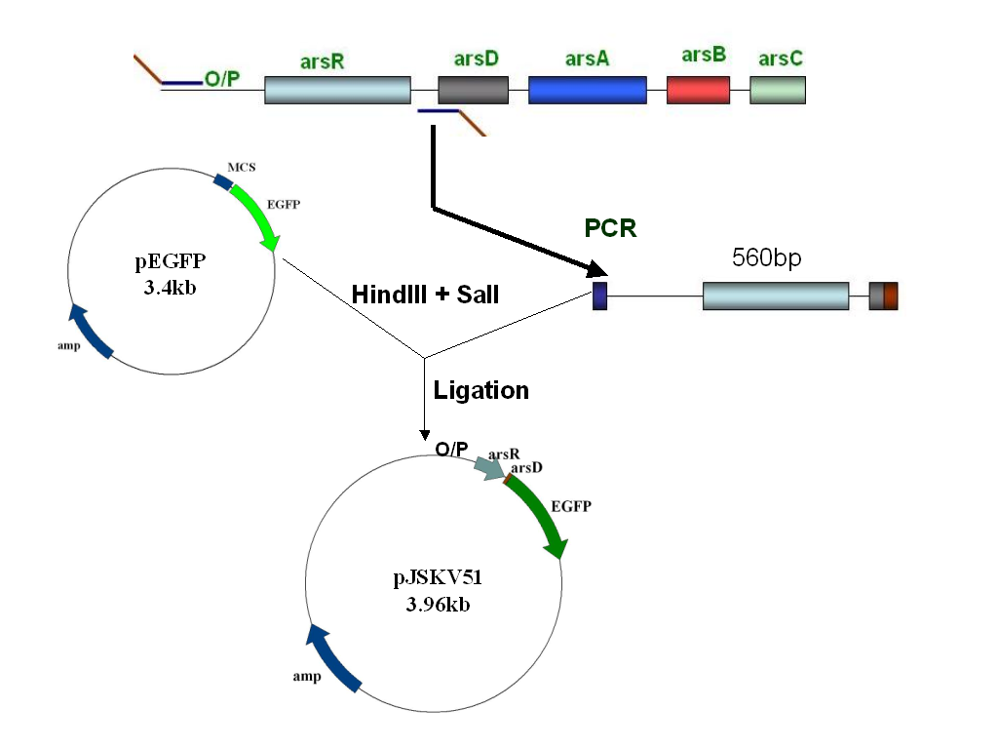
Fig. 4. Cloning strategy for the construction of biosensor plasmid pJSKV51: O/P, arsR and part of arsD was amplified using PCR and was cloned into the HindIII and SalI sites of plasmid pEGFP. The resulting recombinant plasmid was named pJSKV51 and was transformed into E. coliDH5α and this strain E. coliDH5α pJSKV51 was used as arsenic biosensor

2.3.2 Effect of pH
The effect of sample pH on sensitivity of Arsenic biosensor was determined by exposing the cells to samples with varying pH. 2.5ml of Secondary culture was mixed with 2.5 ml of sample having varying arsenite concentration (5ppb-500ppb). Prior to addition of samples to the cells, pH of the sample was adjusted to the desired range (5.0–9.0) with 0.1N nitric acid or 0.1N sodium hydroxide. The tubes were then incubated at 37ºC with 15rpm shaking for 12 hours and 200µl of cells were withdrawn aseptically and fluorescence levels were measured with a multilabel counter.
2.3.3 Effect of temperature
To determine the effect of temperature on the sensitivity of the Arsenic biosensor, 2.5ml of Secondary cells were mixed with 2.5ml of sample having varying arsenite concentration (5ppb-500ppb) and was incubated at varying temperatures (34ºC–40ºC) with 150rpm shaking for 12 hours. At the end of incubation period, 200µl of sample was withdrawn aseptically and fluorescence levels were measured with a multilabel counter.
2.3.4 Effect of photobleaching
Effect of probable light induced photobleaching of EGFP in Arsenic biosensor was studied by exposing cells to different illumination conditions. 2.5ml of Secondary cells were mixed with 2.5ml of sample having varying arsenite concentration (5ppb-500ppb) and was incubated at 37ºC with 150rpm shaking for 12 hours in dark condition. One set of tubes were then exposed to blue light for 10 minutes originating from a 100W mercury lamp fitted a 480nm filter and another set of tubes were exposed to fluorescent light for 10 minutes. Fluorescence levels of these were compared to that of unexposed cells by withdrawing 200µl of cells aseptically and measuring fluorescence levels with a multilabel counter.
2.3.5 Effect of shaking
As E. coli cells are being utilized as host for constructing biosensor strain, agitation of cells during incubating with samples would influence the sensitivity. Effect of shaking on the sensitivity of Arsenic biosensor was tested by incubating 2.5ml of Secondary cells with 2.5ml of sample having varying arsenite concentration (5ppb-500ppb) for 12 hours at 37ºC and with varying levels of shaking (static to 200rpm). At the end of incubation period, 200µl of sample was withdrawn aseptically and fluorescence levels were measured with a multilabel counter.
2.3.6 Effect of cell density.
The minimum cell density required for sensitive detection of arsenic was determined by measuring varying concentrations of samples using Secondary culture grown to varying OD_{600.} Secondary cells were grown to varying OD₆₀₀ (0.4–0.8) and 2.5 ml of these cells were mixed with 2.5 ml of samples with varying concentrations of arsenite (5ppb- 500ppb) and was incubated at 37⁰C for 12 hours with 150rpm shaking. At the end of incubation period, 200µl of sample was withdrawn aseptically and fluorescence levels were measured with a multilabel counter.
2.3.7 Non-specific induction
Probable non-specific induction of EGFP expression by other metal ions that could be present in the sample was tested by incubating Arsenic biosensor with equimolar concentration of several metal ions with arsenic. To study non-specific induction, 2.5 ml of Secondary culture and 2.5 ml of samples containing equivalent concentration of arsenite in combination with other metal ions were mixed and was incubated at 37⁰C for 12 hours with 150rpm shaking. At the end of incubation period, 200µl of sample was withdrawn aseptically and fluorescence levels were measured with a multilabel counter.

2.4.4 Evaluation of Biosensor performance
2.4.4.1 Field Sample collection
To test the efficiency of the biosensor strain, arsenic laden water samples from tube wells of nine arsenic affected districts of West Bengal was collected (Fig.5). Seven samples each were collected from these districts, of which five samples were colleted from arsenic positive tubewells and two samples each were from tube wells which are known to be free of arsenic. Prior to sampling, water was allowed to flow through the pumping pipe for about 10 minutes and 100 ml of water was collected in a sterile polypropylene container and the samples were immediately transported to the laboratory for testing. pH of all water samples were measured using a Hanna H18424 microcomputer pH meter with a gel filled electrode.

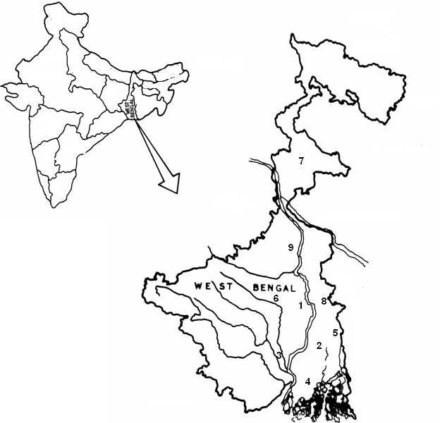

Fig. 5 : Location of water samples collected from WB, India. 1- Balagarh (Hooghly district), 2- South Kolkata (Kolkata District), 3- Bagnan (Howrah district), 4- Joynagar (24 Paraganas South), 5- Barasat (24 Parganas North), 6- Purbasthali (Bardhman district),
7- Englishbazar (Maldah district), 8- Karimpur (Nadia district), 9- Beldanga (Murishidabad)

2.4.4.2 Estimation of arsenic by biosensor.
Single colonies of E.coliDH5α pJSKV51 were picked from Luria Bertani (LB) agar medium containing 100ug/ml of ampicillin and was grown overnight in LB broth containing 100µg/ml of ampicillin. After inoculating 1% of this original cell suspension into fresh LB medium, the cells were grown at 37ºC with vigorous shaking until OD₆₀₀ reached 0.6. For generating a doze response curve, 2.5 ml of deionised water with varying concentrations of arsenite and 2.5 ml of biosensor cell suspension were mixed in sterile test tubes and were incubated at 37ºC for 12 hours with 150rpm shaking. After incubation, the fluorescence from the cells was estimated using a multilabel counter. After generating the doze response curve, the samples were assayed in the similar manner and concentration of arsenic in the samples were inferred by extrapolating the readings with doze response curve.
2.4.4.3 Estimation of arsenic by Atomic Absorption Spectroscopy (AAS).
To compare the performance and to estimate the correctness of quantity detected by Arsenic biosensor, concentration of arsenic in samples were estimated using atomic absorption spectroscopy. Arsenic concentrations in samples were estimated as described in Section 2.2.3.
2.4.4.4 Statistical Analysis
Mean and standard error have been calculated for the data obtained in different experiments and the variation is found to be in the range of 4-5%. The values represent mean of three replicates unless otherwise stated.
Standard Error (SE)
The standard error (SE) of the data on specific observation was calculated as
SE = SD/√n
Where,
SD = Standard deviation
n = Number of variants
Correlation coefficient (r²)
The correlation coefficient (r²) was calculated for specific data to determine correlation between the two variables (‘X’ and ‘Y’) using Microsoft Excel 2003®.

2.5 Results and Discussion

2.5.1 Construction of the biosensor strain
In order to construct biosensor strain for arsenic detection, ars promoter, arsR and part of arsD of ars operon from plasmid pBDG23 was amplified using PCR. When 2μl of PCR product was electrophoresed in a 1% agarose gel and documented with a Syngene gel documentation system. A single band of DNA corresponding to the expected size of 560bp was observed (Fig.6). No other band of DNA was observed which attests the correctness of the designed primers and optimization of PCR reaction conditions. The PCR product was then purified using a Quiagen gel purification kit, and was digested with HindIII and Sal1 restriction endonucleases and was ligated into plasmid pEGFP digested with same set of enzymes. 10μl of this ligation mixture was used to transform competent cells of E. coli DH5α. Clones were selected from plates containing 100μg/ml ampicillin and 200ppb arsenite and the presence and correctness of insert orientation was confirmed by isolating the plasmid from the recombinant cells and digesting with HindIII and SalI enzymes (Fig.7). Recombinants appeared bright green when observed under an Epifluorescence microscope (Fig. 8). The resultant plasmid was named as pJSKV51.

2.5.2 Determination of Sensitivity range and optimal incubation time
The upper and lower limit of detection and the optimal incubation time required by the biosensor for arsenic detection was estimated by incubating biosensor cells with a wide range of arsenic and fluorescence from samples was measured at a gap of every two hours using a multilabel counter and fluorescence microscope. Results in Fig.9 shows that the lower limit of detection of the sensor strain is 5ppb and upper limit is 500ppb. There was no induction of EGFP at 1ppb arsenite concentration and the minimum arsenic concentration required to achieve sufficient EGFP expression over the control was 5ppb. From an arsenic concentration of 100ppb to 500ppb the fluorescence levels increased steadily. However beyond this point, there was a sharp drop in the fluorescence levels. Overall fluorescence levels increased for all samples over time. For arsenic concentrations above 100ppb, fluorescence induction could be seen as early as two hours, whereas arsenic concentrations below 100ppb required longer periods of incubation. Steady state fluorescence for all samples was observed at twelve hours and any further

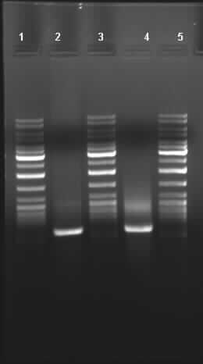

560bp

Fig.6: PCR amplification of arsenic regulatory sequences . Lane 1, 3 and 5 - 10 Kb DNA Ladder, Lane 2 & 4- PCR amplified arsR and ars promotor from pBGD23
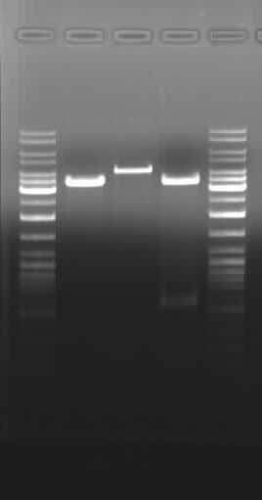
1
2
3
4
5

3.4kb

560bp

Fig. 7: Cloning of ars regulatory sequence into vector pEGFP. Lane 1 and 5 -10 Kb DNA Ladder, Lane 2-Vector pEGFP restricted with HindIII, Lane 3 - Clone pJSKV51 restricted with HindIII , Lane 4 - Clone pJSKV51 restricted with HindIII and SalI

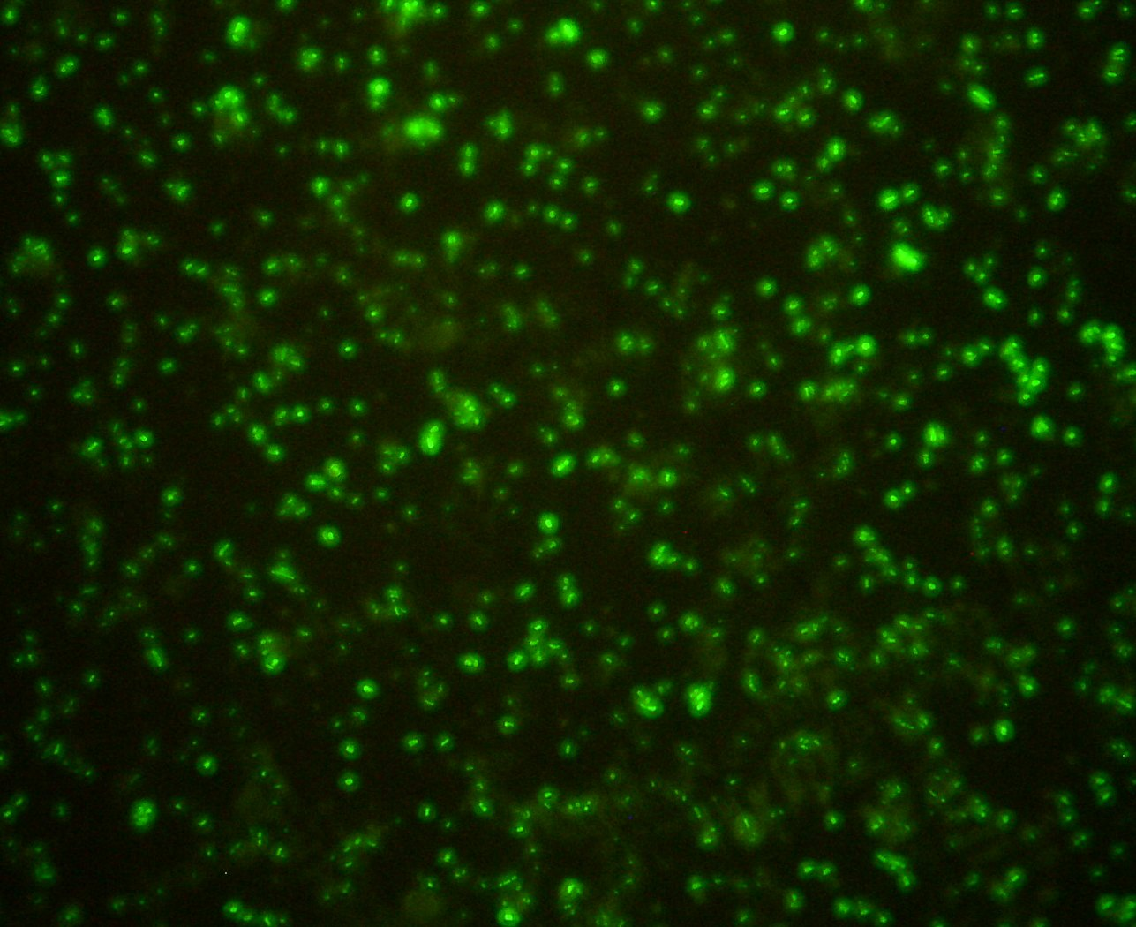
Fig.8: Expression of EGFP from Arsenic biosensor cells grown on LB agar plates containing 100μg/ml ampicillin and 200ppb arsenite. (Magnification 40X)

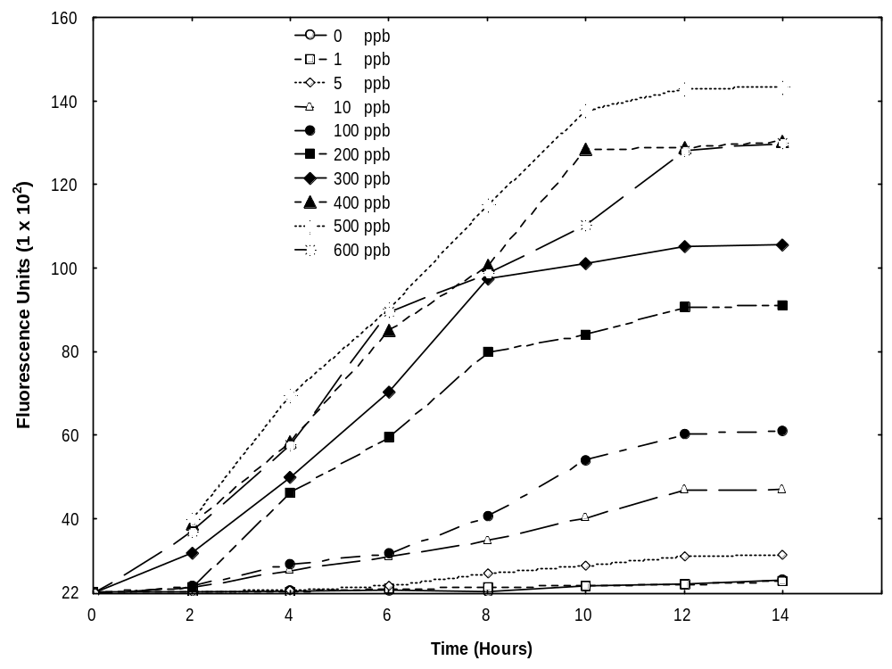

Fig. 9: Induction of EGFP expression by varying arsenite concentrations. 2.5 ml of Biosensor cells were mixed with 2.5 ml de-ionized water containing varying concentrations of arsenite (1ppb-600ppb) and was incubated at 37⁰C with 150rpm shaking and fluorescence levels were measured at every 2 hour interval.

increase in incubation time did not improve the sensitivity. Calculation of induction co-efficient for the lower and upper limit of detection over various time intervals is shown in Fig.10. It clearly indicates that for effective detection of lower concentrations of arsenic longer incubation periods are required where as higher concentrations of arsenic could elicit a faster induction as early as four hours. When the same set of samples was documented with fluorescence microscopy, the effective detection range was considerably less. When observed under epifluorescent microscope, cells appeared dark up to an arsenic concentration of 100ppb and a general increase of fluorescence intensity could be seen with increase in concentration of arsenic up to 500ppb (Fig.11A-E). However detection of EGFP induction of arsenic by epifluorescence microscopy was only qualitative. Previous studies on development of biosensors for arsenic using various reporter genes like ß-galactosidase, lux and GFPuv and GFP have reported different sensitivity ranges and time of sample incubation. Using the regulatory elements from S. aureus plasmid p1258, Tuarianen et al. (1997) developed a set of lux based biosensor for arsenic and tested the performance in different bacterial hosts ( E. coli, B. subtilis, and S. aureus). An effective detection range of 10nM 10uM was observed for these strains. In another study Petanen et al. (2003) reported the development of arsenic sensing Pseudomonas fluorescens strain carrying a lux based recombinant plasmid, which had a similar detection range. Flynn et al. (2002) described the measurement of bio available arsenic in soil samples utilizing V. fischeri luxCDABE as reporter. The lower limit of detection for this biosensor was 0.1ppm and the upper limit of detection was 1.0ppm and required overnight growth of cells and 30 minutes incubation accounting to an overall detection time of 12.5 hours. In another study Ramanathan et al. (1997) constructed a biosensor for arsenic sensing utilizing the arsenic regulatory elements from the ars operon of plasmid R773 and lux as the reporter gene. The sensitivity of this strain ranged between 10⁻¹⁸ M to 10⁻⁸ M. In another study, the same regulatory elements were used
in-frame with ß-galactosidase and the lower limit of detection was reduced to 10⁻⁸ M and upper limit shifted to 10⁻⁴ M (Scott et al. 1997) indicating that choice of the reporter gene is a critical parameter on the sensitivity of biosensor. In contrast, Roberto et al. (2002) reported an improvement of detection range of the sensor strain to 1ppb and 100ppm where in GFPuv was utilized as the reporter gene while the regulatory elements was from

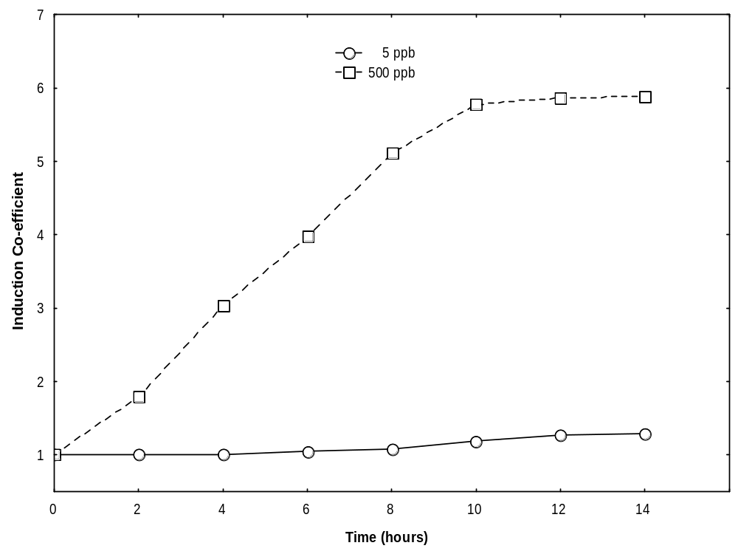
Fig.10: Induction co-efficient for the upper and lower limits detection for Arsenic Biosensor

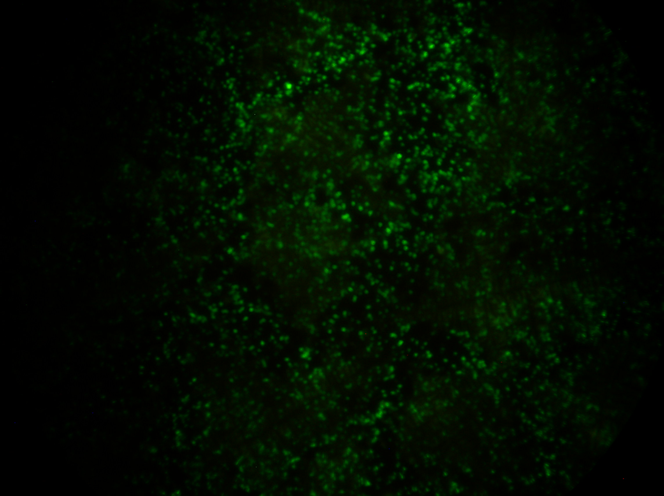
Fig.11A EGFP induction by 100ppb arsenite

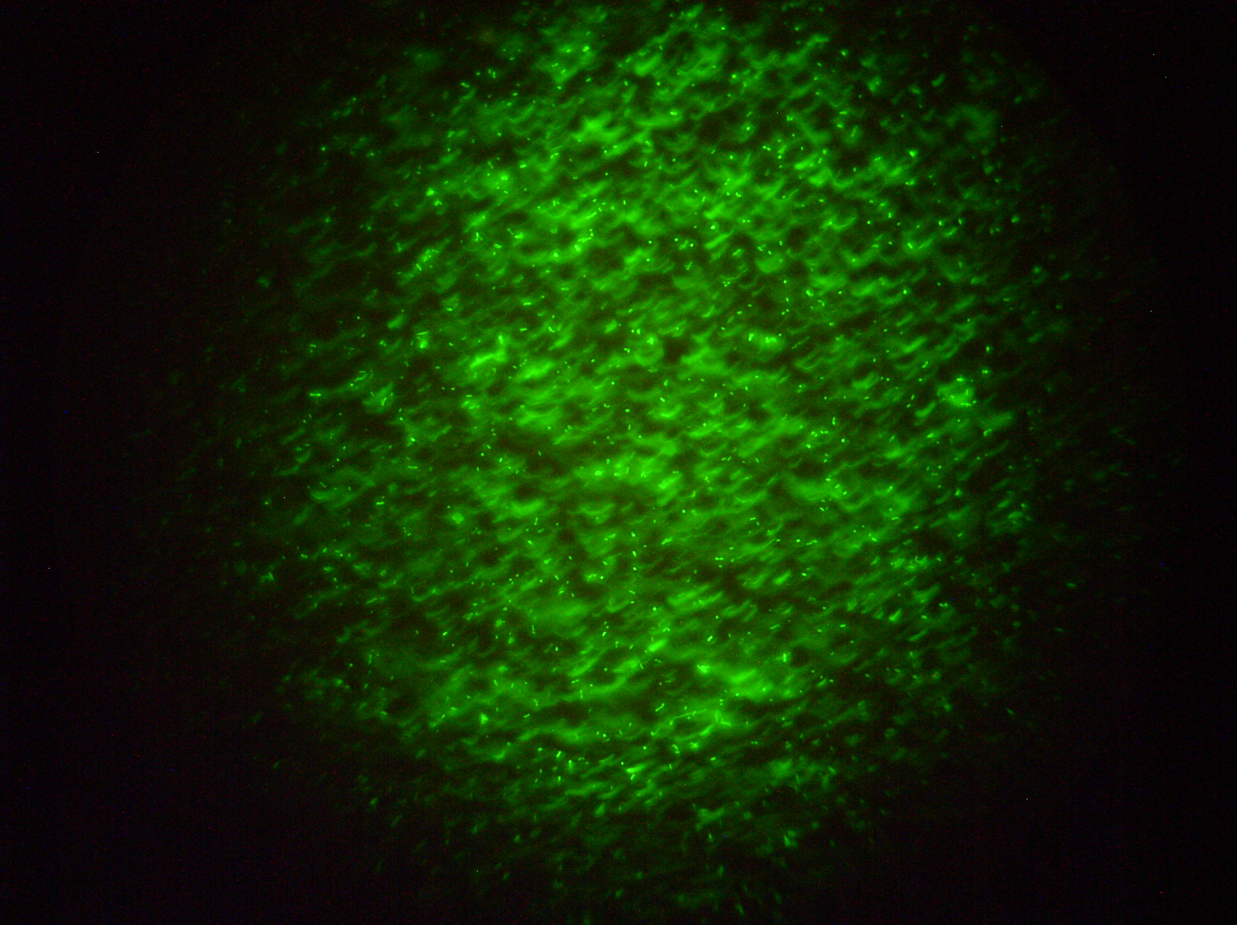 | 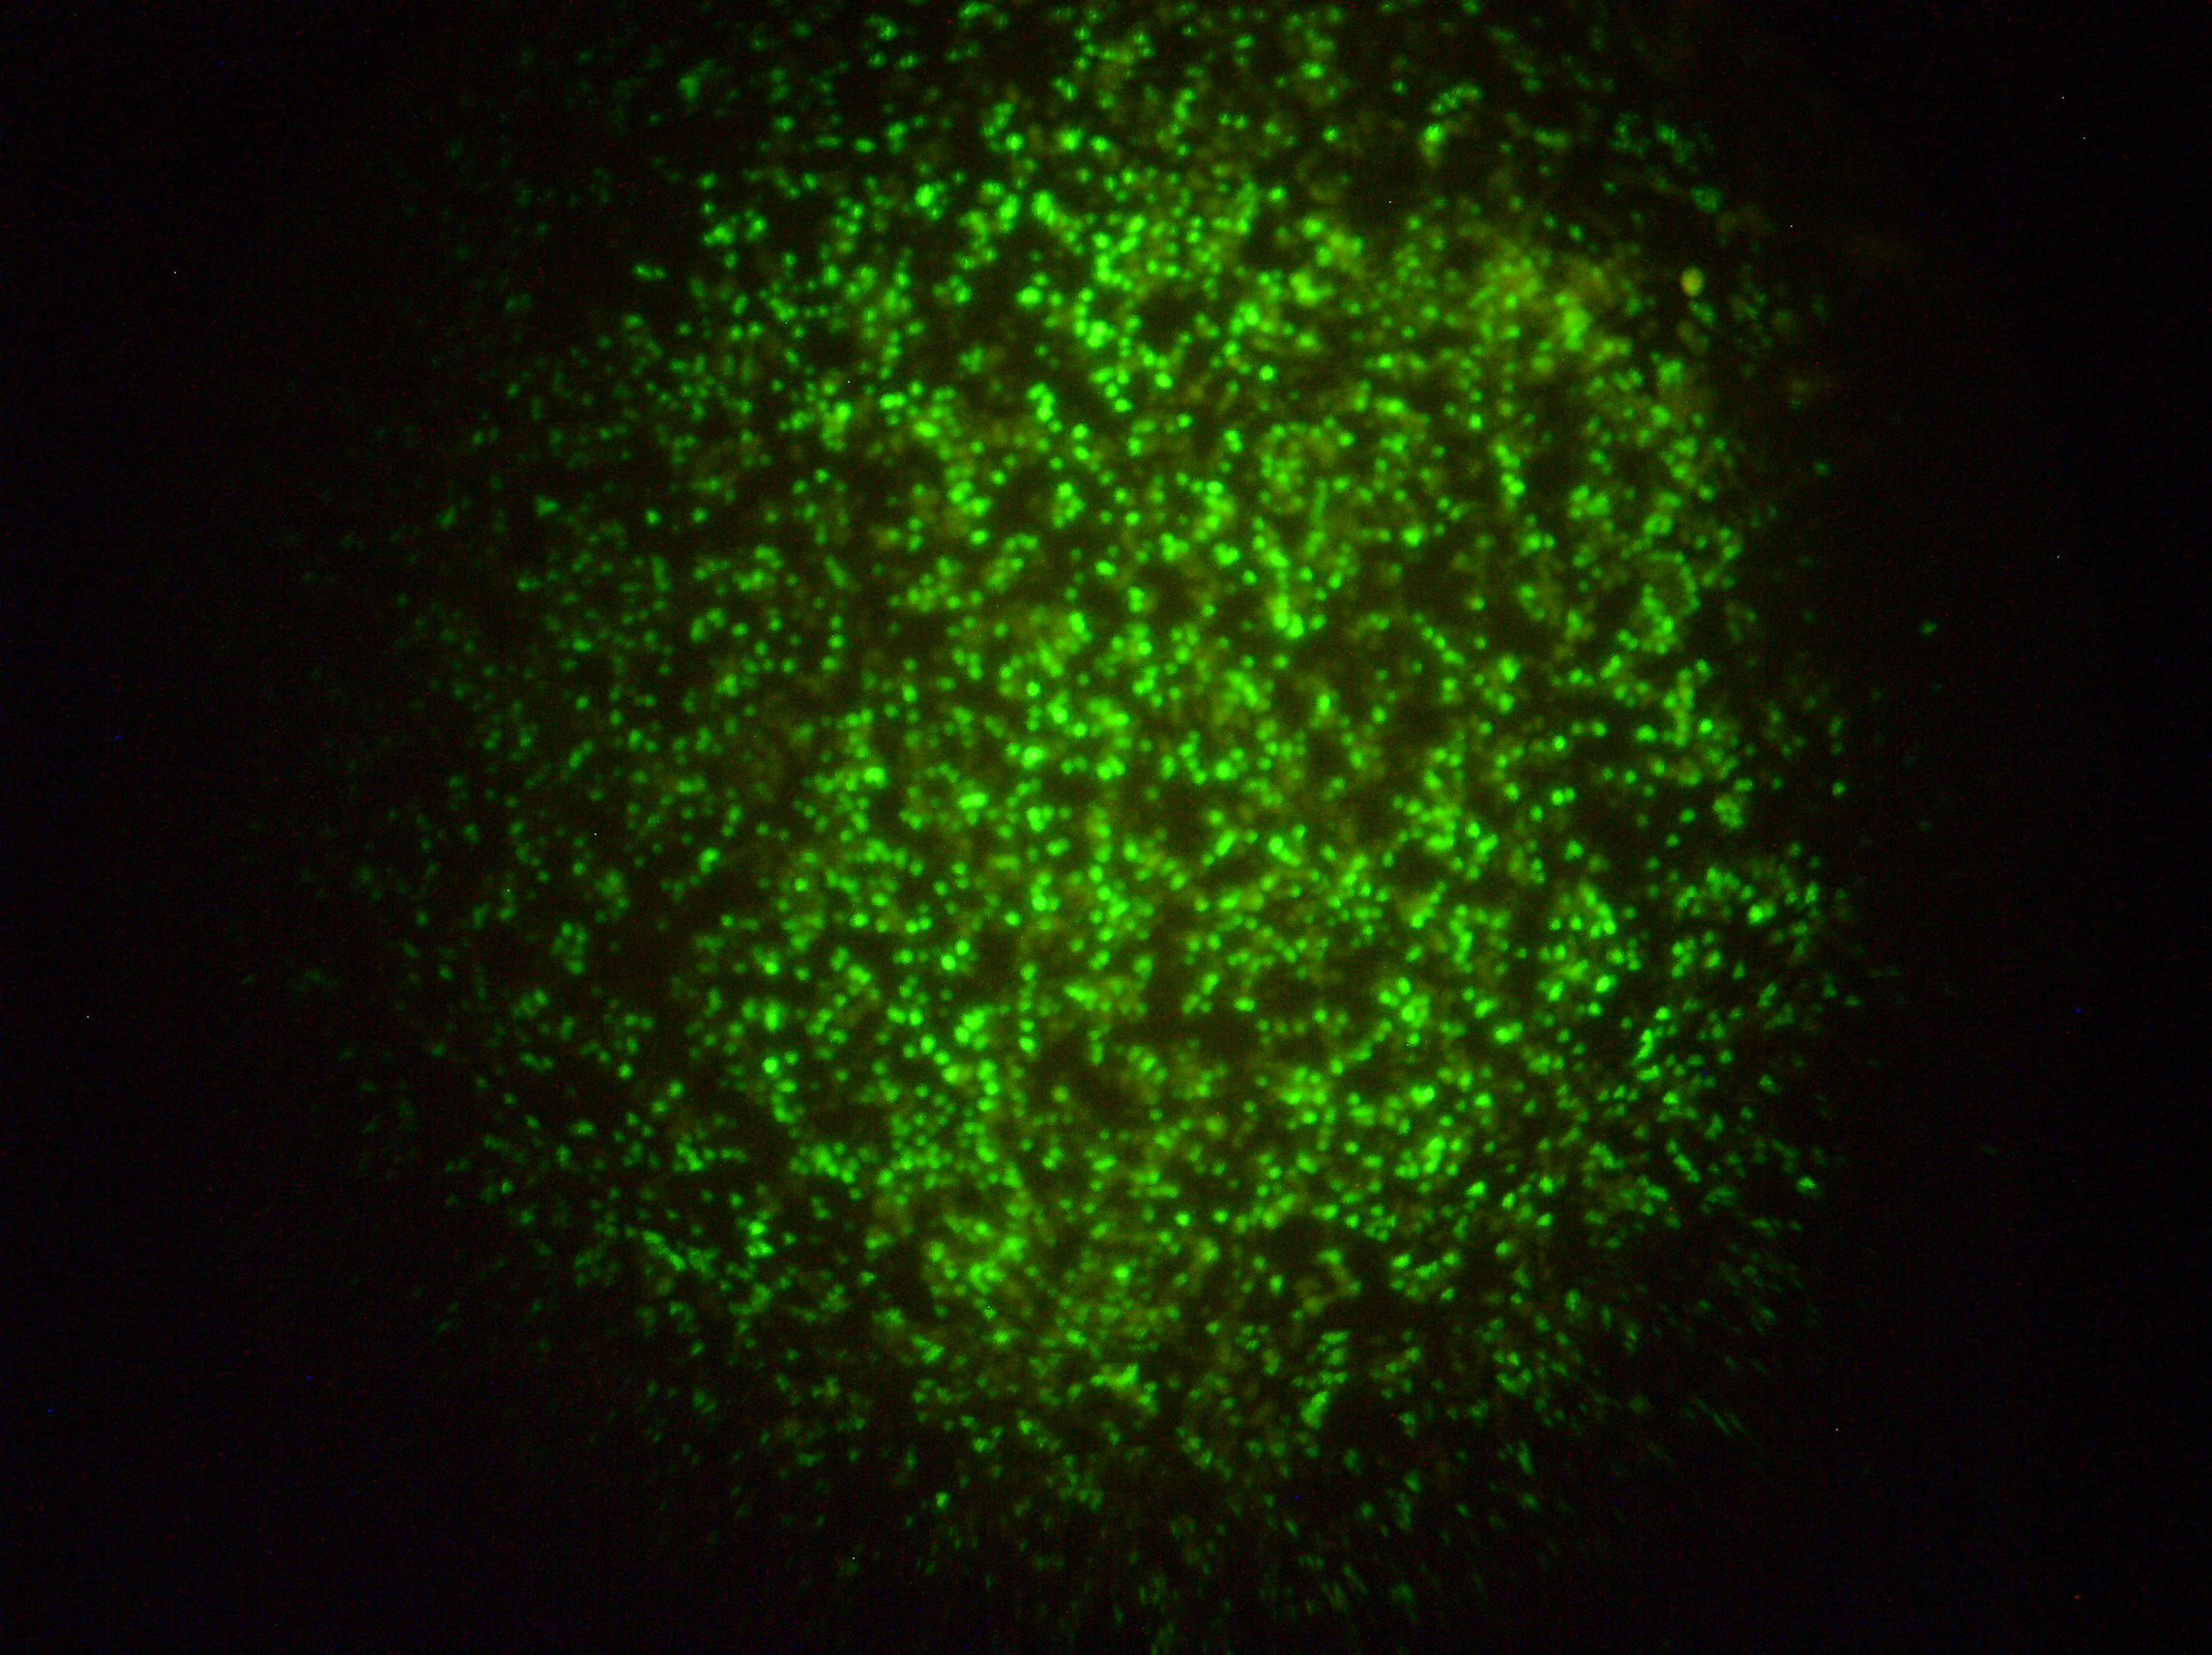
Fig.11B EGFP induction by 200ppb arsenite | Fig.11C EGFP induction by 300ppb arsenite
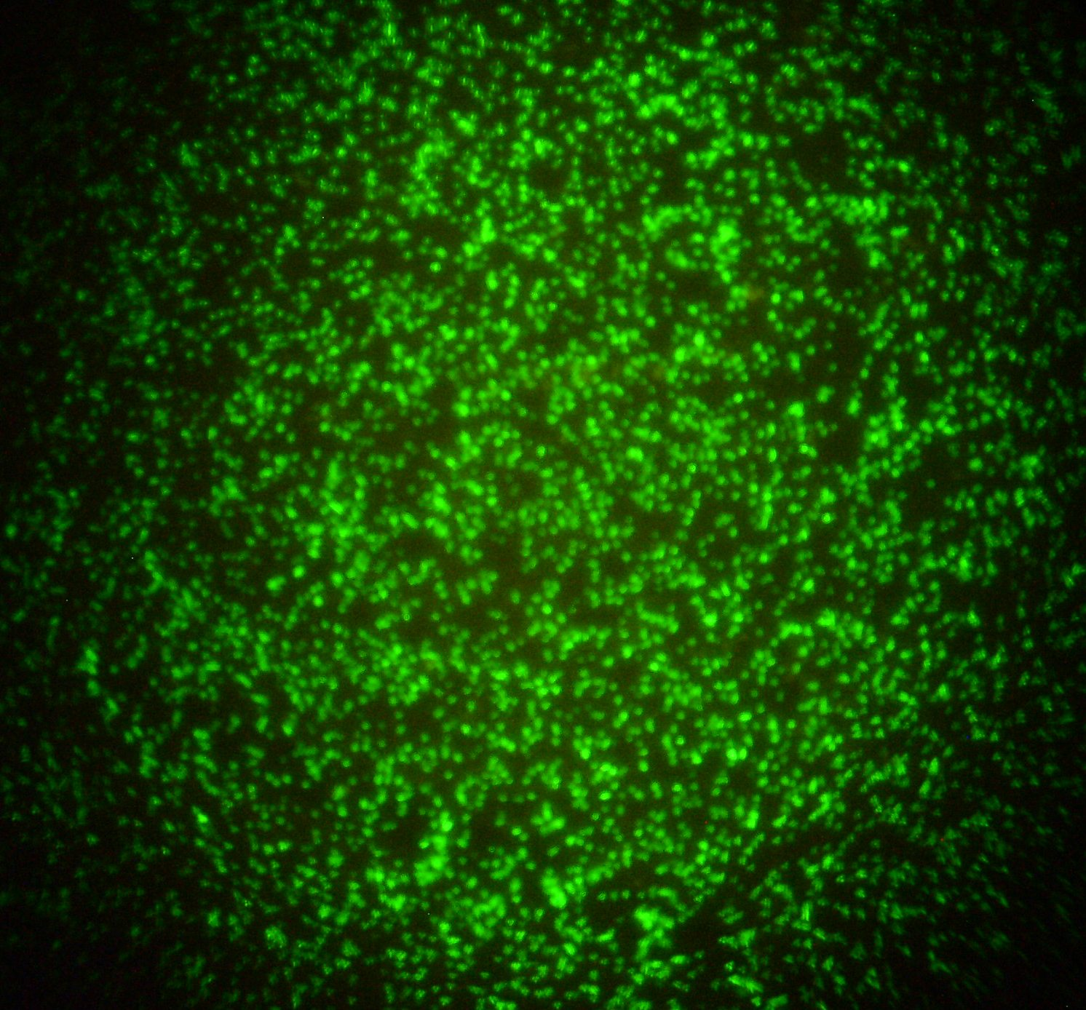 | 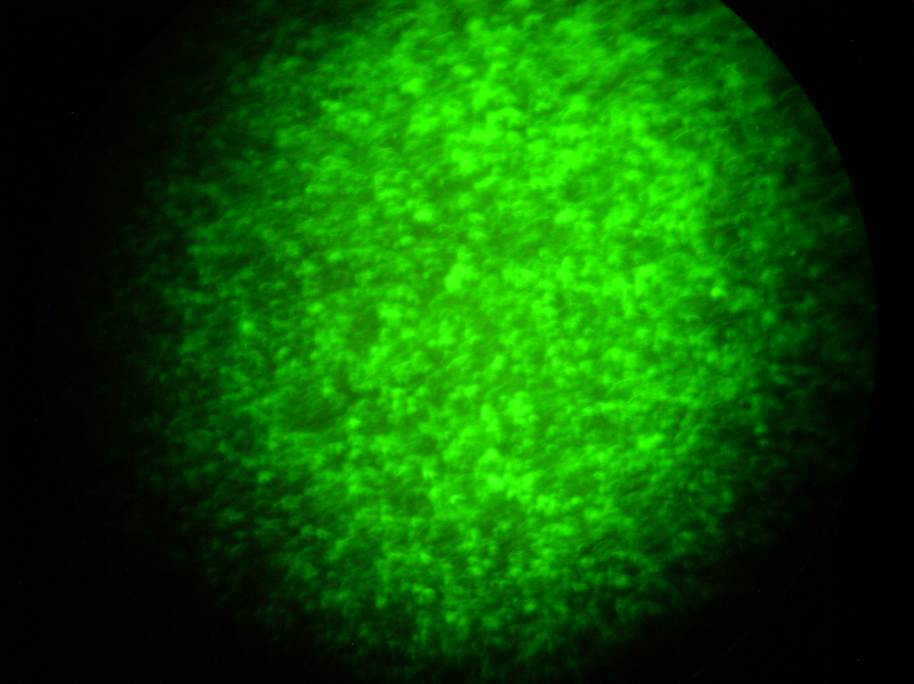
Fig.11D EGFP induction by 400ppb arsenite | Fig.11E EGFP induction by 500ppb arsenite
Fig.11A-E Epifluorescence microscope view of EGFP expression by various concentrations of arsenite from Arsenic biosensor
ars operon of plasmid p1258. This difference in response range reported and the present study could be due to several factors including the host strain, variation in the spectral properties of GFP variants, and also in the sequence diversity of ars operon used. The ars operon of plasmid R773 which is the original source of regulatory elements of this study is similar but not identical to the DNA sequence of ars operon in plasmid p1258. In another report, Stocker et al. (2003) described the development of a set of biosensors for arsenic detection utilizing lacZ, lux and GFP as reporters. However the response range of GFP based biosensor (0.1µM- 1.0µM) was less than that of lux and lacZ based biosensors. Stocker et al. (2003) utilized epifluorescence microscope for the detection of GFP and obtained a lower detection limit, which is in concurrence with microscopy results of the present study. Just as the choice of regulatory elements and reporter genes are critical for the sensitivity of the biosensor, correct choice of instrumentation for measuring the reporter gene activity also greatly influences the sensitivity range. Unlike epifluorescence microscope, use of an instrument like Wallac Victor^{3TM} with superior sensitivity resulted in an improvement in the lower limit of arsenic detection. Arsenic even at low concentrations is toxic to microbial cells. Bacteria like E. coli fight toxicity of arsenic through ars operon (Rosen 1995). The products of genes arsA and arsB codes for an arsenic efflux pump in the bacterial membrane and export out arsenic thereby protecting host bacterium. Also E. coli has a single copy of arsABC genes in the chromosome which is responsible for the protection of host bacterium against arsenic at low concentrations (Wu and Rosen. 1993). In the present biosensor construct only the ars promoter, arsR and part of arsD is present. Hence at low concentrations of arsenic, EGFP induction in the biosensor cell occurs. Whereas as the concentration exceeds a threshold the metal ion becomes lethal to host cell and this explains the reduction of fluorescence intensities beyond 500ppb of arsenic. It has been reported that stable GFP expression requires longer incubation periods as GFP requires longer maturation periods (Crameri et al. 1996). GFP must undergo a series of auto-catalytic reactions in order to become fluorescent (Tisein et al. 1999) and these explains the longer time period required by the biosensor strain to achieve steady state levels of fluorescence. Considering these, an incubation period 12 hours and an effective range of 5ppb to 500ppb of arsenic was accepted as the sensitive range of the Arsenic biosensor.

2.5.3 Effect of pH
Effect of pH fluctuations on the biosensor sensitivity was investigated at varying pH (5.0 – 9.0). There was a drop of fluorescence levels when pH of the sample varied either above or below pH 7.0. When sample pH was reduced to 6.0 there was a 10% reduction of fluorescence levels. At pH 5.0 the fluorescence levels reduced sharply up to 60%. In contrast, the degree of reduction in pH levels, when it was raised above 7.0 was at a lesser rate. When pH of the sample was elevated from 7.0 to 8.0, the maximum fluorescence reduction was only 3%. However a further increase of pH to 9.0, resulted in a fluorescence reduction of 44% (Fig.12). This variations exhibited by change in pH of sample is in expected lines. Wild type GFP retains fluorescence in the range of pH 5.5-12.0, however fluorescence intensity decreases between pH 5.5 and pH 4.0, and drops sharply above pH 12.0 (Bokman and Ward 1981). Because of GFP’s sensitivity to pH it has been used as an intracellular indicator in living cells. Unlike the WtGFP, EGFP exhibits a reduced range of pH stability. For EGFP, fluorescence is stable between pH 7.0 and pH 11.0 and drops sharply above it and decreases between pH 7.0 and pH 4.0, retaining only 50% fluorescence at pH 5.0 (Patterson et al 1997). Hence the greater reduction of florescence levels below pH 7.0 is explained by the extreme pH sensitivity of EGFP. The drop in fluorescence levels above pH 7.0 can be related to pH sensitivity of arsenic. Arsenic is known to precipitate in water when sample pH increases. (Hall et al, 1999). When arsenic containing water samples are to be stored for a prolonged period of time, it has been suggested that acidification of sample with HCl prevents such precipitation (Chackraborati et al, 1999). Unlike classical analytical chemistry protocols, biosensors detects biologically available fraction of a metal in a sample (Petanen and Romantschak, 2003). When metal ions like arsenic are precipitated, it becomes biologically unavailable. Thus, any variation of pH from 7.0 in samples caused a reduction in florescence levels and hence pH 7.0 was chosen as the optimum pH for sample measurements.

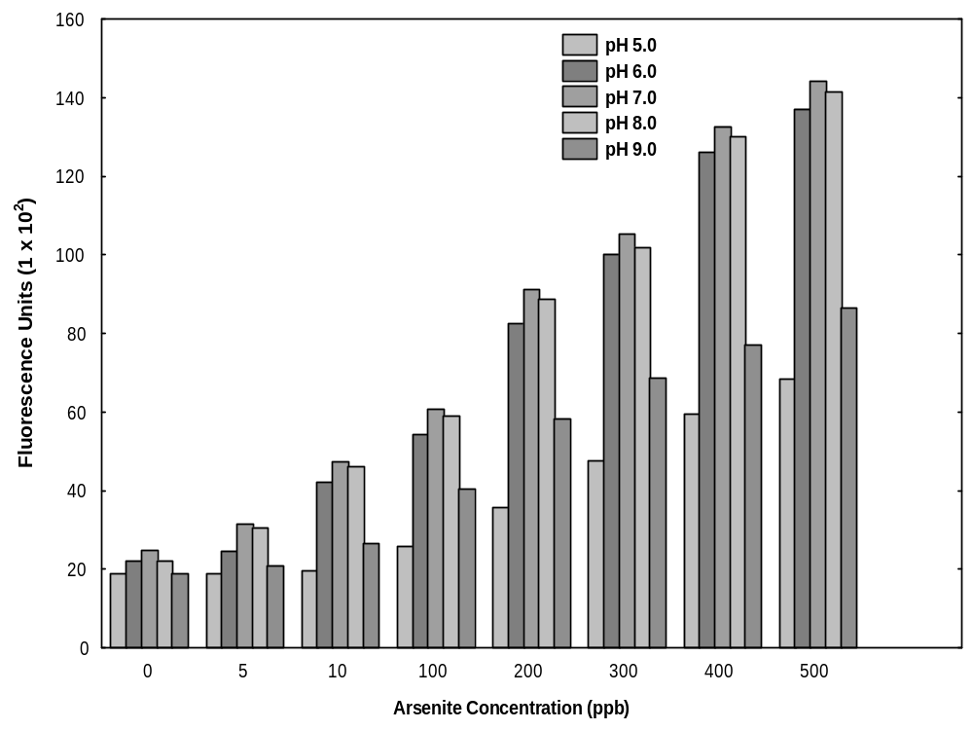
Fig.12: Effect of pH on Arsenic biosensor specificity. 2.5 ml of Biosensor cells were mixed with 2.5 ml de-ionized water containing varying concentrations of arsenite (5ppb-500ppb) and varying pH (5.0 –9.0) and was incubated at 37ºC with 150rpm shaking for 12 hours and Fluorescence levels were measured.

2.5.4 Effect of Temperature
The effect of temperature fluctuation on the sensitivity of Arsenic biosensor was studied over a temperature range of 34°C - 40°C. The data (Fig.13) indicate that there was a reduction of EGFP expression levels when temperature deviated from the standard incubation temperature of 37°C. At 38°C and 36°C EGFP levels decreased only to a maximum extent of 3%. However with every 1°C decrease or increase of temperature beyond this point, EGFP levels showed a higher decrease. At 34°C and 40°C there was an overall reduction of 25% EGFP levels. These results are not surprising as E. coli is being used as the host for biosensor measurements. It is well known that E. coli has a temperature requirement of 37°C for optimum growth. It can grow at elevated or reduced temperature levels than that, but at a lesser rate. EGFP is exceptionally resistant to heat (Bokman and ward 1981). It has a Tm of 70°C and all the enhanced GFP variants show little difference in fluorescence at either 25°C or 37°C (Ward 1980).
These considerations indicate that the reduced EGFP expression when temperature deviates from the standard 37°C incubation temperature, is a result of declining physiological activity of the E. coli host which results in reduced protein expression. This implies that 1°C fluctuation from standard 37°C incubation temperature is hardly of any importance to the sensitivity of the biosensor. However, any further deviation results in a sharper decline of EGFP expression. The previous reports on development of biosensors utilizing GFP as reporter gene also has used 37°C as the standard measurement temperature (Roberto et al. 2002, Stocker et al. 2003). However these studies have not reported the dynamic temperature range of the biosensor explicitly. Considering general similarity of temperature responsiveness of different GFP variants and E. coli requirement of 37°C as the optimal incubation temperature; 37°C was selected as the optimum incubation temperature.

2.5.5 Effect of photobleaching
The possible effects of illumination of samples prior to GFP measurements was studied by exposing the samples to fluorescent and blue light. As Fig.14 indicates, EGFP fluorescence in all samples was stable after exposure to fluorescent and blue excitation.

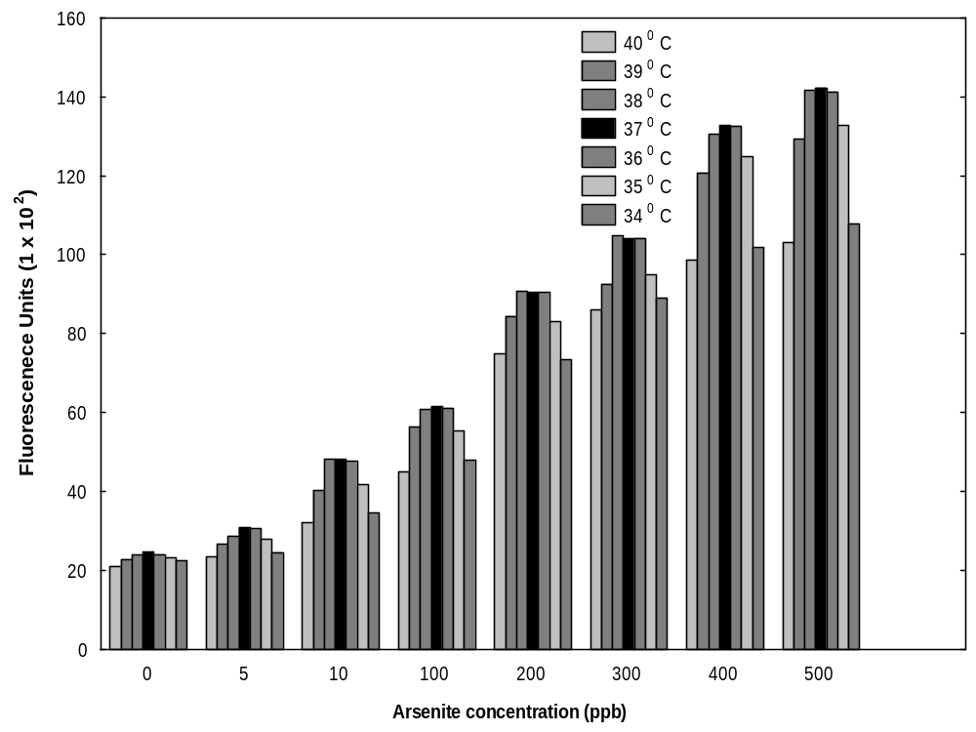
Fig. 13: Effect of temperature on Arsenic biosensor specificity. 2.5 ml of Biosensor cells were mixed with 2.5 ml de-ionized water containing varying concentrations of arsenite (5ppb-500ppb) and was incubated at varying degrees of temperature (34⁰C -40⁰C) with 150rpm for 12 hours and Fluorescence levels were measured.

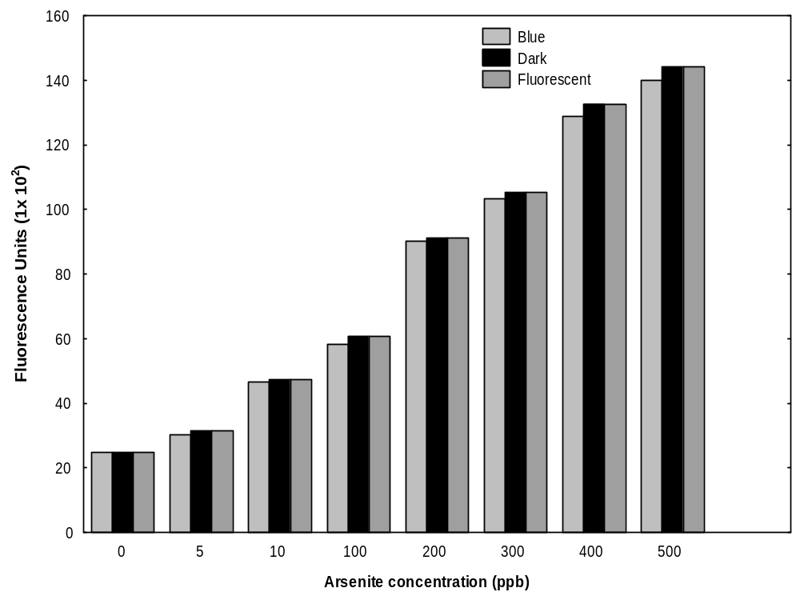

Fig.14: Effect of photobleaching on Arsenic biosensor specificity. 2.5 ml of Biosensor cells were mixed with 2.5 ml de-ionized water containing varying concentrations of arsenite (5ppb-500ppb) and was incubated at 37⁰C with 150rpm for 12 hours. One set of tubes were then exposed to blue light for 10 minutes originating from a 100W mercury lamp fitted a 480nm filter and another set of tubes were exposed to fluorescent light for 10 minutes and fluorescence levels were measured.

However when samples were exposed to blue light of 480nm originating from a mercury lamp, an overall reduction of fluorescence levels (1% - 4%) was observed. It is known that GFP fluorescence is very stable even under high-intensity illuminations. (Wang and Hazelrigg 1994). However some reduction in GFP fluorescence occurs when it is illuminated with 450–490 nm light (Niswender et al. 1995). This reduction of GFP fluorescence due to photobleaching varies with organism used as the host (Chalfie et al. 1994). Hence the reduction of fluorescence levels upon illuminating with 480nm light could be attributed to the photo bleaching of GFP. However such sustained and prolonged illumination of samples prior to measurements are quite unlikely in normal situations. Hence the effect of illumination of samples is of negligible importance on biosensor specificity.

2.5.6 Effect of shaking
Optimal shaking speed and effect of variation in shaking speed on the sensitivity of biosensor was tested by culturing the biosensor cells at static conditions and at increasing degrees of shaking. The results (Fig. 15) indicate that with increasing in the speed of shaking fluorescence levels also increased. However when shaking speed was increased beyond 150rpm, the increase in fluorescence levels were only marginal (2%- 4%). Under static conditions, the range of detection of biosensor plummeted and there was a flat response up to 200ppb, there by reducing the effective detection range between 200–500 ppb. At 50rpm shaking the responsiveness of biosensor increased to 100ppb, and at 100rpm shaking the effective sensitivity reached between 10ppb–500 ppb. No increase in biosensor sensitivity was observed beyond 150rpm shaking. The literature on biosensor development have reported several formats for the sample incubation. Roberto et al. (2003) described a static 96 well microplate format for arsenic detection by GFP based whole cell biosensor. However Stocker et al. (2003) followed the classical conical flask culturing mode with vigorous shaking and that study was very close to the present work as it used same host strain and regulatory elements but a different GFP variant. Considering general agreement of the results of the present study and the report of Stocker et al (2003), a shaking speed of 150rpm was taken as the standard shaking condition for all further measurements.

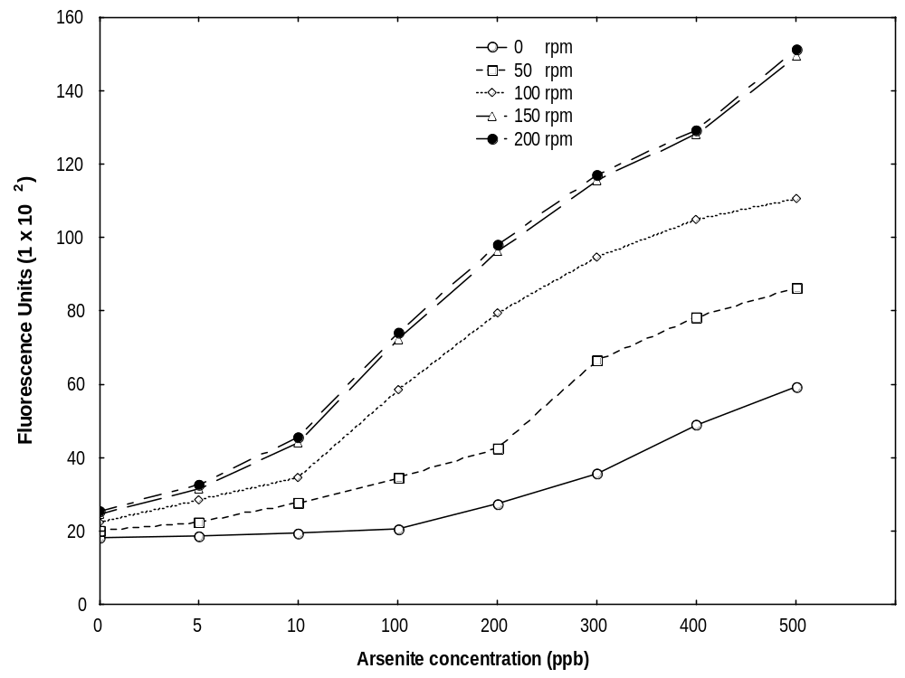
Fig.15: Effect of shaking on Arsenic biosensor specificity. 2.5 ml of Biosensor cells were mixed with 2.5 ml de-ionized water containing varying concentrations of arsenite (5ppb-500ppb) and was incubated at 37⁰C with varying degrees of shaking (static to 200rpm) and EGFP levels were measured after 12 hours.

2.5.8 Effect of cell density
In order to estimate the minimum amount of bacterial cell required for the sensitive detection of arsenic, cells were grown to OD₆₀₀ ranging from 0.3 to 0.8 and was mixed with equal amount of arsenite containing samples and was incubated for 12 hours at 37ºC with 150rpm shaking. As the results in Fig.16 Indicate, with increasing cell densities fluorescence intensities also increased. However at lower cell densities there was a loss of biosensor sensitivity. At a cell density of 0.3 the effective range of detection was between 200ppb and 500ppb of arsenic. At a cell density of 0.4, the effective detection range improved to 100ppb and 500ppb of arsenite. When cell density was further increased to 0.5 the effective detection range expanded to 10ppb and 500ppb. The maximum sensitivity (5ppb-500ppb) was obtained at a cell density of 0.6. Further increase of cell densities up to 0.8 did not improve the detection range but only resulted in a proportionate increase in the fluorescence levels. It has been well established that the sensitivity of the biosensor critically depends on the detection device employed. Use of sensitive instruments like Fluoresce Activated Cell Sorter (FACS) can result in detection of GFP up to single cell level (Hansen et al. 2002). Although spectrofluorimeters like Wallac Victor^{3TM} used in this study are shown to be sensitive, they require higher cell densities to achieve superior sensitivity of detection (Roberto et al. 2002). Previous studies utilizing GFP as reporter gene also reported the requirement of higher cell densities (Roberto et al. 2003, Stocker et al. 2003). Although higher cell densities increased the fluorescence levels due to a dosage effect, it did not improve the sensitivity beyond 0.6. Since achievement of higher cell densities requires longer incubation periods, which ultimately increase the total sample measurement time, a cell density of 0.6 was chosen as the optimum cell concentration required for the sample measurements.

2.5.9 Effect of co-ions
In nature the target metal is usually found in combination with other metal ions, which might produce a non-specific induction of fluorescence or reduce fluorescence induction by the target metal. In order to examine the effect of co-ions on the specificity of biosensor, equal concentrations (200 ppb) of Cd, Co, Cu, Zn and Sb in combination with As was added to the assay mixture and fluorescence levels were measured.

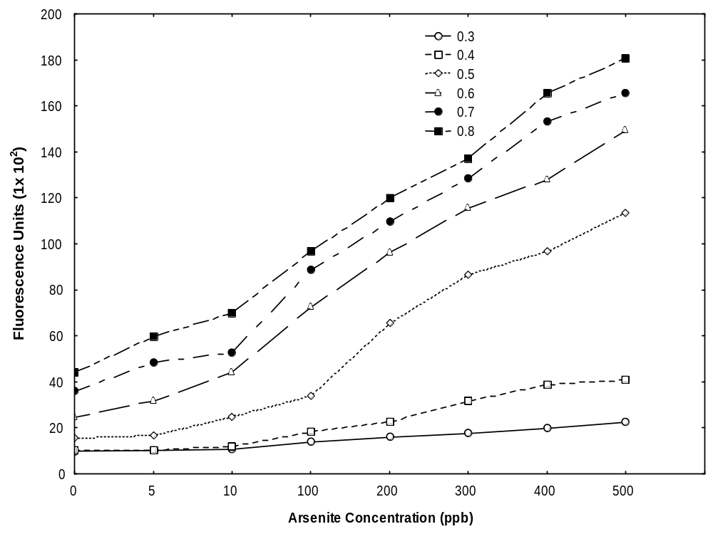

Fig. 16: Effect of cell density on Arsenic biosensor specificity. 2.5 ml of Biosensor cells were grown to varying cell densities (OD₆₀₀ 0.3 – 0.9) and was mixed with 2.5 ml deionised water containing varying concentrations of arsenite (5ppb-500ppb) and was incubated at 37⁰C with 150rpm shaking and EGFP levels were measured after 12 hours.

As the results shown in Fig. 17 indicate, addition of Cd, Co, Cu and Zn did not have any effect on the specificity of the biosensor. However, when equi-molar concentrations (200ppb) of As and antimony (Sb) was used fluorescence levels doubled, indicating a synergistic effect. The synergy exhibited by Sb is not a surprise in the light of chemical properties of Sb and metal binding affinities of arsR. arsR belongs to a group of bacterial transcription regulatory proteins that has two major domains, one is a helix-turn-helix (HTH) motif which interacts with DNA and the second is a metal binding domain (Rosen 1995). The metal binding motif is characterized by a number of well-conserved residues. Two distinct metal-binding sites have been well characterized. The first site comprises cysteine thiolates located in the HTH in helix 3 and another site in the N-terminus, called the alpha3(N) site. The N-terminal arm and its alpha3 site coordinates smaller thiophilic ions like As and Sb. Metal-oxyanions such as arsenite, antimonite and arsenate for arsR. Binding of metal ions to these sites leads to allosteric changes that can derepress the operator/promotor DNA (Rosen 1995). Antimony (Sb) is a metallic element (actually a metalloid) like arsenic. Antimony is located immediately below arsenic in the periodic table, and share many chemical properties of As. In particular, antimony readily forms complex with negatively charged ions like oxygen (oxyanions) in the environment. Antimony can be in the 3+ or 5+ oxidation state in these oxyanions, just like arsenic. Thus arsR is able to bind Sb with equal affinity and thus derepress the ars operon. Reports of Ramanathan et al. (1997) and Scott et al. (1997) and Taurianen et al (1997) also documents a dual response of biosensor to As and Sb when regulatory elements of plasmid R773 and p1258 were used.

2.5.10 Evaluation of Biosensor performance
After optimizing the biosensor assay conditions, the effectiveness of biosensor in detecting arsenic in field conditions was studied by assaying the water samples from WB, with AAS and biosensor cells. Before sample measurements, a doze response curve of arsenite induced EGFP expression was generated (Fig.18), by incubating the cells with varying concentrations of arsenite.

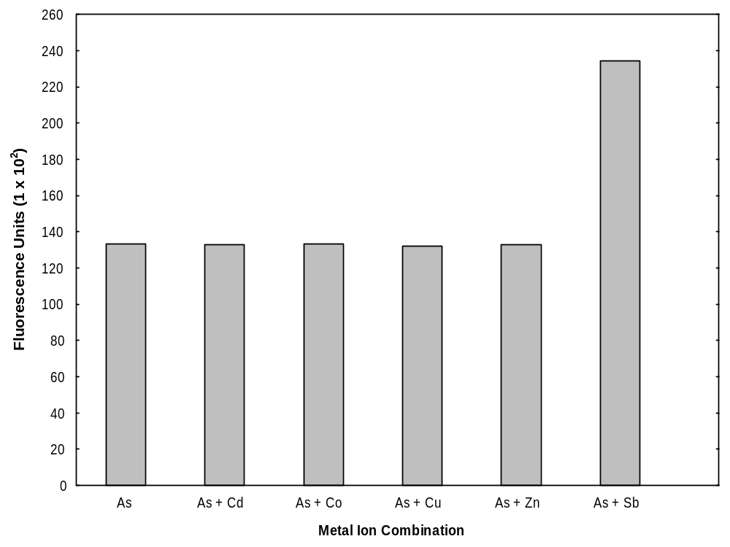

Fig.17: Effect of co-ions on Arsenic biosensors specicficity. 2.5 ml of Biosensor cells were mixed with 2.5 ml de-ionized water containing 200ppb of arsenite (5ppb-500ppb) in combination with 200ppb of Cd, Co, Cu, Zn, Sb was incubated at 37⁰C with 150rpm shaking and EGFP levels were measured after 12 hours.

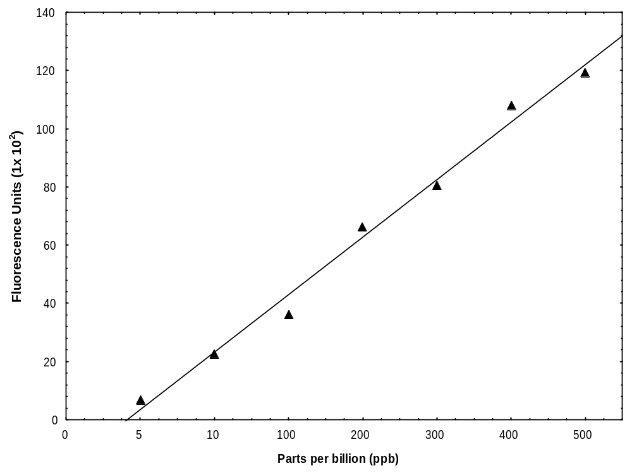
Fig.18: Dose response curve of EGFP induction over different arsenite concentrations. 2.5 ml of Biosensor cells were mixed with 2.5 ml de-ionized water containing varying concentrations of arsenite (5ppb-500ppb) and was incubated at 37⁰C with 150rpm shaking and EGFP levels were measured after 12 hours.

A comparison of arsenic concentration in samples obtained by both biosensor and AAS measurements along with the observed pH is given in Table.8. As the results indicate, both AAS and biosensor showed similar arsenic concentration in all samples. More importantly, both AAS and biosensor showed zero arsenic concentration in arsenic free samples. The pH of the samples ranged between 6.8 to 8.15. The lowest concentration of arsenic (15ppb) was detected in two samples from Englishbazar (Maldah district) and Joynagar (24 Parganas district). Maximum concentration of arsenic (800ppb) was found in a sample from Barasat (24 Paragans North district). There was no correlation between arsenic content and sample pH. The sample with highest pH (8.15) was free of arsenic and the sample with highest arsenic concentration had near neutral pH (7.20). Extensive surveys were conducted by Chakraborti et al. (2004) in West Bengal and neighboring states like Bihar, Uttaranchal, Uttar Pradesh and Assam. It was the pioneering work by this group, which brought the large-scale arsenic contamination in tube well water into limelight. They have used Flow Injection Hydride Generation Atomic Absorption Spectroscopy (FIGAAS) which extremely sensitive for arsenic detection. Based on analysis conducted on thousands of samples nine districts out of eighteen districts of West Bengal was declared as arsenic affected (Chakraborti et al. 2002, Sengupta et al. 2003). These studies have reported that the distribution of arsenic contamination in the region is extremely patchy and in these districts, arsenic concentration could be anywhere between 3ppb-4ppm (Chakraborti et al. 2002). In the present analysis the samples were collected from the same districts and the measurements using biosensor cells also shows a large difference in the distribution of arsenic contamination in the water samples, indicating the accuracy of measurements by biosensor.
Several studies have been conducted to discern the source of arsenic contamination in groundwater. It is now generally accepted that the source of arsenic contamination is due to leaching of arsenic from arsenic containing pyrites in deep soil (Chakraborti et al. 2002). Deltaic areas, such as the Bengal basin, receive large quantities of land-derived and weathered organic rich sediments via Himalayan rivers with high concentration of trace metals, both in particulate and absorbed forms, which have already undergone significant biogeochemical alterations. The combined load of Ganga, Meghna and Brahmaputra (G-M-B) rivers system is reported to be the greatest.
Table.8: Arsenic concentration in samples collected from West Bengal. Arsenic concentration in samples was determined by both biosensor and AAS. Following numbers indicate the location from which samples were collected. 1a-g -Balagarh, 2a-g - South Kolkata, 3a-g - Bagnan, 4a-g - Joynagar, 5a-g - Barasat, 6a-g - Purbasthali, 7a-g - Englishbazar, 8a-g - Karimpur, 9a-g – Beldanga

S.No |  | pH | E. coliDH5α  pJSKV51  (ppb) | AAS  (ppb) | S.No |  | pH | E. coliDH5α  pJSKV51  (ppb) | AAS  (ppb)
1 | a | 8.02 | 150 | 152 | 5 | e | 7.65 | 750 | 762
1 | b | 6.94 | 500 | 449 | 5 | f | 6.90 | 120 | 113
1 | c | 7.53 | 0.00 | 0.00 | 5 | g | 7.42 | 650 | 661
1 | d | 7.40 | 530 | 534 | 6 | a | 7.73 | 0.00 | 0.00
1 | e | 7.12 | 0.00 | 0.00 | 6 | b | 7.91 | 250 | 244
1 | f | 7.25 | 470 | 468 | 6 | c | 8.10 | 400 | 407
1 | g | 7.48 | 730 | 731 | 6 | d | 7.55 | 340 | 336
2 | a | 7.62 | 0.00 | 0.00 | 6 | e | 7.95 | 0.00 | 0.00
2 | b | 7.25 | 200 | 215 | 6 | f | 7.70 | 90 | 92
2 | c | 6.87 | 650 | 642 | 6 | g | 7.85 | 450 | 447
2 | d | 7.94 | 30 | 28 | 7 | a | 7.20 | 760 | 748
2 | e | 8.06 | 0.00 | 0.00 | 7 | b | 7.95 | 200 | 191
2 | f | 7.57 | 50 | 46 | 7 | c | 7.73 | 40 | 34
2 | g | 7.81 | 660 | 668 | 7 | d | 7.84 | 15 | 11
3 | a | 7.29 | 240 | 249 | 7 | e | 7.80 | 650 | 659
3 | b | 7.44 | 250 | 253 | 7 | f | 7.30 | 0.00 | 0.00
3 | c | 8.09 | 300 | 291 | 7 | g | 7.85 | 0.00 | 0.00
3 | d | 7.25 | 140 | 134 | 8 | a | 7.65 | 340 | 358
3 | e | 7.30 | 0.00 | 0.00 | 8 | b | 7.46 | 280 | 264
3 | f | 7.15 | 0.00 | 0.00 | 8 | c | 7.95 | 0.00 | 0.00
3 | g | 7.55 | 40 | 44 | 8 | d | 8.15 | 360 | 351
4 | a | 7.73 | 15 | 20 | 8 | e | 7.32 | 50 | 44
4 | b | 7.62 | 30 | 24 | 8 | f | 7.70 | 180 | 193
4 | c | 7.81 | 220 | 228 | 8 | g | 7.86 | 0.00 | 0.00
4 | d | 7.85 | 0.00 | 0.00 | 9 | a | 7.40 | 640 | 652
4 | e | 7.34 | 400 | 408 | 9 | b | 7.39 | 770 | 757
4 | f | 7.93 | 0.00 | 0.00 | 9 | c | 7.58 | 290 | 306
4 | g | 6.85 | 300 | 304 | 9 | d | 7.95 | 0.00 | 0.00
5 | a | 7.20 | 800 | 821 | 9 | e | 7.56 | 25 | 31
5 | b | 7.63 | 0.00 | 0.00 | 9 | f | 8.15 | 0.00 | 0.00
5 | c | 7.58 | 90 | 96 | 9 | g | 7.75 | 160 | 147
5 | d | 7.40 | 0.00 | 0.00

sediment load of any river systems. Because of the low elevation of the basin (5 –6m) above the mean sea level, the frequent flooding, Holocene sea level changes, precipitation in the upper large catchments areas, and the unethical control of water resources of major rivers at upstream, the lower part of the basin receives huge amount of sediment load carried by G-M-B rivers system. This sediment load originating from Himalayas is believed to be containing high amount of arsenic rich pyrites. Thus the G-M-B river system although is life line of millions of people, caused deposition of arsenic rich sediments in the region. The distribution of arsenic contamination is extremely patchy and the meandering pattern of the river system explains this phenomenon. Until recently the agriculture in West Bengal was rain fed. As a means to provide safe drinking water to people, several thousands of tube wells were drilled in this region in 1970’s and 80’s. (Chakraborti et al. 2004). This is in turn caused drastic changes in microenvironment of water table and deep soil, resulting in the release of arsenic into tube well water (Chakraborti et al. 2002). Studies have concluded that heavy ground water withdrawal aerates the underground aquifer and oxygen causes the degradation of arsenic rich source (Chakraborti et al. 1999). The ground water withdrawal in these districts is extremely high. In one of the most actually affected districts (24 North Parganas) the status of aquifer exploitation is as high as 80% (Chakraborti et al. 1999). It has been found that arsenic concentration in tube well water remains steady even after several hours of continuous pumping (Chackraborti 1997). Calculations have shown that from a single pump, approximately 200 g of arsenic is energizing with ground water withdrawal for a continuous period of 8 hours . There is no evidence that the arsenic levels in tube well water will decrease in space and time. This large scale release of geologic arsenic has ultimately resulted in the entry of arsenic in food chain. In the arsenic affected areas the average arsenic concentration in soil, rice and vegetables were 22.60μg/g, 0.323μg/g and 0.027 μg/g respectively. Study of the arsenic speciation in rice and vegetables irrigated with contaminated water showed that the majority of it is present as inorganic arsenic (Chakraborti et al, 2004). Urine analysis for arsenic metabolites from villagers drinking arsenic safe water (arsenic <3 μg/l) showed arsenic levels 2–3 times higher than normal, indicating the contribution of arsenic from food chain (Chakraborti et al, 2004).
These findings have wide ranging implications, both on the health and well being of people and on the current arsenic testing requirements. Already there are several thousand tube wells in the region and testing of arsenic concentration in them itself is a formidable task. Presence of arsenic in food chain catapults the number of sampling and testing required. Most prevalent testing method used is field test kits, mainly the Merck field test kit. However field test kits have several drawbacks like generation of arsine gas and unreliability in lower arsenic concentrations. Several hundred tube wells have been marked wrongly arsenic positive based on such field test kits (Ahmed 2002). On the contrary, various flavors of atomic absorption spectroscopy have been shown to be reliable and accurate. However the flipside is that this requires special training, expensive instrumentation and also involve higher recurring costs. For instance, cost of arsenic quantization using a field test kit is US$1 whereas Atomic Absorption Spectroscopy will elevate the expense to US$9 (Ahmed 2002). In contrast to this, analysis cost per sample using a biosensor would be considerably less as the cost of E. coli culture maintenance is less demanding.
Arsenic contamination in West Bengal and Bangladesh have been termed as the biggest mass poisoning in history. For a developing country like India the economic burden posed by this calamity is large and hence cheaper arsenic testing technologies like those demonstrated in the present study could be explored. Employment of biosensors for arsenic testing would have an additional advantage as they report the bioavailable fraction of arsenic. Use of EGFP as the reporter gene greatly simplifies the requirements of sample processing. Unlike reporter genes like β- galactosidase and luciferase which require sample cell lysing and addition of reagents for signal detection, GFP can be detected by excitation of samples with UV light (Roberto et al. 2002). Thus, in the present study we have demonstrated that EGFP based bacterial biosensors can be an accurate and cheaper alternative to mass testing of water samples from West Bengal.

Chapter 3

DEVELOPMENT OF INTERNET BASED DATABASE ON ANTIBIOTC RESISTANCE GENES

3.1 Introduction
Since their introduction in clinical medicine more than sixty years ago, antibiotics were considered as wonder drugs for antibacterial therapy. However, emergence and spread of antibiotic resistant bacteria has become a problem of large economic consequences worldwide, and is estimated to cost between US$ 5billion and US$ 24 billion each year in the United States alone (Hall, 2003). There are several molecular mechanisms for drug resistance, but the most threatening are those that involve resistance genes that are on plasmids, transposons and integrons, which can spread from organism to organism, moving not only between individual bacteria, but also between species and even between bacterial kingdoms (Hall 2003). The emergence and spread of antimicrobial resistance among bacteria, viruses, and other disease causing organisms is threatening our ability to combat infectious diseases on a global level. Through the overuse and misuse of antimicrobials and the natural evolution of pathogenic organisms, the world’s weapons against these organisms are decreasing in power.

The full scope of the resistance problem is still largely unknown, due in part to shortcomings in existing antimicrobial resistance surveillance activities and lack of standardized laboratory methodologies. A resistant strain made prevalent by antibiotic selection in bacterial populations of one host is more likely to be among the strains that the host transfers to a second host (Donskey et al. 2000). Similar selection in the second host would boost a strain's chances of becoming established, amplified, and then transferred to a third host. These considerations would predict that resistant strains travel the world selectively through networks of hosts being treated with antimicrobial agents. The experiences of intensive care units, day care centers, and feedlots tend to confirm this prediction. The history of antimicrobial resistance, in the examples where it can be delineated, has often been that of a successful resistance construct evolving under selection somewhere, emerging under further selection, and then spreading nearly everywhere. Strains of Staphylococcus aureus belonging to a few phage types that possessed an inducible penicillinase gradually spread throughout the world's hospitals in the 1950s and throughout communities everywhere in the 1960s (Williams 1959). A few clones with intricate constructs expressing the mec gene then spread methicillin resistance through the world's hospitals (Skurray et al.1988, Skurray and Firth 1997). In the 1970s, a single plasmid carried gentamicin resistance to several genera of enteric bacteria in a number of hospitals in different parts of the United States and in one hospital in Venezuela, none of which had seen any gentamicin-resistant enteric bacteria until then (O'Brien et al. 1985). A particular transposon, Tn1331, was first noted to encode amikacin resistance in Argentina and Chile but was later seen in other parts of the world (Tolmasky et al. 1987). Resistance to sulfonamides, possibly the most prevalent type of resistance, has been found throughout the world encoded by only 2 resistance genes (Davis 1997). One of them was found to be virtually ubiquitous on a small multicopy plasmid (van Treeck et al. 1997) also carrying a streptomycin-resistance gene; this may contribute to the persistence of resistance to streptomycin decades after its use in human therapy has almost completely ceased. Several multidrug-resistant plasmids found to be endemic in several Salmonella serotypes isolated from animals in some US states were found in clinical isolates of the same serotypes from humans infected in distant states (O'Brien et al. 1982). After decades of penicillin use, certain strains of Streptococcus pneumoniae acquired genes expressing foreign penicillin-binding proteins that made the strains resistant to penicillin (Dowson et al. 1994). Once arisen, these new chromosomal genetic constructs spread clonally in strains of Pneumococci belonging to serotypes that could be traced through countries and continents (Thomas 1997). One such construct in serotype 6B, originally prevalent in Spain, was later found in other countries in the Western Hemisphere; its eventual incursion into Iceland accounted for nearly all penicillin-resistant Pneumococci there (Soares 1993). The emergence over the last decade of Vancomycin-Resistant Enterococci (VRE) is especially relevant to discussions of the spread of resistance. Vancomycin had been in use for more than twenty years before anyone saw resistance to it acquired in a species of bacteria that had not always been resistant to it. Within a few years of its emergence, VRE had spread to become a growing nosocomial problem in US hospitals, where the further shift of plasmids carrying it into already multidrug-resistant Enterococcus faecium produced a nearly untreatable antimicrobial-resistance construct (Martone 1998, Suppola 1999). An important issue arose when it was found that in Europe, unlike the United States, VRE are widely distributed in the community, in farm and pet animals, and in meat and meat products, but are still uncommon in hospitals. Concern that this was due to selection by the use for growth promotion in animals in Europe of a vancomycin analog, avoparcin, led to this being banned there in 1997 (Wegener et al. 1999, Kruse et al.1999, Partridge 2000, Jensen 1998).

With the increase in the numbers of multidrug-resistant organisms and the need to monitor evolving patterns of resistance, large multinational surveillance studies have become more critical.Until recently, there have been few adequate international antibiotic resistance surveillance systems, and those that do exist have been driven by the interests of the pharmaceutical industry and are limited in scope (Philips et al. 2004). Surveillance systems like ‘SENTRY’, ‘SMART’, and ‘The Alexander Project’ have yielded valuable information on antibiotic resistance patterns in clinical isolates of resistant pathogens in different parts of the world (Bax et al. 2001). The Danish National System, DANMAP, has now been reporting for six years, and has been unique in trying to bring together the data on the usage of antibiotics and on antibiotic resistance from human and veterinary medicine and food hygiene (Barger et al. 2002). In United States, the National Antimicrobial Resistance Monitoring System (NARMS) is an attempt to do much the same kind of study as DANMAP, and is already yielding valuable data (Marano et al. 2000, Torrens 2001). These surveillance studies have primarily analyzed the Minimum Inhibitory Concentrations (MICs) at which 90% of isolates tested are inhibited (MIC₉₀s), frequency distributions, and percent susceptibility of the drug resistant strains (Poupard et al. 2002). As the global spread of antimicrobial resistance is mediated through mobile genetic elements like plasmids, transposons and integrons, it is important to study their global distribution (Scaria et al. 2005). Also rather than documenting and analyzing the manifestations of such elements, it’s prudent to analyze the distribution of causative factor i.e. the genes responsible. Although the sequence of these genes have been reported from various countries and is deposited in databanks like Genbank, and are freely available, intensive studies on antibiotic resistance genes and their speciation could be better supported with a small specialized database that is developed for these genes alone. Further, such an electronic resource would aid the correct selection of regulatory elements for constructing bacterial biosensors for antibiotic detection. Hence the present study was aimed at creating an Internet based database of antibiotic resistance genes. This database named as ‘Antibiotic Resistance Genes Online (ARGO) is envisaged to be a freely available reference on antibiotic resistance genetic elements for academia and industry.

3.2 Methodology of database development

3.2.1 Gene categories
Tetracyclines are one of the cheapest antibiotics available and are widely used as broad spectrum antibiotic. Vancomycin is a potent antibiotic used against drug resistant bacteria particularly Methicillin Resistant S. aureus (MRSA) and β-lactams are most widely used antibiotics for general antibiotic therapy and account for 50% of drug resistance. Considering the importance of these three classes of antibiotics, information on genes responsible for tetracycline, vancomycin and β-lactam resistance has been included in the present version of ARGO. Antibiotic resistance gene categories are represented in three-letter notation.

3.2.2 Database architecture
ARGO was developed and deployed using open source software. MySQL database version 4.0 was used to store sequence information retrieved from Genbank. ARGO database has four tables namely USERS, ANTIBIOTIC_TYPES, GENBANK_SUBMISSIONS AND GENBANK_DATA. Fig. 19A-B shows the database schema and bottom part of the image shows a block diagram that depicts how the various components of the system work together.

3.2.3 Retrieval of sequence information from Genbank
A routine written in PHP 4.0 was used to automatically parse the sequence information on the targeted gene categories from Genbank. The PHP routine was initially trained to collect the correct set of files by running it against a set of files in Genbank format. These

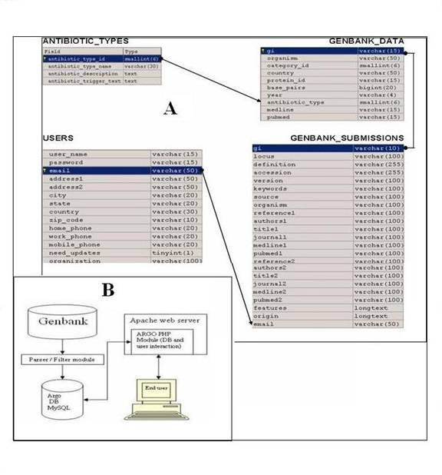
Fig.19 A-B. Architecture of ARGO database: The top part of the figure (A) shows the the structure and characteristics of database tables in ARGO. The bottom part of the figure shows (B) how different components of the database work together.

files were collected by conducting several manual searches of Genbank using TBLASTN. Sequences belonging to cloning vectors, putative antibiotic resistance genes and partial sequences were excluded by the parser routine. Once the PHP routine was able to retrieve correct sequences with high fidelity, it was used to parse Genbank version . 158 and all sequences corresponding to the targeted gene categories were collected and stored in Genbank file format (ASN.1).

3.2.4 PHP Code of Genbank parser routine
The PHP code of the routine used is given below and comments have been embedded in the code for ease of understanding.
<?php
// Encapsulates genbank entry specific parsing routines
class GENBANK_PARSER {
var $totalEntries;
var $annotations;
//Constructor: Initialises "this" object with the location of the annotation file to be parsed
function GENBANK_PARSER($annotationsUrl) {
$this -> annotations = implode("", file(trim($annotationsUrl)));
$this -> totalEntries = substr_count($this-> annotations, "LOCUS ");
}
//Returns a specific annotation from the list of annotations in the annotation file.
function getEntry($entryNumber) {
$matches = preg_split("/\/\/\r\n/mis", $this -> annotations);
// Each annotation ends with a "//"
return $matches[$entryNumber];
}
}
class GENBANK_ENTRY {
/* The following are the properties of a GENBANK_ENTRY. The names are self-descriptive */
var $gi;
var $country;
var $organism;
var $category;
var $year;
var $base_pairs;
var $protein_id;
var $medline;
var $pubmed;
/* Constructor: Parses a particular annotation, gathers details and populates the above variables. */
function GENBANK_ENTRY(&$annotation, &$gene_category) {
$matches = array();
//Get GI. Continue only if GI is found. Otherwise, everything is null.
$this -> gi = $this -> getGI($annotation);
if ($this -> gi != null) {
/*The following statements extracts specific info from the required annotation and stores them in variables. */
$this -> year = $this -> getYear($annotation);
$this -> category = $gene_category;
$this -> base_pairs = (int)($this ->
getBasePairs($annotation));
$this -> country = $this -> getCountry($annotation);
$this -> protein_id = $this -> getProteinID($annotation);
$this -> organism = $this -> getOrganism($annotation);
$this -> medline = $this -> getMedline($annotation);
$this -> pubmed = $this -> getPubmed($annotation);
}
else {
$this -> gi = $this -> location = $this -> organism = $this -> category = null;
echo("<br><i>Parser garbled</i>");
}
}
function getGI(&$annotation) {
// Get GI of the annotation and return it
if (preg_match("/GI:[0-9]*\r\n/ms", $annotation, $matches)) {
return (trim(substr($matches[0], 3)));
}
else {
return (null);
}
}
function getYear(&$annotation) {
// Get year of pubication of the annotation and store it
$matches = array();
preg_match("/LOCUS.*DEFINITION/mis", $annotation,
$matches);
preg_match("/[0-9]{4}\r\nDEFINITION/mis", $matches[0],
$matches);
return (trim(substr($matches[0], 0, 4)));
}
function getOrganism(&$annotation) {
// Get the organism to which the gene belongs to
$matches = array();
preg_match("/ORGANISM.*REFERENCE\040*1/ms",
$annotation, $matches);
preg_match("/ORGANISM.*\r\n.*Bacteria/ms", $matches[0],
$matches);
if (sizeof($matches) == 0) {
//means this is probably a cloning vector or a plasmid
echo ("<br><i>Cloning vector encountered</i>");
/* if a cloning vector is encountered, then it means this annotation is to be rejected by the ARGO database. Therefore, set all properties of the annotation to null */
$this -> year = null;
$this -> country = null;
$this -> protein_id = null;
$this -> location = null;
$this -> organism = null;
$this -> category = null;
$this -> base_pairs = null;
return null;
}
else {
preg_match("/ORGANISM.*\r\n/ms", $matches[0],
$matches);
return (trim(substr($matches[0], 8)));
}
}
function getCategory(&$annotation) {
return (trim($this -> category));
}
function getBasePairs(&$annotation) {
// Get number of base pairs of the DNA sequence of the gene
$matches = array();
preg_match("/[0-9]*\040bp/mis", $annotation, $matches);
return (trim(preg_replace("/\040bp/mis", "", $matches[0])));
}
function getCountry(&$annotation) {
// Get the country of the sample (or the lab) from which the gene was obtained
$matches = array();
preg_match("/JOURNAL.*,(.*)\r\nFEATURES/mis", $annotation,
$matches);
if (empty($matches)) {
return (null);
}
else {
if (strlen($matches[1]) > 30) {
/* this occurs when the "journal" entry does not contain country or if "journal" entry is not immediately followed by "features" entry. */
$matches = array();
preg_match("/country=\"(.*)\"/mis", $annotation,
$matches);
if (empty($matches)) {
return (null);
}
else {
//occurs when country field is present in the "features" section
$matches = preg_split("/\r\n/mis", $matches[1]);
return (trim(preg_replace("/\"/","",$matches[0])));
}
}
else {
/* occurs when a "journal" entry has country name mentioned at the end after a comma and immediately followed by "features" entry */
return (trim($matches[1]));
}
}
}
function getProteinID(&$annotation) {
/* Protein ID is the identifier used by NCBI for uniquely identifying the protein sequence produced by this gene. */
$matches = array();
preg_match("/protein_id=\"(.*)\"/mis", $annotation, $matches);
if (empty($matches)) {
return (null);
}
else{
$matches = preg_split("/\r\n/mis", $matches[1]);
return (trim(preg_replace("/\"/","",$matches[0])));
}
}
function getMedline(&$annotation) {
// Get the unique identifier for the corresponding MEDLINE entry in NCBI
$matches = array();
if (preg_match("/MEDLINE *[0-9]*\r\n/ms", $annotation,
$matches)) {
return (trim(substr($matches[0], 8)));
}
else {
return (null);
}
}
function getPubmed(&$annotation) {
// Get the unique identifier for the corresponding PUBMED entry in NCBI
$matches = array();
if (preg_match("/PUBMED *[0-9]*\r\n/ms", $annotation, $matches)) {
return (trim(substr($matches[0], 7)));
}
else {
return (null);
}
}
} ?>

3. 2.5 Populating ARGO tables
After retrieving and storing the sequence files on the local server, ARGO tables were populated using a second PHP routine, which scans the saved sequence files for required gene information. PHP routine written for this purpose was directed to insert the sequence information into corresponding tables in ARGO, and duplicate entries or missing information is written into a reject file. Such reject files were checked manually and required changes were carried out by using SQL commands directly on mySQL database. The code of the PHP routine used to populate ARGO tables is given below (comments are inserted in appropriate places).
// PARSER ROUTINE
include "GENBANK_PARSER.php";
/* has the class that encapsulates the routines needed for parsing a genbank annotation file */
$gp = new GENBANK_PARSER(trim($_REQUEST["content_path"]));
// Initialise the parser object by passsing the annotation file URL to the constructor
$rejectedGIs = "";
/* Variable to store rejected GIs. Some annotations with missing info and annotations for cloning vectors are rejected by the parser and stored in this variable for reporting/debugging purposes */
$sqlInsertStatements = "";
/* This variable stores sql statements required to populate the ARGO database with information gathered by the parser */
/* The following array defines all gene categories supported by ARGO so far. The following hard-coded elements would be obatained from the database in the future */
$getCategoryNumber = array();
$getCategoryNumber["SHV"] = (int)1;
$getCategoryNumber["TEM"] = (int)2;
$getCategoryNumber["BIL"] = (int)3;
$getCategoryNumber["BLAP"] = (int)4;
$getCategoryNumber["CARB"] = (int)5;
$getCategoryNumber["CMY"] = (int)6;
$getCategoryNumber["CTX"] = (int)7;
$getCategoryNumber["FEC"] = (int)8;
$getCategoryNumber["GES"] = (int)9;
$getCategoryNumber["KLUA"] = (int)10;
$getCategoryNumber["KLUG"] = (int)11;
$getCategoryNumber["LAT"] = (int)12;
$getCategoryNumber["MIR"] = (int)13;
$getCategoryNumber["NPS"] = (int)14;
$getCategoryNumber["PSE"] = (int)15;
$getCategoryNumber["ROB"] = (int)16;
$getCategoryNumber["UOE"] = (int)17;
$getCategoryNumber["VIM"] = (int)18;
$getCategoryNumber["LCR"] = (int)19;
$getCategoryNumber["ACC"] = (int)20;
$getCategoryNumber["DHA"] = (int)21;
$getCategoryNumber["CFXA"] = (int)22;
$getCategoryNumber["CFIA"] = (int)23;
$getCategoryNumber["VEB"] = (int)24;
$getCategoryNumber["IMP"] = (int)25;
$getCategoryNumber["TOHO"] = (int)26;
$getCategoryNumber["LEN"] = (int)27;
$getCategoryNumber["BPS"] = (int)28;
$getCategoryNumber["ACT"] = (int)29;
$getCategoryNumber["FOX"] = (int)30;
$getCategoryNumber["SME"] = (int)31;
$getCategoryNumber["GIM"] = (int)32;
$getCategoryNumber["MOX"] = (int)33;
$getCategoryNumber["PER"] = (int)34;
$getCategoryNumber["NMC"] = (int)35;
$getCategoryNumber["CME"] = (int)36;
$getCategoryNumber["ASBA1"] = (int)37;
$getCategoryNumber["SFO"] = (int)38;
$getCategoryNumber["BLAMOR"] = (int)39;
$getCategoryNumber["CBIA"] = (int)40;
$getCategoryNumber["IMI"] = (int)41;
$getCategoryNumber["A1"] = (int)42;
$getCategoryNumber["AER"] = (int)43;
$getCategoryNumber["IBC"] = (int)44;
$getCategoryNumber["TLA"] = (int)45;
$getCategoryNumber["BES"] = (int)46;
$getCategoryNumber["CCRA"] = (int)47;
$getCategoryNumber["IRT"] = (int)48;
$getCategoryNumber["OHIO"] = (int)49;
$getCategoryNumber["VAN"] = (int)50;
$getCategoryNumber["TET"] = (int)51;
$getCategoryNumber["OTR"] = (int)52;
/* The following array defines all antibiotic types supported by ARGO so far. The following hard-coded elements would be obatained from the database in the future */
$getAntibioticCategoryNumber = array();
$getAntibioticCategoryNumber["beta-lactamase"] = (int)1;
$getAntibioticCategoryNumber["vancomycin"] = (int)2;
$getAntibioticCategoryNumber["tetracycline"] = (int)3;
// Initialise input/ouput/rejected GI file variables
if (strtoupper($_REQUEST["append_output"] == "YES"))
{
$sql_output_file = fopen($_REQUEST["sql_output_file"], 'a') or die ("<hr<h4><i>Unable to open " . $_REQUEST["sql_output_file"] . " for appending</i></h4>");
}
else
{
$sql_output_file = fopen($_REQUEST["sql_output_file"], 'w') or die ("<hr<h4><i>Unable to open " . $_REQUEST["sql_output_file"] . " for writing</i></h4>");
}
if (strtoupper($_REQUEST["append_output"] == "YES"))
{
$rejection_file = fopen($_REQUEST["rejection_file"], 'a') or die ("<hr<h4><i>Unable to open " . $_REQUEST["rejection_file"] . " for appending</i></h4>");
}
else
{
$rejection_file = fopen($_REQUEST["rejection_file"], 'w') or die ("<hr<h4><i>Unable to open " . $_REQUEST["rejection_file"] . " for writing</i></h4>");
}
echo("Total entries: " . $gp -> totalEntries . "<hr>");
/* totalEntries has the number of annotations in the annotation file. Use this info to loop thru all annotations in the file and gather data from all annotations in the annotation file */
for ($i = 0; $i < ($gp -> totalEntries); $i ++)
{
echo("<hr><u>Entry: " . $i . "</u>");
/* use the GENBANK_ENTRY object to gather details from the current annotation in the file and fill up $ge with reqd info from the annotation */
$ge = new GENBANK_ENTRY($gp -> getEntry($i), $_REQUEST["gene_category"]);
// Display parser progress information of the current annotation in the file
echo("<br>GI: " . $ge -> gi);
echo("<br>Year: " . $ge -> year);
echo("<br>Base pairs: " . $ge -> base_pairs);
echo("<br>Organism: " . $ge -> organism);
echo("<br>Category: " . $ge -> category);
echo("<br>Source location: " . $ge -> country);
echo("<br>Protein ID: " . $ge -> protein_id);
echo("<br>Medline: " . $ge -> medline);
echo("<br>Pubmed: " . $ge -> pubmed);
/* If base pairs is too high or if cloning vectoe is encountered, then mark current annotation as "rejected" */
if (($ge -> organism == null) || ($ge -> base_pairs > 999999)) {
$rejectedGIs .= $ge -> gi . " | " . $ge -> category . "\r\n";
echo ("rejected!");
}
else {
/* Add info from current annotation, make an sql statement and store it into the variable that contains all sql statements */
$sqlInsertStatements .= "INSERT INTO genbank_data (gi, organism, category_id, country, protein_id, base_pairs, year, antibiotic_type, medline, pubmed) VALUES ('" . $ge->gi. "', '" . $ge->organism. "', " . $getCategoryNumber[trim($_REQUEST["gene_category"])] . ", '" . $ge->country . "', '" . $ge->protein_id . "', " . $ge->base_pairs . ", '" . $ge->year . "', " . $getAntibioticCategoryNumber[trim($_REQUEST["antibiotic_type"])] . ", '" . trim($ge->medline) . "','" . trim($ge->pubmed) . "');\r\n";
}
}
// save all info (sql statements, rejected GIs) from the above loop into files on the disk
fwrite($sql_output_file, $sqlInsertStatements);
fwrite($rejection_file, $rejectedGIs);
fclose($sql_output_file);
fclose($rejection_file);
// parser has now finished performing all tasks.
echo("<hr><b><i>All done: Output file written to disk</i></b>");
3.2.6 Establishment of Internet based server
To make the database available for online searches, a separate domain (http://www.argodb.org/) was registered and the database was transferred by SSH to the space allotted by Internet service provider (ISP). The online system is on a mySQL server supported by Apache and PHP 4.0 and complies with open source general public license policy requirements.
3.2.7 Analysis of Sequence data in ARGO
The sequence information in ARGO was analyzed to discern the trend of antibiotic resistance gene prevalence and geographical clustering. The year of origin of the sequence file and the country from which the sequence was reported was traced by PHP based searches in ARGO database. For assessing the evolutionary trend and sequence similarity of the antibiotic resistance genes, TEM-1 was chosen as a model and 23 TEM-1 variants (Table-9) reported from 1991 to 2005 was analyzed for their Phylogenetic relationships. All the sequences were aligned using ClustalX and the protein sequence identity matrix was generated using Bioedit using PAM250 matrix as reference. The phylogenetic relations were calculated using Fitch-Margolish method version 3 as implemented in Phylip package.

3.3 Results and Discussion
3.3.1 Construction of the database
A number of multinational surveillance projects have been carried out to monitor evolving patterns of antibiotic resistance and the evolution of multidrug-resistant organisms (Marano et al. 2000, Torrens 2001, Barger et al. 2002). These surveillance studies have primarily analyzed the Minimum Inhibitory Concentrations (MICs) at which 90% of isolates tested are inhibited (MIC₉₀s), frequency distributions, and percent susceptibility of the drug resistant strains (Poupard et al. 2002). As the global spread of antimicrobial resistance is also mediated through mobile genetic elements like plasmids, transposons and integrons, it is important to study their global distribution (Scaria et al. 2005). Although the sequence information on antibiotic resistance genes is freely available in public databases like Genbank, DDBJ and EMBL, they contain huge amount of sequence

Table.9: Details of TEM-1 gene variants used for phylogenetic analysis
S.No | Genbank GI Number | Host Organism
1 | 1045659 | Klebsiella pneumoniae
2 | 12044260 | Klebsiella pneumoniae
3 | 13272528 | Escherichia coli
4 | 16902303 | Serratia marcescens
5 | 21998668 | Pseudomonas aeruginosa
6 | 21998670 | Pseudomonas aeruginosa
7 | 30230644 | Acinetobacter baumannii
8 | 31096324 | Klebsiella pneumoniae
9 | 33303462 | Zymomonas mobilis
10 | 34014594 | Serratia marcescens
11 | 34495353 | Enterobacter cloacae
12 | 37576798 | Streptococcus pneumoniae
13 | 38606069 | Escherichia coli
14 | 41056932 | Escherichia coli
15 | 44194076 | Serratia marcescens
16 | 44194078 | Serratia marcescens
17 | 44194080 | Serratia marcescens
18 | 44194082 | Serratia marcescens
19 | 44194084 | Serratia marcescens
20 | 45558548 | Acinetobacter baumannii
21 | 52699669 | Proteus mirabilis
22 | 55666552 | Escherichia coli
23 | 58257619 | Shigella flexneri

data of several hundreds of whole genomes and many thousands genes from various organisms. Antibiotic resistance gene sequences form only a minor fraction in these huge data warehouses. Intensive studies on antibiotic resistance genes and their speciation could be better supported with a small specialized database that is developed for these genes alone. A PHP module was used to parse and retrieve all the genes responsible for conferring resistance to tetracyclines, vancomycin and β-lactam antibiotics. The parser module retrieved 560 Genbank flat files for β-lactams, 115 files for vancomycin and 68 files for tetracyclines. These sequence files were incorporated to into the relational database tables designed with a mySQL database system and was transferred to the online domain space at http://www.argodb.org. All platforms used for the database development and support complied with open source software foundation requirements. The web domain (http://www.argodb.org) is supported by an Apache web server and dynamic web interface is supported by PHP 4.0. Fig. 20 shows a screen capture of the database homepage. The database can be searched for the geographical location of the genes, host organism, year of reporting, and the type of gene. Three gene categories namely β-lactamase, tetracycline and vancomycin are implemented in ARGO. Each gene category has several sub types of genes which are denoted by a three letter symbol. The gene sequences are clustered based on the three-letter designation (Eg.TEM-1) of the sequence in the Genbank flat file. There are 44 clusters for β-lactamases, one cluster for vancomycin and two clusters for tetracyclines. Database searches based on keywords are sometimes not user-friendly because such searches assumes that users have some prior knowledge of the particular information and when key words that are not highly relevant are entered in the search fields, no relevant data is returned. To avoid such problems ARGO search has been simplified by prompting users to select relevant key word fields that are provided. The complete database records can be retrieved at once by selecting all fields or one can select a particular category alone. Further the records can be displayed in a tabular format or as a list. Also for each record returned, the complete sequence and literature information can be retrieved through the hyperlinks provided. Optionally for each search, ARGO calculates the relative geographical and year wise distribution pattern of the genes and display a bar diagram representing the same. The graphical output of an ARGO search for all β-lactamase genes is shown in Fig. 21.



Fig.20: Screen capture of ARGO homepage (http://www.argodb.org).

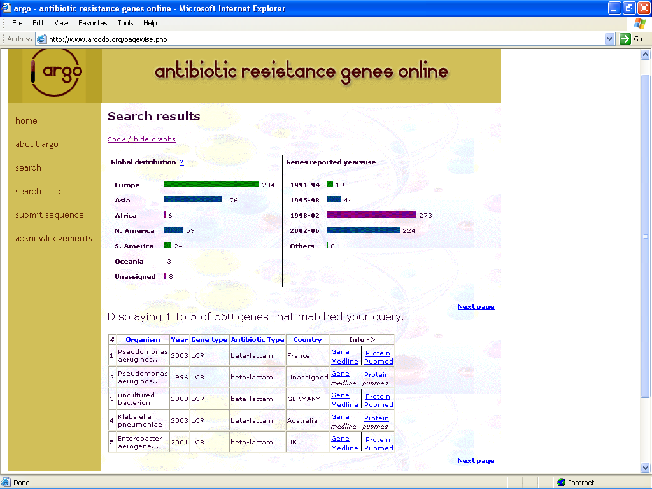

Fig.21: Search page of ARGO: showing the results of a search for β-lactam category of genes(http://www.argodb.org/serach.php/).

3.3.2 Sequence analysis of ARGO data
Clonal expansion and spread of antibiotic resistance genes through transposons, plasmids and integrons is a key factor in the rise of drug resistant bacteria. Hence for surveying the resistance problem, focus should be on two components of the drug resistance phenomenon: the antibiotic agent and the resistance gene (Levy, 2001). Analysis of sequence data in ARGO reveals that there has been a steady increase in the number of unique resistance sequences being reported. Resistance originates as a local phenomenon but can expand to global proportions. When the sequence files in ARGO was analyzed with respect to the time it was submitted to the sequence database, the trend showed a progressive increase in the number of genes submitted every year. It was found that of all the β-lactamase sequences submitted from 1991–2004, 3.39% was reported up to 1994, 7.8% was reported between 1995-98, 48.75% was submitted between 1999-2003 and 40% was submitted between 2002-2004. With respect to vancomycin resistance sequences submitted, 6% was submitted between 1991-94, 14.78% was reported during 1995-98, 57.39 % was submitted during 1999-2002 and 21.23% was submitted during 2002-2004. When tetracycline sequences were analyzed a different trend was observed. Of all the sequences submitted for tetracycline, 87.93 % was submitted between 2002-2004 and the rest accounted for all submissions prior to 2002 . The progressive increase in the number of antibiotic resistance gene sequences in the last decade could be result of increase in the awareness of enormity of the antibiotic resistance problem which in turn fuels more active research in this field. This obviously would elevate the frequency of antibiotic resistance gene sequencing and sequence submission. Successful control of antibiotic resistance must consider every potential source of resistance. Though commensal (normal) bacteria have long been believed to be important reservoirs for antibiotic resistance genes, little information is available about their carriage of such genes (APUA, 2004). ARGO is an organized effort to assemble and make available information on the genotypes and the host bacteria that harbor resistance genes. The frequency of resistance genes in commensal organisms may act as a marker or predictor of the emergence of resistance in pathogenic bacteria, and collection of data on resistance gene frequencies in commensal and pathogenic organisms is necessary for the analysis of the relationship between these frequencies (ROAR, 2004).

Results of Phylogenetic analysis conducted on TEM-1 sequences in ARGO is in concurrence with the clonal expansion theory. 23 TEM-1 sequences reported from 1991 to 2004 were selected and was the evolutionary lineage analyzed using Phylip software package. It was found that one TEM-1 sequence (GI. 21998670) reported in 1991 from France has undergone clonal expansion and has spread to several continents. Variants of this TEM-1 sequence with high similarity in sequence identity was found in China, USA, Canada, Japan, Taiwan and South Africa. An examination of the sequence identity of these variants showed that many of them have 100% similarity (Table. 10) . The closest neighbor of the parental sequence (GI. 31096324) was reported from China. One group of sequences (GI numbers 44194076, 44194078, 44194082, 45558548, 38606069 52699669, 41056932) showing close clustering was found to be from several countries (USA, China, Canada, Japan and Taiwan) (Fig.22). These sequences were found to be reported in a very short span of one year (2004-2005). Such phylogenetic analysis of antibiotic resistance genes can reveal the mutation pattern of antibiotic resistance genes (Scaria et al.2005). By predicting the trend of antibiotic resistance genes, novel antibiotics could be developed before bacterial community develops resistance to the targets (Barlow and Hall 2003). Such in silico analysis will be much cheaper than the in vitro techniques for the experimental prediction of antibiotic resistance genes like that of described by Orencial et al.(2003). The sequence information in ARGO also could be handy aid for the design of correct primers for PCR based detection of antibiotic resistance genes and the design of DNA microarrays for the detection of drug resistant bacteria.

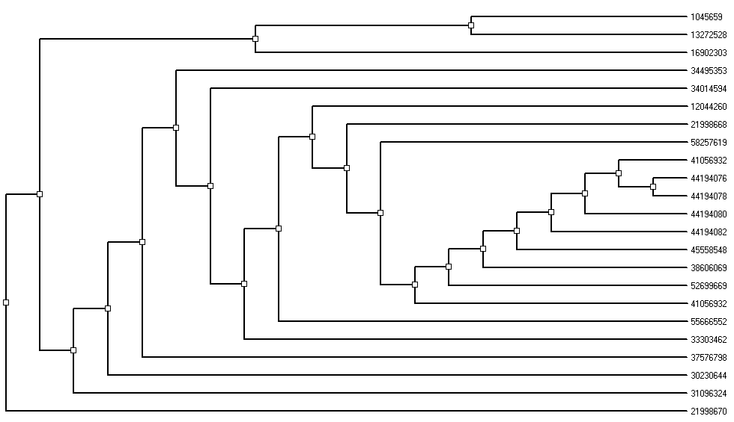

Fig.22: Phylogeny tree of TEM-1 sequences from ARGO. 23 TEM-1 protein sequences reported from 1991 to 2005 was selected from ARGO and was aligned by ClustalX and the phylogeny tree was developed using neighbor joining method as implemented in Phylip package. GI numbers of each sequence is given at the end of each branch.

Chapter 4
DEVELOPMENT OF WHOLE CELL BIOSENSOR FOR THE DETECTION OF TETRACYCLINES

4.1 Introduction
The tetracyclines, which were discovered in the 1940s, are a family of antibiotics that inhibit protein synthesis by preventing the attachment of aminoacyl-tRNA to the ribosomal acceptor (A) site (Schnappinger and Hillen 1996). Tetracyclines are broad-spectrum agents, exhibiting activity against a wide range of gram-positive and gram-negative bacteria, atypical organisms such as chlamydiae, mycoplasmas, and rickettsiae, and protozoan parasites (Chopra and Roberts 2001). The favorable antimicrobial properties of tetracyclines and the absence of major adverse side effects has led to their extensive use in the therapy of human and animal infections. In some countries, including the United States, tetracyclines are added at subtherapeutic levels to animal feeds to act as growth promoters. For humans, tetracyclines have been prescribed for prophylaxis and treatment of community-acquired infections, especially respiratory infections. They have been the drugs of choice for treatment of pneumonia due to Mycoplasma pneumoniae, Chlamydia pneumoniae, and Chlamydia psittaci. However, macrolides and newer quinolones are now often preferred for treatment of infections due to Mycoplasma and Chlamydia species. Use has expanded in the past decade with the discovery that tetracyclines are effective for prophylaxis and treatment of malaria due to Plasmodium falciparum, including that due to mefloquine-resistant P. falciparum. In addition, tetracyclines have been used to treat infections with Entamoeba histolytica, Giardia lamblia, Leishmania major, Trichomonas vaginalis, and Toxoplasma gondii (Chopra and Roberts 2001). More recently, tetracycline is also being used in the treatment of filarial nematodeinfected animals (Smith and Rajan 2000). Tetracyclines have a number of nonantibacterial effects, including anti-inflammation, immunosuppression, inhibition of lipase and collagenase activity, enhancement of gingival fibroblast cell attachment, and wound healing (Chaidemenos 2001, Yanagimura et al. 1989, Ramamurthy et al. 2002). Tetracycline derivatives lacking antibacterial effects have been in development in the hope of exploiting these other properties (Ramamurthy et al. 2002). These properties also make tetracyclines attractive for use in a variety of noninfectious conditions, such as acne and rosacea (Chaidemenos 2001). Tetracyclines are also used in aquaculture to control infections in salmon, catfish, and lobsters (DePaola et al. 1988, Levy 1992). In addition to use in humans and animals, tetracyclines have also been used in agriculture (McManus et al. 2002), which is an area often overlooked when use is examined. Tetracyclines are sprayed onto fruit trees and other plants to treat infection by Erwinia amylovara, injected into palm trees to treat mycoplasma infections (lethal yellow), and used to control infection of seeds by Xanthomonas campestis (black rot) (Levy 1992). They also have applications in the treatment of insects of commercial value; e.g., oxytetracycline is used to treat foulbrood disease of the honeybee, which is caused by either Bacillus larvae or Streptococcus pluton (Levy 1992).
The first tetracycline-resistant bacterium, Shigella dysenteriae, was isolated in 1953, and the first multidrug-resistant Shigella pathogen was isolated in 1955 (Falkow,1975) and was resistant to tetracycline, streptomycin, and chloramphenicol (Akiba et al. 1960, Falkow,1975). Although bacterial resistance to tetracyclines has emerged in plant and fish pathogens as a consequence of using these antibiotics to control disease (Levy, 1984), it is the development of resistance in the context of human and animal use that has raised the greatest levels of concern. The reported rates of bacterial resistance to tetracyclines have varied widely on the basis of geographical locale and year of isolation (Kucers and Bennett 1987). However, by the mid-1970s resistance to tetracycline was common among the Enterobacteriaceae, Staphylococci, Streptococci, and bacteroides (Levy 1984). In some locations resistance rates have been very high. For instance, in a Boston Hospital in the year 1969, 38% of S. aureus, 61% of E. coli, 62% of Klebsiella spp., 58% of Enterobacter spp., 91% of Proteus spp., and 97% of Serratia spp. were found to be resistant to tetracyclines (Sabath 1969). Comparable, high rates of resistance were also recorded in Bacteroides fragilis and H. influenzae in the early 1980s, both in the United States and in Europe (Kucers and Bennett 1987). The emergence of resistance to the tetracyclines in human clinical isolates has severely limited the further utility of these drugs and has undoubtedly been an important factor in the declining use of these antibiotics, in most countries, for the therapy of human infections (Chopra et al 1992, Finch 1997, Kucers and Bennett 1987). With few exceptions, tetracycline-resistant pathogens owe their resistance to the acquisition of tetracycline resistance genes (Chopra and Roberts 2001). The first tetracycline resistance R-factors were identified over 40 years ago in Japan (Watanabe 1963). Since then, tetracycline resistance genes have spread in both gram-negative and gram-positive genera, primarily by conjugal transfer of plasmids and/or transposons. Currently, 33 different tetracycline resistance genes (tet genes) have been characterized, in addition to 3 oxytetracycline resistance genes (otr genes) found in the tetracycline-producing Streptomyces and Mycobacterium species. Twenty-three of these genes code for efflux pumps and belong to the major facilitator superfamily (Bolhuis et al. 1997, Paulsen et al. 1996). All of these tet efflux genes code for energy-dependent, membrane-associated proteins, which export tetracycline out of the cell. This reduces the intracellular concentration of tetracycline and protects most of the ribosomes from the action of tetracycline. Twenty-one of the efflux genes are found exclusively in gram-negative bacteria, whereas 2tet(K) and tet(L)are found primarily in gram-positive isolates, although a few gram-negative isolates with either tet(K) or tet(L) have been described (Chung et al. 1999). All of these genes confer resistance to tetracycline and doxycycline. However, the tet(B) gene confers resistance to tetracycline, doxycycline, and minocycline but not to glycylcyclines. The tet(B) gene has the widest host range among gram-negative pathogens (Testa et al. 1993). Ten genes code for ribosomal protection proteins, producing a protein that protects the ribosomes from the action of tetracycline both in vivo and in vitro. These genes confer resistance to tetracycline, doxycycline, and minocycline. The major genes in this category is tet(O) and tet(M) and are found in gram-positive bacteria, anaerobes, and nonenteric gram-negative bacteria, such as N. gonorrhoeae and Haemophilus ducreyi. The tet(M) gene is the most widely dispersed tet gene in gram-positive pathogens and high-level tetracycline-resistant N. gonorrhoeae. These genes are linked to other antibiotic resistance genes, such as erm genes, which code for resistance to macrolides, lincosamides, and streptogramin B (Chung et al. 1999).

Tetracyclines are one of the cheapest classes of antibiotics available today, making them attractive for use in developing countries with limited health care budgets. As the frequency of tetracycline resistant pathogens are very high, medical use of tetracyclines have diminished considerably, but they are still heavily used in veterinary and agricultural purposes. The total quantity of tetracyclines used per year in the world is difficult to determine in any sector; however, attempts have been made (Col and O'Connor 1987), although the numbers do not always agree between reports. The global consumption of tetracycline per year is not known. One can hypothesize that tetracyclines will be used increasingly against various parasitic diseases and perhaps other bacterial diseases in the future (Chopra and Roberts 2001). The prophylactic and subtherapeutic level usage of tetracyclines for veterinary purposes is a matter of great concern. This type of low-level, long-term use puts significant selective pressure on the bacteria carried by the host and in the environment of the host being treated. EPA (2004) reports indicate that of the total quantity of tetracyclines used, up to 90% may reach environmental waters through excretions that does not undergo metabolism. Recent studies indicate that several antibiotics are present in surface water in low concentrations (Hartman et al. 1998). EPA studies shows that tetracyclines are amongst 40 compounds that could be present in surface waters above the level of 1000ng/L. It has also been reported that tetracyclines were not eliminated during the storage of the manure over a period of 120 days (Kummerer et al. 2001). If nothing is done, the usefulness of tetracycline as an antibacterial agent will soon be limited as bacterial resistance increases. We also require a better understanding of the ecology of resistance to all antibiotics, including tetracyclines, that could lead to the design of new intervention strategies and hence need to better understand the fate of tetracyclines in the environment. Several studies have shown that reduction in the amount of antibiotics used results in significant drop in the prevalence of resistant bacteria (Chopra and Roberts. 2001, Levy, 2002, FDA, 2004). The use of tetracyclines as growth promotant for diseases like mastitis has also resulted in the presence of residual tetracyclines in biological samples like milk. This scenario calls for continuous monitoring of water samples and biological samples like milk for the presence of residual tetracyclines and will require highly sensitive, easy to use continuous detection systems. Several methods like HPLC and immunodetection are available for the detection of antibiotics in various samples (Kumar et al. 2004). However these methods are expensive and require highly trained personnel for testing. FDA approved and widely used microbial inhibition tests like Bacillus Stearothermophilus Disc Assay (BSDA) for detecting antibiotic residues in milk, is not specific for antibiotics like tetracyclines. With the advances in genetic engineering, use of recombinant whole cell bacterial biosensors for the detection of antibiotics have been indicated (Bahl et al. 2004, Hansen and Sorensen 2000, Hansen et al, 2001). Considering this lacuna, an EGFP based E. coli strain for the detection of tetracyclines in water and biological samples like milk was developed and evaluated. For developing the biosensor strain, the transposon mediated tetracycline regulatory elements from plasmid pOT182 was utilized. This plasmid was selected based on searches conducted in the online database ARGO.

4.2 Materials and methods
4.2.1. Host strain, plasmids and reagents.
E. coli JM109 was used as the host for recombinant DNA protocols and biosensor assays. Axenic culture of E. coliJM109 was grown either in Luria Bertani (LB) broth or LB agar purchased from Himedia Labs, Mumbai. Plasmid pEGFP was used as cloning vector. Tn5 transposon containing plasmid pOT182 used as the template for PCR was selected based on searches in online database ARGO and was obtained from National Institute of Genetics, Mishima Japan. All the enzymes, chemicals and media were obtained from sources described in section. 2.2.2

4.2. 2 Fluorescence Microscopy and Fluorescence Assay
Fluorescence emission from biosensor cells were assessed both by epifluorescence microscopy using Olympus CXKX41 epifluorescence microscope and Wallac Victor^{3TM} multilabel counter using identical protocols described in sections 2.2.4 and 2.2.5

4.2.3. Construction of Biosensor Strain
4.2.3.1 PCR amplification of the target
Purification of plasmid DNA, agarose gel electrophoresis and DNA purifications were carried out as per protocols described in sections 2.2.6.1, 2.2.6.2 and 2.2.6.3. PCR primers were designed using Biology WorkBench Suite of programmes hosted at San Diego Super Computing center (SDSC), University of California, San Diego. The published DNA sequence of plasmid pOT182 (Genbank accession no. U73849, Merriman and Lamont, 1993) were used as the target sequences for primer design. The features of designed primers pJSKV13 and pJSKV14 is given in Table 11. Amplification of tetR, tet promoter, part of tetD was carried out using forward primer JSKV 13 and reverse primer JSKV 14 using plasmid pOT182 as template. The composition of PCR amplification mixture given in Table: 12. After adding all compenets of PCR mixture except the pfu polymerase, the enzyme was added to mixture at the end and contents were mixed by tapping the tube gently and briefly spinning the tubes once in an Eppendorf microfuge. PCR reaction on the above mixture was carried out as per reaction conditions given in Table: 13, using a Perkin Elmer gene amp system.At the end of the reaction, the PCR mix was electrophoresed as described in section 1.2. After determining the size of the DNA band of interest, a single band corresponding to 856bp was excised from the gel under UV transillumination and DNA was retrieved using a QIAquick column as described in section 2.2.6.3.
4.2.3.2. Restriction Endonuclease digestion of DNA
To obtain maximum efficiency of restriction digestion of vector as well as insert DNA, both PCR amplified insert DNA and the target vector for cloning (pEGFP) were serially digested with HindIII and SalI restriction enzymes as per the reaction conditions given in table 8 and table 9 digested with HindIII and the DNA at the end of the reaction was purified using a QIAquick column as described section 3; and this digested purified DNA was further digested with Sal I. The restriction digestion conditions for HindIII and SalI are given in Tables 14 and 15.

Table 11: Properties of primer set used to PCR amplify the tet regulatory elements
Parameter | JSKV13 (forward primer) | JSKV14 (reverse primer)
Sequence | 5’GCGAAGCTTGTTGTCTAC  ATGGCTCTGCTG3’ | 5’GCGTCGACCTCAGAATTAC  GATCAGGGGTAT 3’
Molecular weight | 93001.1 | 9640.3
Tm | 49.6 | 49.8
Filter Tm | 42.0 | 42.2
% GC Tm | 47.7 | 47.7
GC + AT Tm | 92.0 | 94.0
ug/A260 | 34.2 | 31.6
%GC | 53.3 | 51.6

Table 12:Composition of PCR mixture used to amplify the tet regulatory elements
Component | Stock | Volume
Template DNA (pOT182)  Forward primer (JSKV13)  Reverse Primer (JSKV14)  Pfu polymerase  Pfu polymerase buffer  dNTP mix  Autoclaved Millipore water | 100 ng/μl  100 ng/μl  120 ng/μl  10 x  10 mM  - | 1 μl  2 μl  2 μl  2 μl  5 μl  5 μl  33 μl
Total |  | 50 μl

Table: 13: PCR Conditions for amplifying tet regulatory sequence.
Component | Temperature (°C) | Time (minutes) | No. of cycles
Initial melting  Denaturation  Annealing  Extension  Final Extension  End Storage | 94  94  65  72  72  4 | 2  2  1.5  1.3  7  ∝ | 25

Table.14: Composition of reaction mixture used for HindIII digestion of tet and pEGFP DNA
Component | Stock | Volume
Component | Stock | Vector | Insert
pEGFP DNA  Insert DNA  Hind III  Hind III buffer  Autoclaved Millipore water | 100 ng/μl  200 ng/μl  10 U/μl  10x  - | 9 μl  -  0.5 μl  2 μl  8.5 μl | -  4 μl  0.5 μl  2 μl  13.5 μl
Total |  | 20 μl | 20 μl

Table.15: Composition of reaction mixture used for Sal1 digestion of tet and pEGFP DNA
Component | Stock | Volume
Component | Stock | Vector | Insert
pEGFP DNA  Insert DNA  Sal I  Sal I buffer  Autoclaved Millipore water | 80 ng/μl  160 ng/μl  10 U/μl  10x  - | 10 μl  -  0.5 μl  2 μl  8.5 μl | -  6 μl  0.5 μl  2 μl  11.5 μl
Total |  | 20 μl | 20 μl

4.2.3.3 End polishing of vector DNA
For reducing the background in the transformation plates the vector dephosphorylated as per protocol described in section 2.29 and insert DNA was phosphorylated as per protocol described in section 2.2.10. The reaction conditions for the dephosphorylation reaction is given in Table 16.

4.2.3.4 Ligation, transformation and selection of recombinants
Ligation of the restriction enzyme digested, phosphorylated insert DNA and the restriction enzyme digested, dephosphorylated pEGFP vector DNA was carried out with T4 DNA ligase. A 10 μl reaction mixture was set up as per the composition given in Table 17.

4.2.3.5 Screening of the transformants for recombinants
After incubation the resulting colonies were replica plated in duplicates to LB agar plates containing 100µg/ml ampicillin and colonies were picked at random and was cultured in culture tubes having 10ml LB broth and was grown for 12 hours at 37ºC. Two ml of the grown culture was used to isolate plasmids and the plasmid DNA was electrophoresed as described in section 2. Recombinants were selected based on the gel mobility shift and pEGFP DNA without the insert DNA served as the control. Recombinant plasmids showing gel mobility shift were selected and the presence of the insert was confirmed by digestion with HindIII and SalI restriction enzymes. The resultant recombinant plasmid was named as pJSKV41and the resultant strain was named as E. coliJM109 pJSKV41. The overall strategy of the biosensor construction is portrayed in Fig.23.
4.2.4 Optimization of biosensor assay conditions and evaluation of strains performance.
4.2.4.1 Determination of sensitivity range and optimal incubation time
The lower and upper limit of detection range of the E. coliJM109 pJSKV41 (henceforth designated as Tetracycline biosensor) was determined by incubating the Tetracycline biosensor with varying concentrations of tetracycline or oxytetracycline. Tetracycline biosensor cells were grown overnight in 10ml LB broth in a conical flask at 37ºC with 150rpm shaking. 1 ml of this culture was used to inoculate 30 ml LB broth and this was

Table.16: Composition of reaction mixture used for phosphorylating tet insert DNA
Component | Stock concentration | Volume
Insert DNA  T4 ligase buffer  T4 Polynucleotide kinase  Autoclaved Millipore water | 40 ng/μl  10 X  1 U/μl  - | 18 μl  5 μl  1 μl  26 μl
Total |  | 50 μl

Table.17: Composition of ligation mixture used to clone tet regulatory elements
Component | Stock concentration | Volume added
pEGFP vector DNA  Insert DNA  T4 DNA ligase  T4 DNA ligase buffer  Autoclaved Millipore water | 20 ng/μl  40 ng/μl  1 U/μl  10 x  - | 2 μl  1.6 μl  1 μl  1 μl  4.4 μl
Total |  | 10 μl

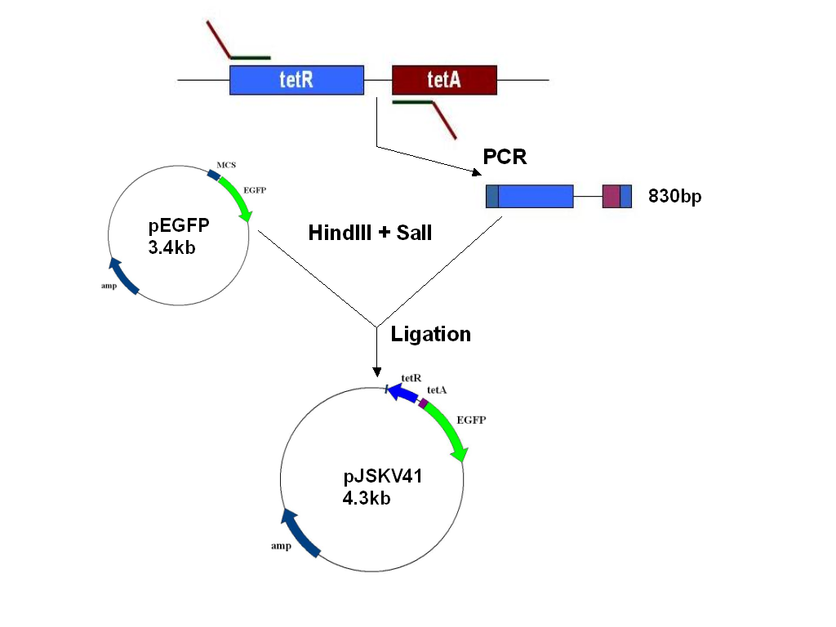
Fig. 23: Cloning strategy followed for the construction of tetracycline biosensor: tetR, tet promoter and part of tetA was amplified using PCR and was cloned into the HindIII and SalI sites of plasmid pEGFP. The resulting recombinant plasmid was named pJSKV41 and was transformed into E. coliJM109 and this strain E. coliJM109 pJSKV41 was used as tetracycline biosensor.

incubated at 37ºC with 200rpm shaking until OD₆₀₀ reached 0.90 (Hence forth referred to as Secondary culture). 2.5ml of this secondary culture was distributed in 50 culture tubes and 2.5 ml of de-ionized water containing varying concentrations of tetracycline (5-70ng/ml) or oxytetracycline (20-150ng/ml) was added. These tubes were then incubated in an Orbital incubator shaker set to 37ºC and 150rpm shaking. At every 2 hours interval, 200µl of samples were withdrawn aseptically, and fluorescence levels were estimated using Multilabel Counter and Fluorescence microscope.

4.2.4.2 Effect of Cell density.
The minimum cell density required for sensitive detection of tetracyclines were determined by measuring varying concentrations of samples using Secondary culture grown to varying OD_{600.} Secondary cells were grown to varying OD₆₀₀ (0.7–1.0) and 2.5 ml of these cells were mixed with 2.5 ml of samples with varying concentrations of tetracycline (10-60ng/ml) or oxytetracycline (25-125ng/ml) and was incubated at 37⁰C for 12 hours with 150rpm shaking. At the end of incubation period, 200µl of sample was withdrawn aseptically and fluorescence levels were measured with a multilabel counter.

4.2.4.3 Effect of temperature
To determine the effect of temperature on the sensitivity of the Tetracycline biosensor, 2.5ml of Secondary cells were mixed with 2.5ml of sample having varying antibiotic concentration (tetracycline 10-60ng/ml or oxytetracycline 25-125ng/ml) and was incubated at varying temperatures (34ºC–40ºC) with 150rpm shaking for 12 hours. At the end of incubation period, 200µl of sample was withdrawn aseptically and fluorescence levels were measured with a multilabel counter.

4.2.4.4 Effect of Photobleaching
Effect of probable light induced photobleaching of EGFP in Tetracycline biosensor was studied by exposing cells to different illumination conditions. 2.5ml of Secondary cells were mixed with 2.5ml of sample having varying antibiotic concentration (tetracycline 10-60ng/ml or oxytetracycline 25-125ng/ml) and was incubated at 37ºC with 150rpm shaking for 12 hours in dark condition. One set of tubes were then exposed to blue light for 10 minutes originating from a 100W mercury lamp fitted with a 480nm filter and another set of tubes were exposed to fluorescent light for 10 minutes. Fluorescence levels of these were compared to that of unexposed cells by withdrawing 200µl of cells aseptically and measuring fluorescence levels with a multilabel counter.

4.2.4.5 Effect of pH
The effect of sample pH on sensitivity of Tetracycline biosensor was determined by exposing the cells to samples with varying pH. 2.5ml of Secondary culture was mixed with 2.5 ml of sample having varying antibiotic concentration (tetracycline 10-60ng/ml or oxytetracycline 25-125ng/ml) . Prior to addition of samples to the cells, pH of the sample was adjusted to the desired range (5.0–9.0) with 0.1N nitric acid or 0.1N sodium hydroxide. The tubes were then incubated at 37ºC with 150rpm shaking for 12 hours and 200µl of cells were withdrawn aseptically and fluorescence levels were measured with a multilabel counter.

4.2.4.6 Effect of Shaking
Effect of culture agitation (shaking) on the sensitivity of Tetracycline biosensor was tested by incubating 2.5ml of Secondary cells with 2.5ml of sample having varying antibiotic concentration (tetracycline 10-60ng/ml or oxytetracycline 25-125ng/ml) for 12 hours at 37ºC and with varying levels of shaking (static to 200rpm). At the end of incubation period, 200µl of sample was withdrawn aseptically and fluorescence levels were measured with a multilabel counter.
4.2.4.7 Effect of co-antibiotics.
Possibility of non-specific induction of EGFP expression by other antibiotics that could be present in the sample was tested by incubating Tetracycline biosensor with equimolar concentration of other antibiotics with Tetracycline or oxytetracycline. To study effect of co-antibiotics, 2.5 ml of Secondary culture and 2.5 ml of samples containing 50ng/ml of tetracycline or oxytetracycline in combination with 50ng/ml of other antibiotics (Ampicillin, Kanamycin, Vancomycin, Streptomycin, Oxacillin and Amoxicillin) were mixed and were incubated at 37⁰C for 12 hours with 150rpm shaking. At the end of incubation period, 200µl of sample was withdrawn asceptically and fluorescence levels were measured with a multilabel counter.

4.2.5 Evaluation of Biosensor performance
4.2.5.1 Estimation of tetracyclines in water and determination of Biosensor stability Single colonies of E. coli JM109 pJSKV41 was picked from Luria Bertani (LB) agar medium containing 100ug/ml of ampicillin and was grown for ten hours in LB broth containing appropriate amount of ampicillin. After inoculating 1% of this original cell suspension into fresh LB medium, the cells were grown at 37 º C with vigorous shaking until OD₆₀₀ reached 0.9. Optimal incubation time required for the biosensor assay was determined by mixing 2.5ml of this cell suspension and 2.5ml of de-ionized water containing 50ng/ml tetracycline in sterile 50 ml test tube and was incubated at 37 º C with 150rpm shaking. Tetracycline induced EGFP in the biosensor cells was estimated at regular intervals by aseptically pipetting out 200ul of this cell suspension into a low background fluorescence microtiter plate and fluorescence was measured with a Wallac 1420 Victor3TM multilabel counter (Wallac Oy, Turku, Finland). For generating a doze response curve, 2.5 ml of de-ionized water with varying concentrations of tetracycline or oxytetracycline and 2.5 ml of biosensor cell suspension were mixed in sterile test tubes and were incubated at 37 º C for 12 hours with 150rpm shaking. After incubation, the fluorescence from the cells was estimated using multilabel counter as described above. For assessing the efficacy of the strain in detecting residual tetracyclines in environmental water samples, the strain was tested against tetracycline spiked pond water samples. To make the water samples free of microbes, collected pond water (pH 7.4) was filtered through a 0.22μm membrane filter and was spiked with varying concentrations of tetracycline (10ng/ml, 30ng/ml and 60ng/ml) and oxytetracycline (25ng/ml, 75ng/ml and 125ng/ml). 2.5ml of these samples and 2.5 ml of biosensor cells grown as described earlier was mixed and incubated at 37 º C for 12 hours and fluorescence levels were determined in similar conditions as mentioned before. For determining the stability and longevity of the biosensor strain for prolonged storage, 50 ml Tetracycline biosensor cells were lyophilized, and the biosensor strain was revived by inoculating 1 mg of the lyophilized cells into 10ml of LB broth and induction assay with known concentrations of tetracyclines were repeated and fluorescence levels were estimated with Multilabel counter.

4.2.5.2 Estimation of tetracyclines in Milk and comparison with BSDA method
The efficacy of biosensor in detecting tetracyclines in biological samples was determined by using this strain to detect residual tetracyclines in milk samples. To obtain tetracycline containing milk samples, a lactating goat producing 1.0 L/Day milk and weighing 30kg was given a single intravenous dose of 40mg/kg tetracycline and milk samples were collected at every 12-hour interval after the injection. After three weeks period the same goat was given a dose of 30mg/kg oxytetracycline and milk samples were collected in the same manner. Another lactating goat of the same size served as the control. Tetracycline containing and control milk samples were centrifuged at 12000rpm for 10 minutes and supernatant was filtered through a 0.22μm membrane filter. 2.5 ml of diluted milk filtrate and 2.5 ml of biosensor cell suspension grown as described previously was mixed in a 50 ml culture tube and was incubated at 37 ⁰ C for 12 hours with 150rpm shaking and fluorescence levels were estimated as mentioned previously. The concentrations of tetracycline or oxytetracycline in the samples were calculated by extrapolating the values against respective standard curves. For comparing the efficacy of biosensor with the widely used BSDA method, the same samples were assayed by BSDA protocol described in section.3.3. Statistical Analysis of the experiments was done as described in section. 1.7.

4.3 Results and Discussion
4. 3.1 Construction of the biosensor strain.
The main factor that decides the specificity and efficiency of a whole cell biosensor is the regulatory sequences that controls the expression of the reporter gene in the recombinant plasmid. The choice of the regulatory sequences for an inducer like arsenic is simple as there are very few arsenic resistant microorganisms reported and resistance determinants characterized. Unlike arsenic, for tetracyclines several resistant bacteria have been known and resistance plasmids have been reported (Roberts, 2003). This diversity of resistance determinants makes the selection of regulatory elements difficult rather than making it simple. One method of identifying regulatory sequences for biosensor construction is to screen tetracycline resistant microbes for tetracycline resistance conferring sequences. However this approach may not be always successful as mutations that alter the permeability of the outer membrane porins and/or lipopolysaccharides in the outer membrane can also affect the bacterial host's resistance to tetracycline. Such instances have been reported for tetracycline-resistant Helicobacter pylori and Mycobacterium avium. Mutations that up-regulate innate efflux pumps can alter the host's susceptibility profile. One example is N. gonorrhoeae, which have a mtrCDE-encoded efflux pump. When there is a 1-bp deletion of an A or double TT insertion within the 13-bp inverted repeat sequence of the mtrR promoter region, the host cell shows a 4-fold increased resistance to tetracycline, penicillin and erythromycin (Zarantonelli et al.1999). Hence screening of microorganisms based on their Minimum Inhibitory Concentration (MIC) profile to tetracycline need not culminate in a strain harboring resistance plasmids.

Even when the tetracycline resistance is due to resistance plasmids, the selection of right sequence is important due to the nature of the resistance elements. Currently, 33 different tetracycline resistance genes (tet genes) have been characterized, in addition to 3 oxytetracycline resistance genes (otr genes) (Roberts, 2003). Ten of these genes code for ribosomal protection proteins, producing a protein that protects the ribosomes from the action of tetracycline both in vivo and in vitro. These genes confer resistance to tetracycline, doxycycline, and minocycline and code for a 72.5-KDa cytoplasmic protein, which has GTPase activity. Spahn et al.(2001) recently explained the mechanism of ribosomal protection proteins like the Tet(O) protein. The Tet(O) protein binds GTP to create a Tet(O)-GTP complex, which then binds to and chases the tetracycline off the ribosome, after which the GTP is cleaved from Tet(O), creating Tet(O)-GDP, which unbinds the ribosome. Then the ribosome can then return to its normal post-translocational conformational state. The ribosomal protection proteins are found in gram-positive bacteria, anaerobes, and nonenteric gram-negative bacteria, such as N. gonorrhoeae and Haemophilus ducreyi. Since these sequences does not have a tetracycline regulated promoter/regulator sequence in the resistance operon, these category of resistance sequences cannot be utilized for biosensor construction purpose.
However, twenty-three categories of genes code for efflux pumps and belonging to the major facilitator superfamily (MFS), whose products include over 300 individual proteins (Bolhuis et al. 1997, Paulsen et al. 1996). All the tet efflux genes code for membrane-associated proteins which export tetracycline from the cell. Export of tetracycline reduces the intracellular drug concentration and thus protects the ribosomes within the cell. Efflux genes are found in both gram-positive and gram-negative species. Most of these efflux proteins confer resistance to tetracycline but not to minocycline or glycylcyclines. In contrast, the gram-negative tet(B) gene codes for an efflux protein which confers resistance to both tetracycline and minocycline but not glycylcyclines (Chopra et al. 1992, Taylor et al. 1998). These category of genes are regulated by the tetR gene located upstream of the efflux genes having the convergent promoters in between them and could be used for biosensor development. Based on searches in the online database ARGO, for the construction of tetracycline regulated biosensor strain, we have used the tetracycline regulatory elements in plasmid pOT182 ( Merriman and Lamont, 1993). Tet operon in plasmid pOT182 consists of tetR (which codes for tetracycline regulatory protein) tetA (which coded for tetracycline efflux pump) and a set of overlapping promoters that controls the expression of these two genes and is located in between these two genes (Merriman and Lamont, 1993). In the absence of tetracycline, TetR binds to the promoter region and block the expression of both tetR and tetA. When tetracycline enters the cell, it binds to TetR and releases it from the promoter region and both tetA and tetR are expressed. The TetA protein act as an efflux pump, actively removing tetracycline from the cell, thereby protecting it from the inhibitory action of tetracycline. For the development of the biosensor strain, 856 bp region of this operon, containing tetR gene, tet promoter and part of tetA was amplified using PCR. The PCR reaction products when checked by agarose electrophoresis and gel documentation showed a single band corresponding to 856 bp (Fig.24). This band was retrieved and purified using a Qiagen gel purification kit and was digested with HindIII and SalI restriction enzymes cloned into plasmid pEGFP digested with same set of enzymes. The recombinants were selected by randomly picking colonies from transformation plates containing 100μg/ml ampicillin and 50ng/ml tetracycline and was viewed under epifluorescence microscope for GFP expression. Colonies exhibiting bright fluorescence was further confirmed for the
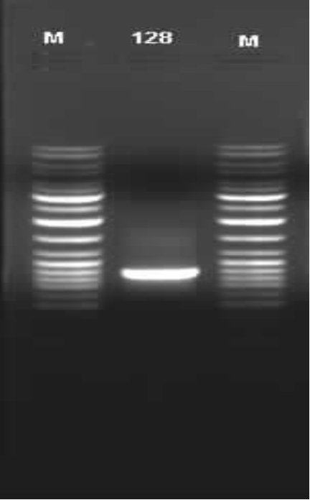
182

856bp

Fig. 24. PCR amplification of tet regulatory elements. 856bp region of tet operon containing tetR, tet promoter and part of tetA was amplified using primers JSKV13 and JSK14. Lane M- 10 Kb Ladder (SMO331, MBI Fermentas), Lane 182 - PCR amplified tetR & tet promotor from pOT182 (856bp)
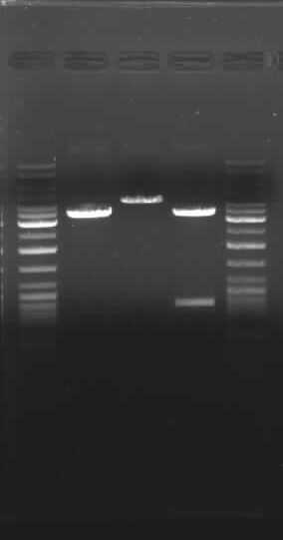
1
2
3
4
5

3.4kb

856bp

Fig.25 . Cloning of tet regulatory sequnce into vector pEGFP. Lanes 1 & 5 = 10 Kb Ladder (SMO331, MBI Fermentas), Lane 2= Vector pEGFP restricted with HindIII, Lane 3 = Clone pJSKV41 restricted with HindIII, Lane 4 = Clone pJSV41 restricted with HindIII and SalI
presence of insert by isolating plasmid DNA from these and the correctness of the inserts orientation was checked by double digesting the DNA by HindIII and SalI. The recombinant plasmid thus verified by restriction digestion (Fig.25) and was named as pJSKV41 and was used for standardization of assay conditions and detection of tetracyclines.

4.3.2 Optimization of biosensor assay conditions and evaluation of strains performance.
4.3.2.1 Determination of sensitivity range and optimal incubation time
The detection range of Tetracycline biosensor was determined by incubating the biosensor cells in the presence of varying concentrations of tetracycline (5ng/ml-70ng/ml) or oxytetracycline (15ng/ml-150ng/ml). Results indicate that the sensitivity range of biosensor for tetracycline (Fig. 26) is 10ng/ml-60ng/ml where as for oxytetracycline it was found to be in the range of 25ng/ml-125ng/ml (Fig.27). Tetracyclines arrest bacterial growth by preventing the attachment of aminoacyl-tRNA to the ribosomal acceptor (A) site. Hence tetracyclines at higher concentrations inhibit the expression of EGFP in biosensor cells. However the affinity of tetracyclines is 1000 times higher to TetR repressor protein than to ribosomes (Tanakashi et al. 1986). Hence low concentrations of tetracyclines activate GFP expression, but since the functional TetA is absent in the biosensor cells, at higher concentrations the protein synthesis as well as GFP expression is inhibited (Hansen and Sorensen, 2000, Hansen et al. 2001). Hence the biosensor responds to sub-lethal concentrations of tetracyclines and the detection ranges observed in the present study are similar to the detection range of tetracycline responsive biosensors developed by Hansen and Sorensen (2000) and Hansen et al. (2001). Tetracycline molecules comprise a linear fused tetracyclic nucleus (rings designated A, B, C, and D) to which a variety of functional groups are attached. These variants are known to have differential affinity to TetR and also has varying degrees of permeability through bacterial membrane (Chopra and Roberts, 2001). This could explain the difference in the sensitivity range of tetracycline and oxytetracycline exhibited by the biosensor cells. The detection range of the biosensor also is greatly determined by the type of reporter gene used and also by the sensitivity of instruments
used to detect reporter gene expression. Studies have shown that when wild type GFP was used as the reporter gene, it did not produce sufficient fluorescence even by Fluorescence Activated Cell Sorter (FACS). Use of different GFP variants improve the detection capacity and when FACS optimized GFP variant was used the fluorescence levels were 21 times higher than that of wild type GFP (Hansen et al. 2001). In this study a different GFP variant (EGFP) is used which is 36 times more fluorescent than wild type GFP (Cormack et al. 1996) and thus has resulted in improved fluorescence levels that could be detected by a multilabel counter like Wallac Victor.

To determine optimum time required for the sensitive detection of tetracyclines, the EGFP expression from biosensor cells were measured at various time intervals. As it could be seen from the results in Fig. 26 and Fig.27 up to six hours of incubation, the lower limit of detection of tetracycline and oxytetracycline was less and steady state fluorescence levels with improved sensitivity was observed beyond ten hours. Since the sensitivity did not improve beyond 12 hours of incubation, this time duration was selected as the optimal period of incubation for all further measurements.

4.3.2.2 Effect of cell density
Although the use of Whole cell bacterial biosensors expressing GFP is a convenient format for biosensor assays, it can sometimes pose difficulties for sensitive detection of target analyte due to high background fluorescence from the cells. The minimum cell density required for the detection of tetracyclines was determined by growing secondary culture of biosensor cells to varying OD₆₀₀ (0.7–1.0) and mixing equal amount of these cells to varying concentrations of tetracycline (10ng/ml – 60ng/ml) and oxytetracycline (25ng/ml –125ng/ml). The results in Fig.28 and Fig.29 indicate that at least an OD₆₀₀ of 0.9 is required for detecting both tetracycline and oxytetracycline without loosing sensitivity. At a cell density of 0.7 the lower limit of detection for tetracycline was 30ng/ml and for oxytetracycline it was 75ng/ml. Increase in the number of cells improved the sensitivity, but elevation of cell density beyond 0.9 merely increased the total fluorescence without improving sensitivity. Hence a cell density of 0.9 (OD₆₀₀) was chosen as the amount of cells required for biosensor assays. In comparison with arsenic
biosensor strain which required only a cell density of 0.6 (at OD₆₀₀), the tetracycline strain biosensor required notably higher cell density (0.9 at OD₆₀₀). It is well known that the expression of the reporter gene in a cloning vector is greatly dependent on the strength of the promoter (Sambrock et al. 1988). Studies have shown that for optimal adaptation to the diverse host organisms, the promoter/regulatory sequences of tetracycline resistance genes undergo mutations that alter the promoter activity (Chopra and Roberts, 2001). Hence, the requirement of higher cell density for tetracycline detection could be due to the less strong induction of EGFP by the tet promoter used.

4.3.2.3 Effect of temperature
The effect of temperature fluctuation on the sensitivity of Tetracycline biosensor was studied over a temperature range of 34°C - 40°C. The overall trend of the results (Fig.30 and Fig.31) indicate that EGFP levels reduced when the incubation temperature departed from the standard E. coli incubation temperature of 37°C. At 38°C and 36°C EGFP levels decreased only to a maximum extent of 2 %. But with every 1°C decrease or increase of temperature beyond this point, EGFP levels showed a higher decrease. At 34°C and 40°C there was an overall reduction of 10% EGFP levels. It is well known that EGFP is exceptionally resistant to heat (Bokman and ward 1981) and all the enhanced GFP variants show little difference in fluorescence at either 25°C or 37°C (Ward 1981). This indicates that the reduction of fluorescence levels at elevated or reduced temperature ranges from 37°C could be due to the reduced metabolic activity of E. coli host cells.
When compared to fluctuations in sample pH and cell density, effect of temperature fluctuations during incubation has less impact on the sensitivity of the biosensor. Use of reporter genes like lux results in extreme sensitivity to the temperature as it is not stable beyond 30ºC (Kurittu et al. 2000). These results confirm the superiority of EGFP as reporter gene for biosensor development.

4.3.2.4 Effect of Photobleaching
When GFP is exposed intense light it is known to loose some fluorescence due to photo bleaching. The effect of exposure of sample to different illumination conditions was studied by exposing the samples to blue and fluorescent light while samples grown under dark conditions serves as control. Fig.32 and Fig.33 indicate that fluorescent light did not have any effect on the sensitivity of biosensor while exposure of samples to blue light resulted in an over all reduction fluorescence levels in the range of 1.5% to 2 %. Although GFP is known to undergo some photo bleaching, it is known to be less than that of fluorescin (Wang and Hazelrigg 1994). However as it was found in the case of arsenic biosensor strain, the chance of such prolonged illumination of samples to a narrow range of wavelength (480nm) is highly unlikely and hence the possibility of illumination effecting the sensitivity of the tetracycline strain is very less.

4.3.2.5 Effect of pH.
Effect of pH variations on the specificity of the tetracycline biosensor was studied at different ranges of sample pH (pH 5.0-pH 9.0). When the pH of the sample was increased from neutral pH to 8.0, an overall reduction of 2% fluorescence was observed for both tetracycline and oxytetracycline. When the pH was further increased to 9.0, the fluorescence levels dropped sharply up to 46% (Fig.32 and Fig.33). It has been reported that the activity of tetracyclines is highest in acidic medium (Egorov 1985). At pH 14.0 it is inactivated by 50% in 40 seconds and at pH 8.5 in 12 hours. This explains the sharp reduction of fluorescence levels beyond pH 8.0. At pH levels beyond 8.0 tetracyclines are progressively inactivated and hence the bioavailable fraction for inducing the biosensor is reduced thereby resulting in a drop in fluorescence levels. When pH of the sample was reduced from 7.0 to 6.0, for both tetracycline and oxytetracycline the fluorescence levels reduced up to 9 %. At pH 5.0, the over all fluorescence levels reduced up to 48 %. Also the lower detection level of tetracycline at pH 5.0 was reduced to 20ng/ml. A similar effect was seen for arsenic biosensor also under acidic pH. This indicates that although tetracyclines are more stable in acidic conditions, GFP looses activity under acidic conditions, thereby resulting in such sharp reduction in fluorescence. EGFP is one of the GFP variants, which has less tolerance for acidic conditions (Patterson et al. 1997). Due to this divergent behavior of EGFP and tetracyclines, a pH of 7.0 was chosen as the optimum pH for biosensor assays.

4.3.2.6 Effect of Shaking.
As it is known that E. coli grow better when the culture is agitated, the optimal shaking speed and effect of variation in shaking speed on the sensitivity of biosensor was tested by culturing the biosensor cells at static conditions and at increasing degrees of shaking. The results (Fig.36 and Fig 37) indicate that with increasing in the speed of shaking fluorescence levels also increased. At static conditions the over all fluorescence levels were considerably less than that of the samples grown with agitation. However when shaking speed was increased beyond 150rpm, the increase in fluorescence levels were only marginal. It was observed that under static conditions, the sensitivity range of the biosensor narrowed for both tetracycline as well as oxytetracycline. Under static conditions biosensor failed to detect tetracycline below 30ng/ml and oxytetracycline below 75ng/ml. Under 50rpm of shaking the sensitivity of biosensor expanded, and for tetracycline the range increased to 20ng/ml and for oxytetracycline it improved to 50ng/ml. When the shaking speed was elevated further up to 150rpm the sensitivity range for tetracycline improved to 10ng/ml and 25ng/ml for oxytetracycline. Further increase in the agitation speed did not improve the sensitivity range and hence 150rpm was chosen as the optimal agitation speed for biosensor assays.

4.3.2.7 Effect of co-antibiotics.
There are large numbers of antibiotics that are used for medical and non medical purposes and this might result in the present of more than one antibiotic in the same sample. Simultaneous presence of such antibiotics on the specificity of tetracycline biosensor was tested by incubating the biosensor cells in a combination mixture in which 5ng/ml tetracycline or oxytetracycline was mixed with equal quantity of other antibiotics and fluorescence induction after 12 hours incubation was measured. Results indicate that when tetracycline or oxytetracycline was incubated in combination with ampicillin, kanamycin, vancomycin, streptomycin, oxacillin and amoxicillin, none of the combination produced any differences in the fluorescence levels from the biosensor cells (Fig.38 and Fig.39). These results are in consistence with the fact that tet operon is induced only by tetracycline class of antibiotics and other antibiotics does not have any effect on the tet operon (Chopra and Roberts, 2001). This high specificity of the tet
operon to tetracycline class of antibiotics provides an upper hand to the biosensor assay to other microbial inhibition based antibiotic detection methods like BSDA.
4.3.3 Estimation of tetracyclines in water and determination of Biosensor stability
For testing the effectiveness of the biosensor strain in detecting tetracyclines in water a dose response curve was developed by incubating the biosensor cells with varying concentration of tetracycline (10ng/ml-60ng/ml) and oxytetracycline (25ng/ml-125ng/ml) dissolved in deionised water (Fig 40 and Fig 41). For determining the stability and longevity of the biosensor strain for prolonged storage, 50 ml Tetracycline biosensor cells
were lyophilized, and the biosensor strain was revived by inoculating 1mg of the lyophilized cells into 10ml of LB broth and induction assay was repeated with the same concentrations of tetracyclines as mentioned above and fluorescence levels were estimated in the same manner. The results of this study showed that there was no difference in fluorescence levels when lyophilized cells were used to inoculate the primary culture instead of overnight colonies of biosensor cells.

A large proportion of tetracyclines used for veterinary and agricultural purposes are released into aquatic environment via water effluents and agricultural run off as results of incomplete metabolism, ineffective treatment removal or improper disposal. EPA supported studies have predicted that due to such contamination, approximately 1200ng/L tetracyclines are likely to be found in surface waters in United States (EPA, 2004). Hence the biosensor was tested for its efficacy in detecting tetracyclines in natural water by spiking pond water samples with different concentrations of tetracyclines (10ng/ml, 30ng/ml and 60ng/ml of tetracycline and 25ng/ml, 75ng/ml and 125ng/ml of oxytetracycline). The fluorescence induction in biosensor cells by all concentrations of tetracycline spiked pond water samples was equivalent to that of the EGP induction levels that was obtained by same concentrations of tetracyclines dissolved in de-ionized water(Fig.42-43). Although large quantities of antibiotics are used for veterinary purposes, the type and amounts of antibiotics that are likely to be found in surface water will strongly depend upon the types of livestock operations within watershed (Hirsch et al.1999). Land application of animal waste provides another route for agricultural antibiotics to enter the
aquatic environments, which may eventually reach drinking water supplies (Kuhne et al.2000). It has been reported that tetracyclines have half-lives up to several hundred days in aquatic environments (Kummerer, 2001). The persistence of such residual tetracyclines promotes microbial resistance to tetracyclines, and will limit the usefulness of tetracyclines over time. Continuous monitoring of residual antibiotics in environment is seldom carried out due to the high cost of detection by existing technologies like HPLC and Mass spectroscopy. The biosensor developed in this study has the potential of being a cheaper alternative for such technologies and could be used for continuous monitoring of residual tetracyclines in surface water samples.

4.3.4 Estimation of tetracyclines in Milk and comparison with BSDA method
The efficiency of the biosensor strain in detecting tetracyclines in biological samples like milk was carried out by testing milk samples collected from a goat given a single intravenous dose of tetracycline or oxytetracycline. A healthy goat was treated with tetracyclines and milk samples were collected at every 12-hour interval after the injection. These samples were then assay with both biosensor cells and BSDA. Results in Fig.44 shows that highest amount of antibiotic was found after 24 hours of antibiotic injection and up to five days detectable amount of antibiotic persisted in milk. When the same samples were assayed with BSDA, the assay detected residual antibiotic only up to 86 hours (zone of inhibition > 16mm) where as biosensor assay showed the presence of tetracyclines up to 120 hours. Such long term persistence of tetracyclines in milk has been reported previously. Hajukura et al (2003) reported the persistence of tetracycline in milk from cows after treatment for acute endometris. Residual tetracyclines could be detected up to 120 hours in milk samples from cows treated with a single dose of tetracycline (Hajukura et al.2003). Similarly residual oxytetracycline could be detected up to 160 hours in milk taken from cows undergoing tetracycline treatment for mastitits (Jevinova et al. 2003). However when same samples were screened with BSDA, no tetracycline could be detected beyond 82 hours. The persistence of tetracyclines in goat milk detected by both BSDA and biosensor assay is in general agreement with these studies. Several methods have been reported for the detection of residual tetracyclines in milk samples. These detection methods belong to two categories. The first category of

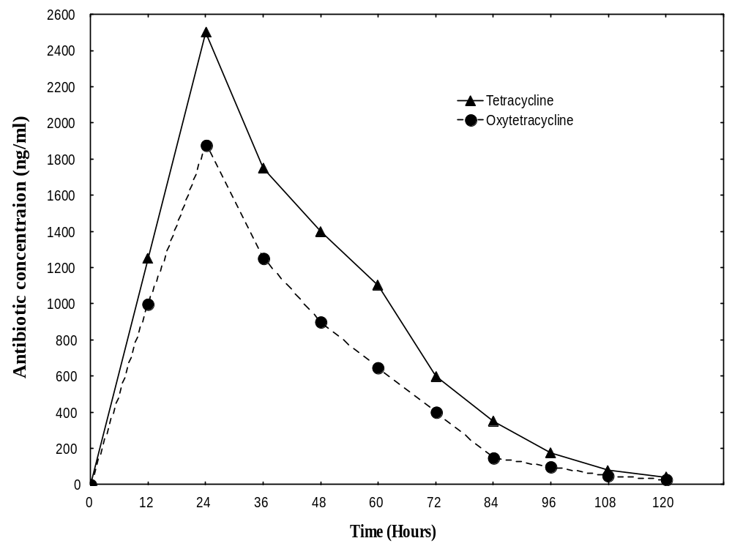Figure. 44: Detection of tetracycline and oxytetracycline in milk samples. A healthy goat given a single intravenous injection of 40mg/kg tetracycline or 30mg/kg oxytetracycline and milk was collected before injection and at every 12 hours after injection. Milk was filtered through a 0.2μm membrane filter and 2.5 ml of diluted milk filtrate and 2.5 ml of biosensor sensor cells (OD₆₀₀-0.9) and was incubated for 12 hours at 37⁰C and fluorescence levels were measured.

tests include High Performance Liquid Chromatography (HPLC), Enzyme Linked Immunosorbent Assay (ELISA), Liquid Chromatography-Mass Sprectormetry (LC-MS) and Fuorier Transform Near Infrared (FT-NIR). FT-NIR and LC-MS determination of tetracyclines in milk is highly accurate and tetracycline detection up to ppb levels has been reported (Sivakesava and Irudayaraj, 2002). There are several ELISA based kits available for the detection of several antibiotics including tetracyclines. These kits typically have very low detection limits (0.05ug/L) for tetracyclines (Kumar et al. 2004). LC-MS methods for tetracyclines are more accurate than ELISA protocols. Similarly HPLC methods could detect tetracyclines up to 5ng/ml range (Zhao et al. 2004). Although extremely sensitive, the employment of these techniques to detect tetracyclines in milk samples on a large scale is not practical due to the high expenses. The second category of tests used are quantitative and are used for screening of milk samples for the presence of tetracycline residues. Two popular tests that belong to this category are Screening Test for Antibiotic Residues (STAR) and BSDA (Gaudin et al. 2004). Although these tests are shown to be sensitive, they are not specific for any particular antibiotic. BSDA is an FDA approved and widely used method for the detection of antibiotic residues in milk. Although it is sensitive for antibiotics like β-lactams, it fails to detect tetracyclines in the European Union (EU) specified Maximum Residue Limit (MRL) of 100ng/ml. This is a major drawback when samples contain low concentrations of tetracyclines or when tetracycline containing milk lots are diluted with milk lots which does not have them. Such presence of such low level tetracyclines promote selection of resistant bacteria. The biosensor developed in the present study has the high accuracy of expensive protocols like HPLC and at the same time is cheaper and easy to perform as the samples cold be detected in highthroughput detection format and hence has the potential to be used as a substitute of the classical protocols for tetracycline detection.

Chapter 5
SUMMARY

The advances in recombinant DNA technology has enabled the development of reporter gene based whole cell bacterial biosensors as sensing devices for the detection of a wide variety of organic compounds, heavy metals, antibiotics and genotoxins. Unlike other reporter genes like β-gal and lux, GFP does not require any cofactors for its activity and GFP based biosensors can be analyzed without cell lysis or addition of specific substrates. Several GFP variants like EGFP with superior fluorescence emission are available and this makes GFP as the best choice for whole cell biosensor construction. The present work was planned towards developing GFP based whole cell bacterial biosensors to aid detection studies on two serious problems facing the country i.e. rise in the prevalence of antibiotic resistant bacteria and arsenic contamination in Gangetic basin of north-eastern India. The overall results obtained from the study are

- An EGFP based whole cell bacterial biosensor for arsenic detection was constructed by PCR amplifying the regulatory sequences (ars promoter/operator, arsR and part of arsD) from plasmid pBDG23 and cloning the same into the vector pEGFP. This resulted in a recombinant plasmid containing a transcriptional fusion of ars regulatory sequences with EGFP. This plasmid was named as pJSKV51 and was transformed into E. coli DH5α and the new strain (E. coli DH5αpJSKV51) was used as a whole cell bacterial biosensor for the detection of arsenic in drinking water samples from W. Bengal.

- Assay conditions for arsenic detection using the newly developed strain was optimized. The Arsenic biosensor strain (E. coli DH5α pJSKV51) required cell density of 0.6 (at OD₆₀₀), a pH range of 6.0 to 8.0, 150rpm shaking, and a temperature range of 35ºC to 37ºC for sensitive detection of arsenic in water.

- Although the Arsenic biosensor could emit bright fluorescence as early as 4 hours after exposure to samples, steady state fluorescence levels required 12 hours of incubation with samples. Under optimal conditions, the Arsenic biosensor strain could detect arsenic from 5ppb to 500ppb. This range of detection satisfies the WHO standards of detection limits (50ppb) for arsenic in drinking water samples.

- To evaluate the efficacy of biosensor strain constructed, arsenic contaminated water samples were collected from nine districts of W. Bengal and the arsenic concentration in samples were tested by biosensor and the correctness of the results were determined by measuring the same samples by Atomic absorption spectroscopy (AAS). It was found that Arsenic biosensor correctly detected the concentration of arsenic in all water samples and the analysis results obtained by both biosensor and AAS correlated well. Further the biosensor identified arsenic positive and arsenic negative samples with high accuracy.

- In order to facilitate the selection of correct sequences for the construction of biosensor for antibiotic detection and to aid detailed studies on antibiotic resistance genes, an online database named “Antibiotic Resistance Genes Online (ARGO)” was developed by extracting sequences responsible for conferring resistance to tetracyclines, vancomycin and β-lactams from Genbank. A PHP script was used to extract and populate the database tables designed by the support of mySQL.

- To make the database freely available for academia and industry, a separate WWW domain was registered (http://www.argodb.org) and the database was transferred to this space. The online database is supported by an Apache web server and PHP scripts provide seamless search interface online. The database can be searched for the type of the antibiotic resistance genes, host organism, year and country of origin of the sequence. Also complete sequence and literature information on the selected sequences can be obtained through hyperlinks provided.

- Analysis of sequence information revealed a progressive increase in the number of antibiotic resistance genes being reported from all over the world. More than 60% of the resistance genes were reported after 1998. Results of the phylogenetic analysis of TEM-1 class of sequences was in concurrence with the clonal expansion theory, and showed that the antibiotic resistance genes are undergoing selection and global spread.

- Based on the searches made in ARGO database, tet operon present in plasmid pOT182 was selected as the target of regulatory sequences for developing biosensor strain for the detection of tetracyclines. An 856bp region of tet operon containing tetR, tet promoter and part of tetA was amplified by PCR and was cloned into plasmid pEGFP. This plasmid was named as pJSKV41 and was transformed into E. coli JM109 and the new strain named as E. coli JM109 pJSKV41 was used as biosensor for the defection of residual tetracyclines in milk and water samples.

- The optimum conditions for the biosensor assay for tetracyclines was standardized. The strain required an incubation temperature in the range of 35-39ºC, 150rpm shaking, a cell density of 0.9 (at OD₆₀₀), sample pH of 6.0-8.0 and 12 hours of incubation with samples. Under optimal conditions the biosensor could detect tetracycline in the range of 10-60ng/ml and oxytetracycline in the range of 25-125ng/ml.

- Tetracycline biosensor was tested for its efficiency by using it to determine the concentration of tetracyclines in milk samples taken from a goat given a single dose of tetracycline and oxytetracycline and the results were compared with the widely used BSDA method. When the same samples were assayed with BSDA, the assay detected residual antibiotic only up to 86 hours (zone of inhibition > 16mm) whereas biosensor assay showed the presence of tetracyclines up to 120 hours after the injection. This was due to the inability of BSDA method to detect tetracyclines below 200ng/ml whereas the biosensor strain had a detection limit well beyond the European Union (EU) specification of 100ng/ml.

- The biosensor was also tested for its efficacy in detecting tetracyclines in natural water by spiking pond water samples with different concentrations of tetracyclines (10ng/ml, 30ng/ml and 60ng/ml of tetracycline and 25ng/ml, 75ng/ml and 125ng/ml of oxytetracycline). The fluorescence induction in biosensor cells by all concentrations of tetracycline spiked pond water samples was equivalent to that of the EGP induction levels that was obtained by same concentrations of tetracyclines dissolved in de-ionized water. Hence the biosensor developed in this study has the potential of being used as a cheaper alternative for such technologies and could be used for continuous monitoring of residual tetracyclines in surface water samples.

Future scope of the work

In the past decade whole cell biosensors have been tremendously improved in terms of their size, detection time and field applicability by introduction of new technologies such as advances in signal measurement, visualization and optic techniques. Unlike other reporter genes like lux and β-gal which require addition of special substrates or the need for lysis of the host cell for signal generation/measurements, GFP does not require any co factors for its activity and need only simple excitation with UV light for fluorescence emission. This makes GFP an ideal choice for biosensor development. The sensor strains developed in this study when tested under different conditions detected the analyte concentration accurately showing their potential to be used as a cheaper alternative to the current methods of arsenic and antibiotic detection. The strains could possibly be improved and their use might increase substantially in two directions purely on the basis the adoption of Micro Electro Mechanical Systems(MEMS) or Nano Electro Mechanical System (NEMS) and the implementation of DNA microarrays or protein chips in the search for different promoter sequences. Regulatory Sequences with better sensitivity range could possibly be identified by sequence analysis of newly sequenced genomes. The expansion of ARGO database to include further gene categories could aid in the prediction of the trend of evolution of antibiotic resistance genes. Such predictions could culminate in the design of futuristic drugs, that can be made available before the target bacteria actually develops resistance. Further different GFP variants could be employed that folds and matures faster so that the incubation time required for the sensitive detection could be reduced.

References
Acharyya SK, Shah BA (2004) Risk of arsenic contamination in groundwater affecting the Ganga Alluvial Plain, India. Environ Health Perspect 112: A19-20
Ahmed K (2002) Wrong test used for checking arsenic contamination of wells in Bangladesh. The Lancet 360: 1757
Ahmed KM, Bhattacharya P, Hasana AH, Akhtera SH, Alamc SMM, Bhuyiana MAH,Imama MB, Khana K, Sracekd O (2004) Arsenic enrichment in groundwater of the alluvial aquifers in Bangladesh: an overview. Appl Geochem 19:181-200
Akai J, Yoshimura T, Ohfuji HKH, Yabe J, Nakamura T (1998) Origin of minerals for arsenic pollution in Bangladesh groundwater. In 3rd Forum on Arsenic Contamination of Groundwater in Asia, Effects, Cause and Measures. Miyazaki University, Miyazaki, Japan
Akiba T, Koyama K, Ishiki Y (1960) On the mechanism of the development of multiple-drugresistant clones of Shigella. Jpn J Microbiol 4: 219 -227
Alam MG, Allinson G, Stagnitti F, Tanaka A, Westbrooke M (2002) Arsenic contamination in Bangladesh groundwater: a major environmental and social disaster. Int J Environ Health Res 12: 235-253
Alliance for the Prudent Use of Antibiotic(2004) Worldwide prevalence of drug resistant pathogens. http://www.apua.org/
Anawar, HM, Akai J, Mostofa KM, Safiullah S, Tareq SM (2002) Arsenic poisoning in groundwater: health risk and geochemical sources in Bangladesh. Environ Int 27: 597-604
Association of Official Analytical Chemists (1984). Official Methods of Analysis, 14th ed., secs 16.163; 42.299-42.303. AOAC, Arlington, VA.

Aubel D, Morris R, Lennon B, Rimann M, Kautmann H, Folchet M, Bailey JE, Thompson CJ, and Fussenegger M (2001) Design of novel mammalian screening system for the detection of bioavailable, non cytotoxic streptogamin antibiotics. J. Antibiot. 54: 44-55.
Bager F, Emborg HD, Heuer OE (2002) DANMAP 2001—Use of antimicrobial agents and occurrence of antimicrobial resistance in bacteria from food animals, food and humans in Denmark. Statens Serum Institut, Danish Veterinary and Food Administration, Danish Medicines Agency, Danish Veterinary Institute, Copenhagen, Denmark. ISSN 1600–2032
Bahl MI, Hansen LH, Licht TR and Sorensen SJ ( 2004) In vivo detection and quantification of tetracycline by use of a whole cell biosensor in rat intestine. Antimicro. Agent. Chemother. 48: 1112-1117.
Barkay T, Turner RR, Rasmussen LD, Kelly CA, Rudd JWM (1998) Luminescence facilitated detection of bioavailable mercury in natural waters. In Methods in Molecular Biology-Bioluminescence Methods and Protocols, Eds R. LaRossa: Humana Press Inc, Totowa, NJ pp. 231-246.
Bax R, Bywater R, Cornaglia G. (2001) Surveillance of antimicrobial resistance—what, how and whither? Clin. Microbiol. Infec. 7: 316–25
Belkin S (2003) Microbial whole-cell sensing systems of environmental pollutants. Curr Opin in Microbiol 6: 206-212
Belkin S, Smulski DR, Vollmer AC, Van Dyk TK, Larossa RA (1996) Oxidative stress detection with Estherichia coli harboring a katG':lux fusion. Appl Environ Microbiol 62: 2252-2256
Berg M, Tran HC, Nguyen TC, Pham HV, Schertenleib R, Giger W (2001) Arsenic contamination of groundwater and drinking water in Vietnam: a human health threat. Environ Sci Technol 35: 2621-2626
Bhattacharya P Jacks G, Ahmed KM, Routh J, Khan AA (2002) Arsenic in groundwater of the Bengal delta plain aquifers in Bangladesh. Bull Environ Contam Toxicol 69: 538-545
Bhattacharyya R, Chatterjee D, Nath B, Jana J, Jacks G, Vahter M (2003) High arsenic groundwater: mobilization, metabolism and mitigation-an overview in the Bengal Delta Plain. Mol Cell Biochem 253: 347-355
Billard P, DuBow MS (1998) Bioluminescence-based assays for detection characterization of bacteria and chemicals in clinical laboratories. Clin Biochem 31: 1-14
Billinton N, Barker MG, Michel CE, Knight A W, Heyer WD, Goddard NJ, Fielden PR, Walmsley RM (1998) Development of a green fluorescent protein reporter for a yeast genotoxicity biosensor. Biosen and Bioelectron 13: 831-838
Bokman SH, Ward WW.(1981) Renaturation of Aequorea green fluorescent protein.
Chemosphere. 50:409-13.
Bolhuis H, Van Veen HW, Poolman B (1997) Mechanisms of multidrug transporters. FEMS Microbiol Rev 21:5584
Bose P, Sharma A (2002) Role of iron in controlling speciation and mobilization of arsenic in subsurface environment. Water Res 36: 4916-4926
Burlage RS, Sayler GS and Larimer F (1990) Construction of a bioluminescent reporter strain to detect polychlorinated biphenyls. J Bacteriol 172: 4749-4757
Chackraborti D, Basu GK, Biswas BK, Chowdhury UK, Rahman MM Paul K (2001) Characterization of arsenic bearing sediments in Gangetic Delta of West Bengal-India In Arsenic Exposure and Health Effects Eds Chappel WR New York: Elsevier Science. pp. 27-52.
Chackraborti D, Mukherjee SC Pati S (2003) Arsenic Groundwater cotamination in middle Ganga plain, Bihar, India: A future danger? Environ Health Perspect 111: 1194-1200
Chaidemenos GCH (2001) Tetracycline and niacinamide in the treatment of blistering skin diseases. Clin Dermatol 19:7815
Chakraborti D, Basu GK, Biswas BK, Chowdhury UK, Rahman MM, Paul K (2001) Characterization of arsenic bearing sediments in Gangetic Delta of West Bengal-India In Arsenic Exposure and Health Effects. pp. 27-52. Edited by Chappelll WR & C. RL. New York: Elsevier Science
Chakraborti D, Biswas BK, Chowdhury TR, Basu GK, Mandal BK, Chowdhury UK (1999) Arsenic groundwater contamination and sufferings of people in Rajnandangao. Madhya Pradesh, India. Curr Sci 77: 502-504
Chakraborti D, Das D, Chatterjee A, Jin Z, Jiang SG (1992) Direct determination of some heavy metals in urban air particles by electrothermal atomic absorption spectrometry using Zeeman background correction after simple acid decomposition. Part IV: Applications to Calcutta air particles. Environ Technol 13: 95-100
Chakraborti D, Hussam A, Alauddin M. (2003) Arsenic: environmental and health aspects with special reference to groundwater in South Asia. Foreword. J Environ Sci Health A Tox Hazard Subst Environ Eng 38: xi-xv
Chakraborti, D, Sengupta MK, Rahman MM. (2004) Groundwater arsenic contamination and its health effects in the Ganga-Meghna-Brahmaputra plain. J Environ Monit 6: 74N-83N
Chalfie M, Tu Y, Euskirchen G, Ward WW, Prasher DC (1994) Green fluorescent protein as a marker for gene expression. Science 263: 802-805
Charkraborti D, Rahman MM, Chowdhury UK, Paul K, Sengupta MK, Lodh D (2002) Arsenic calamity in the Indian subcontinent: what lessons have been learned? Talanta 58: 3-22
Chatterjee A, Das A, Chakraborti D (1993) A study of ground water contamination by arsenic in the residential area of Behala, Calcutta due to industrial pollution. Environ Pollut 80: 57-65
Chopra I, Hawkey PM, Hinton M (1992) Tetracyclines, molecular and clinical aspects. J. Antimicrob. Chemother 29:245-277
Chopra I, Roberts MC (2001) Tetracycline antibiotics: mode of action, applications, molecular biology, and epidemiology of bacterial resistance. Microbiol Mol Biol Rev 65:232-260
Chowdhury AM (2004) Arsenic crisis in Bangladesh. Sci Am 291: 86-91
Chung WO, Young K, Leng Z, and Roberts MC (1999) Mobile elements carrying ermF and tetQ genes in Gram-positive and Gram-negative bacteria. J. Antimicrob. Chemother 44:329-335
Chung WO, Werckenthin C, Schwarz S, Roberts MC (1999) Host range of the ermF rRNA methylase gene in bacteria of human and animal origin. J. Antimicrob. Chemother 43:5-14
Col NF, O'Connor RW (1987) Estimating worldwide current antibiotic usage: report of task force 1. Rev Infect Dis 9(Suppl):S23243
Collard JM, Corbisier P, Diels L (1994) Plasmids for heavy metal resistance in Alcaligenes eutrophus CH34: mechanisms and applications. FEMS Microbiol Rev 14: 405-414
Condee CW, Summers AO (1992) A mer-lux transcriptional fusion for real-time examination of in vivo gene expression kinetics and promoter response to altered superhelicity. J Bacteriol 174: 8094-8101
Corbisier P, Diels L (1998) Reporter gene bioassays in environmental analysis. USPTO. USA
Cormack BP, Valdivia RH and Falkow S (1996) FACS-optimized mutants of the green fluorescent protein (GFP).Gene 173:33-8
Cormack, BP, Bertram G, Egerton M, Gow NA, Falkow S, Brown AJ (1997) Yeast enhanced green fluorescent protein (yEGFP): a reporter of gene expression in Candida albicans. Microbiology 143(Pt 2): 303-311
D’sousa SF (2001) Microbial biosensors. Biosensors Biolelectronics 16: 337-353
Das D, Samanta G, Mandal BK, Roy Chowdhury T, Chanda CR, Chowdhury PP, Basu GK, Chakraborti D (1996) Arsenic in groundwater in six districts of West Bengal, India. Environ Geocliem Health 18: 5-15
Das HK, Mitra AK, Sengupta PK, Hossain A, Islam F, Rabbani GH (2004) Arsenic concentrations in rice, vegetables, and fish in Bangladesh: a preliminary study. Environ Int 30: 383-387
Davies JE (1997) Origins, acquisition and dissemination of antibiotic-resistant determinants. In: Chadwick DJ, Goode J, eds. Antibiotic resistance: origins, evolution, selection and spread. Vol 207. Chichester: Wiley:1527

DePaola A, Flynn PA, McPherarson RM, Levy SB (1988) Phenotypic and genotypic characterization of tetracycline- and oxytetracycline-resistant Aeromonas hydrophila from cultured channel catfish (Ictalurus punctatus) and their environments. Appl. Environ. Microbiol. 54:1861-1863
Dey S, Rosen BP (1995) Dual mode of energy coupling by the oxyanion-translocating ArsB protein. J Bacteriol 177: 385-389
Donskey CJ, Chowdhry TK, Hecker MT (2000) Effect of antibiotic therapy on the density of vancomycin-resistant enterococci in the stool of colonized patients. N Engl J Med 343:192532
Dowson C, Coffey T, Spratt B. (1994) Origin and molecular epidemiology of penicillin-binding proteinmediated resistance to beta-lactam antibiotics. Trends Microbiol 2:3616
Dyk TKV, Mararian WR, Konstantinov KB, Young RM, Dhurjarti PS, Larossa RA (1994) Rapid and sensitive pollutant detection by induction of heat shock gene-bioluminiscence gene fusions. Appl Environ Microbiol 60: 1414-1420
Egorov NS (1985) Antibiotics a Scientific Approach . 2nd Ed. Mir Pub. Moscow 7: 246-273
Environmental Protection Agency (EPA) (2004) Persistence of residual antibiotics in surface waters in USA. http://www.epa.gov/esd/chemistry/ppcp/images/ngwa_abs.pdf
Erickson BE (2003) Field kits fail to provide accurate measure of arsenic in groundwater. Environ Sci Technol 37: 35A-38A
Falkow S (1975) Infectious multiple drug resistance. Pion Ltd., London, United Kingdom
Finch RG (1997) Tetracyclines In Antibiotic and chemotherapy, 7th ed. Churchill Livingstone Ltd., New York, N.Y p469-484.
Flach J, Bossie M, Vogel J, Corbett A, Jinks T, Willins DA, Silver PA (1994) A yeast RNA-binding protein shuttles between the nucleus and the cytoplasm. Mol Cell Biol 14: 8399-8407
Gales AC, Jones RN (2000) Antimicrobial activity and spectrum of the new glycylcycline, GAR-936, tested against 1203 recent clinical bacterial isolates. Diagn Microbiol Infect Dis 36:1936
Gaudin V, Maris P, Fuselier R, RobouchonJL, Cadien N, Rault A (2004). Validation of a microbiological method: the STAR protocol, a five plate test, for the screening of antibiotic residues in milk. Food Addit Contam 24:422-433
Guzzo A, Diorio C, Dubow MS (1991) Transcription of the Escherichia coli fliC gene is regulated by metal ions. Appl Environ Microbiol 57: 2255-2259
Hajuria J, Nagy Y, Popelka P, Rozenska H, Sokol J, Cabadaj R, Hura V (2003). Tetracycline concentrations in blood milk of cows following intrauterine treatment of acute or subacute/chronic endometris. Bull Vet Inst Pulaway 47:435-447
Hakkila K, Lappalainen J Virta M (2004) Toxicity detection from EILATox-Oregon Workshop samples by using kinetic photobacteria measurement: the Flash method. J Appl Toxicol 5:349-353
Hall BG (2004) Predicting the evolution of antibiotic resistance genes Nat Rev Microbiol. 2:430-435
Hansen LH, Sorensen SI (2000) Detection and quantification of tetracyclines by whole-cell biosensors. FEMS Microbiol Lett 190: 273-278
Hansen LH, Ferrari B, Sorensen AH, Veal D, Sorensen SJ (2001) Detection of oxytetracycline production by Streptomyces rimosus in soil microcosms by combining whole-cell biosensors and flow cytometry. Appl Environ Microbiol 67: 239- 244
Heitzer A, Malachowsky K, Thonnard JE, Bienkowski PR, White DC, Sayler GS (1994) Optical biosensor for environmental on-line monitoring of naphthalene and salicylate bioavailability with an immobilized bioluminescent catabolic reporter bacterium. Appl Environ Microbiol 60: 1487-1494
Hirsch R, Ternes T, Haberer K, Kratz KL (1999) Occurrence of Antibiotics in the Aquatic Environment. The Sci. of the Tot Environ. 225: 109-118
Hussam A, Alauddin M, Khan AH, Rausi SB, Munir AKM (1999) Evaluation of arsenic generation in Arsenic feild kit. Environ Sci Technol 33: 3686-3688
Hussam A., Habibuddowla M., Alauddin M., Hossain ZA., Munir, AK, Khan AH (2003) Chemical fate of arsenic and other metals in groundwater of Bangladesh: experimental measurement and chemical equilibrium model. J Environ Sci Health A Tox Hazard Subst Environ Eng 38: 71-86
Imaeda T, Masana MH (1994) Methods for detection of mutagens using luminescence gene. USPTO
Inouye S, Tsuji F (1994) Aequorea green fluorescent protein: Expression of the gene and fluorescent characteristics of the recombinant protein. FEBS Lett 341: 277-280
Jensen LB (1998) Differences in the occurrence of two base pair variants of Tn1546 from vancomycin-resistant enterococci from humans, pigs, and poultry. Antimicrob Agents Chemother 42:24634
Jevinova P, Durikova E, Sokol J, Nagy J, Mate D, Pipova M, Cabadaj R (2003) Determination of oxytetracycline residues in milk with the use of HPLC method and two microbial inhibition assays. Bull Vet Inst Pulaway 47: 211-216
Ji G, Silver S (1992) Reduction of arsenate to arsenite by the ArsC protein of the arsenic resistance operon of Staphylococcus aureus plasmid pI258. Proc Natl Acad Sci USA 89: 9474-9478
Ji G, Silver S (1992a) Regulation and expression of the arsenic resistance operon from Staphylococcus aureus plasmid pI258. J Bacteriol 174: 3684-3694
Ji G, Silver S (1992b) Reduction of arsenate to arsenite by the ArsC protein of the arsenic resistance operon of Staphylococcus aureus plasmid pI258. Proc Natl Acad Sci U S A 89: 9474-9478
Johnson I, Hutchings M, Benstead R, Thain J, Whitehouse P (2004) Bioassay selection, experimental design and quality control/assurance for use in effluent assessment and control. Ecotoxicology 5: 437-447
Kaur P, Rosen BP (1992) Plasmid-encoded resistance to arsenic and antimony. Plasmid 27: 29-40
Khang YH, Yang ZK, Burlage RS (1997) Measurement of iron-dependence of pupA promoter activity by a pup-lux bioreporter. J of Microbiol and Biotechnol 7: 352-355
Khatlwada, N. R., Takizawa, S., Tran, T. V, Inoue, M (2002) Groundwater contamination assessment for sustainable water supply in Kathmandu Valley, Nepal. Water Sci Technol 46: 147-154
King IMH, DiGrazia PM, Applegate B, Burlage R, Sanseverino I, Dunbar P, Larimer F, Sayler GS (1990) Rapid, sensitive bioluminescent reporter technology for naphthalene exposure and biodegradation. Science 249: 778-781
Kobatake E, Niimi T, Haruyama T, Ikariyama Y, Aizawa M (1995). Biosensing of benzene derivatives in the environment by luminescent Escherichia coli. Biosens Bioelectron 10:601-605.
Kohler S, Belkin S, Schmid RD (2000) Reporter gene bioassays in environmental analysis. Fresenius J Anal Chem 366: 769-779
Kruse H, Johansen BK, Rorvik LM (1999) The use of avoparcin as a growth promoter and the occurrence of vancomycin-resistant Enterococcus species in Norwegian poultry and swine production. Microb Drug Resist 5:1359
Kucers, A, and N. McK. Bennett (1987) The use of antibiotics, 4th ed. Heinemann Medical, Oxford, United Kingdom
Kuhne M, Ihnen D, Moller G, and Agthe O (2000) Stability of Tetracycline in Water, Liquid Manure. J. Vet. Med: 47:379-384
Kumar K, Thompson A, Singh AK, Chander Y, Gupta SC (2004) Enzyme linked immunosorbent assay for ultra trace determination of antibiotics in aqueous samples. J. Environ. Qual. 33: 250-256
Kummerer K, Al-Ahmed and Mersch-Sundermann V (2000) Biodegradability of some antibiotics, elimination of the genotoxicity and affection of wastewater bacteria in a simple test. Chemosphere 40: 701-710.
Kummerer K (2001) Drugs in the environment: emission of drugs, diagnostic aids and disinfectants into waste water by hospitals in relation to other sources. Chemosphere. 45: 957-969
Kurittu J, Karp M, Korpela M (2000) Detection of tetracyclines with luminescent bacterial strains. Luminescence , 15: 291-297
LaRossa RA, Majarian WR, Van Dyk TK (1994) Highly sensitive method for detecting environmental insults. USPTO. USA
Layton AC, Muccini M, Ghosh MM, Sayler GS (1998) Construction of a bioluminescent reporter strain to detect polychlorinated biphenyls. Appl Environ Microbiol 64: 5023-5026
Lelie Dvd, Regniers L, Borremans B, Provoost A, Verschaeve L (1997) The VITOTOX test, an SOS bioluminescence Salmonella typhimurium test to measure genotoxicity kinetics. Mutat Res 389: 279-290
Levy SB (1992) The antibiotic paradox: how miracle drugs are destroying the miracle. Plenum Press, New York, N.Y
Levy SB (1984) Resistance to the tetracyclines, In Antimicrobial drug resistance. Academic Press, Orlando, pp191-240
Levy SB (2002) Factors impacting on the problem of antibiotic resistance. J. Antimicrob. Chemother. 49: 25-30.
Mandal BK, Chowdhury TR, Samanta G (1998) Impact of safe water for drinking and cooking on five arsenic affected families for 2 years in West Bengal, India. Sci Total Environ 218: 185-200
Marano NN, Rossiter S, Stamey K. (2000) The National Antimicrobial Monitoring System (NARMS) for enteric bacteria 1996–1999: surveillance for action. J Am Med Assoc 217: 1829–30
Marco MP, Barcelo D (1996) Environmental applications of analytical biosensors. Meas Sci Technol 7: 1547-1562
Marshall J, Molloy R, Moss GWJ, Howe JR, Hughes TE (1995) The jellyfish green fluorescent protein: a new tool for studying ion channel expression and function. Neuron 14: 211-215
Martone WJ (1998) Spread of vancomycin-resistant enterococci: why did it happen in the United States? Infect Control Hosp Epidemiol 19:53945. 27
Matrubutham U, Thonnard JE, Sayler GS (1997) The Use of Whole-Cell Biosensors to Detect and Quantify Compounds or Conditions Affecting Biological Systems. Appl Microbiol Biotechnol 47: 604-609
Matschullat, J (2000) Arsenic in the geosphere-a review. Sci Total Environ 249: 297-312
McManus PS, Stockwell VO, Sundin GW, Jones AL (2002) Antibiotic use in plant agriculture. Annu Rev Phytopathol 40: 44365
Meharg AA, Rahman M.M (2003) Arsenic contamination of Bangladesh paddy field soils: implications for rice contribution to arsenic consumption. Environ Sci Technol 37: 229-234
Merriman TR, Lamont IL (1993) Construction of a self cloning promoter probe vector for gram negative bacteria. Gene 126 : 17-23
Morin J, Hastings JW (1971) Energy transfer in a bioluminescent system. J Cell Physiol 77: 313-318
Mukherjee AM, Sengupta MK, Hossain MA (2005) Are some animals more equal than others? Toxicology 208: 165-169
Mushtaq A, Chowdhury R (1999) Testing of water for arsenic in Bangladesh. science 284: 15-16
Naylor LH (1999) Reporter gene technology: the future looks bright. Biochem Pharmacol 58: 749-757
Nickson R, McArthur J, Burgess W, Ahmed KM, Ravenscroft P, Rahman M (1998) Arsenic poisoning of Bangladesh groundwater. Nature 395: 338
Nickson RT, McArthur JM., Ravenscroft P, Burgess WG, Ahmed KM (2000) Mechanism of arsenic release to groundwater, Bangladesh and West Bengal. Appl Geochem 15: 403-413
Niswender KD, Blackman SM, Rohde L, Magnuson MA, Piston DW (1995) Quantitative imaging of green fluorescent protein in cultured cells: comparison of microscopic techniques, use in fusion proteins and detection limits. J Microbiol 180:109-116
Nordstorm DK (2002) Worldwide occurances of arsenic in ground water. Science 29: 2143-2145
Nouws JF, Loeffen G, Schouten J, Egmond VH, Kenkens H, and Stegeman H (1998) Testing of raw milk for tetracycline residues. J. Dairy Sci. 81: 2341-2345.
Nunoshiba T, Nishioka H (1991) Rec-lac test for detecting SOS-inducing activity of environmental genotoxic substances. Mut Res 254: 71-77
O'Brien TF (2002) Emergence, Spread, and Environmental Effect of Antimicrobial Resistance: How Use of an Antimicrobial Anywhere Can Increase Resistance to Any Antimicrobial Anywhere Else Clin Infec Dis 34:S78-S84
O'Brien TF, Hopkins JD, Gilleece ES (1982) Molecular epidemiology of antibiotic resistance in Salmonella from animals and human beings in the United States. N Engl J Med 307:16
O'Brien TF, Pla MP, Mayer KH, (1985) Intercontinental spread of a new antibiotic resistance gene on an epidemic plasmid. Science 230:878
Oda Y, Nakamura S, Oki I, Kato T, Shinagawa H (1985) Acute toxicity, mutagenicity, and estrogenicity of bisphenol-A and other bisphenols. Mut Res 147: 219-229
Pallava Bagla, Jocelyn Kaise (1996) India’s spreading health crisis draws global arsenic experts. Science 274: 174-175
Partridge IG (2000) Vancomycin-resistant enterococci and use of avoparcin in animal feed: is there a link? Med J Aust 172:434
Patterson G.H, Knobel SM., Sharif WD, Kain SR, Piston DW (1997) Use of the green fluorescent protein and its mutants in quantitative fluorescence microscopy. Biophys J 73: 2782-2790
Paulsen IT, Brown MH, Skurray RA (1996) Proton-dependent multidrug efflux systems. Microbiol Rev 60:575608
Peitzsch N, Eberz G, Nies DH (1998) Alcaligenes eutrophus as a bacterial chromate sensor. Appl Environ Microbiol 64: 453- 458
Petanen T, Romantschuk M. (2003) Toxicity and bioavailability to bacteria of particle-associated arsenite and mercury. Biochem Biophys Res Commun.101:1372-1380.
Phillips I, Casewell M, Cox T, De Groot B, Friis C, Jones R, Nightingale C, Preston R, Waddell J (2004) Does the use of antibiotics in food animals pose a risk to human health? A critical review of published data. J Antimicrob Chemother 53:28-52
Poupard J, Brown J, Gagnon R, Stanhope J M, Stewart C (2002) Methods for Data Mining from Large Multinational Surveillance Studies. Antimicrob Agents Chemother;46:2409-2419
Prasher D, Eckenrode V,Ward W, Prendergast F, Cormier, M. J (1992) Primary structure of the Aequorea victoria green fluorescent protein. Gene 111: 229-233
Prest AG, Winson MK, Hammond IRM, Stewart GSAB (1997) The construction and application of a lux-based nitrate bio- sensor. Lett Appl Microbiol 24: 355-360
Quillardet P, Hofnung M (1993) Accumulation of mutagenic xenobiotics in fresh water (Lake Baikal) and marine (Hornoya Island) ecosystems. Mut Res 297: 235-279
Rahman, MM, Sengupta MK, Ahamed S (2005) The magnitude of arsenic contamination in groundwater and its health effects to the inhabitants of the Jalangi-one of the 85 arsenic affected blocks in West Bengal, India. Sci Total Environ 338: 189-200
Ramamurthy NS, Rifkin BR, Greenwald RA (2002) Inhibition of matrix metalloproteinasemediated periodontal bone loss in rates: a comparison of 6 chemically modified tetracyclines. J Periodontol 73:72634
Ramanathan S, Ensor M, Daunert S (1997) Bacterial biosensors for monitoring toxic metals. Trends Biotechnol 15: 500- 506
Reservoirs Of Antibiotic Resistance: (ROAR) (2004) http://www.tufts.edu/med/apua/ROAR/description.htm
Roberto FF, Barnes JM, Bruhn DF (2002) Evaluation of a GFP reporter gene construct for environmental arsenic detection. Talanta 58 :181-188
Roberts MC (2003) Tetracycline Therapy: Update Clinical Infectious Diseases 36: 462-467
Rosen BP.(1995) Resistance mechanisms to arsenicals and antimonials.J Basic Clin Physiol Pharmacol. 6:251-63.
Rosen BP, Bhattacharjee H, Shi W (1995) Mechanisms of metalloregulation of an anion-translocating ATPase. J Bioenerg Biomembr 27: 85-91
Rozen Y, Nejidat A, Gartemann KH, Belkin S. (1999) Specific detection of P-chlorobenzoic acid by Escherichia coli bearing a plasmid-borne fcbA'&unknown;lux fusion. Chemospere 38:633-641
Rouch DA, Parkhill J, Brown NL (1995) sInduction of bacterial mercury- and copper-responsive promoters: functional differences between inducible systems and implications for their use in gene-fusions for in vivo metal biosensors. J Ind Microbiol 14: 249-253
Rouch DA, Parkhill J, Brown NL (1995) Induction of bacterial mercury- and copper-responsive promoters-functional differences between inducible systems and implications for their use in gene-fusions for in vivo metal biosensors. J Ind Microbiol 14: 349-353
Roychowdhury T, Uchino T, Tokunaga H, Ando M (2002) Survey of arsenic in food composites from an arsenic-affected area of West Bengal, India. Food Chem Toxicol 40: 1611-1621
Sabath LD (1969) Current concepts: drug resistance of bacteria. N Engl J Med 280:91-94
Saha KC (1984) melanokeratosis from arsenic contaminated tubewell water. Indian J Dermatol 29: 37-46
San Francisco MJ, Hope CL, Owolabi JB, Tisa LS, Rosen BP (1990) Identification of the metalloregulatory element of the plasmid-encoded arsenical resistance operon. Nucleic Acids Res 18: 619-624
Scaria J, Umamaheswarn C, Verma SK. (2005) Antibiotic Resistance Genes Online (ARGO): A Database on vancomycin and b-lactam resistance genes. Bioinformation 1: 5-7
Scheller FW, Wollenberger V, Warsinke A, Lisdat F (2001) Research and development in biosensors. Cur opin in biotech 12:35-40
Schnappinger D, and Hillen W (1996) Tetracyclines: antibiotic action, uptake, and resistance mechanisms. Arch. Microbiol. 165:359-369
Scott DL, Ramanathan S, Shi WP, Rosen BP and Daunert S (1997a) Genetically engineered bacteria-electrochemical sensing systems for antimonite and arsenite. Anal Chem 69: 16-20
Scott DL, Ramanathan S, Shi WP, Rosen BP, Daunert S (1997b) Genetically engineered bacteria-electrochemical sensing systems for antimonite and arsenite. Anal Chem 69: 16-20
Selifonova O, Burlage R, Barkay T (1993) Bioluminescent sensors for detection of bioavailable Hg(ll) in the environment. Appl Environ Microbiol 59: 3083-3090
Selifonova OV, Eaton RW (1996) Use of an ipb-lux Fusion to study regulation of the Isopropylbenzene catabolism operon of Pseudomonas putida RE204 and to detect hydrophobic pollutants in the environment. Appl Environ Microbiol 62: 778-783
Sengupta MK, Mukherjee A, Hossain MA, Ahamed S, Rahman MM, Lodh D, Chowdhury UK, Biswas BK, Nayak B, Das B, Saha KC, Chakraborti D, Mukherjee SC, Chatterjee G, Pati S, Dutta RN, Quamruzzaman Q.(2003) Groundwater arsenic contamination in the Ganga-Padma-Meghna-Brahmaputra plain of India and Bangladesh. Arch Environ Health 58: 701-702
Shi W, Wu J, Rosen BP (1994) Identification of a putative metal binding site in a new family of metalloregulatory proteins. J Biol Chem 269, 19826-19829
Shimomura O, Johnson FH, Saiga Y. (1962) Extraction, purification and properties of aequorin, a bioluminescent protein from the luminous hydromedusan, Aequorea. J Cell CompPhysiol 59: 223-227
Silver S, Budd K, Leahy K. M.,Shaw WV, Hammond D. Novick RP, Willsky GR, Malamy MH, Rosenberg H (1981) Inducible plasmid-determined resistance to arsenate, arsenite, and antimony (III) in Escherichia coli and Staphylococcus aureus. J Bacteriol 146: 983-996
Silver S, Ji G, Broer S, Dey S, Dou D, Rosen BP (1993) Orphan enzyme or patriarch of a new tribe: The arsenic resistance ATPase of bacterial plasmids. Mol Microbiol 8: 637-642
Simpson ML, Sayler GS, Applegate BM, Ripp S, Nivens DE, Paulus MJ, Jellison GE (1998) Bioluminescent-bioreporter integrated circuits form novel whole-cell biosensors. Trends Biotechnol 16: 332338.

Sivakesava s and Irudayaraj J (2002). Rapid determination of tetracycline in milk by FT-MIR and FT-NIR spectroscopy. J. Diary Sci 85: 487-493
Skurray RA, Firth N (1997) Molecular evolution of multiply-antibioticresistant staphylococci. In: Chadwick DJ, Goode J, eds. Antibiotic resistance: origins, evolution, selection and spread. Chichester: Wiley Vol 207:16781
Skurray RA, Rouch DA, Lyon BR (1988) Multiresistant Staphylococcus aureus: genetics and evolution of epidemic Australian strains. J Antimicrob Chemother; 21:1939
Smith HL, Rajan TV (2000) Tetracycline inhibits development of the infective-stage larvae of filarial nematodes in vitro. Exp Parasitol 95:26570
Soares S, Kristinsson K, Musser J (1993) Evidence for the introduction of a multiresistant clone of serotype 6B Streptococcus pneumoniae from Spain to Iceland in the late 1980s. J Infect Dis 168:15863
Spahn CMT, Blaha G, Agrawal RK (2001) Localization of the ribosomal protection protein Tet(O) on the ribosome and the mechanisms of tetracycline resistance. Mol Cell; 7:1037-45
Stearns, T (1995) The green revolution. Curr Biol 5: 262-264
Sticher P, Jaspers MCM, Stemmler K, Harms H, Zehnder AJB, van der Meer JR. (1997) Development and characterization of a whole cell bioluminescent sensor for bioavailable middle-chain alkanes in contaminated groundwater samples. Appl Environ Microbiol 63: 4053-4060
Stocker, J., Balluch, D., Gsell, M., Harms, H., Feliciano, J., Daunert, S., Malik, K. A, van der Meer JR. (2003) Development of a set of simple bacterial biosensors for quantitative and rapid measurements of arsenite and arsenate in potable water. Environ Sci Technol 37, 4743-4750
Subramanian KS, Kosnett MJ (1998) Human exposures to arsenic from consumption of well water in West Bengal, India. Int J Occup Environ Health 4: 217-230
Sudershan RV and Bhat RV (1995) A survey on veterinary drug use and residues in milk in Hyderabad. Food Addit. Contam. 12: 645-650.
Suppola JP, Kolho E, Salmenlinna S (1999) vanA and vanB incorporate into an endemic ampicillin-resistant vancomycin-sensitive Enterococcus faecium strain: effect on interpretation of clonality. J Clin Microbiol 37:39349
Takahashi Y, Minamikawa R, Hattori KH, Kurishima K, Kihou N, Yuita K (2004) Arsenic behavior in paddy fields during the cycle of flooded and non-flooded periods. Environ Sci Technol 38:1038-1044
Tauriainen S, Karp M, Chang W, Virta M (1997) Recombinant luminescent bacteria for measuring bioavailable arsenite and antimonite. Appl Environ Microbiol 63: 4456-4461
Tauriainen S, Karp M, Chang W, Virta M (1998) Luminescent bacterial sensor for cadmium and lead. Biosensors Bioelectron 13: 931-938
Taylor, D. E., C. A. Trieber, G. Trescher, M. Bekkering (1998) Host mutations (miaA and rpsL) reduce tetracycline resistance mediated by Tet(O) and Tet(M). Antimicrob. Agents Chemother. 42:59-64
Testa RT, Petersen PJ, Jacobus NL, Sum PE, Lee VJ, Tally FP (1993) In vitro and in vivo antibacterial activities of the glycylcyclines, a new class of semisynthetic tetracyclines. Antimicrob. Agents Chemother. 37:2270-2277
Thevenot DR, Toth K, Durst RA, Wilson GS (1999) Electrochemical biosensors: recommended definitions and classification. Pure Appl Chem 71: 2333-2348.
Tsien RY(1999) Rosy dawn for fluorescent proteins.Nat Biotechnol. 10:956-957.
Tolmasky ME, Crosa JH (1987) Tn1331, a novel multiresistance transposon encoding resistance to amikacin and ampicillin in Klebsiella pneumoniae. Antimicrob Agents Chemother 31:195560
Tomasz A (1997) Antibiotic resistance in Streptococcus pneumoniae. Clin Infect Dis 24:S858
Torrence ME (2001) Activities to address antimicrobial resistance in the United States. Prev Vet Med 51:37–49
Van der Lelie, Renigers L, Borremans B, Provost A, Verschaeve L (1997) The VIVOTOX test, an SOS biolouminiscence Salmonenna typhimurium test to measure genotoxicity kinetics. Mut Res 389:S279-290
Van Geen A, Cheng Z, Seddique AA, Hoque MA, Gelman A, Graziano JH, Ahsan H.,Parvez F, Ahmed K M. (2005) Reliability of a commercial kit to test groundwater for arsenic in Bangladesh. Environ Sci Technol 39: 299-303
Van Treeck U, Schmidt F, Wiedemann B (1981) Molecular nature of a streptomycin and sulfonamide resistance plasmid (pBP1) prevalent in clinical Escherichia coli strains and integration of an ampicillin resistance transposon (TnA). Antimicrob Agents Chemother; 19:37180
Virta MLJ, Karp M (1995) Comparison of the total mercury content in sediment samples with a mercury sensor bacteria test and Vibrio Fischeri toxicity test. Anal Chem 67: 667-669
Vollmer AC, Belkin S, Smulski DR, Van Dyk T, Larossa RA (1997) Detection of DNA damage by use of Escherichia coli carrying recA':Iux, uvrA':Iux, or alkA':lux reporter plasmids. Appl EnvironMicrobiol: 2566-2571
Wang HC., Wang HP, Peng CY, Liu HL, Huang H.L (2003) X-ray absorption spectroscopic studies of As-humic substances in the ground water of the Taiwan blackfoot disease area. Bull Environ Contam Toxicol 71: 798-803
Wang S, Hazelrigg T (1994) Implications for bcd mRNA localization from spatial distribution of exu protein in Drosophila oogenesis. Nature 369: 400-403
Ward WW, Bokman SH (1982) Reversible denaturation of Aequorea green-fluorescent protein: physical separation and characterization of the renatured protein.Biochemistry. 21:4535-40.

Ward WW, Cody CW,Hart RC, Cormier MJ (1980) Spectrophotometric identity of the energy transfer chromophores in Renilla and Aequorea green-fluorescent proteins. PhotochemPhotobiol 31: 611-615
Watanabe T (1963) Infectious heredity of multiple drug resistance in bacteria. Bacteriol. Rev. 27:87-115
Wegener HC, Aarestrup FM, Jensen LB (1999) Use of antimicrobial growth promoters in food animals and Enterococcus faecium resistance to therapeutic antimicrobial drugs in Europe. Emerg Infect Dis 5:32935
World Health Organization (WHO) (1984) Guideline for Drinking Water Quality, vol 1 and 2. Geneva
World Health Organization (WHO) (1999) Arsenic in Drinking Water. In Office of Public Information: Fact Sheet 210. Geneva:
Willardson BM, Wilkins.JF, Rand TA, Schupp JM, Hill KK, Keim P, Jackson PJ (1998) Development and testing of a bacterial biosensor for toluene based environmental contaminants. Appl Environ Microbiol 64: 1006-1012
Williams REO (1959) Epidemic staphylococci. Lancet 1:1905
Wu J, Rosen BP (1991) The ArsR protein is a trans-acting regulatory protein. Mol Microbiol 5: 1331-1336
Wu J, Rosen BP (1993) The arsD gene encodes a second trans-acting regulatory protein of the plasmid-encoded arsenical resistance operon. Mol Microbiol 8: 615-623
Yanagimura M, Koike F, Hara K (1989) Collagenase activity in gingival crevicular fluid and inhibition by tetracyclines. J Dent Res 68:16913
Yang F, Moss LG, Phillips GN (1996) The molecular structure of green fluorescent protein. Nature Biotechnol 14: 1246-1251
Yoon KP, Misra TK, Silver S (1991) Characterization of a metalloregulatory bismuth(III) site in Staphylococcus aureus pI258 CadC repressor. J Bacteriol 173: 7643
Zaldivar R, Ghai GL (1980) Clinical epidemiological studies on endemic chronic arsenic poisoning in children and adults, including observations on children with high- and low-intake of dietary arsenic. Zentralbl Bakteriol [B] 170: 409-421
Zarantonelli L, Borthagaray G, Lee EH, Shafer WM (1999) Decreased azithromycin susceptibility of Neisseria gonorrhoeae due to mtrR mutations. Antimicrob Agents Chemother; 43:246872

Zhao F, Zhang X, Gan Y (2004) Determination of tetracyclines in ovine milk by high performance liqiuid chromoatography with a colorimetric electrode array system. J Chromatogr A 1055:109-114

Appendix-1 List of Publications

Publications in peer Reviewed Journals

- Joy Scaria, Chandramouli U & Verma SK. (2005) “Antibiotic Resistance Genes Online (ARGO): A Database on vancomycin and β-lactam resistance genes.” Bioinformation 1: 5-7.

- Joy Scaria and Verma SK (2005) “Development and evaluation of an EGFP based bacterial biosensor for the detection of arsenic in potable water from West Bengal, India.” Biotechnology & Bioengineering (Under review)

- Joy Scaria and Verma SK (2005) “ Construction and testing of an EGFP based bacterial biosensor for the detection of residual tetracycline in milk and water samples” Biotechnology Letters (under review)

- V Raveender, Joy Scaria & Verma SK (2004) Bioaccumulation and biosorption of heavy metals by Spirulina platensis. International Journal of Biodeterioration and Biodegradation Vol 53 (4) 229

- Joy Scaria, Raveender V, & Verma. SK (2001). Molecular and Genomic Databases. In: Emerging Trends in Bioinformatics (eds) I.A. Khan, Vikaaz Publications, Hyderabad, India, pp. 24-60

- RaveenderV, Scaria J, & Verma SK (2002) “Application of mutant strains of cyanobacteria for Cadmium removal.” Bull. Environ. Contamin. Toxicol. 69: 632-637.

Publications in Conference/ Proceedings

- Joy Scaria, F. Davamani and S.K Verma (2003) “Detection of ultra low concentrations of tetracycline in field samples using reporter gene based bacterial biosensors”. Conference on Medical Science and technology for Population welfare 27-29 October, School of Medical science and technology, IIT, Kharagpur, India.

- Joy Scaria, F. Davamani, and S.K Verma (2003). “Sensing residual antibiotics
in field samples using genetically engineered bacterial biosensors”. 55th
Indian Pharmaceutical congress, December, 19-21, Chennai, India

- Joy Scaria, Nirmala Hariharan, and S K Verma (2004). “Genome wide Codon
usage analysis of Bacillus anthracis as a tool for probable heterologous gene
expression studies”. 6th National Symposium on Biochemical engineering
and Biotechnology, 12-13th March, IIT Delhi, India.

Appendix-II Biographies of Prof.S.K Verma and Mr. Joy Scaria

Biography of Prof.S.K Verma

Prof.Sanjay Kumar Verma obtained master's degree from Banaras Hindu University(BHU) with specialization in cyanobacteria and applied phycology before completing PhD in the area of Environmental Biotechnology from the same university. He worked as post Doctoral fellow at University of Hyderabad in the area of microbial and molecular genetics. Prof.Verma has handled several research projects related to bioremediation and biodegradation of toxic industrial waste, Development of recombinant bacterial biosensors for environmental applications, funded by Department of Atomic Energy (DAE), University Grants Commission(UGC) and Department of Science & Technology(DST). Currently he is working as group leader (Head) of Biological Sciences Group and Centre for Biotechnology, Birla Institute of Technology & Science, Pilani. His major research interest lies in Environmental Biotechnology, molecular biology and biochemistry of cyanobacteria.

Biography of Mr. Joy Scaria

Mr. Joy Scaria completed MPhil Genetics, from P.G Institute of Basic Medical Sciences, University of Madras. Mr.Scaria has been a research fellow working for his PhD at BITS, Pilani from 2000-2005. He is a recipient of Council Scientific and Industrial Research (CSIR) fellowship. Mr.Scaria has an active interest in genomics and database technologies. He has also been involved in teaching and bioinformatics activities of Biological Sciences Group, BITS, Pilani. He has published research articles in renowned International journals and presented papers in various International and National conferences/symposims.

