Table 5.3
Chapter 5

Pyrimethamine Sulphadoxine Resistance genes in Plasmodium vivax

Introduction

With the emergence of chloroquine-resistant P. falciparum strains in the late 1950s, antifolate drugs, including proguanil, cycloguanil and pyrimethamine, were massively employed as alternative antimalarial agents to treat or prevent malarial infections in areas where P. falciparum and P. vivax co-exist (Wernsdorfer et al., 1991). Soon after the introduction of these drugs in endemic areas, numerous cases of antifolate treatment failure were reported in patients infected with P. vivax, which had led some malariologists to conclude that this parasite is intrinsically resistant to antifolate drugs (Young et al., 1959). However, recent reports have clearly established the association between pyrimethamine resistance and PvDHFR mutations. For example, the wild-type PvDHFR enzyme expressed in Escherichia coli showed a higher catalytic activity than the mutant type enzyme (Leartsakulpanich et al., 2002; Tahar et al., 2001). Similarly, wild-type and different mutant alleles of PvDHFR were expressed in Saccharomyces cerevisiae and tested for their susceptibilities to pyrimethamine. The yeast cells harboring the mutant PvDHFR constructs showed their survival at a higher concentration of pyrimethamine than those cells that were harboring the wild-type PvDHFR construct (Hastings et al., 2005).

Pyrimethamine resistance in P.vivax is associated with two key DHFR mutations, S58R and S117N, which are equivalent to the C59R and S108N mutations of the PfDHFR (Pecoulas et al., 1998). In addition, other mutations reported from PvDHFR are: P33L, I13L and I173L (in the isolates from Madagascar and Cameroon Islands), F57L/I, and T61M (from Madagascar, Thailand, Indonesia and India) and R38G, S93C/H, S109H, R131G, I188V and V159A (from Indian isolates). Besides these non synonymous mutations, there were present some synonymous mutations also at codon 8, 9, 69, 94, 95, 99 and 114 (Pecoulas et al., 1998; Imwong et al., 2003; Kaur et al., 2006). The degree of pyrimethamine resistance in P. vivax also increases with the sequential addition of each mutation in the dhfr gene, and extremely resistant parasites carry an S117T mutation (Hastings et al., 2005; Imwong et al., 2003). Studies by Hastings and Sibley, (2002) showed that single base pair mutation resulting in S117N substitution increased IC₅₀ value for pyrimethamine more than 80 folds and together with S58R the enzyme was more than 400 folds resistant to pyrimethamine. The transfection studies done in P.falciparum based system using Pvdhfr gene also showed that quadruple mutations causes less susceptibility to pyrimethamine (O’Neil et al., 2007).

Like all protozoans, in P.vivax also, the DHFR and TS are bifunctional enzymes encoded by a single gene. The P.vivax sequence contains 3 structural domains: a 5’ end DHFR domain (711bp), a linker region (300bp) and a 3’ end TS domain (861bp). The DHFR domain and the linker region of P.vivax are larger than those of P.falciparum (684bp DHFR domain and 282bp junction) and P. chabaudi (687bp DHFR domain and 204bp linker region). The P.berghei DHFR domain is of same size as of P.vivax but the linker region of P.vivax is larger than P.berghei. The relatively large DHFR domain in P.vivax is due to a tandem repeat sequence GGDN occupying the region between nucleotides 262 and 309 (amino acid residues 88 - 106) that is absent in P.falciparum and P.chabaudi. In P.berghei, in this region there is present a repeat of ELNT. The tandem repeat region shows a lot of polymorphism in P.vivax due to addition and deletions of these repeats (Pecoulas et al., 1998).

The DHFR domain of P.vivax shows a high level of conservation in several regions among different Plasmodia species. In the DHFR domain, Plasmodium vivax shows 66%, 60% and 64% identical residues with P.falciparum, P.berghei and P.chabaudi respectively. In comparison, the junctional region of P.vivax shows essentially no isology with that of other malarial species. But this region has probably no physiological role as the recombinant P.falciparum DHFR-TS enzyme lacking this region can be expressed in E.coli. In contrast to these two domains, the TS domain of P.vivax shows an extensive homology with the sequences of other malarial species.

Like pyrimethamine resistance, point mutations in the dhps gene are found to be responsible for sulphadoxine resistance in both P. falciparum and P.vivax in the laboratory (Hyde, 2005). But in vivo the picture is still not clear, and P.vivax is thought to be intrinsically resistant to these drugs. But as it is inevitable that P.vivax will have the same drug pressure as in case of P.falciparum so the dhps gene of P.vivax is also studied for the above mutations in recent years, though is has not been well characterized as compared to other genes.

Similar to P.falciparum, dhps gene in P.vivax is a part of bifunctional enzyme PPPK-DHPS. The entire pppk-dhps gene of P.vivax consists of 2,591 bp with 2 introns. Intron 1 is 246 bp in length (nucleotides 128 to 373) and intron 2 is 149 bp in length (nucleotides 2327 to 2475). The coding region of the gene contains 2,196 bp encoding 731 amino acids. At amino acid level, P. vivax PPPK-DHPS has 56, 56, 59, and 50% homology to PPPK-DHPS from P. berghei, P. chabaudi, P. falciparum, and P. yoelii, respectively. The pppk-dhps sequence is highly homologous between different species of malaria parasites; however, a repetitive domain that was not found in the other malaria parasites sequences exists at the PvDHPS C-terminal region. This domain consists of 7-amino-acid tandem repeats of GEA/GKLTN (Korsinczky et al., 2004).

Compared to PvDHFR, limited polymorphism has been reported from PvDHPS. Only two amino acid changes have been reported in the PvDHPS among the P. vivax isolates: A383G in isolates from Thailand and West Papua and A553G in Thai isolates, equivalent to A437G and A581G in P. falciparum DHPS, respectively (Auliff et al., 2006). Homology modeling and sulfadoxine docking has shown that these mutations have the same effect on the susceptibility to sulfadoxine as seen in case of P.falciparum. In addition to this, in the predicted sulfadoxine binding site, the only change between P.falciparum and P.vivax is at the position 585 where a Valine is present in place of Alanine (corresponding to residue 613 of P. falciparum). This valine, due to its large side chain is thought to cause steric hindrance for drug binding and thus is thought to be responsible for innate resistance (Korsinczky et al., 2004). The studies done in various countries have also shown only Valine present at this position (Imwong et al., 2005).

Results and Observation:

Amplification of Genes:

To amplify the dhfr-ts and pppk-dhps genes, sequences of respective gene were obtained from NCBI database, (Accession Nos. – X98123 and AY186730). Primers were designed (Table: 5.1) to amplify the complete genes and partial regions and were synthesized commercially. The forward and reverse primers were designed with a GCG overhang and restriction sites were incorporated for cloning purposes.

Table 5.1: Primers for Plasmodium vivax dhfr-ts and pppk- dhps genes

PRIMER Id. | SEQUENCE
SGAKD5 | ^{5’}GCG GAG CTC ATG GAG GAC CTT TCA GAT GTA TT ^{3’}
SGAKD6 | ^{5’}GCG AAG CTT CAT GAT GAT GTC GTA TAT GAT GC ^{3’}
SGAKD7 | ^{5’}GCG GAG CTC GAG AAA AAC CCG GAG CAC CTG ^{3’}
SGAKD8 | ^{5’}GCG AAG CTT TTA GGC GGC CAT CTC CAT GGT ^{3’}
SGAKD25 | ^{5'} GCG GGA TCC ATG GAG GAT TCA AAC ACG GG ^{3'}
SGAKD26 | ^{5'} GCG AAG CTT CAC AGG ATC GAC AAA TAA ACC ^{3'}
SGAKD27 | ^{5'} GCG GGA TCC AGA GGC TAT ACG TAT TGA AAG A ^{3'}
SGAKD28 | ^{5'} GCG AAG CTT CAC TGC CAG GAG ATT ACC C ^{3'}

Amplification of dhfr-ts gene from P.vivax:
The whole 1.8kb Pvdhfr-ts gene was amplified from 60 proven cases of Plasmodium vivax using primers SGAKD5 and SGAKD8 (Fig. 5.1). The central primers were designed to amplify the upper and lower approx. 1kb regions containing the dhfr and ts genes respectively. The upper region was amplified using SGAKD5 and SGAKD6 (Fig. 5.2), while for the lower region SGAKD7 and SGAKD8 were used (Fig. 5.3). A band at 1056 bp and 921 bp respectively was obtained for the above amplifications.

Reaction Conditions: (SGAKD5 and SGAKD8)
Pre Denaturation - 94ºC for 2 min
Denaturation - 94ºC for 1 min
Annealing - 61ºC for 1.5 min
Extension - 72ºC for 2.5 min
Post Extension - 72ºC for 4 min

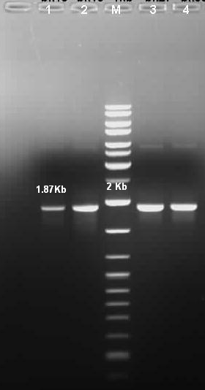
Figure 5.1: Amplification of complete Pvdhfr-ts gene; M = 1kb DNA Ladder Mix (Fermentas #SM0331)

Reaction Conditions for SGAKD5 and SGAKD6 | Reaction Conditions for SGAKD7 and SGAKD8
Pre Denaturation - 94ºC for 2 min  Denaturation - 94ºC for 1 min  Annealing - 58ºC for 1 min  Extension - 72ºC for 1.5 min  Post Extension - 72ºC for 4 min | Pre Denaturation - 94ºC for 2 min  Denaturation - 94ºC for 1 min  Annealing - 62ºC for 1 min  Extension - 72ºC for 1.5 min  Post Extension - 72ºC for 4 min

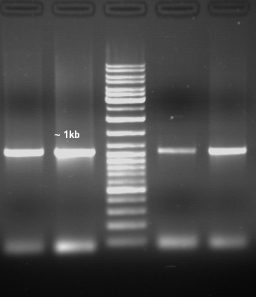  1 2 M 3 4 | 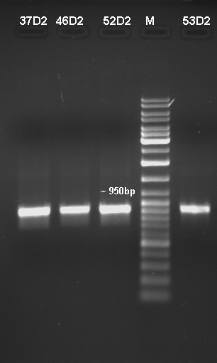
Figure 5.2: Amplification of upper 1056 bp region of Pvdhfr-ts gene; M = 1kb DNA Ladder Mix (Fermentas #SM0331) | Figure 5.3: Amplification of lower 921 bp region of Pvdhfr-ts gene; M = 1kb DNA Ladder Mix (Fermentas #SM0331)

Amplification of pppk-dhps gene from P.vivax:
The whole of the pppk- dhps gene was amplified from the confirmed cases of P.vivax using two sets of primers. The upper half was amplified using the primers SGAKD25 and SGAKD26 (Fig. 5.4) while the lower half was amplified using primers SGAKD27 and SGAKD28 (Fig. 5.5). A band at approximately 1.3 kb was obtained for the upper region and a band at approx. 1.4Kb was obtained for the lower region.

Reaction conditions (SGAKD25 & SGAKD26) and (SGAKD27 & SGAKD28)
Pre Denaturation - 94ºC for 3 min
Denaturation - 94ºC for 1 min
Annealing - 59ºC for 2 min
Extension - 72ºC for 2 min
Post Extension - 72ºC for 4 min

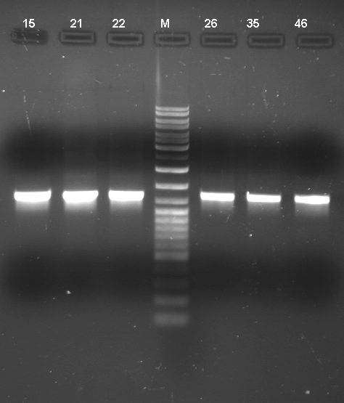  1.3kb |  | 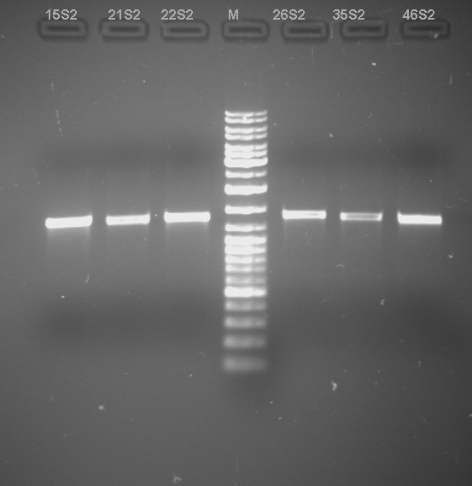  1.4kb
Figure 5.4: Amplification of upper region of pppk-dhps of P.vivax; M = 1kb DNA Ladder Mix (Fermentas #SM0331) |  | Figure 5.5: Amplification of lower region of pppk-dhps of P.vivax; M = 1kb DNA Ladder Mix (Fermentas #SM0331)

Sequence Analysis:

(A) PvDHFR – TS
The amplicons obtained were gel eluted using QIAquick gel extraction kit (QIAGEN) and the purified products and clones were sent for commercial sequencing to LabIndia, New Delhi and Shankar Netralaya, Chennai. The obtained sequences were analysed for the mutations using the ClustalW Software (Thompson et. al., 1994). The changes were confirmed by repeated sequencing and checking the respective peaks carefully in the chromatogram from both ends. The changes observed at the nucleotide and the amino acid levels are listed in the Table 5.2 and 5.3 respectively.

A large number of fractions i.e. 42 of 60 isolates represented gene sequence identical to the wild type sequence whereas 18 samples showed mutations responsible for pyrimethamine resistance. The most prevalent combination among all the mutant isolates constitutes double mutations; S58R and S117N in 12 of 60 samples. 6 isolates showed single mutation S117N and no change was observed at residue 58 compared to the wild type isolate. 4 isolates showed a single mutation S93H. 2 isolates showed mixed characters. Electropherogram showed double peaks of similar amplitude at codon 58 and 117, suggesting the mixed presence of S58R and S117N (Fig. 5.6).

Table 5.2: Changes observed at the nucleotide level in the dhfr-ts gene of P.vivax.

Type | Position of nucleotides |  |  |  |  |  |  | No. of isolates
 | 174 | 207 | 277 | 278 | 350 | 402 | 1104 | Out of 60
A | G | T | A | G | A | C | A | 12
B | C | C | A | G | G | C | A | 20
C | C | T | C | A | G | C | A | 4
D | C | T | A | G | G | C | A | 18
E | C | T | A | G | G | T | A | 2
F | C | C | A | G | A | C | A | 2
G | C | T | A | G | A | C | A | 2
Standard | C | T | A | G | G | C | T

Table 5.3: Changes observed at the amino acid level in the PvDHFR-TS
Type | Positions of amino acid |  |  |  |  | No. of isolates
 | 58 | 93 | 117 | 253 – 336 | 368 | Out of 60
A | R | S | N | DSASENCNALNCNAPKCSAPNCRSPNGGTAQQGEWGKGPAACPWQKNNAEAEEDDLVYFSFNNKVGEKNPEHLQDFKIYNSLKIK | K | 12
B | S | H | S | DSASENCNALNCNAPKCSAPNCRSPNGGTAQQGEWGKGPAACPWQKNNAEAEEDDLVYFSFNNKVGEKNPEHLQDFKIYNSLKIK | K | 4
C | S | S | S | DSASENCNALNCNAPKCSAPNCRSPNGGTAQQGEWGKGPAACPWQKNNAEAEEDDLVYFSFNNKVGEKNPEHLQDFKIYNSLKIK | K | 38
D | S | S | N | DSASENCNALNCNAPKCSAPNCRSPNGGTAQQGEWGKGPAACPWQKNNAEAEEDDLVYFSFNNKVGEKNPEHLQDFKIYNSLKIK | K | 6
Std | S | S | S | TALRRTAMRSTAMRRNVAPRTAAPPMGPHSRANGERAPPRARARRTTPRQRKTTSCTSALTTKWGRKTRSTCKILKFTTASRLM | N | None
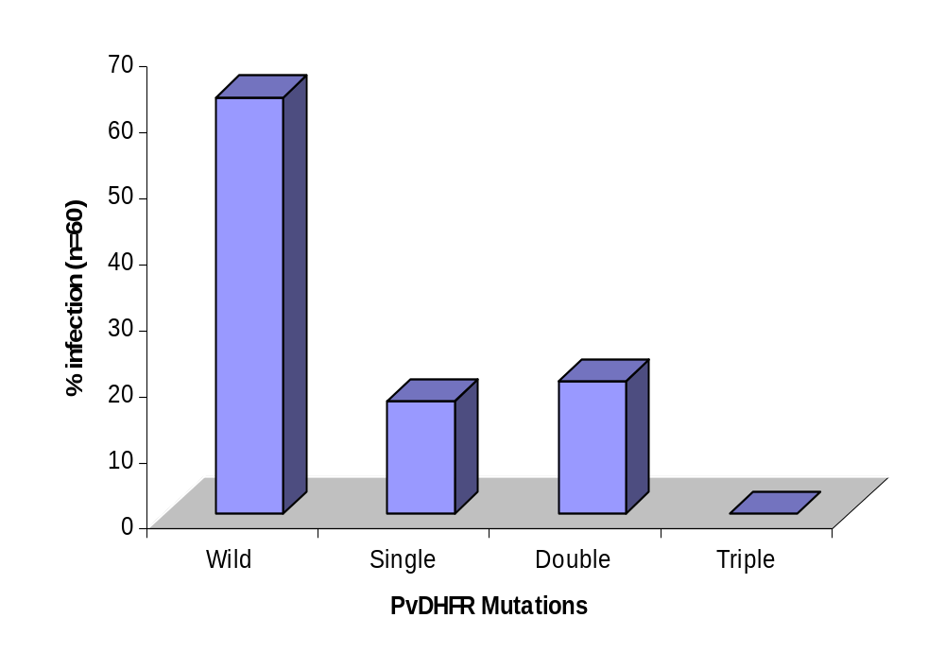
Figure 5.6: Prevalence of dhfr mutations in P. vivax isolates from Bikaner

Besides the non-synonymous mutations, there were also some synonymous mutations. At codon 69, TAT in 22 isolates was replaced by TAC (both code for Tyrosine). This TAC at position 69 was associated mostly with the wild type (20 isolates) but in two isolates it was associated with the single mutant S117N genotype. In two of the isolates another novel synonymous mutation occurred at codon 134, where GTC was replaced by GTT (both code for valine).

In the tandem repeat region between amino acids 88 – 106 of PvDHFR, there were variable numbers of GGDN repeats present in the P.vivax isolates (Fig. 5.7), as reported previously from other regions (Imwong et al., 2003; Kaur et al., 2006). Majority of them i.e.52/ 60 were found to contain three GGDN repeats. 4 samples contained four GGDN repeats and other four samples consisted of only two GGDN repeats. One of the samples showing a deletion of GGDN repeat had a histidine at codon 93. Also in the tandem repeat region, four isolates showed a change at codon 93 where a Serine was replaced by Histidine.

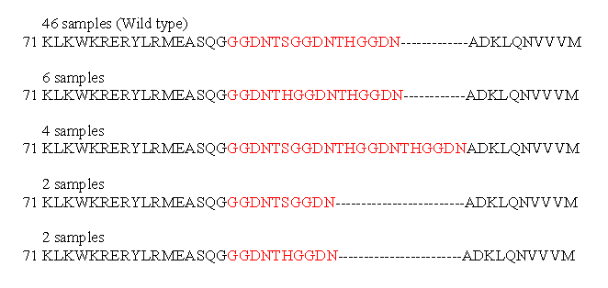
Figure 5.7: Polymorphism observed in the tandem repeat region (71-110) of Pvdhfr gene from Bikaner region.

The sequences of the connector region and the TS region of all the isolates were also compared with the standard wild type sequence (Genbank Accession No. X98123). All our isolates showed a different connector region as compared to the above wild type sequence, as seen from other parts of world also (Imwong et al., 2003). Sequence comparison revealed that the reading frame was shifted by one insertion of G at the 5’ end of the joining region and three more insertions of G base 80 bp later. However the frame shift was restored by a deletion 170bp later, close to the start of the ts domain. The sequence in the connector region from the 5’ end was –

DSASENCNALNCNAPKCSAPNCRSPNGGTAQQGEWGKGPACPWQKNNAEAEEDDLVYFSFNNKVGEKNPEHLQDFKIYNSLKIK

In the TS region, a change was observed at the conserved residue 368 where a Lysine was seen in place of Asparagine in all our samples, as compared to sequence X98123. This Lysine is present at the corresponding position in P. falciparum, P. coatneyi and P. berghei also. In addition, two samples showed a silent mutation in the TS region at the codon 574; a change from AGC to AGT (both codes for Serine).

(B) Pppk-dhps gene
The Pvdhps gene was sequenced and analysed from 52 isolates. Most of the isolates sequenced (75%) showed wild type genotype for this gene. Of all the reported mutations at codon 383 and 553, none of the mutation was present in our samples. As previously reported (Korsinczky et. al. 2004), at codon 585, a valine was present in all our isolates (corresponding to codon 613 of P.falciparum where an alanine is present). Some novel mutations were also observed in the DHPS region of various isolates from Bikaner. 2 isolates showed F365L mutation while other two showed D459A mutation. 3 isolate were M601I mutated and 11% of the samples showed E618D mutation (Table 5.4). Among the mutants, 92% samples were single mutant while rest was double mutant at codon 601 and 618 (Fig. 5.8).

Table 5.4: Novel mutations observed in DHPS region
S. No. | Amino acid Position | Mutation |  | No. of isolates
S. No. | Amino acid Position | From | To | No. of isolates
 | 365 | Phe | Leu | 2
 | 459 | Asp | Ala | 2
 | 601 | Met | Iso | 3
 | 618 | Glu | Asp | 6

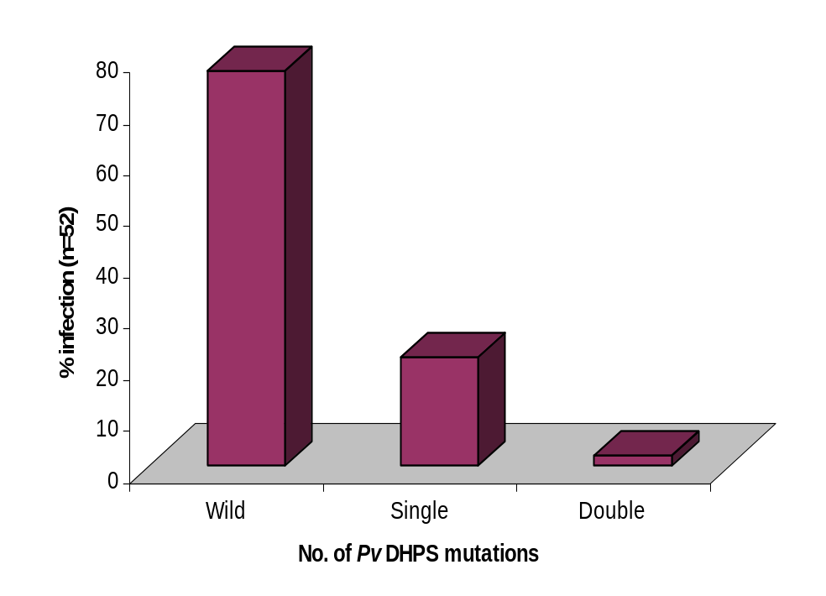
Figure 5.8: Prevalence of DHPS mutations in P. vivax isolates in Bikaner

One of the unique features in the PvDHPS is the presence of a tandem repeat region between amino acid residues 596 and 672 (Korsinckzy et al., 2004). Size polymorphism in this repeat region of PvDHPS resulting from a deletion or repetition of these 7 amino acid units GEA/GKLTN was seen. Various isolates showed different combinations of these repeat regions leading to polymorphism in this region. Only two of the samples showed similar pattern of repeat region as that of wild type. All the other 50 samples were distributed into four different classes based on polymorphism in the tandem repeat region (Fig. 5.9). In the repeat region, six
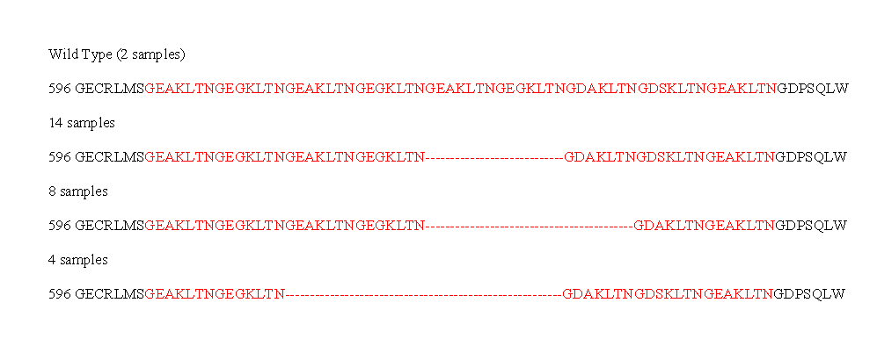
Figure 5.9: Polymorphism observed in the tandem repeat region (71-110) of pppk-dhps gene from Bikaner region.
isolates showed synonymous mutations at codon 617 and 622 for Glycine and Threonine respectively. At codon 617, in place of GGG, all the six isolates showed GGT (both codes for Glycine) and at codon 622 ACT was present in place of ACC.

In the pppk region, two novel non-synonymous changes at codon 207 and 217 were seen. There was Aspartic Acid in place of Alanine at position 207 and Threonine in place of Proline at codon 217 in all our isolates.

Discussion

Antifolate drugs are commonly used for the treatment of falciparum malaria. But in regions where P.falciparum and P.vivax coexists, both of them are at risk of being exposed to these drugs, as they have a common target enzyme (Pecoulas et al. 1998). In Bikaner region, both P.falciparum and P.vivax malaria are seen after every rainy season, thus it is expected that the antifolate drug pyrimethamine used for mainly P. falciparum, will affect both P. falciparum and P.vivax.

In Bikaner, majority of the isolates showed the wild type genotype at codon 58, 117 and 173 of the Pvdhfr gene, as reported from different parts of India, especially Northern India (Kaur et al., 2006). Among the mutants, isolates showing double mutations were predominant, suggesting that this combination may be the result of primary drug selection. Similar to data obtained from other regions of India (Kaur et al., 2006; Alam et al., 2007), we have not found any mutation at codon 13, 33 and 173 of the Pvdhfr gene in the isolates from Bikaner. The novel mutations reported at codon 37, 109, 131, 159, 171 and 188 (Kaur et al., 2006) were not seen in any of our isolates. These mutations have not been reported till now from any other region of the world.

Variable number of GGDN repeats was observed at amino acid positions 88 of PvDHFR. Majority of them showed 3 GGDN repeats (86.7%), while the rest showed either 2 or 4 repeats. All mutant isolates showed 3 repeats except one single mutant that showed only 2 repeats. This suggests that the presence of different number of GGDN repeats is not associated with any one specific genetic profile. Four isolates from this region showed S93H mutation, which was found to be associated only with wild type isolates as reported in isolates of Uttar Pradesh, India. (Alam et al., 2007)

In the Pvdhps gene, all the isolates showed wild type alleles for codon 383 and 553 (Fig. 5.10). However, in contrast to the limited polymorphism reported in the PvDHPS, the isolates from Bikaner showed 4 sets of novel mutations. Two of these mutations were found in the repeat region and thus are thought to have no or negligible effect on the binding of Sulfadoxine. But the effect of other two mutations needs to be further elucidated by either modeling, crystallographic or transfection studies. To understand the effect of the novel mutations on the drug binding, structures were generated for the wild type and the mutant forms by homology modeling. The effect on binding affinity of Sulfadoxine was checked by Molecular docking, as discussed in Chapter 6.

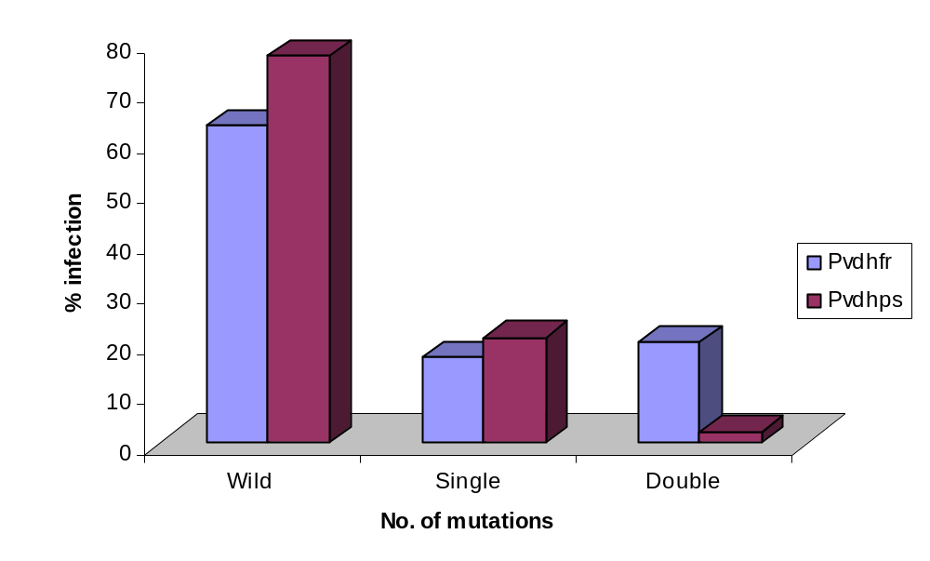
Figure 5.10: Mutation patterns of P. vivax DHFR and DHPS genes in Bikaner isolates

On comparison of both PvDHFR and PvDHPS from same samples for the reported mutations found to impart resistance, it was observed that all the isolates were showing wild genotype for DHPS but wild, single mutant or double mutant genotype for DHFR. This supports the asymmetric distribution of these mutations in P.vivax, as observed in P.falciparum.
When the above genes from P.vivax were compared with the dhfr and dhps genes of P.falciparum, it was seen that the respective genes in P.falciparum showed higher degree of mutation rate as compared to P. vivax. In comparison to only 37% of mutant dhfr isolates in P.vivax, approximately 93% of P.falciparum isolates showed mutations in the dhfr gene. However, for both the species, double mutants were more prevalent as compared to single mutants. Similar to PfDHFR, no triple or quadruple mutations were observed in P.vivax DHFR. The above data suggests that the mutation rate in DHFR of P.vivax is slower than that of P.falciparum.

The DHPS also showed the mutation rate to be slower in P.vivax, but in contrast to DHFR, most of the P.falciparum and P.vivax isolates showed the wild type genotype. Only 15.38% of P.falciparum isolates showed the single mutation at codon 437, but none of the P.vivax isolate showed any mutation at residues responsible for resistance (Fig. 5.11). Novel mutations were observed in both PfDHPS and PvDHPS, irrespective of the small number of samples analyzed. This gene is reported to be of highly conserved in both P.falciparum and P.vivax. Whether these mutations affect the resistance patterns of these parasites or are just a reflection of geographic origin, has to be further investigated.

To conclude, in regions where other drug regimens are failing, this kind of data showing the patterns of DHFR and DHPS mutations from P. falciparum and P.vivax can help in taking decisions about drug choice on a regional bias. Since till date, the diagnostic services are rudimentary in many parts of the country, malaria infections are often misinterpreted. This mis-speciation will be less detrimental if treatment given is effective against both P. falciparum and P. vivax. In India, the combination of SP with artesunate for P. falciparum is the policy in some regions. In many of these regions P.vivax infection is also common. Because artesunate has activity against P.vivax, artesunate derivatives coupled with antifolates might be a practical drug regimen in regions where P. falciparum and P.vivax coexists and where local P.vivax has predominantly wild type or less mutated allele (Hawkins et al., 2007). Also it seems from our results that antifolates used for the treatment of P. falciparum malaria are also affecting P.vivax mutations. This warrants that antifolates should be used carefully to check the development of cross species resistance.

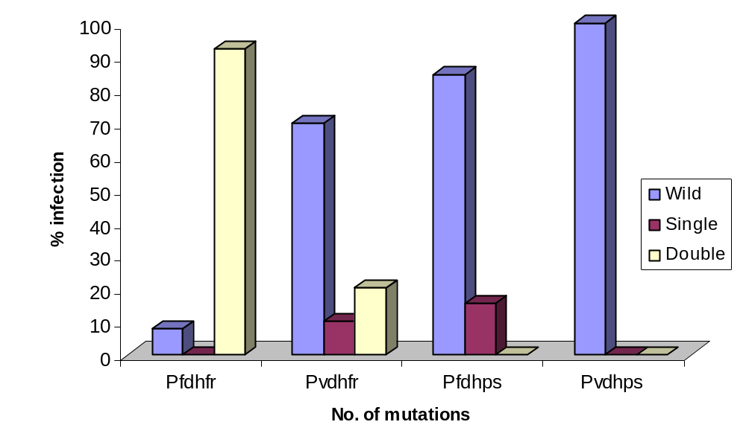
Figure 5.11: Prevalence of DHFR and DHPS mutations reported to be responsible for SP resistance in P.falciparum and P.vivax from Bikaner

