Review of literature
Leishmaniasis, a globally widespread group of diseases caused by a heterogeneous group of obligatory, intracellular, haemoflagellate protozoan parasites belonging to the genus Leishmania (family Trypanosomatidae), results in a variety of different clinical syndromes ranging from the self-healing cutaneous lesions to the more serious, potentially fatal visceralizing form, and includes the metastasizing muco-cutaneous form, and the post kala-azar dermal leishmaniasis.
Leishmaniasis is considered as one of the 6 diseases selected by WHO for its special Programme for research and training in tropical diseases (WHO, 1984). It ranks next to malaria among human protozoan diseases (Chang et al, 1985). It has been an antique public health problem, clinically subdivided into three distinct entities: i) CL caused by L. major, L. tropica and, rarely, L. infantum and L. donovani, in the Old World (OW) and L. mexicana in the New World (NW); ii) VL caused by representatives of the L. donovani complex and, rarely, by L. tropica in the OW and, rarely, L. amazonensis in the NW; and iii) mucocutaneous leishmaniasis (MCL) caused by L. braziliensis, L. panamensis, and L. guyanensis, in the NW, with reported cases by L. donovani, L. major, and L. infantum in the OW. Sometimes a special form of CL is described as a fourth independent entity: diffuse cutaneous leishmaniasis (DCL) caused by L. aethiopica in the OW and L. amazonensis in the NW [Desjeux, 1996; Herwaldt, 1999; Saliba & Oumeish, 1999; Ben Ami et al., 2002; Bulle et al., 2002]. The disease is endemic in 88 countries, of which 66 are in the OW, 22 in the NW and 72 in the developing countries. It has been estimated that 350 million people are at risk, with 500,000 new VL cases each year. Confirmed cases of VL have been reported from 66 countries, 90% of the world’s VL burden lies on the Indian subcontinent (India, Bangladesh and Nepal), East Africa (Sudan, Ethiopia and Kenya) and Brazil [WHO 1996; 1998]. There are 1.0-1.5 million cases of CL each year, with 90% of CL cases occurring in 7 countries: Afghanistan, Algeria, Brazil, Iran, Peru, Saudi Arabia and Syria, [Desjeux, 1999; Desjeux, 2004; http://www.who.int/tdr/diseases/leish/default.htm].
Visceral leishmaniasis
VL, also known as ' black fever' or 'kala-azar' in Asia, is the most severe form of the disease, the parasite invades internal organs (spleen, liver, bone marrow) and the consequence is fatal if left untreated. It is characterized by irregular fever, loss of weight, splenomegaly, hepatomegaly and/or lymphadenopathy and anaemia [Sundar & Rai, 2002].
Post kala-azar dermal leishmaniasis (PKDL)
It is a dermatropic form of leishmaniasis developed in 10-15% of apparently cured VL cases, at the same time, cases without any previous known history of VL are also reported (El-Hassan et al., 1992]. The disease presents as erythema, hypopigmented macules and combinations of papules, nodules and plaques, which first appear around the mouth, become denser and slowly spread over the entire body. The interval between the end of treatment of VL and the onset of PKDL is variable [Zijlstra et al., 2003]. The disease is relatively common in the Indian subcontinent (India, Nepal, and Bangladesh), East Africa (Sudan, Ethiopia, and Kenya), and China, where the causative agent for VL is L. donovani [Leng, 1982; Guerin et al., 2002]. In the absence of an animal host, cases of PKDL serve as a major reservoir for the leishmanial parasite and play an important part in KA transmission.
Cutaneous leishmaniasis
CL manifests itself starting from small erythematous papules through nodules and to ulcerative lesions. Unusual clinical manifestations are sporotrichoid patterns, i.e., subcutaneous nodules developing along lymphatics, and hyperkeratosis, i.e., thick adherent scale, as well as leishmaniasis recidivans, also known as lupoid leishmaniasis [Klaus & Frankenburg, 1999].

Mucocutaneous leishmaniasis
MCL is a severe form of CL, as it produces disfiguring lesions and mutilations of the face, nose and throat [Desjeux, 1999]. These lesions commonly appear in the mouth and nose where they erode the underlying tissue and cartilage [Ashford, 2000]. If the lesions spread to the roof of the mouth and the larynx, they may prevent speech. Other symptoms include fever, weight loss, and anaemia. There is always a substantial danger of bacteria infecting the already open sores.
Diffuse cutaneous leishmaniasis
DCL produces disseminated and chronic skin lesions resembling those of lepromatous leprosy. It is difficult to treat [http://www.who.int/tdr/diseases/leish/default.htm, Ashford, 2000].
Life cycle of Parasite
The life cycle of Leishmania species is digenetic, the intracellular amastigote stage is found in the vertebrate host and the extracellular promastigote in the invertebrate host (Fig. 2.1) [Hommel, 1999]. Briefly, the female sand fly picks up infected cells from the skin during their blood meal. The amastigotes are released in the midgut of the insect, transform to the procyclic stage and start multiplying actively without penetrating the hemocoele. After few days, numerous procyclic conquers the gut of the insect. Then the elongated procyclic promastigotes attach to the midgut epithelium by inserting their long flagella between the microvilli that line the midgut. They migrate to the cardiac valve, where they transform into short, spherical, non-dividing promastigotes (10-20μm). Then the parasites are released from the midgut and penetrate the pharynx (proboscis) as metacyclic promastigotes, also termed as paramastigotes. From proboscis, the metacyclic promastigotes are ousted to the new mammalian host. Metacyclic promastigotes enter the skin of the vertebrate host when the infected sandfly takes its blood meal. It may inoculate 10-200 promastigotes into the dermis. Within the macrophages and related cell types, they rapidly transform into amastigotes, remain within the phagocytic vacuole, where they develop and multiply. At some stage this infected cell, which may harbour up to 20 or more amastigotes (3-7 µm in diameter), bursts and released free amastigotes, which infect other cells. Infected macrophages move from the skin to other tissues, while certain parasites exhibit a specific tropism for each given host e.g. viscerotropism or dermatotropism. The features that control this tropism has not yet been elucidated but are thought to include host and parasite genetics as well as the status of immunity [Hommel, 1999].
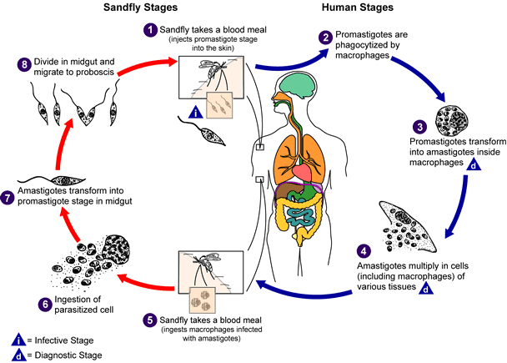
Fig. 2.1. Life cycle of the Leishmania parasite. Source: CDC
Leishmaniasis is transmitted by the bite of female phlebotomine sandflies. The sandflies inject the infective stage, promastigotes, during blood meals [Myler & Fasel, 2008]. Promastigotes that reach the puncture wound are phagocytized by macrophages [Houston chronicle, 2007] and transform into amastigotes [Lewis]. Amastigotes multiply in infected cells and affect different tissues, depending in part on the Leishmania species [Sotto et al., 2007]. This originates the clinical manifestations of leishmaniasis. Sandflies become infected during blood meals on an infected host when they ingest macrophages infected with amastigotes [Arevalo et al., 2007; Sundar et al., 2007]. In the sandfly's midgut, the parasites differentiate into promastigotes [Mueller et al., 2007], which multiply and migrate to the proboscis [Jha et al., 1999].
Occasionally, sandflies are not involved in transmission. VL can be directly initiated by amastigotes via blood (shared needles, transfusion, transplacental spread) or organ transplantation; cutaneous infection can develop after inadvertent needlestick if the needle or syringe contains infected material [Cruz et al., 2002; Basset et al., 2005].
Most leishmaniasis are zoonotic (transmitted to humans from animal reservoir hosts), and humans become infected only when accidentally exposed to the transmitting sandflies. However, in the anthroponotic form (those transmitted from human to human through the sandfly vector), humans are probably the sole reservoir host [Gramiccia & Gradoni, 2005].

Host-parasite interactions
In the mammalian host, Leishmania replicates within resident macrophages in the skin, liver, spleen and bone marrow. During the interaction of Leishmania parasite with mononuclear phagocytes, multiple receptor-ligand interactions have been implicated to play an important role in the entry and survival of the parasite in macrophages. Several host cell surface molecules and derived opsonins (complement, fibronectin, and immunoglobulin) have been proposed to mediate internalization of Leishmania into macrophages [Mosser et al., 1985; Culley et al., 1996; Bodman et al., 2002]. Further, C-reactive proteins (CRP) has been specifically associated with its binding to lipophosphoglycan (LPG) on L. donovani, which in turn triggers phagocytosis via the CRP receptor without leading to macrophage activation [Culley et al., 1996; Bodman et al., 2002]. Depending on the parasite stage and species, Leishmania can evade humoral innate defences, remodel intracellular compartments and pathways, and impair macrophage and dendritic cell mechanisms [Sacks & Sher, 2002; Engwerda et al., 2004; McMahon-Pratt & Alexander, 2004]. Infection manipulates intracellular kinases and phosphatases, downregulates activating-type signalling pathways, upregulates suppressive-type signalling pathways, and affects transcription factors and gene expression [Buates & Matlashewski, 2001; McMahon-Pratt & Alexander, 2004; Rodriguez et al., 2004]. In turn, macrophage responsiveness to and secretion of cytokines, surface molecule expression, and generation of leishmanicidal mechanisms (reactive oxygen and nitrogen intermediates) are compromised.
Similarly, parasites reside in dendritic cells and modulate its activities which are critical to antigen presentation, T-cell co-stimulation, and efficient development of acquired Th1 responses [Brandonisio et al., 2004]. Effects on dendritic cells include inhibition of migration, maturation and activation, and IL-12 production. During Leishmania infection, local inflammatory process initiates which involves the accumulation of leucocytes at the site of parasite delivery. In this process, chemokines plays a fundamental role in attracting specific subsets of leucocytes to the site of infection and then stimulating them [Ritter & Moll, 2000]. The chemokines affect the leukocyte recruitment by inducing the expression of several chemokine genes.
Genetic susceptibility
Different species of Leishmania parasite isolates produce different infection patterns suggesting that parasite related factors play an important role in the resistant versus susceptibility status and in the type of immune response elicited by the infected host. In this context different parasitic genes such as LPG, GP63, CPB were associated directly or indirectly with disease outcome [Alexander et al., 1998]. Similarly, host genetic make-up undoubtedly plays an important role. Several groups have attempted to find association of severity of human leishmaniasis with candidate genes. These studies have largely centred on specific alleles of the HLA class I, II and III regions. Cabrera et al. [1995] found association of MCL to alleles of the HLA class III genes, TNF-α and TNF-β in a group of individuals in Venezuela. A further study found association of TNF locus polymorphisms with severity of disease in people infected with L. chagasi [Karplus et al., 2002]. Alleles of HLA-A and -B were found to be associated with disease in a study of CL in Venezuela [Lara et al., 1991]. Blackwell et al. [1997] conducted a study on families in Brazil in an attempt to find linkage and/or association of VL, leprosy and tuberculosis to genes and loci previously implicated in response to infection with various Leishmania species in the mouse model of these diseases. These genes or loci were the MHC, NRAMP1 (now SLC11A1), two loci syntenic with regions on mouse chromosome 11 (Scl1 and the ‘T helper 2’ cytokine gene cluster) and a locus syntenic with chromosome 4 (Scl2). The MHC was found to have weak allelic association with VL, but none of the other loci showed any linkage or association to disease [Blackwell, 1998]. It has been reported that susceptibility to L. major showed high concordance rates with BALB/c alleles on chromosome11 (Scl-1) in two different sets of recombinant inbred mice and in two infection systems, infection with amastigotes in the footpad and promastigotes in the rump [Roberts et al., 1993; Mock et al., 1993]. It was also found Scl-2 appeared to be important in susceptibility to L. mexicana infection [Roberts et al., 1990], and linkage to the T lymphocyte ‘T helper 2’ cluster of genes on a more proximal region of chromosome 11 considered important, late in infection with L. major [Roberts et al., 1993].
Distribution of Cutaneous Leishmaniasis
In the Old World, CL is caused by L. major, L. tropica and, rarely, by L. infantum and L. donovani. Global distribution of CL is described in Fig. 2.2. L. major and L. tropica are the prevalent species in semiarid subtropical regions, important foci being in the Middle East, Middle Asia, Transcaucasia and India [Schwenkenbecher et al., 2006]. CL by L. tropica is often described as being urban and anthroponotic since most cases are reported from densely populated cities in west and central Asia. In Africa and Middle East, however the paucity of cases and the occurrence of sudden outbreaks point to the presence of zoonotic forms of L. Tropica. Recently, there has been an upsurge of CL cases caused by L. tropica, including the emergence of several new foci such as Morocco [Rhajaoui et al., 2004], Kenya [Jhonson et al., 1999], Ethiopia [Gebre-Michael et al., 2004], Israel [Schnur et al., 2004], The Palestinian authority [Al-Jawabreh et al., 2004], Jordan [Kamhawi et al., 1995], Iran [Yaghoobi-Er-Shadi et al., 2002], Afghanistan [Reithinger et al., 2005] and India [Dogra et al., 1990; Sharma et al., 2005]. The rapid spreading of parasite with increasing rates of infection begs epidemiological and molecular investigations.
In India, CL is reported primarily in some pockets in the Thar Desert of Rajasthan state located in the Western part of the country [Dogra et al., 1990] (Fig. 2.3) and bordering Pakistan [Bari & Rahman, 2006]. The first evidence for possible existence of a zoonotic infection was based upon clinico-epidemiological analysis of cases in 1973 during large-scale outbreak of CL in Bikaner. Over two thousand people suffered from this infection, during course of time sporadic cases were detected in villages in vicinity of Rajasthan canals [Sharma et al., 1973c]. Sporadic cases of CL are reported in India such as Himachal Pradesh where both L. tropica and L. donovani were found as the causative agents [Sharma et al., 2005]. Recently, sporadic cases of CL were also reported in Ajmer and Jodhpur in Rajasthan [Rastogi & Nirwan, 2007], Assam [Baishya & Hazarika, 1996] and Kesargod district in Western ghats region of south India [Kumaresan & Kumar, 2007].
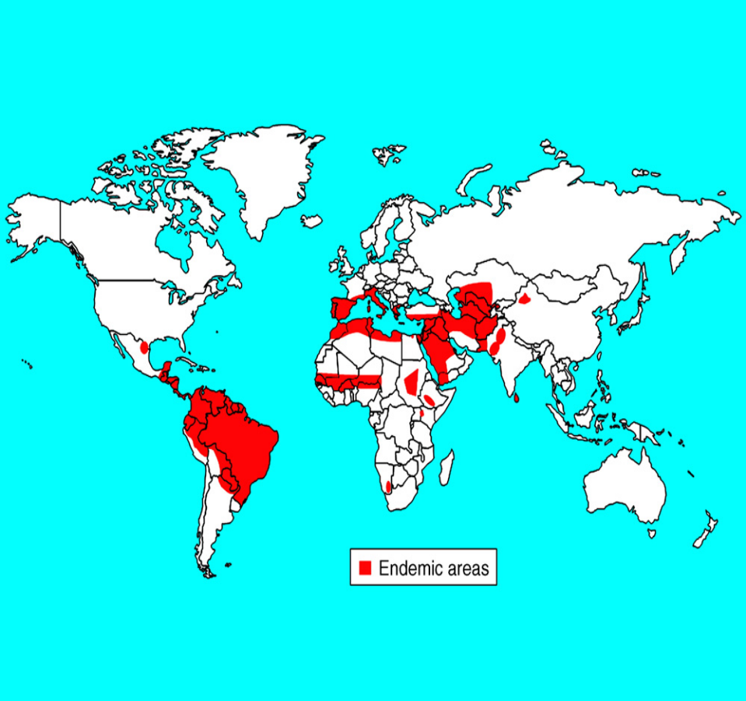
Fig. 2.2. Global distribution of CL (redrawn from P Desjeux/WHO, 2003)

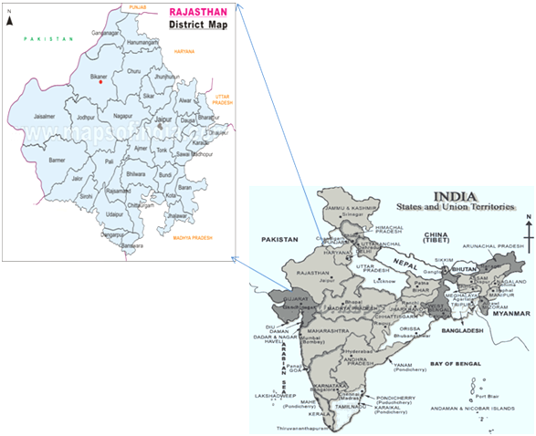
Fig. 2.3. Endemic region of CL in India
Distribution of L. tropica and L. major
L. tropica or L. major is the causative agent of CL [Ashford, 1999]. The endemic areas are usually identified by active or passive case reporting while the epidemic areas are usually identified by an early warning system. The distribution and epidemiology of both parasites is governed by several factors. These factors are population migration, urbanization, farming, malnutrition, climatic factors and global warming, notably bioclimatic and vegetation zones, and finally ambiguous rodent population fluctuations [Neoumine, 1996; Ashford, 1999; Klaus & Frankenburg, 1999; Anis et al., 2001]. L. tropica and L. major are restricted to the OW, mainly in the Mediterranean basin, East Africa, Indian subcontinent, and West and Central Asia (Table 2.1 ). CL by L. tropica is more common in urban areas and in hilly rural areas [Klaus & Frankenburg, 1999]. CL by L. major, by contrast, is found in low lying arid and semiarid deserts [Klaus & Frankenburg, 1999]. Examples for urban L. tropica foci are Baghdad in Iraq, Aleppo in Syria, Kabul in Afghanistan, Sanliurfa in South-east Turkey and Bikaner and Himachal Pradesh in India [Dogra et al., 1990; Jacobson, 2003; Sharma et al., 2005;]. Within the past decade, the world’s largest L. tropica focus was in Kabul [WHO, 2002]. Other smaller foci for L. tropica can be found in Shiraz in Iran, Mosul in Iraq, Ashkhabad in Turkmenistan, and Taza in Morocco [WHO, 2002]. While L. major foci are Jericho in Palestine [Al-Jawabreh et al., 2003; 2004] and Sidi-Bozaid in Tunisia [Ben Ismail et al., 1997].
Table 2.1. Summary of epidemiological and clinical features of CL caused by L. tropica and L. major
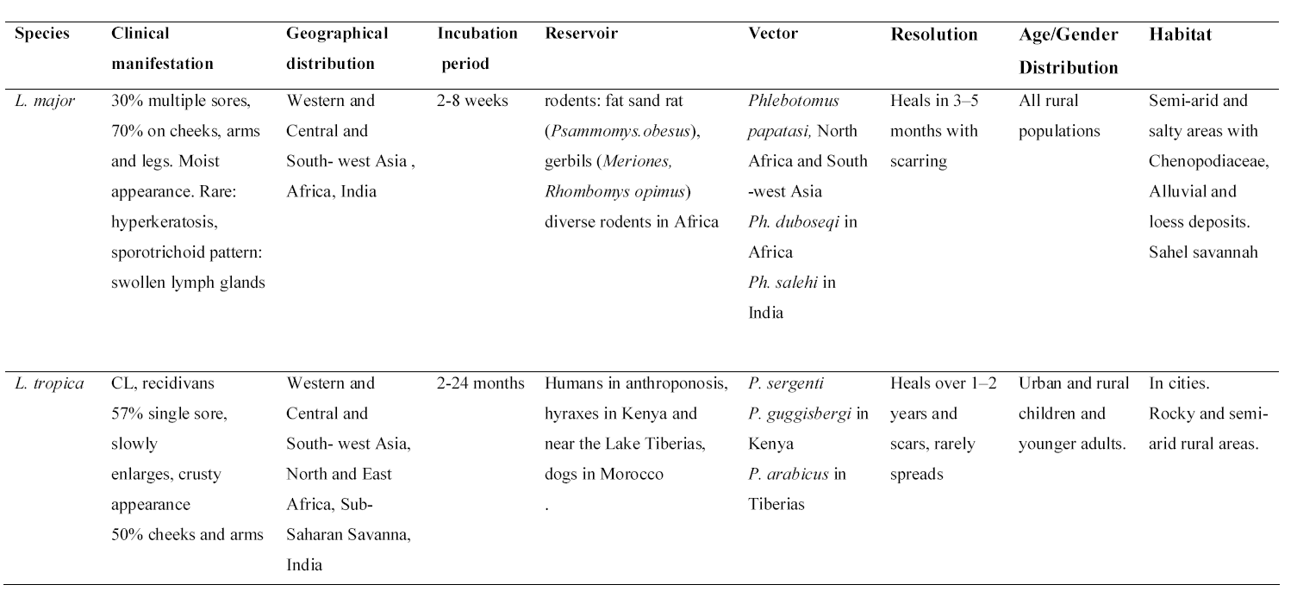
Clinical features of cutaneous leishmaniasis
CL usually presents as a small papule that enlarges and ulcerates at its centre to produce a volcano-shaped “wet” lesion. Ulcerated lesions are typical of infection due to L. major and the New World species such as L. Mexicana. Alternatively, the lesion may not ulcerate but remain as a smooth nodule or the surface may become hyperkeratotic, which are both described as “dry” lesions. Nodular lesions are typical of L. aethiopica and L. donovani complex infections, and hyperkeratotic lesions are typical of L. tropica infections. The thickened edge of all these forms is characteristic of CL and usually correlates with the activity of a lesion. The disease is most likely to occur on exposed skin surfaces, and lesions may be circular or oval with the long axis oriented in line with local skin creases. Cutaneous leishmaniasis lesions may become large (>5 cm) but are rarely larger than 10 cm in diameter, and any ulceration rarely penetrates into subcutaneous tissues, except for cartilage in the pinna of the ear. Lesions are usually painless unless secondary infection occurs. CL with local dissemination is caused by the spread of either parasites or their antigens away from the site of a primary lesion and can occur in several forms of varying severity. Lesions may have extensive subcutaneous induration, and satellite lesions may also develop [Kubba et al., 1988; Bailey & Lockwood, 2007]. Lymphatic involvement may take the form of subcutaneous nodules in sporotrichoid lymphatic spread or regional lymphadenopathy [Gaafar et al., 1994; Bailey & Lockwood, 2007;]. Secondary lesions due to autoinoculation or the Koebner phenomenon have been reported to occur after trauma, surgical procedures, or tattooing [Wortmann et al., 2000; Bailey & Lockwood, 2007]. A rare form of CL by L. tropica is known as Leishmania recidivans, or lupoid leishmaniasis. This is a late manifestation of an L. tropica infection that comes years after the infection has resolved. It presents as boggy papules in or around the scars of primary lesions. The papules transform slowly into a spreading Leishmania recidivans [Momeni et al., 1995; Klaus & Frankenburg, 1999]. Abnormal manifestations for L. major are the enlargement of regional lymph nodes which is found in about 10% of patients. At times, the infection spreads deeply into subcutaneous tissue and muscle [Al-Gindan et al., 1989; Vardy et al., 1993]. Hyperesthesia or anesthesia around the lesion was reported [Satti et al., 1989]. CL, generally, is adversely affected by HIV. The adverse effects are shown by diffuse widespread eruption of lesions over the body which may reach up to hundreds [Gillis et al., 1995].
Vector
It is commonly known that L. tropica is transmitted mainly by females of Phlebotomus sergenti and L. major by P. papatasi, (Diptera, Nematocera, Psychodidae, Psychodinae) (Fig. 2.4). Sand flies are smaller than 3 mm and spend the day in burrows and cracks to prevent drying out. The female flies are active during the evening, hopping around silently for their blood meals for reproduction. Sand flies have biting season during which they are active in transmission of infection. There are other vetors for L. tropica such as P. (Larroussius) guggisbergi in Kenya [Lawyer et al., 1991] with an infection rate of 4.3%, and P. (L.) arabicus in Tiberias [Jacobson et al., 2003] with an infection rate of 5%.
Vectors are either specific or permissive. Permissive vectors like P. argentipes, P. (L.) arabicus, P. perniciosis and P. halepensis have O-glycosylated receptors on their midgut epithelium supporting the adherence of different Leishmania species. In contrast, specific vectors like P. sergenti and P. papatasi lack these receptors and harbour only single species of Leishmania, L. tropica and L. major, respectively [Peckova et al., 2005]. This is in agreement with the finding of Kamhawi et al. [2000] that P. sergenti does not support L. major and L. donovani.

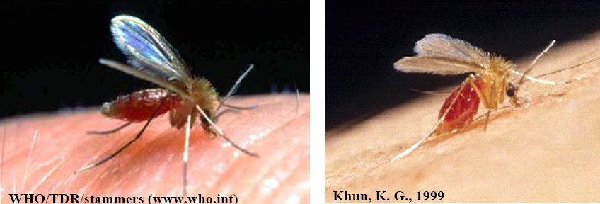
Fig. 2.4. Phlebotomus species are the vectors for the Old World Leishmaniasis. They are small (2–3 mm), hairy, midge-like insects, with long slender legs and rather short mouth parts. They are not strong fliers and usually stay within 200 m of their breeding sites. In cities, they breed in refuse piles, in cracks in the walls, and foundations of buildings and fences. In desert areas they breed within the burrows of rodents (Killick-Kendrick, 1999; Klaus & Frankenburg., 1999).
Reservoir
A reservoir host is the ecological system in which an infectious agent survives persistently [Ashford, 1996]. CL is either anthroponotic, where infection is transmitted by the vector from man to man, or zoonotic, where an animal reservoir host is involved. In North Africa and South-west Asia it is Psammomys obesus, a rodent living in underground burrows [Ashford, 1996; Klaus & Frankenburg, 1999] (Fig. 2.5A). In Iran and Central Asia, gerbils are the common reservoirs, either Meriones libycus or Rhombomys opimus.
CL caused by L. tropica is anthroponotic in urban areas and zoonotic in rural villages [Klaus & Frankenburg, 1999]. L. tropica has been isolated from hyraxes (Procavia capensis) in several rural areas in Kenya and near Lake Tiberias (Fig. 2.5B) [Ashford & Sang, 2001; Jacobson et al., 2003] and M. Hurrianae in Bikaner region in India [Mohan & Suri, 1975].
L. major is completely zoonotic with various animals being confirmed as reservoirs. L. major has also been isolated from Meriones shawi and Meriones lybicus [Rioux et al., 1986; Ben-Ismail et al., 1987].

A B
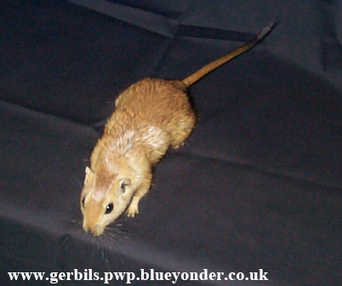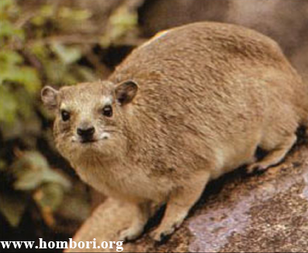

Fig. 2.5. (A) Psamommys obesus, fat sand rat, the established reservoir for L. major. (B) Rock hyrax from which L. tropica has been isolated.

Diagnosis of Cutaneous Leishmaniasis
CL has a broad differential diagnosis because of its diverse clinical presentations. Most cases will present with a nonhealing skin ulcer, which is initially thought to be an infected insect bite or a true “tropical ulcer”. Less common bacterial causes include actinomycetoma, Buruli ulcer, ulceroglandular tularemia, and cutaneous anthrax, but these can usually be distinguished by their clinical features. Cutaneous tuberculosis, however, produces a variety of lesions and similar granulomatous changes on histology. Fungal causes such as eumycetoma and paracoccidioidomycosis may also need to be considered and sought with specific investigations. Noninfectious causes of chronic skin ulceration include pyoderma gangrenosum, squamous cell carcinoma, basal cell carcinoma, and cutaneous lymphoma. Hyperkeratotic lesions may resemble impetigo or psoriasis, diffuse lesions may resemble lepromatousleprosy, and lymphatic involvement may resemble sporotrichosis or Mycobacterium marinum infection. Therefore, the confirmation of parasite is mandatory when the diagnosis is suspected.
The confirmation of CL, however, should be sought wherever possible because of the broad differential diagnosis and potentially toxic treatments that may be required. The investigations available have a wide range of reported sensitivities because of variations in the techniques used and because results are usually worse for older lesions. Various sampling methods are available to obtain tissue for further investigation, and simple aspiration or scraping can produce good results if performed correctly [Ramirez et al., 2000]. Skin biopsy samples, however, will usually produce better results and also enable more tests to be performed, resulting in a greater sensitivity overall [Dar & Khurshid, 2005]. Various techniques may be used, but punch biopsy tools have the advantages of producing standard sample sizes and being safer for use by non-specialists. One or two 4-mm punch biopsies taken from the edge of the lesion will be sufficient to perform microscopy of smear preparations, histological investigations, polymerase chain reaction (PCR) tests, and parasite culture. Microscopy of tissue fluid from aspiration, scrapings, or biopsy smears can be performed after staining with Giemsa at pH 6.8 to look for the presence of Leishmania amastigotes. This, however, is a specialist technique, which may not be widely available and has limited sensitivity. Histological investigations of skin biopsy samples are used to identify either amastigotes or pathologic features that are suggestive of CL [Mehregan et al., 1999]. These may also be helpful in differentiating CL lesions from other similar clinical presentations. Most pathologists will be able to identify Leishmania amastigotes, so long as they are alerted to this possibility. The culture of Leishmania parasites can be performed from aspirates, scrapings, and fresh skin biopsies. It is not widely available in regional clinics and is usually found to be the least sensitive method used [Laskay et al., 1995; Ramirez et al., 2000; Allahverdiyev et al., 2004; Weina et al., 2004; Chargui et al., 2005]. These investigations, however, may produce nonspecific results and are less sensitive than other methods. Polymerase chain reaction tests can be performed on aspirates, scrapings, biopsy smears, and fresh or preserved skin biopsies stored in either liquid medium or wax blocks [Laskay et al., 1995]. The latest real-time PCR tests are increasingly automated and can generate results within a few hours [Wortmann et al., 2005]. This technique has revolutionized the diagnosis of CL because of its high sensitivity, which may enable less than one parasite to be detected, and its high specificity, which may enable a species-specific diagnosis to be made.
Treatment of cutaneous leishmaniasis
The large number of reported treatments for CL indicates that no single ideal therapy has yet been identified (Table 2.2) [Bailey et al., 2005]. When reviewing therapeutic trials, it is important to note the natural history of the disease, the quality of trials with respect to the identification of parasites and significance of results, and also whether the reported findings are comparable with other trials or applicable in different settings. With so many treatments available against CL, it is also not surprising that considerable variation exists in clinical practice and there is a need for guidelines to optimize treatment in different settings. The most common treatment of CL in most parts of the world is the intralesional application of pentavalent antimonials (SbV), e.g. sodium stibogluconate commercially known as Pentostam (Glaxowellcom) [Croft & Yardley, 2002]. Pentostam can be given intramuscularly (IM) or intravenously (IV) depending on the progress and stage of the lesion. Meglumine antimonate or Glucantime are other forms of antimony compounds that were used once. Patients with CL lesions not responding to SbV treatment have been reported [Dowlati, 1996], and these patients may require alternative treatments. In 2002, an outbreak of CL occurred in Mashhad, north-east Iran, where almost 4,900 CL cases have been detected by clinical and parasitological methods [Khorassan Health Centers Reports 2000–2002]. The results of a cross-sectional study in this area showed that 94.2% of isolates were L. tropica [Hajjaran et al., 2004] and that almost 12% of the patients did not respond to treatment with meglumine antimonate [Hadighi et al., 2006]. Paromomycin, in combination with methyl benzethonium chloride gave different rates of success when applied in areas where either L. major or L. tropica [Klaus & Frankenburg, 1999] is endemic. L. tropica tends to be less responsive to therapy, In a few cases, it took more than 6 months for large lesions to heal up (observations from patients in Bikaner). Other than paromomycin and limited studies with miltefosine, there are no highly efficacious drugs or candidates in advanced stages of development, nor a screening program in place for the identification and evaluation of new chemical entities active against the pathogens that cause target CL [Croft & Coombs, 2003]. In case of CL where injectable treatment is not feasible, Rifampicin, which is an oral drug for CL, is given to the patients which are having multiple lesions and pediatric patients (<5 years) and if patients do not respond to Sodium stibogluconate. Various oral medications such as ketoconazole, itraconazole, metronidazole, allopurinol, and dapsone have also been tried but their effects were not constant [Kochar et al., 2000].

Table 2.2. An approach to differential treatment of CL [Bailey et al., 2005]
Parasites | Simple lesion | Complex lesion
L major | IL SSG weeklyX1-4 weeks or a physical treatment | IV SSG 20 mg/kgX10-20 days
L tropica | IL SSG weeklyX1-4 weeks or a physical treatment | IV SSG 20 mg/kgX10-20 days
Unidentified/other OWCL species | IL SSG weeklyX1-4 weeks or a physical treatment | IV SSG 20 mg/kgX10-20 days
NWCL due to L (Leishmania) spp  (L mexicana complex) | IL SSG weeklyX1-4 weeks or a physical treatment | IV SSG 20 mg/kgX20 days
NWCL due to L (Viannia)spp (L braziliensis complex) | IV SSG 20 mg/kgX20 days | IV SSG 20 mg/kgX20 days
Unidentified/other NWCL species | IV SSG 20 mg/kgX 20 days | IV SSG 20 mg/kgX 20 days

Immunological responses in CL
In the mammalian host, Leishmania are obligate intracellular parasites of macrophages that survive within the severe environment of the phagolysosome and evade the defence mechanisms induced during host immune responses. There is considerable evidence that outcome of Leishmania infection is mediated by the cellular immune response of the host, which results in leishmanicidal macrophage activation. The first evidence for the development of Th1 and Th2 cells and their effect on the outcome of disease in vivo was obtained in the murine model of infection with L. major [Gumy et al., 2004; Scott et al., 2004]. In murine model, resolution of the infection is associated with the capacity of Th1 cells to generate IFN-γ and TNF-α. Th1 CD4⁺ T cell response confers resistance to infection, while Th2 CD4⁺ T cell response results in exacerbation of infection and renders mice susceptible to disease. The events responsible for resistance or susceptibility occur early in infection and appear to involve elements of the innate immune response that precedes the development of Th1 and Th2 CD4⁺ T cells [Scott et al., 2004; Campos-Neto, 2005]. Effective killing of intracellular parasites requires IFN-γ, which is usually contributed by natural killer cells and the Th1 subpopulation of T helper lymphocytes [Weinstock et al., 1997]. Insufficient activation by IFN-γ of macrophage and thereby, lack of intracellular killing are thought to be the reason for a non-self limiting course of the infection. The immune reactions leading to either sufficient macrophage activation, with killing of the parasites or insufficient macrophage activation allowing the infection proceed have been extensively studied in the murine models. It is demonstrated in genetically resistant mice (e.g. C57BL/6), a Th1-type response with predominant production of IL-2 and IFN-γ develops, and thus resulting in effective killing of the parasites, while in genetically susceptible mice (e.g. BALB/c), a Th2-type response with production of IL-4 and IL-10 is mounted. Both IL-4 and IL-10 inhibit maturation of IFN-γ producing Th1 cells and are powerful inhibitors of macrophage activation by IFN-γ [Rogers et al., 2002]. There are also some debates concerning the importance of IFN-γ in favoring Th1 cell response during infection with L. major. IFN-γ could influence Th1 differentiation by enhancing either IL-12 expression or responsiveness of naïve T cells to IL-12. Furthermore, since IFN-γ activation of T-bet through signal transducer and activator of transcription (STAT-1) signaling induces IL-12 Rβ2 chain expression on CD4⁺ T cells, IFN-γ could influence the IL-12 responsiveness of these cells [Afkarian et al., 2002]. However, and interestingly, there is no evidence for major differences in IFN-γ production between resistant and susceptible mice during the early phase of infection. Thus other mechanisms than imply differences in levels of IFN-γ production are needed to explain the role of IFN-γ in Th1 cell differentiation. The role of IL-12 in Th1 cell development has been documented by the fact that genetic deficiency of a transcription factor T-bet [Szabo et al., 2002] or co-stimulatory molecules (CD40-Cd40L) [Campbell et al., 1996], which are involved in a Th1 response, rendered resistant mice susceptible to infection with L. major. Indeed, these deficient mice exhibited a down-regulation of the IL-12 production associated with maturation of a typical Th2 cell response. However, the precise timing of IL-12 production in vivo following infection with L. major is still unclear. Functional expression of IL-12R has been shown to be enhanced in the presence of IL-12 suggesting that IL-12 regulates its own receptor [Sinigaglia et al., 1999]. However, TNF-α is also critical for resolution of L. major infection since infection with the parasite in TNF-α knockout mice is fatal; the most obvious is its ability to enhance macrophage activation, NO production and thus parasite clearance. In addition to IL-12, other cytokines such as IL-18, IL-23 and IL-27 favour IFN-γ production by CD4⁺ T cells [Gumy et al., 2004]. Understanding the basis of such conflicting issues might rely on the assessment of Th2 cytokines such as IL-13, IL-4, IL-10 and TGF-β in the development of T cell responses. TGF-β is a pleiotropic cytokine known to inhibit the differentiation of naïve T cells into either Th1 or Th2 cells. However, TGF-β could also act directly on T cells since it inhibits the expression of T-bet, a transcription factor central to Th1 differentiation [Gorelik et al., 2002]. It has also been shown that IL-10 is implicated in persistence of Leishmania in healed lesions of resistance mice since complete elimination of parasites occurred in these mice only when the IL-10 signaling pathway was abrogated with anti-IL-10R mABs [Belkaid et al., 2001]. Furthermore, IL-4 and IL-13 might be as important as TGF-β and IL-10 in the development of susceptibility. IL-4 rapidly produced after infection with L. major inhibits IL-12RB2 chain expression on CD4⁺ T cells resulting in a state of unresponsiveness to IL-12 and a Th2 development [Himmelrich et al., 1998]. Previous observations suggest that IL-13 shares biological functions with IL-4 [Chomarat & Banchereau, 1998]. Genetic mapping of loci involved in the outcome of infection with L. major demonstrated that one of the loci involved maps to chromosome 11 contains the IL-4/IL-13 gene cluster [Beebe et al., 1997].
The immune response of humans to infection with Leishmania is not clear as it is not well characterized as the response in mice. Despite this, there have been several studies investigating the cytokines produced by peripheral blood mononuclear cells (PBMC) or present in the lesion in patients with CL. Very early studies showed that recovery from infection correlated with the induction of delayed-type hypersensitivity to Leishmania antigens, pointing to the importance of the cell-mediated immune response [Bryceson, 1970]. Measurement of the proliferative response of PBMC induced by stimulation with L. major preparations has indicated that a higher level of proliferation is associated with milder disease and healing, presumably due to a more robust T cell response to infection [Kemp et al., 1994; Gaafar et al., 1995a; 1995b; Ajdary et al., 2000]. Several groups have measured the cytokine profile of PBMC from patients infected with L. major and showed that in patients who had cured their infection, had sub-clinical infection or had milder disease, high levels of IFN-γ and low levels of IL-4 were detected. Those with more severe or non-healing disease had low levels of IFN-γ and most reported high levels of IL-4 [Kemp et al., 1994; Gaafar et al., 1995b; Ajdary et al., 2000; Habibi et al., 2001]. It was reported that IL-12p40 and IFN-γ were positively associated with the presence of parasites in the lesion and that elevated levels of IL-12p40, IFN-γ and IL-10 were associated with an unfavourable evolution of disease [Louzir et al., 1998]. It was suggested that IL-10 was inhibiting the macrophage activating effects of IFN-γ in this situation. Similar investigations in patients infected with L. guyanensis found an association between high levels of IL-10 and poor response to treatment and a possible role for IL-13 in the down-regulation of IL-12RB2; an indicator of a predominantly Th2 response [Bourreau et al., 2001a; 2001b]. A report on the cytokines detected in biopsies of patients infected with L. braziliensis or L. mexicana has indicated a difference of response in patients with varying severity of the disease. Patients with diffuse cutaneous leishmaniasis, or non-healing disease, exhibited a Th2 cytokine profile, those who cured their lesions produced Th1-type cytokines and those with an intermediate form of the disease produced a mixed response [Diaz et al., 2002]. Until recently, the role of nitric oxide (NO) in human leishmaniasis has been controversial. However, it has now been reported that inducible nitric oxide synthase (iNOS) can be detected in cells from cutaneous lesions, indicating that NO is likely to be involved in macrophage-mediated parasite killing in humans [Arevalo et al., 2002]. This is supported by in vitro data, which demonstrated that human macrophages killed parasites in a NO dependent manner [Vouldoukis et al., 1995]. Therefore, a strong T cell response, with the production of IFN-γ to induce iNOS expression in macrophages seems also to be required for the clearance of the parasite in humans.
Cytokines are directly involved with chemokine production and can also precede the expression of some chemokines, which in turn induce the production of additional inflammatory mediators. Cytokines exert a secondary effect on leukocyte recruitment by inducing the expression of several chemokine genes [Ohmori et al., 1993]. TNF-α and IL-1β released from activated neutrophils (PMNs) and macrophages have been implicated in chemokine synthesis in several cell types, including PMNs, fibroblasts, and endothelial and epithelial cells [Moser et al., 2004]. In leishmaniasis, cytokines seem to synergize with leishmanial elements to regulate chemokine production. TNF-α and IL-1β, together with macrophage inflammatory protein (MIP)-1α (also known as CCL3), were reported to regulate langerhans cell-mediated transport of Leishmania from the infected skin to regional lymph nodes (LNs) in murine CL [Arnoldi & Moll, 1998]. IL-12 is required for the induction of Th1-related chemokines such as XCL1 (also known as lymphotactin), IFN-inducible protein 10 (also known as CXCL10 or IP-10; hereafter referred to as CXCL10) and monocyte chemotactic protein 1 (also known as CCL2 or MCP-1; hereafter referred to as CCL2) in LNs of resistant L. major-infected mice [Zaph & Scott, 2003]. Interestingly, Th1- and Th2-derived cytokines can have antagonistic effects on chemokines. For example, some chemokines, such as monokine induced by IFN-γ (also known as CXCL9 or MIG; hereafter referred to as CXCL9) and CXCL10 are more selectively induced by IFN-γ [Farber, 1997]. The Th2-related cytokines IL-4 and IL-13 induce macrophage- derived chemokine (also known as CCL22 or MDC) and CCL6 (also known as C10) production in macrophages, and this production is inhibited by IFN-γ [Bonecchi et al., 1998; Orlofsky et al., 2000]. During infection, cytokines can also act synergistically with chemokines. IFN-γ acts with CCL2 to eliminate L. major from infected macrophages that have been stimulated by CCL2, whereas IL-4 antagonizes the production of this chemokine by Leishmania-infected macrophages [Ritter & Moll, 2000]. Cytokine regulation of chemokines also appears to be cell specific, as illustrated by the observation that IL-4 and IL-13 strongly induce the production of CCL2 in endothelial cells but inhibit production in epithelial cells [Kucharzik et al., 1998]. Therefore, there is interplay between cytokines and chemokines. Chemokines are implicated in cell migration and/or activation of both resident and migratory cells, and such cells, in turn, produce cytokines that influence chemokine expression.
While L. major has become a favorite model for immunologists, the CL caused by L. tropica has not been studied thoroughly. Hardly any molecular and immunological studies have been carried out in Indian patients of CL. The present study will be the first comprehensive study in the Bikaner region of Rajasthan [India] exploiting molecular tool for diagnosis and species identification. Species identification is a vital step in the diagnostic procedure, especially in areas where more than one species of Leishmania occurs. This study will help in accurate diagnosis, species identification and understanding the mechanisms associated with immune response. Most of the studies on the immune responses were carried out in CL caused by L. major, however, the information on contribution of immune responses against L. tropica is very scarce. In present study, we examined the comprehensive profile of circular and localized immune response in patients of CL. The characterization of the immune status of the CL will shed light on the factors that are responsible for development of CL; such information can be incorporated into ongoing vaccine studies.

