Characterization of circulating humoral and cellular immune responses in CL patients

Introduction
Outcome of Leishmania infections depends on arm’s race between host’s immune system and parasite’s evasion mechanism, where Th1 responses enhance cell-mediated immunity leading to control of infection and resistance to re-infection while Th2 responses leads to a dominantly humoral response and exacerbation of the infection. For decades, the high titers of anti-leishmanial antibodies have been exploited for the development of serological diagnostic tools and elucidation of humoral response in VL [Ansari et al., 2008]. An exceptionally high antibody titre against Leishmania antigens can be detected in VL, as a consequence of polyclonal activation of B cells [Galvao-Castro et al., 1984]. It has been shown that IgG not only fails to provide protection against this intracellular pathogen, but that it actually contributes to disease progression [Miles et al., 2005]. Analysis of Leishmania antigen-specific immunoglobulin isotypes and IgG subclasses in VL patient sera revealed elevated levels of IgG, IgM, IgE and IgG subclasses during disease [Atta et al., 1998; Anam et al., 1999; da Matta et al., 2000; Ryan et al., 2002; Ravindran et al., 2004]. The possible role of antibody-mediated protection against Leishmania signifies the importance of identification of antigens that may elicit protective antibodies. Post-treatment VL sera tested for most of the IgG subclasses indicate a potential role of gp63 in protection against this disease [Ravindran et al., 2004]. Although there is considerable progress in understanding the importance of humoral response in VL, few reports are available to study humoral response in CL [Gutierrez et al., 1991]. The role of antibody titres in resolution of CL and protective immunity is largely unknown.
Leishmania is an intracellular pathogen that lives in host cells, and survival is dependent on coexistence with the host. In their intracellular niche, it is well shielded from the effecter cells of the immune system. The pathogenesis of leishmaniasis appears to be highly dependent on cell-mediated immune responses, which have been proposed to influence the clinical outcome of the disease either by T-lymphocyte subset effector functions or cytokine/chemokine profile [Pirmez et al., 1993; Da cruz et al., 1994; 2002]. Although CD4⁺ T cells are central to acquired resistance, Leishmania-reactive CD8⁺ T cells may also play a role in cure of leishmaniasis, by modulating CD⁺ T-cell activity and/or via a possible direct cytolytic effect on parasitized macrophages [Hill et al., 1989; Smith et al., 1991; Da cruz et al., 1994].
T cells exert an antileishmanial role by production of lymphokines such as TNF-α and IFN-γ [Murray et al., 1987; Titus et al., 1989]. In response to signals initiated by these activating factors, infected cells produce microbicidal molecules such as reactive oxygen intermediates (ROI) and nitric oxide [Assreuy et al., 1994]. Cytokines have long been recognized as key elements in the host response against Leishmania, In recent years, a new class of cytokines with chemotactic properties known as chemokines has also been identified. Chemokines have different roles in Leishmania infection; the most obvious is the recruitment of immune cells to the site of parasite delivery but they also have roles in adaptive immunity and in macrophage activation and parasite killing [Muller et al., 2001]. In humans, polymorphonuclear (PMN) cells containing Leishmania start secreting chemokines such as IL-8 (also known as CXCL8) [Laufs, et al., 2002] which is essential in attracting PMNs to the site of infection. Upon experimental infection with L. major, MIP-2 and keratinocyte-derived cytokine (KC; also known as CXCL1), the functional murine homologs of human IL-8 [Modi & Yoshimura, 1999], are rapidly produced in the skin [Muller et al., 2001]. Studies with human biopsy samples have shown that lesions of patients with CL contain high levels of CC chemokine ligand (CCL2/MCP-1), CXCL9/Mig, CXCL10/IFN-γ-inducible protein (IP)-10, whereas samples from patients with DCL express CCL3/MIP-1α, suggesting that different chemokines patterns may be linked to unique phenotypes of leishmaniasis [Ritter & Korner, 2002; Ji et al., 2003]. Previously, it has been reported that circulating plasma levels of the pro-inflammatory cytokines such as interleukin (IL)-1β, IL-6, IL-8 and tumor necrosis factor (TNF)-α were significantly higher for CL patients [Kocyigit et al., 2002]. Study of immune-regulators at circulating levels in CL patients caused by L. tropica remains to be determined.
Most of the studies on the immune responses were carried out in CL caused by L. major, however, the information on contribution of the T-cell-mediated immune responses against L. tropica is very scarce (Sadick et al., 1984, Serarslan et al., 2005). In the present study, we examined the comprehensive profile of cellular and humoral response in sera of patients of CL at pre-treatment and post-treatment stage. Study of some parameters such as interleukin (IL)-8, monocyte chemoattractant protein (MCP)-1 and inducible nitric oxide (iNOS) was also carried out at localized level in dermal lesions of CL patients.
Reagent and Chemicals
RPMI-1640, Histopaque-1077, Griess reagent, o-phenylenediamine (OPD), HRP conjugated human IgG, and Heparin were obtained from Sigma, USA and other fine chemicals such as Reverse transcriptase, and RNAse free water were from Ambion, and Trizol, Taq DNA polymerase, dNTPs and MgCl₂, from Invitrogen, USA and RNAsin from promega. MCP-1 and IL-8 ELISA kit were purchased from BD Biosciences, USA. FITC or PE conjugated antibodies directed against the CD3⁺, CD4⁺, CD8⁺ and CD45RA⁺ were obtained from (BD Biosciences, USA). Other reagents and chemicals were as described earlier.

Experimental methods
Patients and samples:
Patients of CL reporting to the Department of Skin, V. D. & Leprosy, S. P. Medical College, Bikaner (Rajasthan), India were included in the study. After approval of the study by Ethical Committee of the S. P. Medical College and A. G. of Hospitals, Bikaner, (Rajasthan), a detailed history was obtained from each patient and a clinical examination was conducted. The information collected included age, sex, residence of patients, and site, number, characteristics and duration of lesions. In an endemic area, suspected CL is largely diagnosed clinically as described in chapter 4.
Parasite cultures
Parasites isolated from lesions of CL patients were propagated as promastigotes as described earlier.
Preparation of Leishmania antigen
Promastigotes were harvested during the late log phage, after 4 times washing with cold Phosphate buffer saline (PBS) the cells were lysed by boiling for 5 min in buffer containing 50mmol/L Tris-HCL (pH 7.0), 3% sodium dodecyl sulphate (SDS) and 1 mmol/L phenyl methyl sulphonyl fluoride [Sreenivas et al., 2002]. Protein concentration in the lysates was determined using the DC protein assay kit (Bio-Rad).
Isolation of serum: Whole blood (1 ml) was collected into sterile tubes at pre-treatment stage in all cases and at post treatment stage and from healthy volunteers. Blood was allowed to coagulate for 2 to 3 hour at 4⁰C prior to centrifugation. Sera were preserved at -70⁰C until use.
Detection of IgG in sera using ELISA:
The Leishmania specific IgG antibodies were detected using ELISA. In brief, the plates were coated with Leishmania antigen in carbonate buffer [pH 9.0] at 37⁰C for 3 hours. After blocking with 1% BSA for 1hr, plates were washed and subsequently incubated for 2hrs at 37⁰C with sera (1:20 dilution) from patients and controls. Again the plates were washed, and incubated with peroxidase-conjugated goat polyclonal antibody directed against human IgG (1:1000 dilution, Sigma). Finally after 3 washes, o-phenylenediamine was applied as the enzyme substrate and the optical density [OD] was read at 492nm in an ELISA reader [Tecan].
Flow cytometry:
Blood samples of confirmed CL patients were collected in heparin tubes from the patients before and after therapy and from control subjects. PBMC were separated by Histopaque-1077 (Sigma, USA) density gradient centrifugation, washed two times in RPMI-1640 supplemented with 10% heat inactivated fetal bovine serum (FBS). PBMC were incubated with 45 min. at RT with a panel of fluorescein isothiocyanate- or phycoerythrin-conjugated antibodies directed against the CD3⁺, CD4⁺, CD8⁺ and CD45RA⁺ (BD Biosciences, USA). After washing twice with 1x PBS, the cells were acquired on flowcytometer [BD Biosciences, USA]. Data was analyzed using Cell quest software [BD Biosciences, USA]. Isotope matched control antibodies and unstained PBMCs were used to detect nonspecific binding to the cells in each step. Statistical markers were set using the isotype match antibody and negative control as a reference.
Circulating cytokine measurement. Cytokine levels in serum were determined by utilizing inflammatory cytokine bead array (CBA) kit (BD Biosciences, USA) by flow cytometry which detects IL-1β, IL-6, IL-8, IL-10, TNF, and IL-12p70. Briefly, 50μl of bead populations with discrete fluorescence intensities coated with cytokine specific capture antibodies were added to 50μl of patient sera, and 50μl of phycoerythrin (PE) conjugated antihuman inflammatory cytokine antibodies. Simultaneously, standards for each cytokine (0 to 5,000 pg/ml) were likewise mixed with cytokine capture beads. The vortexed mixtures were allowed to incubate for 1.5 hrs in dark. After washing the beads, 50 μl of the human inflammation PE detection reagent was added and incubated for 1.5 hrs in dark. Beads were washed and analyzed using flowcytometry (FACS Calibur, BD). Quantity (pg/ml) of respective cytokine was calculated using CBA software. Standard curves were derived from the cytokine standards supplied with the kit.
Enzyme–Linked Immunosorbent Assay (ELISA) for analysis of IL-8 and MCP-1. The BD OptEIATM human IL-8 and MCP-1 ELISA Kit was used for the quantitative determination of human IL-8 and MCP-1 in sera of CL patients and in healthy controls. Sera were diluted (1:20) with standard diluent and appropriate standards were prepared according to manufacturer’s instructions. In brief, 100 μl of each standard or sample was added to each well of 96 well plate. After incubation of 2 hrs at room temperature (RT), wells were washed with wash buffer (300 µl/well). Next 100 µl of prepared working detector was added to each well and incubated for 1 hr at RT. After washing, 100 µl of prepared substrate solution was added. 50 µl of stop solution was added to each well after incubation of 30 min. at RT. Absorbance measurement was taken at 450 nm within 30 min. of stopping reaction.
Determination of serum nitric oxide (NO). Serum nitric oxide (NO) is degraded quickly into nitrite and nitrate, therefore, the serum concentration was determined by Griess reaction as an indicator of NO. Griess reagent (Sigma, USA) was dissolved in 250 ml of nitrite-free water, 50 µl of reagent and equal volume of the sample was added in an ELISA plate (Griener) and mixed immediately. After 30 min of incubation at room temperature, the absorbance was read at 540 nm.
RNA extraction from biopsy specimens:
Skin biopsies of 5–10 mm in diameter were taken in RNA stabilising agent RNA later (Ambion) for extraction of RNA under sterile conditions from the border of the ulcers and transported to New Delhi from endemic area with all the necessary precautions. Total RNA was isolated using Trizol reagent, in accordance with the manufacturer’s instructions. Briefly, the dermal tissue was grounded to powder in chilled conditions and was lysed in Trizol, at room temperature and to the homogenized samples, 0.2 volumes of chloroform was added followed by centrifugation at 12,000 x g for 15 min. The aqueous phase was collected and 0.5 volumes of isopropyl alcohol were added to precipitate total RNA. The total RNA was pelleted by centrifugation and washed in 70% ethanol (in autoclaved DEPC treated water) and stored at –70°C till further use.
cDNA synthesis and Reverse transcriptase-PCR. cDNA was prepared using SuperScript RNase H- Reverse Transcriptase kit (Invitrogen), in accordance with the manufacturer’s instructions. In brief, 2µg of total RNA was mixed with 0.5 µg of Oligo(dT) primer and 1 µL of 10 mmol/L dNTP mix in a total volume of 12 µL. The samples were heated at 65ºC for 5 min and then quickly chilled on ice. Subsequently, RTmixture (4 µL of 5X first strandbuffer and 2 µL of 0.1 mol/L dithiothreitol) and 20 U RNAse-In (Promega) were added, and the mixtures were incubated at 42ºC for 2 min. Next, 200 U of reverse transcriptase was added. The reaction was incubated at 42⁰C for 1 h, followed by heating at 70ºC for 15 min, to inactivate the enzyme. Published sequences for oligonucleotide primers based on the cDNA sequences of human IL-8, MCP-1, and HPRT were used for the study [Coste et al., 2001, Yoshida et al., 2001; Dasgupta et al., 2003; Shimabukuro et al., 2005]: IL-8, 5'-AAGCTGGCCGTGGCTCTCTTG-3' and 5'-AGCCCTCTTCAAAAACTTCTC-3'; MCP-1, 5'-GCTCATAGCAGCCACCTTCATTC-3' and 5'-GTCTTCGGAGTTTGGGTTTGC-3'; iNOS, 5’-GTCAACTGCAAGAGAACGGAGAAC-3’ and 5’-GAGCTCCTCCAGAGGGTAGG-3’ and HPRT, 5'-CGAGATGTGATGAAGGAGATGGG-3' and 5'- CCTGACCAAGGAAAGCAAAGTCTG-3'. The primer estimated lengths of the PCR products for IL-8, MCP-1, iNOS and HPRT are 291bp, 296bp, 454bp and 303bp respectively. To compare the results between different categories, the cDNAs were normalized on the basis of the expression of HPRT products. The reaction mixture (20 µL) for PCR contained normalized cDNA, 200 mmol/L each dNTP, 1.5 mmol/L MgCl₂, 25 pmol of each primer, and 0.5 U of Thermus aquaticus (Taq) DNA polymerase in PCR buffer (Invitrogen, USA). PCR was performed in a DNA thermal cycler (Applied Biosystem, USA). Cycling parameters for HPRT were as follows: initial denaturation at 94ºC for 2 min; amplification cycles at 94ºC for 30 s, 66ºC for 45 s, and 72ºC for 30 s; and final extension at 72ºC for 5 min. The number of amplification cycles was 30. The PCR conditions for iNOS were as follows: initial denaturation at 94ºC for 2 min; amplification cycles at 94ºC for 30 s, 55 ºC for 1 min., and 72 ºC for 45 s; and final extension at 72 ºC for 7 min. The number of amplification cycles was 35. For IL-8, the PCR conditions were as follows: initial denaturation at 94 ºC for 2 min; amplification at cycles at 94 ºC for 30s, 57 ºC for 30s, and 72 ºC for 1 min; and final extension at 72 ºC for 5 min. The number of amplification cycles was 38. Cycling parameters for the mRNA amplification for MCP-1were 30 s at 94 ºC, 30 s at 55 ºC, 1 min. at 72 ºC for 35 cycles and final extension was 72 ºC for 5 min. After the PCR amplification, 2 µL of tracking dye was added to the sample, and 10 µL of sample products were run on 1.5% agarose gel containing ethidium bromide (1 mg/mL) in TAE buffer (0.04 mol/L Tris acetate, 0.001 mol/L EDTA). A 100-bp DNA ladder was used as a molecular marker.
Statistical Analysis
The differences between experimental groups were examined by using student’s paired and unpaired t-test; P<0.05 was considered to be statistically significant. Data are expressed as Means ± SE.
Results
Determination of IgG in sera samples:
Immunoglobulins plays an important role in defence mechanism in leishmaniasis, therefore, levels of IgG was analyzed at pre-treatment stage (n=36) and in serum samples of CL patients and compared with post-treatment stage (n=16) and healthy control sera (n=12) (Fig. 6.1). Level of IgG was found to be significantly higher in CL samples at pre-treatment stage (0.147±0.0086) compared to post-treatment stage (0.097±0.016) (P<0.05) or control (0.0215±0.004) (P<0.05).

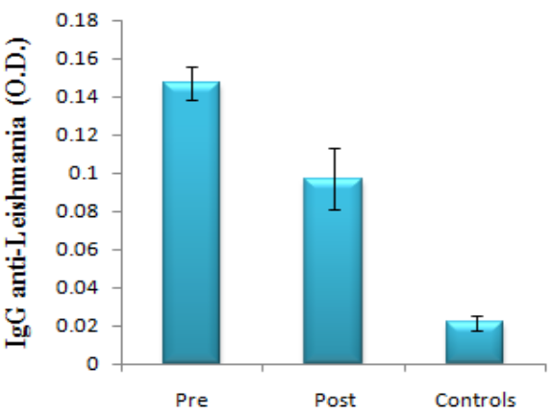
Fig. 6.1. Analysis of IgG in sera (1:25 dilution) of CL patients by ELISA. Levels of IgG at pre-treatment stage (n=36) compared with post-treatment stage (n=16) and healthy controls (n=12). Values are Mean ± SE. P <0.05 was considered to be statistically significant.
Phenotypic characterization of Cell subpopulation in Blood samples
The cell sub-population profile in blood was analyzed at pre-treatment stage (n=13) and post-treatment stage (n=10) in blood samples of CL patients and compared with healthy control sera (n=5) (Fig. 6.2). The percentage of CD3⁺, CD4⁺, CD8⁺ and CD45RA⁺ was decreased significantly (P<0.03) in CL samples at pre-treatment stage compared to controls. Percentage of CD4⁺ cells were significantly increased (p<0.05) at post-treatment stage (59.48±3.25) compared to pre-treatment stage (32.47±2.98). CD3⁺, CD8⁺, and CD45RA⁺ remained unaltered at post-treatment stage. Results are summarised in table 6.1.
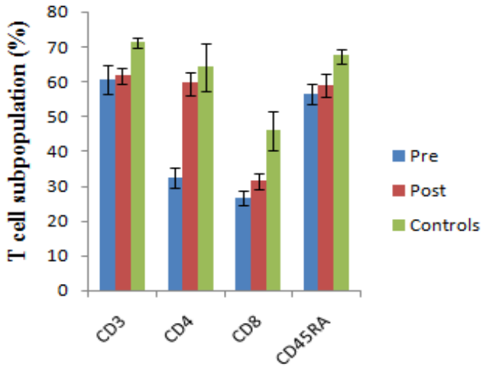
Fig. 6.2. Flowcytometric analysis of T cell subpopulation in blood samples of CL patients. CD3⁺, CD4⁺, CD8⁺ and CD45RA⁺ T cells at pre-treatment stage (n=13) compared with post-treatment stage (n=10) and healthy controls (n=5). Values are Mean±SE. Y-axis represents T cell subpopulation in percentage (%) and X-axis represents different types of cell subpopulation. The bars indicate SEs. P <0.05 was considered to be statistically significant.
Table 6.1. Comparative analysis of mononuclear cell subpopulation in blood samples obtained from CL patients in endemic area (Cell number in percentage ±Standard error).
Cells | Pre-treatment (n=13) | Post-treatment (n=10) | Controls (n=5)
CD3 | 60.45±4.16 | 61.7±2.4 | 71.26±1.52
CD4 | 32.47±2.98 | 59.48±3.25 | 64.18±6.7
CD8 | 26.56±1.88 | 31.32±2.26 | 46±5.59
CD45RA | 56.30±2.92 | 59 ±3.42 | 67.44±2.09

Cytokine levels in sera of CL patients by Cytokine Bead Array. In order to understand the in vivo circulating cytokine profile, serum cytokine levels were analyzed at pre-treatment stage and post-treatment stage in CL patients and compared with healthy controls (sera not diluted). Level of IL-8 was found to be significantly higher in CL samples at pre-treatment stage (1022.4± 313.78 pg/ml) compared to post-treatment stage (10.11± 6.97 pg/ml) or control (10.48±3.9 pg/ml). The level of IL-8 was restored to normal level after treatment (Fig. 6.3). Other circulating inflammatory cytokines examined, including IL-1β, IL-6, IL-10, TNF, and IL-12p70 were not detectable in sera.
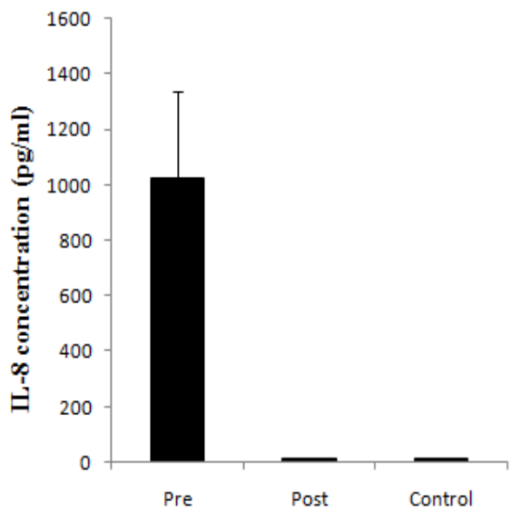
Fig. 6.3. Quantitative estimation of interleukin [IL]-8 in sera of CL patients by cytokine bead array analysis (CBA). Analysis of IL-8 at protein level was carried out at pre-treatment (n=15), and post-treatment stage (n=9) and in healthy controls (n=4). Values are Mean ± SE. The bars indicate SEs.

Measurement of IL-8 and MCP-1 by ELISA in sera of CL patients. IL-8 and MCP-1 both are chemoattractant cytokines, IL-8 recruits neutrophils at the site of infection, while MCP-1 involves in the recruitment of macrophage [Aga et al., 2002; Ji et al. 2003]. Quantitative analysis of IL-8 and MCP-1 was carried out at pre-treatment stage (n=20) and post-treatment stage (n=9) in sera samples of CL patients and compared with healthy control sera (n=9) (Fig. 6.4). Since IL-8 was detected at a significant level by CBA, its concentration was further evaluated by the more sensitive ELISA method. Level of IL-8 determined in sera (1:20 dilution) was found to be significantly higher (P<0.001) in CL patients (20/20) at pre-treatment stage (89.04±18.8 pg/ml) compared to post-treatment stage (13.12±5.16 pg/ml) or control (5.16±1.45 pg/ml). Similarly, elevated level of MCP-1 was observed in all 20 CL cases at pre-treatment stage (39.25±5.29pg/ml) compared to control (21.1±2.6 pg/ml, P<0.01) which remained high at post-treatment stage (47.77±3.03 pg/ml, P>0.05).
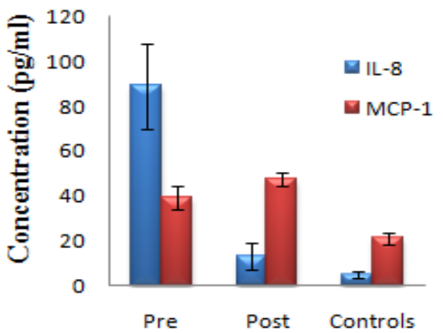
Fig. 6.4. Quantitative analysis of Interleukin [IL]-8, and monocyte chemoattractant protein (MCP)-1 in sera of CL patients by ELISA. Levels (pg/ml) of IL-8 and MCP-1 in 1:20 dilution of sera at pre-treatment (n=20), and post-treatment stage (n=9) in patients and controls (n=9). Values are Mean± SE. The bars indicate SEs.
Quantitative assessment of NO in Sera samples. MCP-1 orchestrates the induction of leishmanicidal activities via generation of NO [Ji et al., 2003], therefore, circulating levels of NO was analyzed at pre-treatment stage in CL patients (n=32) and healthy controls (n=10), followed by evaluation at post-treatment stage (n=10) (Fig. 6.5). The level of NO was found to be significantly higher in CL samples at pre-treatment stage (61.37±2.46 µM) as compare to healthy controls (15.4±0.99 µM, P<0.001) while it was not significantly down-regulated after treatment (41.1±10.11 µM, P>0.05).
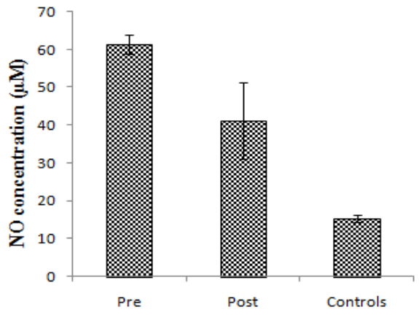
Fig. 6.5. Quantitative analysis of Nitric oxide (NO) in sera of CL patients by ELISA. NO level (µM) at pre-treatment (n=32), and post-treatment stage (n=10) in Indian CL patients and controls (n=10). Values are Mean± SE. The bars indicate SEs.
Intralesional expression of IL-8, MCP-1 and iNOS:
To establish the association between the circulating and localized response of IL-8, MCP-1 and nitric oxide, transcripts of IL-8, MCP-1 and iNOS was analyzed in CL patients by RT-PCR at pre-treatment stage (n=9) compared with post-treatment stage (n=9) and healthy controls (n=6) (Fig. 6.6). Significantly elevated level of IL-8, MCP-1 (P<0.001 for both IL-8 and MCP-1) and iNOS (P<0.05) was obtained in CL lesions at pre-treatment stage compare to healthy controls. Level of IL-8 was significantly decreased after treatment (p<0.05), close to the level in controls, while MCP-1 and iNOS remained high at post-treatment stage compare to control (p>0.05).

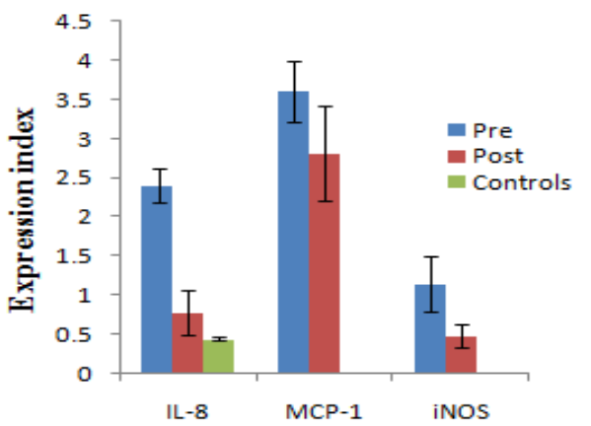
Fig. 6.6. Comparative analysis of mRNA expression of interleukin [IL]-8, monocyte chemotactic factor (MCP), and inducible nitric oxide (iNOS) in CL patients at pre-treatment stage and at post-treatment stage compared with healthy controls. Transcripts levels of cytokine IL-8, MCP-1 and iNOS in paired lesion tissues from CL patients at pre-treatment (n=9), post-treatment stage (n=9) and in healthy controls (n=6). Normalized cDNA was amplified with respective cytokine primers. PCR products were electrophoresed, and the intensity of signal was determined by densitometry. The graph shows results as an expression index, defined as the ratio of the intensity of cytokine with respect to the HPRT gene. The bars indicate SEs. P <0.05 was considered to be statistically significant.

Discussion
Despite the complex range of diseases and responses associated with leishmaniasis, outcome of Leishmania infections depends upon host and parasite related factors where Th1 responses enhance cell-mediated immunity leading to control of infection and resistance to re-infection and Th2 responses leads to humoral response and exacerbation of the infection. There is little information currently available about humoral response in human CL. Cytokines elaborated by activated T cells induce the switching of B lymphocytes to IgG production and are thus obligatory for some humoral responses. Our study showed higher levels of IgG in the sera (1:25 dilution) of patients with CL, however, antibody titre was very low in comparison to KA/PKDL where 1:100 serum dilution was used [Ansari et al., 2008]. Previous studies suggest that levels of IgG and its sub-classes, particularly IgG1 and IgG3, in sera of patients with active CL are significantly upregulated which was determined by nephelometer (Behring 100) [Ozbılge et al., 2006]. Therefore, a critical role for antibody in the pathogenesis associated with CL infection remains to be determined. Therefore, study of cellular immune responses was undertaken to understand the disease pathogenesis of CL
Cell-mediated immune response is known to be important to control Leishmania sp. infection. Impairment in type 1 immune responses can lead to parasite multiplication and dissemination [Pirmez et al., 1993; Rocha et al., 1999]. The concepts that T cells may participate in leishmaniasis pathology in humans have been suggested from previous studies [Bottrel et al., 2001; Bacellar et al., 2002]. The resolution of CL is primarily associated with the development of a cell mediated immune response against parasite [Kemp et al., 1999]. Our study shows the low percentages of Leishmania reactive CD3⁺, CD4⁺, CD8⁺, and CD45RA⁺ T cells in peripheral blood of CL patients in comparison to healthy individuals, revealing that these cells could be recruited to the site of lesions from peripheral blood [Gaffaar et al., 1999; Kemp et al.,1999; Da cruz et al., 2005]. Frequency of activated effectors CD4⁺ T cells was increased significantly after treatment (p<0.05), and approached near to the percentage of healthy controls and CD3⁺, CD8⁺, and CD45RA⁺ T remain unaltered, suggesting that CD4⁺ T cells could be implicated in the process of cure of CL. However, it is not clear whether the process of cure is associated only with the increased percentage of CD4⁺ T cells or whether it depends on the balance of CD4⁺ and CD8⁺ cells. Previous studies have shown that cellular immunity against CL caused by L. major is mediated predominantly through CD4⁺ T cells (77-97%), remaining cells were either CD8⁺ (2-17%) or CD4⁻CD8⁻ (0-8%) [Kemp et al., 1999; Carvalho et al., 2007]. Human vaccine studies with L. braziliensis infection have also shown increased frequency of CD8⁺ T cells in PBMC culture [Da cruz et al., 1994]. In Brazil, different ratios of T-cell distribution in lesions have been reported: CD4⁺ > CD8⁺ [Barral et al., 1987], CD4⁺=CD8⁺ [Lima et al., 1994] and CD4⁺ < CD8⁺ [Vieira et al., 2002; Amato et al., 2003]. Higher proportions of CD8⁺ T cells have been observed in CL caused by Old World [Nilsen & Mshana, 1987] and NW Leishmania species [Isaza et al., 1996]. The present study revealed the distribution of T cells in peripheral blood of CL patients before treatment is as follows; CD3⁺>CD45RA⁺>CD4⁺>CD8⁺.
Patients with CL showed a significant increase in the expression of IL-8, MCP-1 and nitric oxide molecules (iNOS & NO) in both tissue lesion and sera sample. A significant down-regulation in the expression of IL-8 in both tissue lesion and sera was noticed after therapy. These observations suggest that concentration of IL-8 modulates the leishmaniscidal activity. IL-8 is a potent chemotactic cytokine which interacting with PMN, stimulates their chemotaxis as well as release of lysosomal enzymes and reactive oxygen intermediates [Bazzoni et al., 1991]. In humans, PMNs containing Leishmania start secreting chemokines such as IL-8 [Laufs et al., 2002] that are essential in attracting PMNs to the site of infection. It was reported that higher than normal concentration of IL-8 delays the apoptosis of PMNs [Aga et al., 2002; Zandbergen et al., 2002], therefore, rapid recruitment of PMN is beneficial for the survival of parasites. PMNs are the primary effector cells in infection-induced acute inflammatory reactions and exert antileishmanial activity by phagocytosing and killing of Leishmania parasites [Chang et al., 1981; Pearson et al., 1981] using both opsonin-dependent and opsonin-independent uptake mechanisms [Laufs et al., 2002]. Neutrophil granulocytes are inherently short-lived cells with a half life of only ~6–10 h in the circulation, after which they undergo apoptosis [Savill et al., 1989; Payne et al., 1994]. Due to the short lifetime of PMN, however, the parasites can survive the first day intracellularly only if the PMN apoptosis is delayed. All internalized parasites are not killed immediately in PMN, as demonstrated by the finding that morphologically intact parasites were detected in granulocytes of infected animals [Brandonisio et al., 1996]. Moreover, infected neutrophils were observed in chronic lesions of mice after infection with L. major [Belkaid et al., 2000]. Therefore, after being recruited to the site of infection, granulocytes can internalize Leishmania and possibly can provide an intracellular milieu for the survival of the parasites. After ingesting apoptotic PMNs, macrophages undergo inhibition of their pro-inflammatory cytokine production, through mechanisms involving transforming growth factor (TGF)-β, prostaglandin E2 and platelet-activating factor [Fadok et al.,1998; Ribeiro-Gomes et al., 2004]. These events contribute to a ‘silent’ entry of Leishmania into macrophages, its main host cell type [Laskay et al., 2003]. This fits into the “safe target” theory, which suggested that myeloid cells provide intracellular niche for the survival of Leishmania [Mirkovich et al., 1986], and can explain the reported disease promoting effect of neutrophil granulocytes in experimental L. major infection [Tacchini-Cottier et al., 2000].
MCP-1 and iNOS & NO remained high after therapy in CL patients in both tissue lesions and sera as compared to before therapy, while IL-8 approached the baseline levels. MCP-1 appeared to contribute to control of Leishmania infection by stimulating leishmanicidal function of macrophage via generation of NO or via activation of NK cells to release IFN-γ. This is in agreement with previous studies that MCP-1 is high in CL patients with self healing lesions, whereas it is not detectable or minimal in DCL lesions [Ji et al., 2003]. It was also demonstrated that both susceptible and resistant mice produced MCP-1 during the course of infection with L. mexicana as well as in L. major [Bonecchi et al., 1998; Colmenares et al., 2002]. MCP-1 has been demonstrated to recruit monocytes into foci of active inflammation [Ajuebor et al., 1998]. MCP-1 not only contributes to the recruitment of macrophage but also NK cells, T cells and dendritic cells to the site of infection [Loetscher et al., 1996; Ritter & Moll, 2000]. MCP-1 activates macrophage for parasite killing, an effect that is enhanced by IFN-γ derived NK cells and T cells associated with a Th1 response [Ritter & Moll, 2000]. Macrophage serves as host cells for Leishmania species and also modulates the specific cellular immune response [Ritter & Moll, 2000]. Nitric oxide and inducible nitric oxide synthase regulates inflammatory responses and act as an effector molecule of macrophage cytotoxicity against invading parasite [Brunet, 2001]. During parasitic infections such as malaria, toxoplasmosis, and leishmaniasis increased synthesis of NO mediates host protection [Brunet et al., 2001]. It was reported that L. major infection in mice depends on the generation of Th1 response with production of IFN-γ, with consequent induction of iNOS in the infected mice [Srenger et al., 1994]. iNOS protein has been found to be increased upon infection of human macrophages with L. chagasi promastigotes in vitro in the presence of IFN-γ and it has been suggested that O2- and NO each contribute to intracellular killing of L. chagasi in human and murine macrophages [Gantt et al., 2001].
In this study, characterization of cell mediated and humoral immune response was performed in peripheral blood and skin biopsies obtained from patients with CL. The present results showed that cure in CL patients is associated with increment in the percentages of CD4⁺ T cells after treatment. Since leishmanial lesions are often multiple and the immune response in the peripheral blood would be expected to be a summation of different stages of immune responses in all lesions, sub-population profile in peripheral blood is a better indicator of immunological changes. IL-8, MCP-1 and NO emerged as the principal immune-determinants in the pathogenesis of CL. IL-8 may prolong the life span of Leishmania infected PMN by inhibiting the spontaneous apoptosis of these cells. MCP-1 possibly activates macrophages to eliminate intracellular parasite through the production of nitric oxide.

